R10521516廖浚評 HW8

Python OpenCV

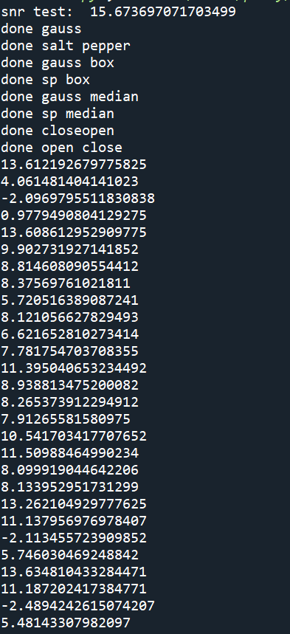Snr test = 15.673697077

a.



SNR of g10 =13.612



SNR of g30 = 4.061

b.



SNR of sp01 =-2.097



SNR of sp005 = 0.978

c. BOX Filter



SNR of g10box3 = 13.6086



SNR of g30box3 = 9.9027



SNR of g10box5 = 8.8146



SNR of g30box5 = 8.37569



SNR of sp01box3 =5.7205163



SNR of sp005box3 = 8.121



SNR of sp01box5 = 6.6216



SNR of sp005box5 = 7.7818

d. Median Filter



SNR of g10median3 = 11.39504



SNR of g30median3 = 8.9388



SNR of g10median5 = 8.265



SNR g30median5 = 7.9127

SNR of sp01median3 = 10.5417



SNR of sp005median3 = 11.5098



SNR of sp01median5 = 8.09992



SNR of sp005median5 = 8.1334

e. openclose closeopen



SNR of g10co = 13.2621



SNR of g30co = 11.138



SNR of sp01co = -2.1135



SNR of sp005co = 5.746



SNR of g10oc = 13.6348



SNR of g30oc = 11.1872

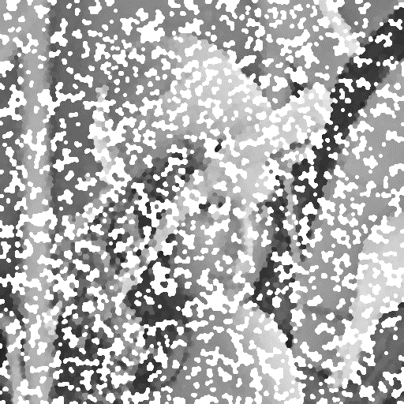

SNR of sp01oc = -2.489424



SNR of sp005oc = 5.48143