**Object-Oriented Programming Language**

**03/09/2023**

**Lab Assignment 3**

1. Write a program that inputs 3 triangles each with three vertices. Store

them in an **array**, and then determine if the given triangles are right triangles (直角三角形). Here are some sample code you can use.

struct Vertex {

double x;

double y;

};

struct Triangle {

Vertex A;

Vertex B;

Vertex C;

bool right;

};

A sample run of the program is as follows:

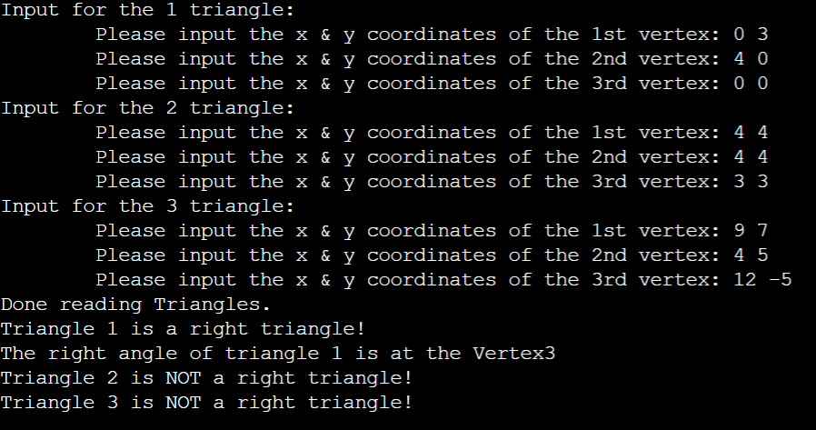

2.Write a program that input two number. Store them in a **string**, and return the sum.

You **should** use the following code in your code.

void initial (string &a, string &b) {

while (a.size() < b.size()) a = '0' + a;

while (b.size() < a.size()) b = '0' + b;

}

bool del (string &a) {

if (a[0] == '0') {

a.erase (0, 1);

return true;

}

return false;

}

string add (string a, string b) {

initial (a, b);

a = '0' + a;

b = '0' + b;

// Please fill this blank

del(a);

return a;

}

int main() {

string a, b;

cin >> a >> b;

cout << add(a,b);

return 0;

}

A sample run of the program is as follows:

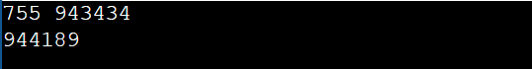

3.Write a program that input a (r x c) matrix and return the transpose of the matrix.

r,c <=10

A sample run of the program is as follows:

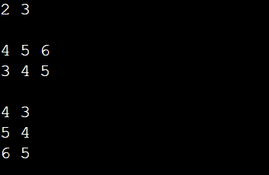

4.Write a program that input a string and test if it is a palindrome(回文)

You **can’t** use the reverse() in the #include <algorithm>

(hint: input N character, compare the first and the N-th, second and the (N-1)-th and so on)

Some sample runs of the program are as follows:

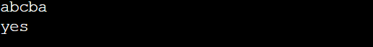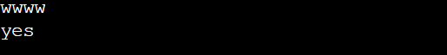



5. write a program that input a number as a **string** and return its reverse

(hint: You can use reverse() in the #include <algorithm> and there is no ‘0’ at the beginning but the end of the input number )

Some sample runs of the program are as follows:





6.Write a program that input an arithmetic sequence’s (等差數列) first number , last number and the common difference of successive members. Please return the whole

arithmetic sequence.

Some sample runs of the program are as follows:

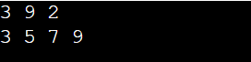

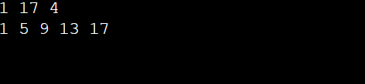

7.Write a program that input a number n and return a “cool” pyramid. For example, if n=3, first row has 1 * and 4_, second row have 3* and 2_, third row has only 5*. That is, creating a (2n-1) x(2n-1) matrix.

Some sample runs of the program are as follows:

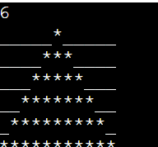

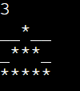

8. There is very simple encryption method in cryptography(密碼學) which is add a certain integer K to each character of the code to obtain the characters of the password For example, if K=2, then apple becomes crrng after encryption .Write a program that input a string and return a string after **encryption.**

Please use K=7

Some sample runs of the program are as follows:

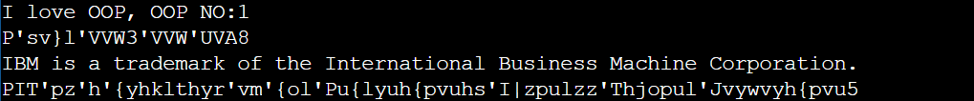

You can copy the sample input here

I love OOP, OOP NO:1

IBM is a trademark of the International Business Machine Corporation.

(HW_1). Write a program that input a number, return the factorization of the number

A sample run of the program is as follows:

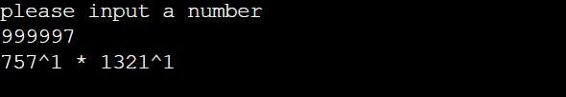

(HW_2). write a program that input a number as an **int** and return its reverse

You should use only #include <iostream>

(hint: use the “%” operator and there is no ‘0’ at the beginning but the end of the input number)

Sample runs are same to the question 5