1.There is a see-saw with n stones on it. Each stone has an integer weight denoted by wi (i = 1, 2, . . . , n), and the distance between any two adjacent stones is 1 unit . Now you are asked to put the pivot under one of the stones to balance the see-saw.

For example, if we put the pivot under stone 2 below, then the total

torque (力矩) would be: (9 × 1) − (2 × 1 + 2 × 2 + 1 × 3) = 0. That is, the see-saw would be balanced.

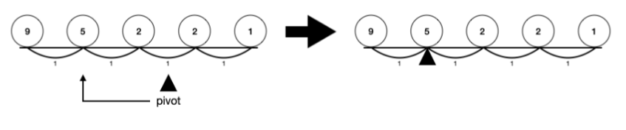

Given n such weights stored in an integer array, please design an program that finds the smallest location to place the see-saw-balancing pivot with O(n)-time and O(1)-extra-space. If the pivot is not under the stone return -1.

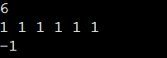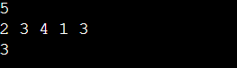

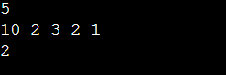

Credit: 2022 DSA CSIE HW1

2. Write a function to determine the number and types of intersections in a city. We use a n by n integer array to represent a city. A one in the array indicates a road, and a zero in the array indicates a building. There are four kinds of intersection of roads.

* A cell is an intersection if it is one, and all of its four neighbors are also one.
* A cell is a T-junction if it is 1 and exactly three of its neighbors are 1.
* A cell is a turn if it is 1 and exactly two of its neighbors are 1, and these two neighbors do not form a straight line that goes through the cell.
* A cell is a dead end if it is 1, and exactly one of its neighbors is 1.

Now given the matrix, please compute the number of intersections, T

-junctions, turns and dead ends.

Input format

there are n+1 lines in the input. The first line has n. Each of the next lines has n integers. These integers are either 0 or 1.

A sample input and out are as follow

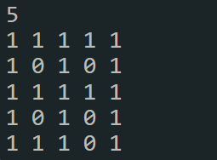 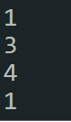

an intersection is at point (2,2) , T-junctions are at point (0,2)(2,0)(2,4), turns are at point (0,0)(0,4)(4,0)(4,2) and dead end is at (4,4)

Credit: https://judgegirl.csie.org/problem/0/33