1、简单绘图示例：

|  |
| --- |
| >>>from matplotlib.pyplot import *  >>>plot ([1,2,3,10])  >>>xlabel ("x- axis") #x轴标签  >>>ylabel ("my numbers") #Y轴标签  >>>title ("my figure")  >>>show () |

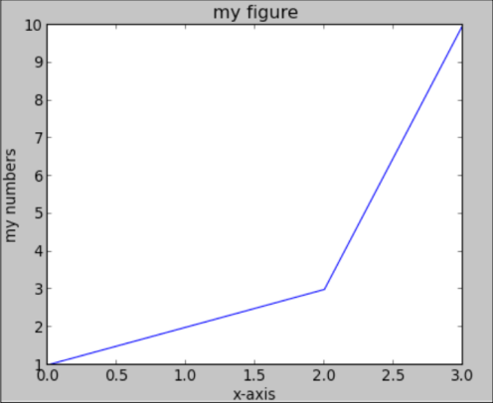

2、绘制正弦函数

|  |
| --- |
| >>>from pylab import *  >>>x = np.linspace(-np.pi, np.pi, 256,endpoint=True)  >>>C,S = np.cos(x), np.sin(x)  >>>plot(x,C),plot(x,S)  >>>show() |

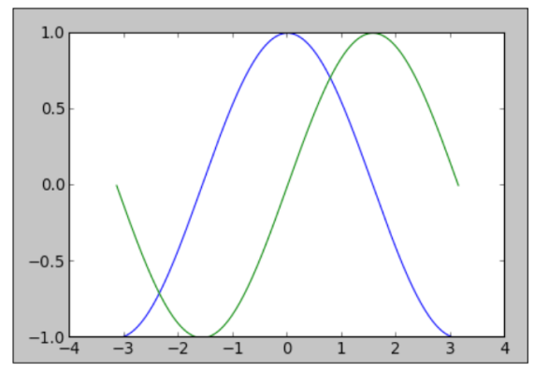

3、