# 2022 MCM

**Problem C: Trading Strategies**

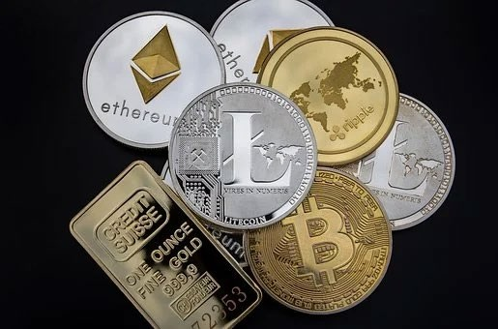

# Background

Market traders buy and sell volatile assets frequently, with a goal to maximize their total return. There is usually a commission for each purchase and sale. Two such assets are gold and bitcoin.

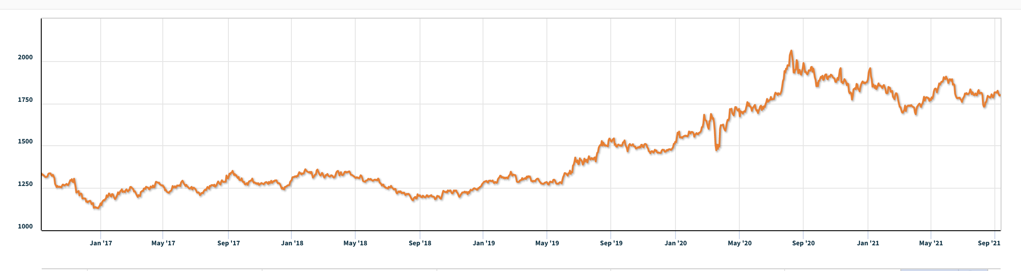

**Figure 1:** Gold daily prices, U.S. dollars per troy ounce. Source: London Bullion Market Association, 9/11/2021

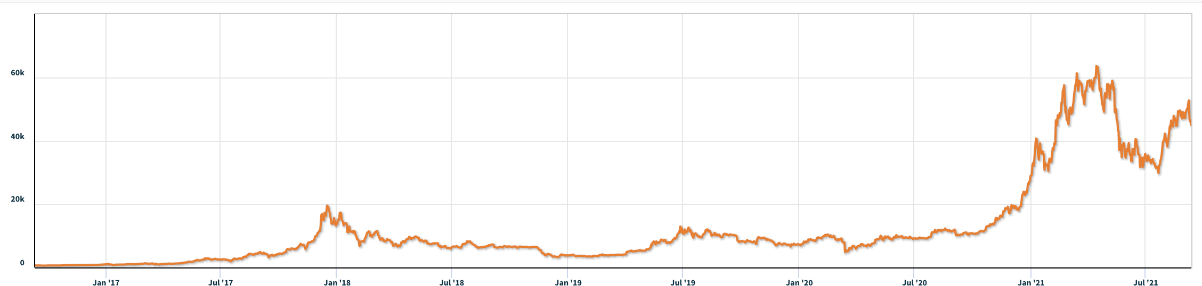

**Figure 2:** Bitcoin daily prices, U.S. dollars per bitcoin. Source: NASDAQ, 9/11/2021

# Requirement

You have been asked by a trader to develop a model that uses **only** the past stream of daily prices to date to determine each day if the trader should buy, hold, or sell their assets in their portfolio.

You will start with $1000 on 9/11/2016. You will use the five-year trading period, from 9/11/2016 to 9/10/2021. On each trading day, the trader will have a portfolio consisting of cash, gold, and bitcoin [C, G, B] in U.S. dollars, troy ounces, and bitcoins, respectively. The initial state is [1000, 0, 0]. The commission for each transaction (purchase or sale) costs α% of the amount traded. Assume αgold = 1% and αbitcoin = 2%. There is no cost to hold an asset.

Note that bitcoin can be traded every day, but gold is only traded on days the market is open, as reflected in the pricing data files LBMA-GOLD.csv and BCHAIN-MKPRU.csv. Your model should account for this trading schedule.

# To develop your model, you may only use the data in the two spreadsheets provided:

LBMA-GOLD.csv and BCHAIN-MKPRU.csv.

* Develop a model that gives the best daily trading strategy **based only on price data up to that day.** How much is the initial $1000 investment worth on 9/10/2021 using your model and strategy?
* Present evidence that your model provides the best strategy.
* Determine how sensitive the strategy is to transaction costs. How do transaction costs affect the strategy and results?
* Communicate your strategy, model, and results to the trader in a memorandum of at most two pages.

Your PDF solution of no more than 25 total pages should include:

* One-page Summary Sheet.
* Table of Contents.
* Your complete solution.
* One- to two-page Memorandum.
* Reference List.

Note: The MCM has a 25-page limit. All aspects of your submission count toward the 25-page limit (Summary Sheet, Table of Contents, Reference List, and any Appendices). You must cite the sources for your ideas, images, and any other materials used in your report.

# Attachments

THE TWO DATA FILES PROVIDED CONTAIN THE ONLY DATA YOU SHOULD USE FOR THIS PROBLEM.

1. LBMA-GOLD.csv
2. BCHAIN-MKPRU.csv

# Data Descriptions

1. LBMA-GOLD.csv

* **Date**: The date in mm-dd-yyyy (month-day-year) format.
* **USD (PM)**: The closing price of a troy ounce of gold in U.S. dollars on the indicated date.

1. BCHAIN-MKPRU.csv

* **Date**: The date in mm-dd-yyyy (month-day-year) format.
* **Value**: The price in U.S. dollars of a single bitcoin on the indicated date.

中文翻译：

# 2022 MCM

**问题 C： 交易策略**



# 背景

市场交易者经常买卖波动性资产，目标是最大限度地提高总回报。每次购买和销售通常都有佣金。黄金和比特币就是两种这样的资产。



**图1：** 黄金每日价格。来源：伦敦金银市场 协会， 2021 年 9 月 11 日



**图2：**比特币每日价格。 资料来源：纳斯达克，2021年9月11日

# 要求

一位交易者要求您开发一个模型，该模型**仅**使用迄今为止过去的每日价格流来确定交易者每天是否应该购买，持有或出售其投资组合中的资产。

您将在2016年9月11日从$ 1000开始，使用从2016年9月11日至 2021年9月10日的五年交易期。 在每个交易日，交易者将拥有一个由现金，黄金和比特币[C，G，B]组成的投资组合，分别以美元，金衡盎司和比特币表示。初始状态为 [1000， 0， 0]。每笔交易（购买或出售）的佣金成本为交易金额的α%。假设α黄金= 1%，α比特币= 2%。持有资产没有成本。

请注意，比特币可以每天交易，但黄金只在市场开放的日子交易，这反映在定价数据文件中LBMA-GOLD.csv和BCHAIN-MKPRU.csv。您的模型应考虑此交易时间表。

# 要开发模型，您只能使用提供的两个电子表格中的数据：

LBMA-GOLD.csv和BCHAIN-MKPRU.csv。

* 开发一个模型，**仅根据当天的价格数据**提供最佳的每日交易策略**。** 使用您的模型和策略，2021年9月10日的初始1000美元投资价值是多少？
* 提供证据 ，证明您的模型提供了最佳策略。
* 确定策略对交易成本的敏感程度。交易成本如何影响策略和结果？
* 在最多两页的备忘录中将您的策略，模型和结果传达给交易者。

您的 PDF 解决方案的总页数不超过 25 页，应包括：

* 一页摘要表。
* 目录。
* 您的完整解决方案。
* 一到两页的备忘录。
* 参考列表。

注意：MCM 有 25 页的限制。提交的所有内容都会计入 25 页的限制（摘要表、目录、参考列表和任何附录）。您必须引用您的想法，图像和报告中使用的任何其他材料的来源。

# 附件

提供的两个数据文件包含应用于此问题的唯一数据。

1. LBMA-GOLD.csv

2. BCHAIN-MKPRU.csv

# 数据 描述

* 1. LBMA-GOLD.csv
* **日期**： 月-日-年（月-日-年）格式的日期。
* **美元（PM）：**美国一金衡盎司黄金的收盘价指定日期的美元。

2.BCHAIN-MKPRU.csv

**日期**： 月-日-年（月-日-年）格式的日期。

* **值**： 美国的价格 指定日期 单个比特币 的美元。