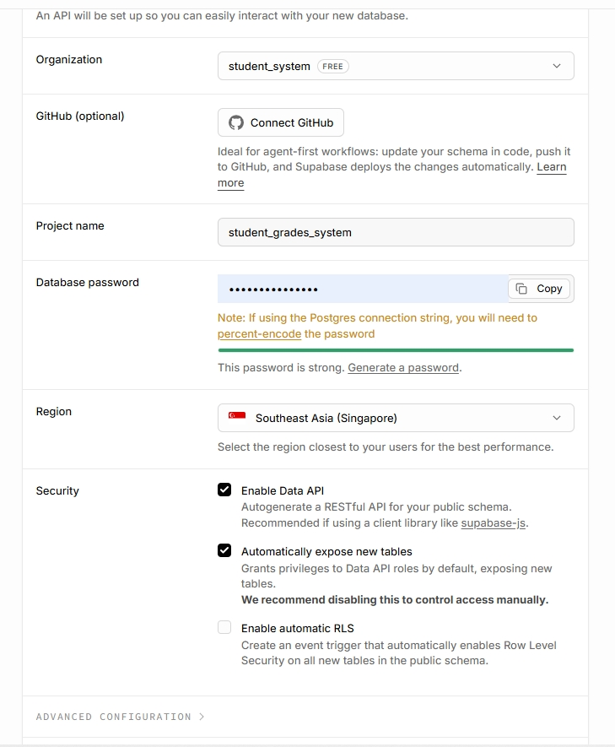

Project name:
student_grades_system

Database password:
$#E-?2G#pFhTgck

