my project is to study the behavior of hypervolume-based EMOAs on the effect of dynamic reference point adaptation mechanism. In my project, I examined algorithms including SMSEMOA, FVMOEA[1] and HypE on dimension 3, 5, 8 and 10. I chose DTLZ, WFG, MaF[2] problem sets as the test problems. Both convergence effect and diversity effect were tested.

I used many different dynamic reference point strategies as shown below, implementing by r = ax2 + bx + c (x is the current evaluated count). Here were my experiment settings:

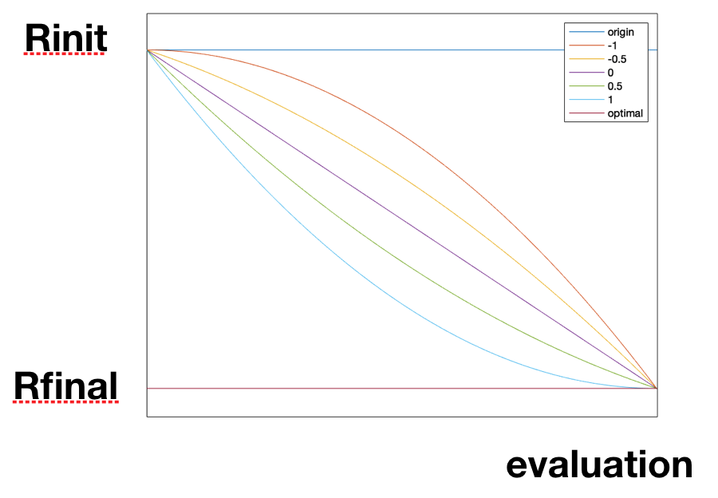

* + problems: DTLZs, WFGs, MaFs
  + algorithm: SMSEMOA, HypE, FVEMOA
  + N = 100 population number
  + m = 3,5,8,10 problem dimension
  + evaluation = 100,000 total evaluation number
  + Rinit = 2 initial r value(reference point = r \* estimated nadir point)
  + Rfinal = 1+1/H final r value
  + run = 5 for each parameter setting, run 5 times

As the parameters shown above, the whole data needs thousands of time, and I have not finished all the experiments yet. I just show the results on HypE below. (note that: ①the performance metric is hypervolume with reference point: 1.1×PF; ②~ means experiment has not finished).

inverted triangular pareto front: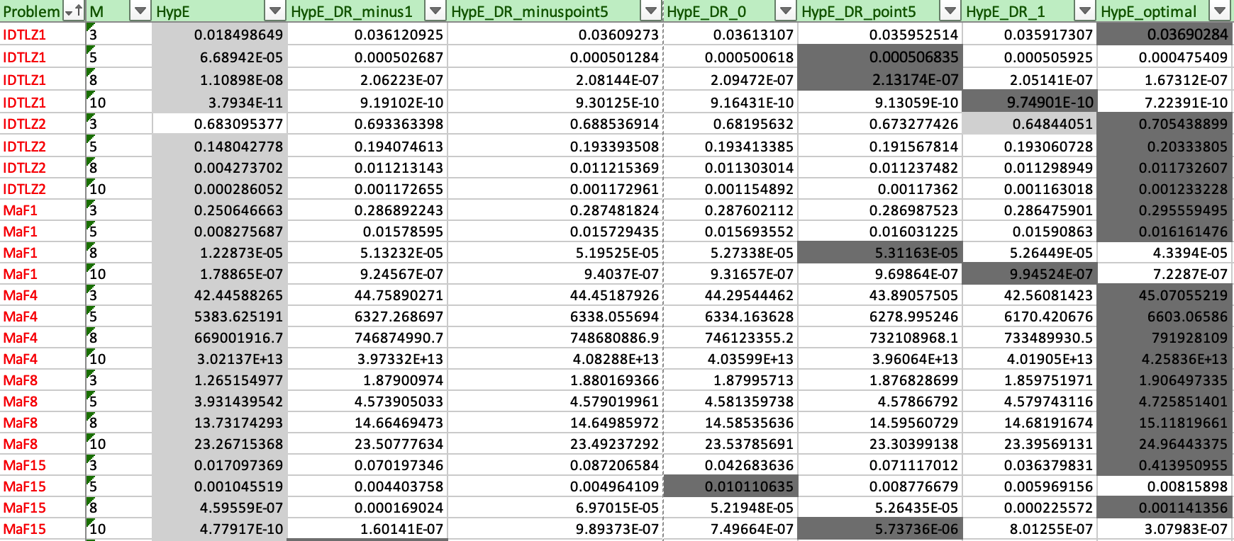

triangular pareto front: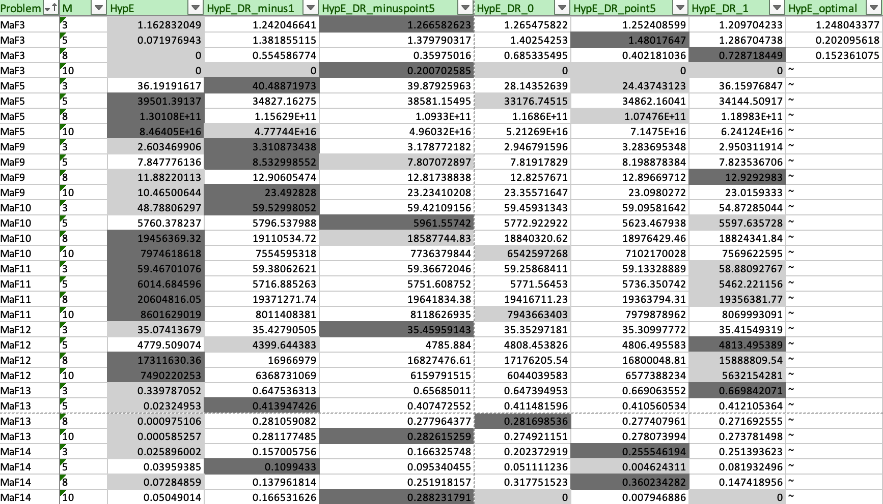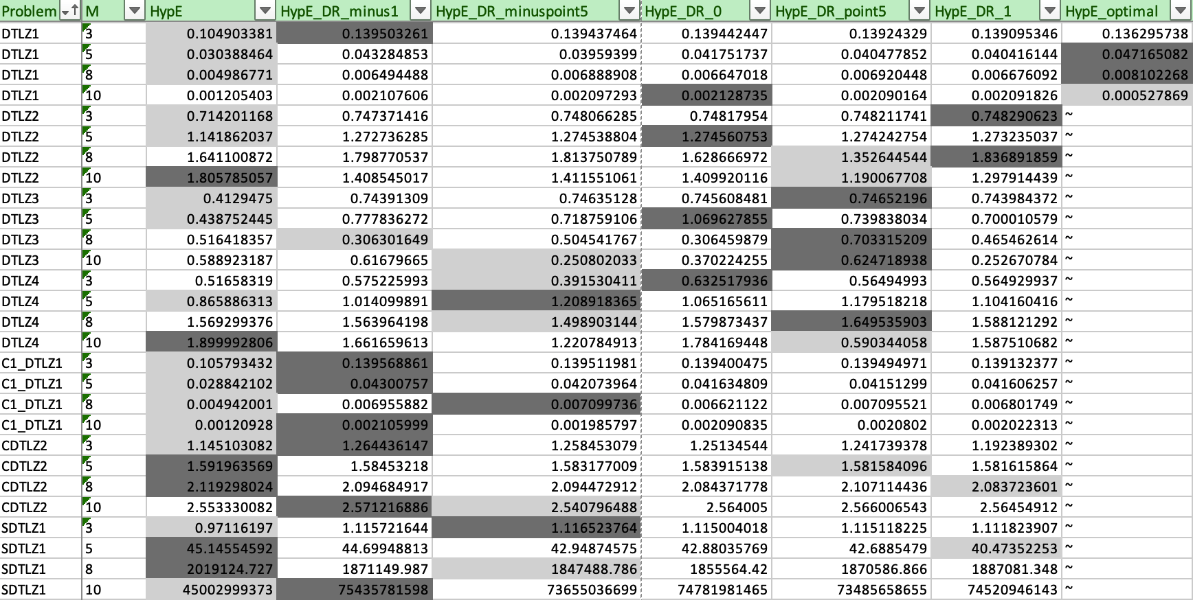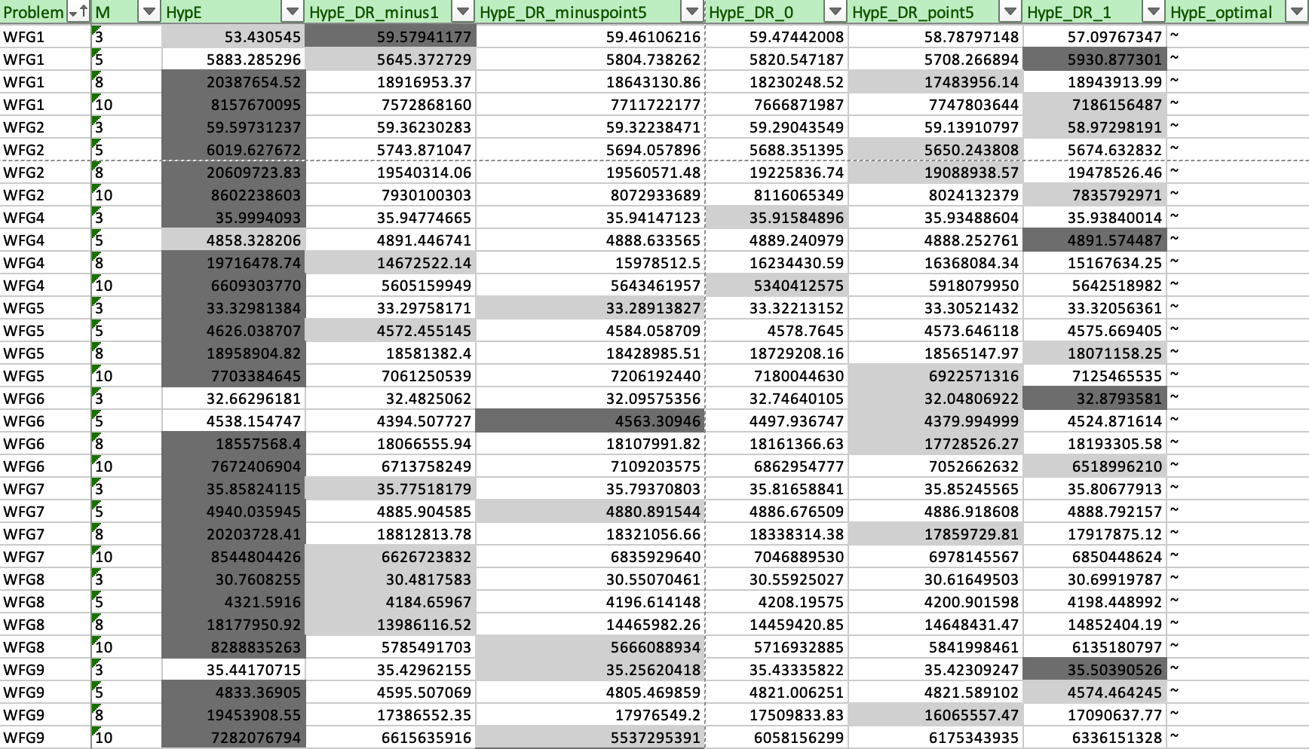

special pareto front: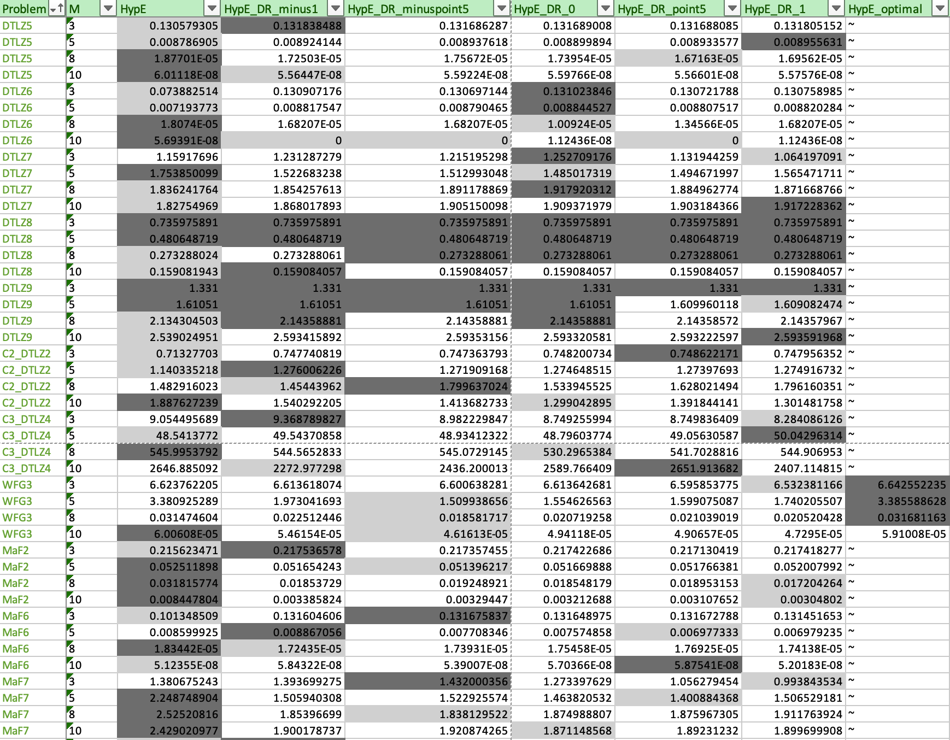

We can see that the algorithms with reference point adaptation are better than those without adaptation on inverted triangular pareto fronts, but do not have good performance on triangular pareto fronts and some other special pareto fronts.

Then I draw some pictures on specific runs, in order to study the behavior on the convergence stage.

MaF1: x range from(0~100,000) and (0~10,000)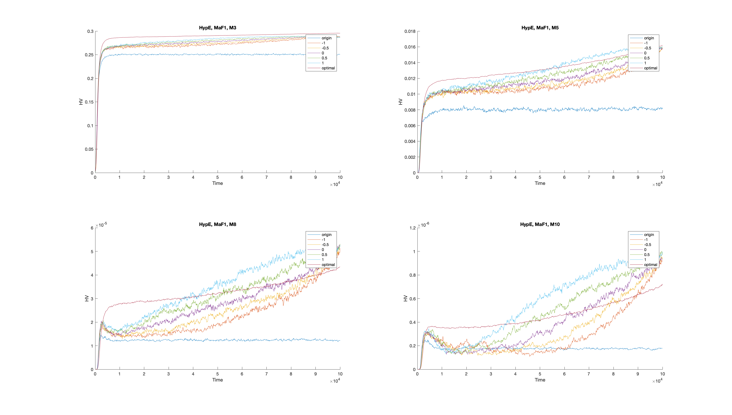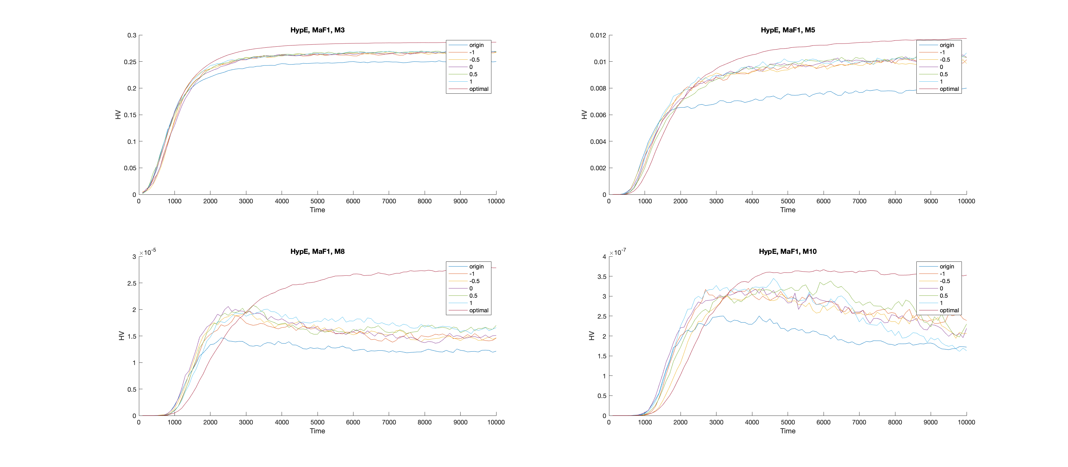

IDTLZ1: x range from(0~100,000) and (0~20,000)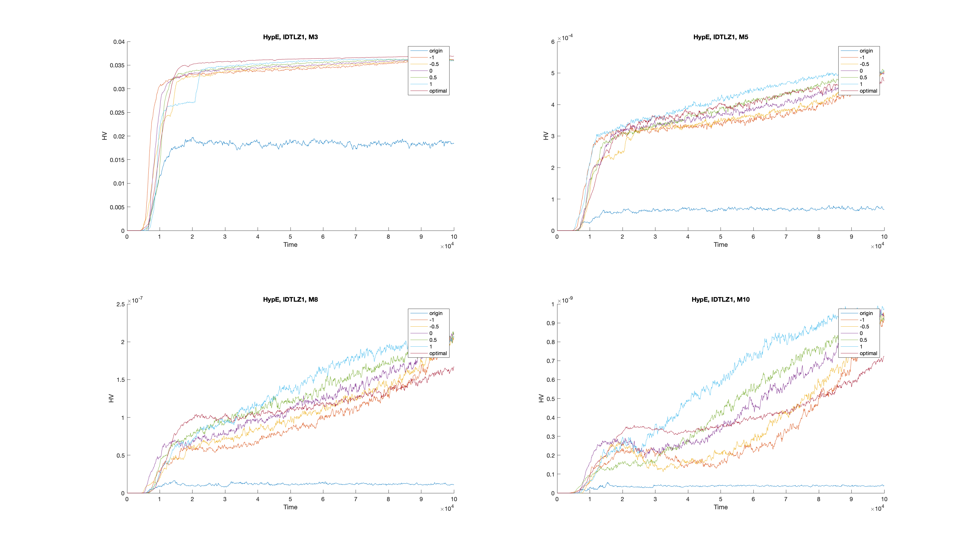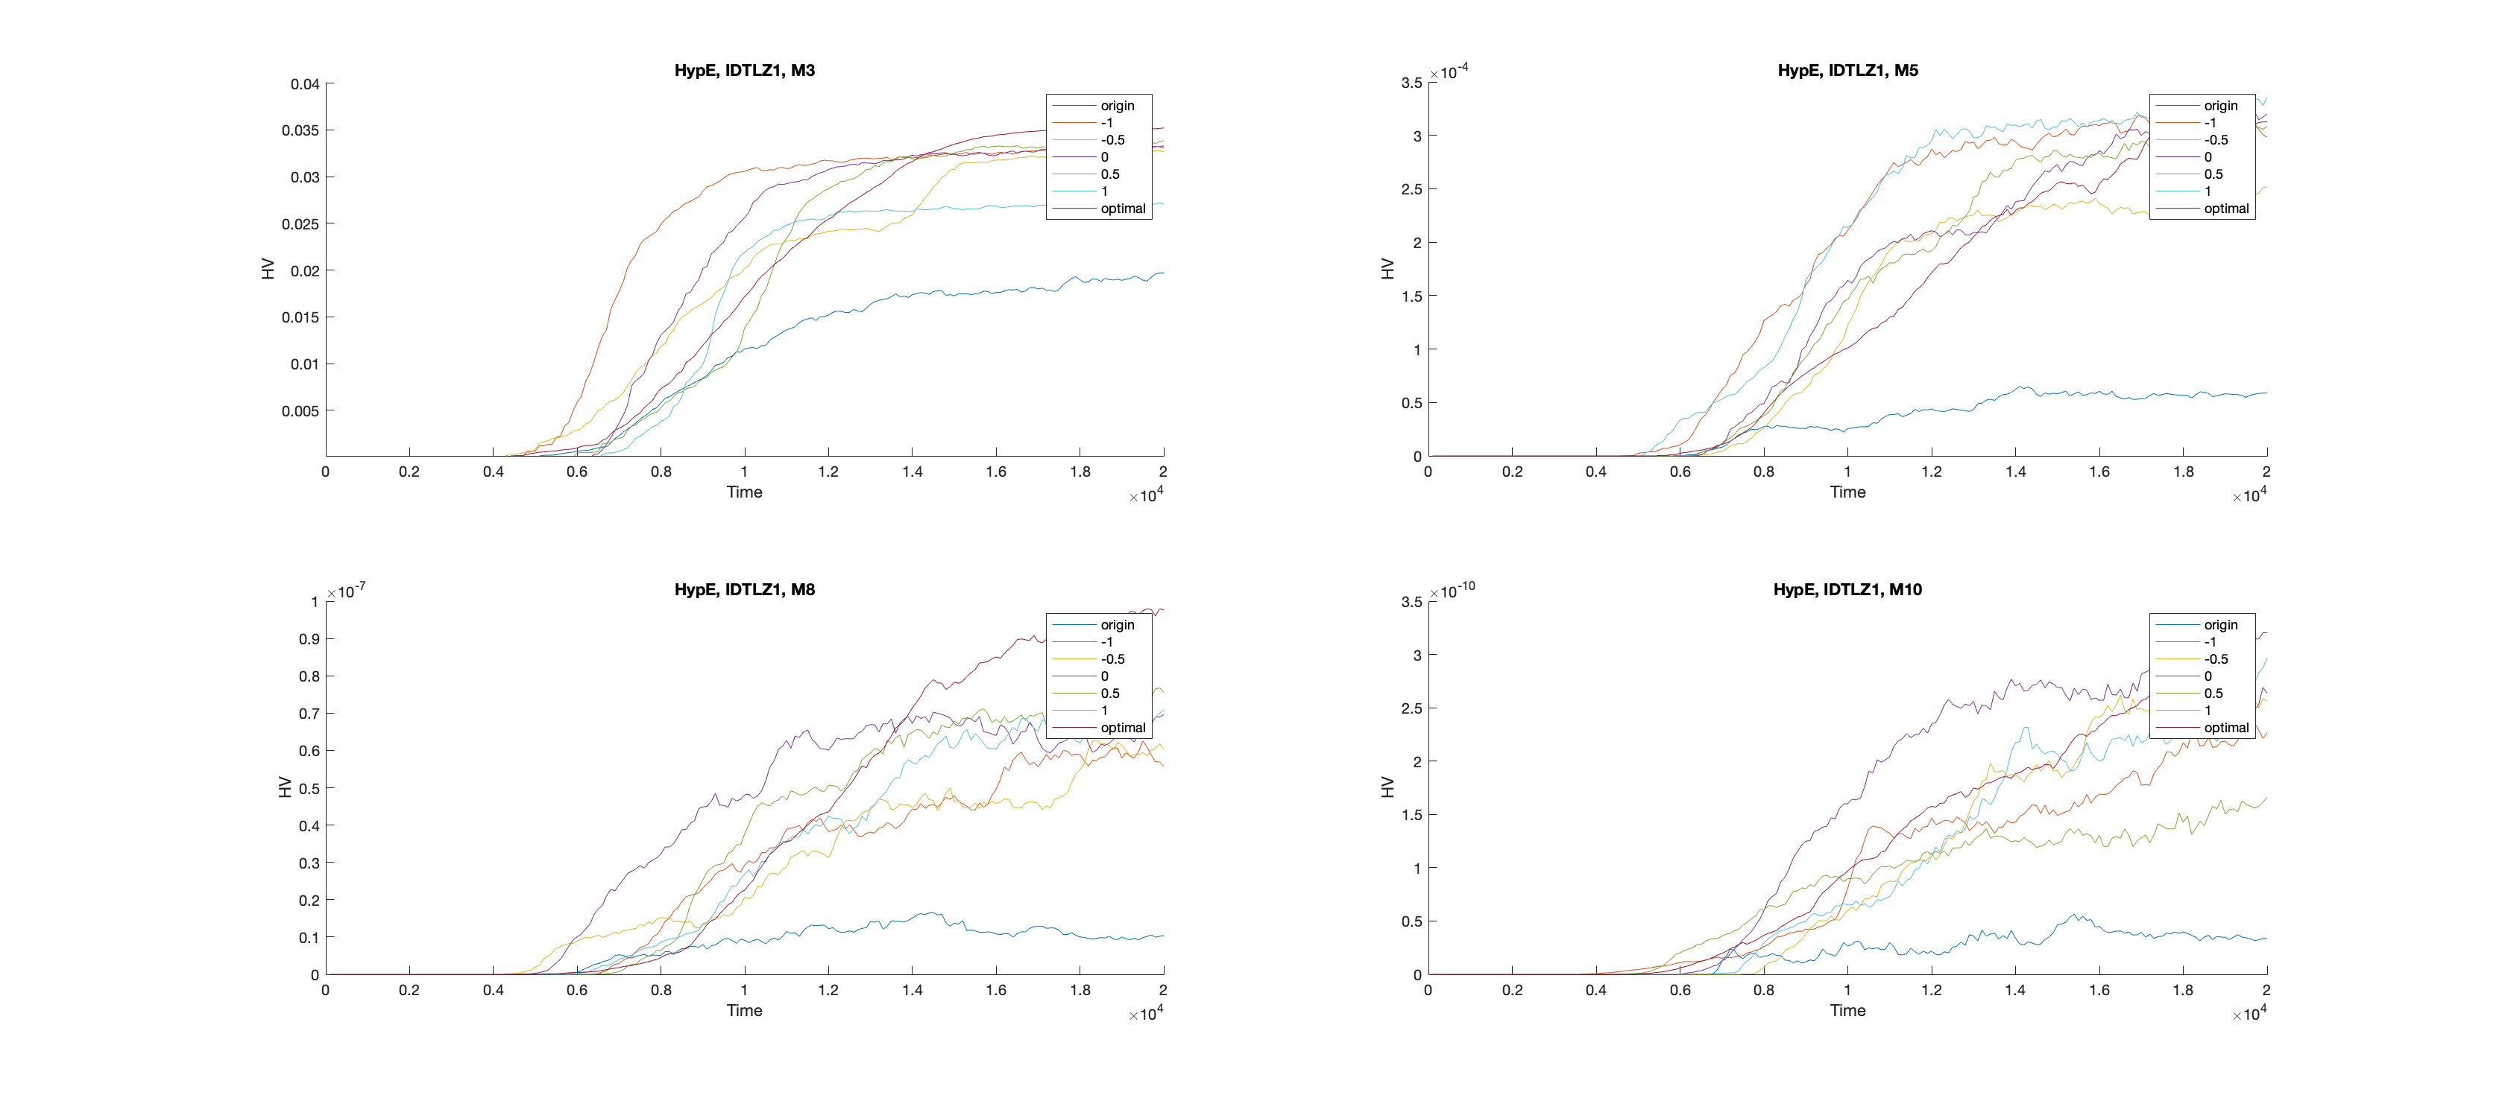

IDTLZ2: x range from(0~100,000) and (0~5,000)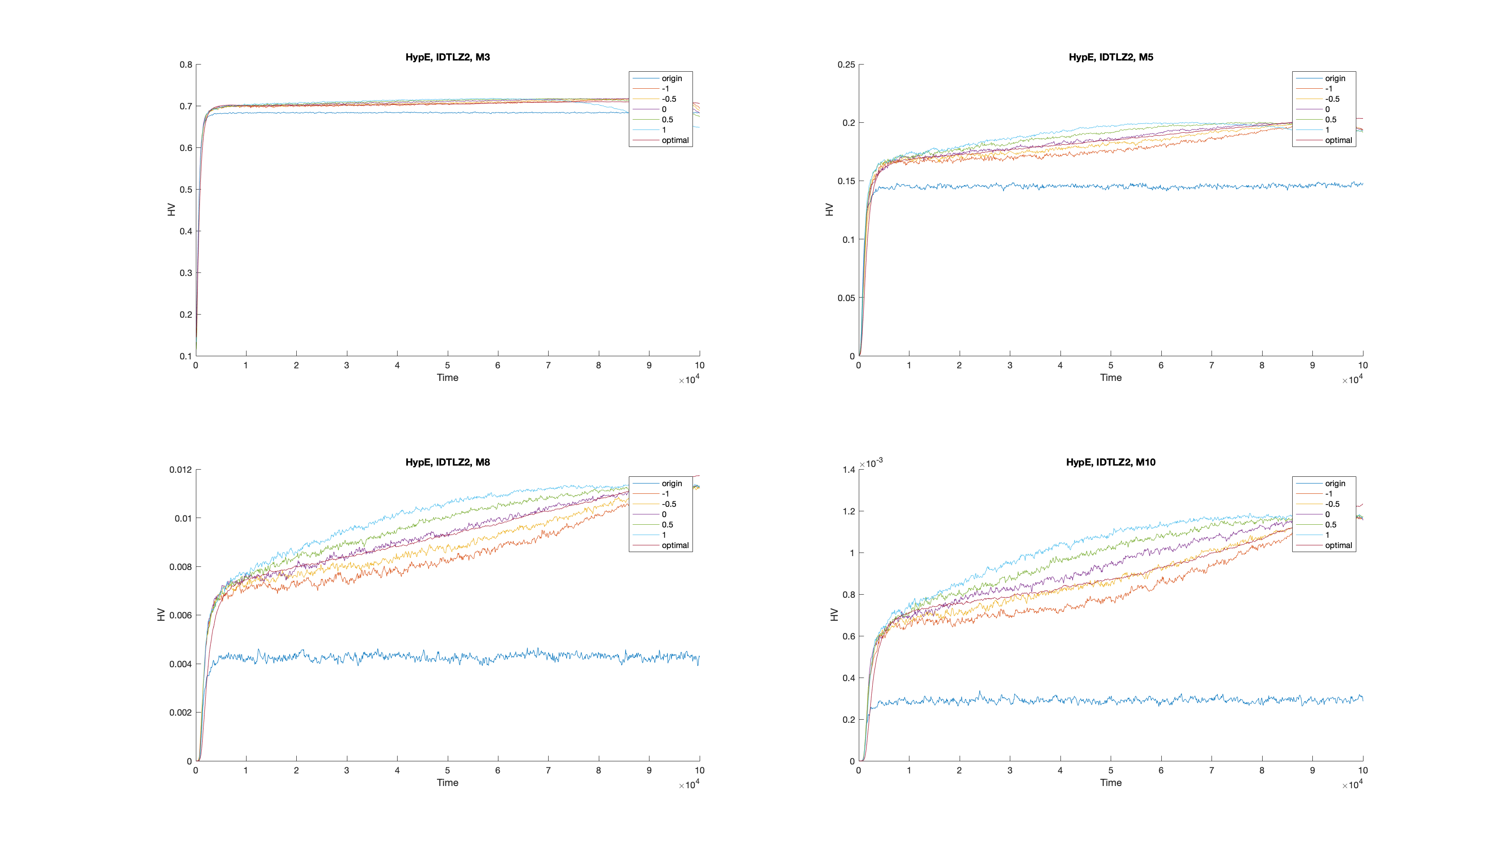

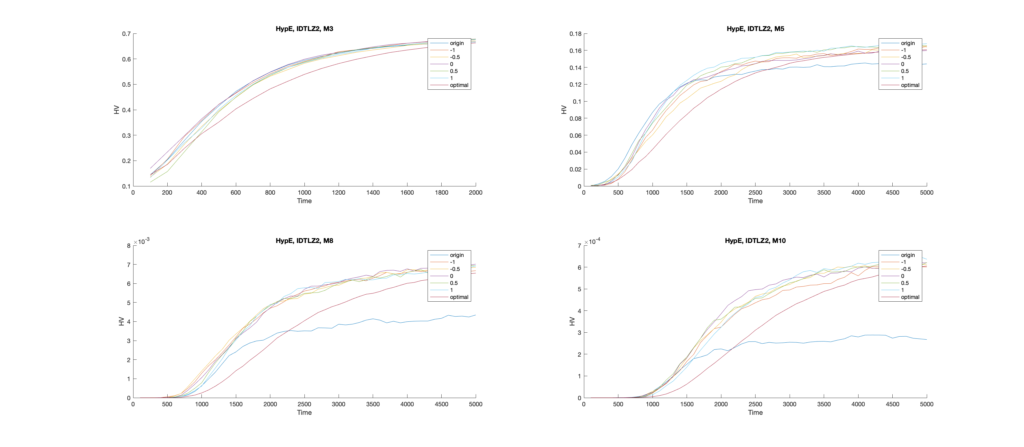

DTLZ1: x range from(0~100,000) and (0~20,000)

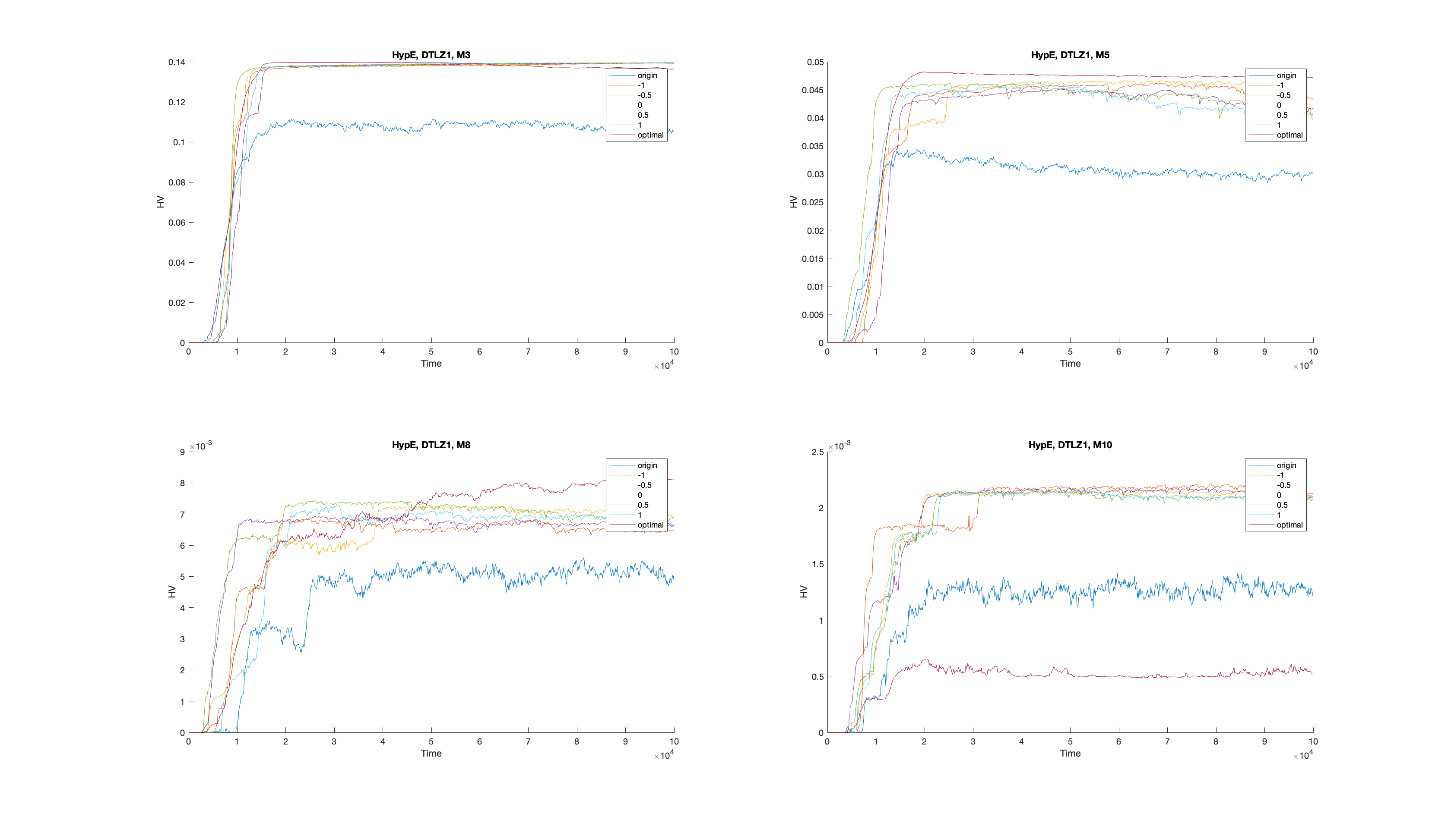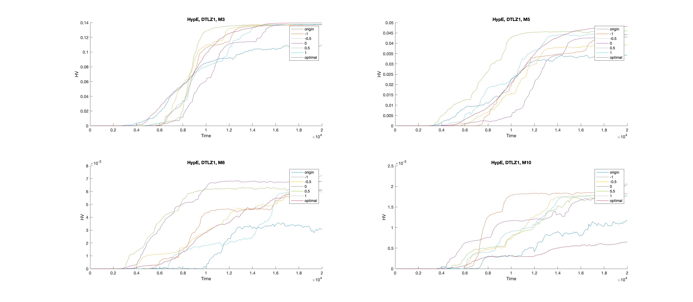

We can see that, on inverted triangular pareto front problem’s convergence stage, using optimal strategy(r = 1+1/H all the time) is not a good idea, for that the convergence speed in almost all pictures is slower than other dynamic strategies. Triangular pareto front problem however, it is not always worse.

But it is hard to say which dynamic strategy is the best, because different problems with different m values different.

I am very glad if you give me some comments and advices on my results.

Reference:

[1] S. Jiang, J. Zhang, Y.-S. Ong, A. N. Zhang, and P. S. Tan, “A simple and fast hypervolume indicator-based multiobjective evolutionary algorithm,” IEEE Transactions on Cybernetics, vol. 45, no. 10, pp. 2202– 2213, 2015.

[2] R. Cheng, M. Li, Y. Tian, X. Zhang, S. Yang, Y. Jin, and X. Yao, A benchmark test suite for evolutionary many-objective optimization, Complex & Intelligent Systems, 2017, 3(1): 67-81.