<http://mongocxx.org/mongocxx-v3/installation/>

<http://mongoc.org/libmongoc/current/installing.html#building-windows>

**1, 先编译mongo-c driver**

cd E:\code_test\git\multi_tech\cpp\3rd\build\mongo-c-driver-1.22.1

E:

mkdir cmake-build

cd cmake-build

cd

cmake -G "Visual Studio 15 2017 Win64" "-DCMAKE_INSTALL_PREFIX=E:\code_test\git\multi_tech\cpp\3rd\build\mongo-c-driver-1.22.1" "-DCMAKE_PREFIX_PATH=E:\code_test\git\multi_tech\cpp\3rd\build\mongo-c-driver-1.22.1"  ..

**修改bson_static和mongoc_static的output选项。正确导出好看的pdb文件**

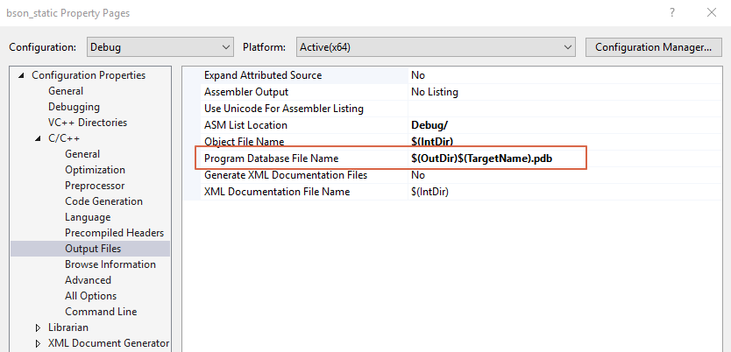

"C:\Program Files (x86)\Microsoft Visual Studio\2017\Professional\MSBuild\15.0\Bin\MSBuild.exe" /p:Configuration=RelWithDebInfo ALL_BUILD.vcxproj  
"C:\Program Files (x86)\Microsoft Visual Studio\2017\Professional\MSBuild\15.0\Bin\MSBuild.exe" INSTALL.vcxproj

**2，再编译mongo-c++ driver**

cd E:\code\3rd_src\mongo-cxx-driver-r3.4.0

modify E:\code\3rd_src\mongo-cxx-driver-r3.4.0\src\CMakeLists.txt

**add_definitions(-D_ENABLE_EXTENDED_ALIGNED_STORAGE)**

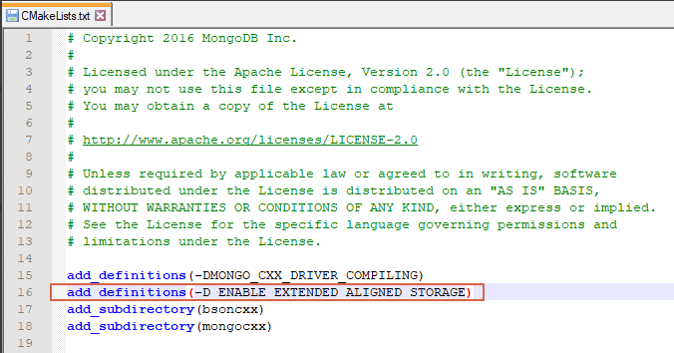

cmake -G "Visual Studio 15 2017 Win64" "-DCMAKE_INSTALL_PREFIX=E:\code\3rd_src\mongo-cxx-driver-r3.4.0" "-DCMAKE_PREFIX_PATH=E:\code\3rd_src\mongo-c-driver-1.13.0" -DBOOST_ROOT=E:\code\3rd_build\boost_1_68_0

* Note for users of mongocxx 3.2.x and newer: advanced users may build static libraries, if desired, by specifying -DBUILD_SHARED_LIBS=OFF to CMake. Specifying this option will introduce a dependency on the libmongoc static libraries. Linking an application against both shared libmongoc and static mongocxx is not supported, nor is linking against both static libmongoc and shared mongocxx.

**修改bsonxx和mongocxx的output选项。正确导出好看的pdb文件**

"C:\Program Files (x86)\Microsoft Visual Studio\2017\Professional\MSBuild\15.0\Bin\MSBuild.exe" /p:Configuration=RelWithDebInfo ALL_BUILD.vcxproj  
"C:\Program Files (x86)\Microsoft Visual Studio\2017\Professional\MSBuild\15.0\Bin\MSBuild.exe" INSTALL.vcxproj