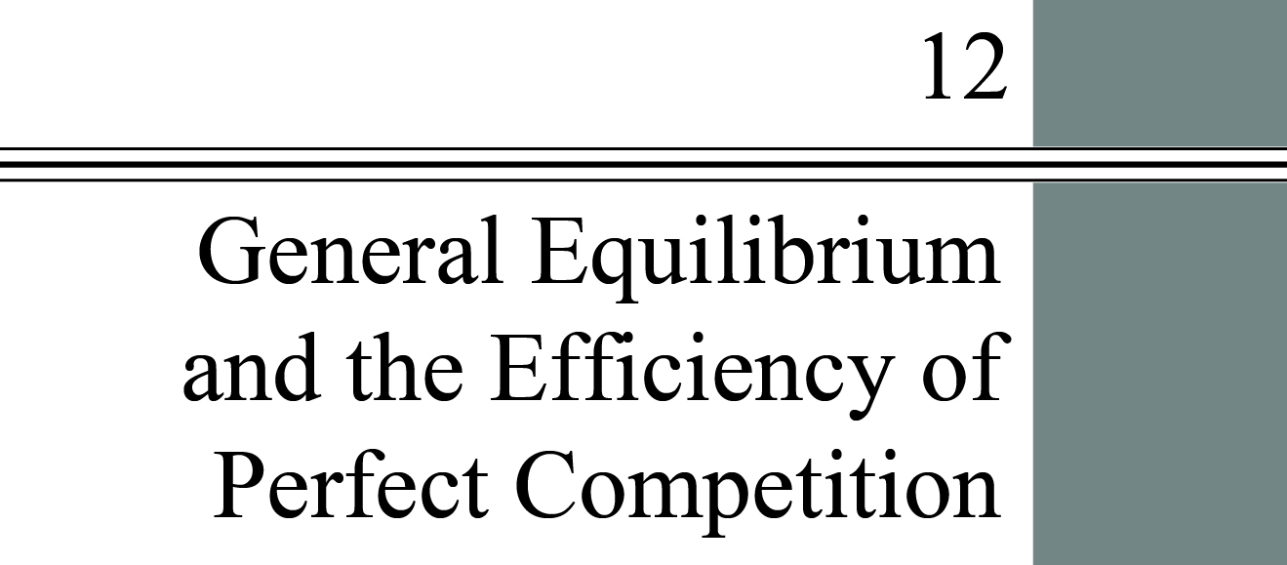

**chapter Outline**

***Market Adjustment to a Change in Demand***

Discuss the relationship between general equilibrium and demand shifts

***Allocative Efficiency and Competitive Equilibrium***

Explain the principles of economic efficiency

***The Sources of Market Failure***

Describe four sources of market failure

***Evaluating the Market Mechanism p***

Understand the way that market imperfections may interfere with the ability of the market to achieve efficiency

detailed chapter Outline

I. Introduction

A. Markets and products are heavily interdependent. The demand for auto mechanics depends on the demand for automobiles, the ability and willingness of people to repair their own cars, income, and a host of other factors. Input and output markets cannot be considered as if they operated independently. We now need to look at the operation of the system as a whole.

1. *Households* make constrained choices in both input and output markets (Chapters 3–6).

2. *Firms* attempt to maximize profits by making constrained choices in input and output markets (Chapters 7–11).

3. *Households* and *firms* therefore interact in both *input* and *output* markets.

4. *Input* and *output* markets can’t be treated independently. Understanding how market systems work requires looking at the entire system.

B. Chapters 3 through 11 use *partial equilibrium analysis*, the process of examining the equilibrium conditions in individual markets and for households and firms separately.

C. A *general equilibrium* exists when all markets in an economy are in simultaneous equilibrium.

1. An event that disturbs the equilibrium in one market will always disturb the equilibrium in other markets as well.

2. The ultimate impact of the event depends on the ways in which various markets adjust to it.

D. In judging the performance of any economic system we use two criteria: efficiency and equity. In economics, *efficiency* means “allocative efficiency.” The condition in which the economy is producing what people want at least possible cost.

II. Market Adjustment to Changes in Demand

A. Example: Amazon’s Kindle

1. Amazon introduced its e-book reader, the Kindle, in 2007.

2. Partial equilibrium analysis will not give us an adequate picture of this market. Events in the e-book market are almost certain to cause changes in the printed book market.

3. And the ripple effects go beyond Amazon.com. Other booksellers find the prices of their printed books changing.

4. Extending the ripple effect even further, companies like UPS will notice the decrease in books being shipped.

B. A Two Market Example

1. Suppose the demand for a good X increases. The price of X will also rise. Assuming demand for X is inelastic, consumers will increase their spending on X. Firms producing X will experience economic profits.

2. With limited income, consumers must reduce spending on some other good. Call that good Y and let Y represent all other goods and services. The demand curve for Y shifts inward, causing the price to fall and firms to experience losses.

3. Profits in the X industry will attract new firms. Resources formerly used to produce Y will shift to producing X.

4. Since both markets are perfectly competitive, the long-run adjustment will return both industries to zero profits.

III. Allocative Efficiency and Competitive Equilibrium

A. Introduction: If the assumptions of perfect competition in all markets and perfect information hold, the economy will produce an efficient allocation of resources.

B. *Pareto Efficiency* or *Pareto optimality* is a condition in which no change is possible that will make some members of society better off without making some other members of society worse off.

Example: Budget cuts in Massachusetts substantially reduced services at the Registry of Motor vehicles. One estimate was that 500 people stood in line every day for one hour. If the time is valued at $2 per hour, the annual cost to car owners of reduced services at one office was $250,000 per year. The gain from reducing staffing was $80,000 per year.

C. The Efficiency of Perfect Competition: The perfectly competitive system leads to an efficient or Pareto optimal allocation of resources: resources are allocated among firms efficiently, final products are distributed among households efficiently, and the system produces the things that people want.

1. All societies must answer these questions.

a. What gets produced?

b. How is it produced?

c. Who gets what is produced?

2. Efficient Allocation of Resources among Firms: We assume that firms maximize profits, which in turn means that they minimize costs as long as all markets are perfectly competitive and in long-run equilibrium. The market also leads to an efficient allocation of resources across firms. The efficient allocation of resources means each input is being used in its highest-value uses.

3. Efficient Distribution of Outputs Among Households: With free and open markets and voluntary exchange, no redistribution of outputs will make anyone better off. Each good is distributed to the households that place the highest value on it.

4. Producing What People Want: The Efficient Mix of Output is ensured by the condition *P*= *MC*. This means that households’ willingness to pay is equated to the opportunity cost of the resources needed to produce a good. Minimizing cost means the lowest possible price to households.

D. Perfect Competition versus Real Markets: Since the assumptions we have made do not always hold in the real world the efficient outcome may not occur. The rest of this chapter discusses some of the sources of inefficiencies that occur naturally some markets.

IV. The Sources of Market Failure

A. *Market failure* occurs when resources are misallocated, or allocated inefficiently. The result is waste or lost value. There are four important sources of market failure.

B. Imperfect Competition

1. Imperfect competition describes an industry in which single firms have some control over price and competition. Imperfectly competitive industries give rise to an inefficient allocation of resources.

2. Imperfect competition implies that the equilibrium price is greater than marginal cost. This is a major source of inefficiency.

C. *Public goods*, or *social goods* are goods that are nonrival in consumption and their benefits are nonexcludable. The classic example is national defense.

1. A completely unregulated market economy would underproduce public goods. In the most extreme case none of the good would be produced at all, despite the fact that society values it.

2. Public goods are the opposite of *private goods*, goods and services produced by firms for sale to individual households.

3. Public goods suffer from the free-rider problem, the idea that many people will realize they can benefit from a public good without paying for it.

D. An *externality* occurs when actions of one party impose costs or benefits on a second party. For an economy to achieve an efficient allocation of resources all costs and benefits must be taken into account by decision makers. Not fully accounting for the costs and benefits of externalities causes inefficiency.

E. *Imperfect Information* is the absence of full knowledge concerning product characteristics, available prices, and so on. Lack of complete information can lead to transactions that are ultimately disadvantageous to at least one of the parties.

V. Evaluating the Market Mechanism

Learning Objectives: Understand the way that market imperfections may interfere with the ability of the market to achieve efficiency

The market system does seem to provide most participants with the incentive to weigh costs and benefits and to operate efficiently. But markets are far from perfect. Although some call for government involvement in the economy to correct for market failure others feel that government involvement in the economy causes more inefficiency than it cures.

****Extended Applications

Application 1: The Cost of Spam

One of the worst aspects of Internet e-mail is spam, unwanted e-mail from strangers offering all manner of products and services. Wise consumers delete these messages without even opening them. But there is a cost to spam. Read on.

The head of information technology at a medium-sized West Coast university once stated that implementing an anti-spam solution would cost $60,000 per year. At about the same time an administrative assistant in an academic department estimated that she spent 15 minutes per day deleting spam. The university has 1,000 employees. What value is the IT director placing on the employees?

Let’s be conservative and assume the real time spent deleting spam e-mail is 15 minutes per week. That’s 13 hours per year per employee. Multiplying by 1,000 employees gives 13,000 worker hours per year. The IT director implicitly assumed a wage rate of less than $60,000/13,000 = $4.62 per hour. In other words the IT folks have assumed university employees’ time is worth less than the minimum wage!