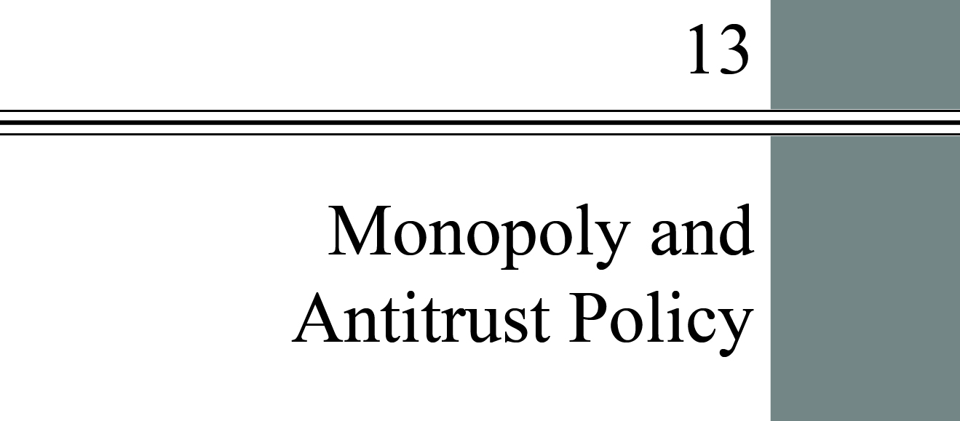

**chapter Outline**

**Imperfect Competition and Market Power: Core Concepts**

Explain the fundamentals of imperfect competition and market power.

**Price and Output Decisions in Pure Monopoly Markets**

Discuss revenue and demand in monopolistic markets.

**The Social Costs of Monopoly**

Explain the source of the social costs for a monopoly.

**Price Discrimination**

Discuss the conditions under which we find price discrimination and its results.

**Remedies for Monopoly: Antitrust Policy**

Summarize the functions and guidelines of federal antitrust laws.

detailed chapter outline

I. Introduction

This chapter begins to explore the implications of relaxing one of the assumptions made in earlier chapters, that a large number of buyers and sellers interact in each market. The focus is on the case of a single firm in an industry: a monopoly. Recent examples of antitrust investigations include Microsoft (1999) and Google (2010–2013).

II. Imperfect Competition and Market Power: Core Concepts

A. An *imperfectly competitive* industry is an industry in which individual firms have some control over the price of their output. All firms in such a market have *market power*, the ability to raise price without losing all of the quantity demanded for their product.

B. Forms of Imperfect Competition and Market Boundaries

1. The existence and degree of closeness of substitutes limits a firm’s market power.

2. A *pure monopoly* is an industry with a single firm that produces a product for which there are no close substitutes and in which significant barriers to entry prevent other firms from entering the industry to compete for profits.

3. Defining the boundary of the market is important. The narrower the definition, the more likely close substitutes exist. This tends to increase demand elasticity.

III. Price and Output Decisions in Pure Monopoly Markets

Learning Objectives: Discuss revenue and demand in monopolistic markets.

A. We assume that entry is blocked, the firm seeks to maximize profits and the firm buys inputs from perfectly competitive markets. That means the monopolist’s costs are identical to those of a perfectly competitive firm. All firms choose the technology and input quantities that minimize the cost of production. We also assume no price discrimination.

B. Demand in Monopoly Markets

1. In a monopoly market the demand curve facing the firm is the market demand curve. We assume that the firm does not engage in price discrimination and that the demand curve is known.

2. Marginal Revenue and Market Demand: In order to sell more the monopolist must lower the price on all units of output sold. Marginal revenue will be less than price. Marginal revenue is the change in total revenue when the firm produces and sells one more unit of output per time period.

3. The Monopolist’s Profit Maximizing Price and Output will be the one at which *MR* = *MC*. Price will be above MC and the firm may earn economic profits.

4. The Absence of a Supply Curve in Monopoly is due to the fact that the monopolist sets both price and quantity, so output depends on not just the marginal cost curve but also on the demand curve.

C. Perfect Competition and Monopoly Compared

1. Relative to a competitively organized industry, a monopolist restricts output, charges higher prices, and earns economic profits.

2. Imagine a perfectly competitive market in long-run equilibrium earning zero economic profit. If all the firms in the market merge into a single firm, that firm will charge a higher price and produce less output than was the case when the market was perfectly competitive.

D. Monopoly in the Long Run: Barriers to Entry

1. *Barriers to entry* are factors that prevent new firms from entering and competing in imperfectly competitive industries. There are several types of barriers to entry.

a. Economies of Scale cause average cost to fall as the scale of a production operation rises. The most extreme examples is a *natural monopoly,* an industry that realizes such large economies of scale in producing its product that single-firm production of that good or service is most

b. *Patents* are legal barriers that grants exclusive use of the patented product or process to the inventor. Patents are meant to provide an incentive for invention and innovation. In most countries patent protection is granted for 20 years from the date the patent is filed.

c. Government Rules: A monopoly can be created by a government directive. Such actions are often justified by large economies of scale, equity, or the government’s desire to control a particular market.

d. Ownership of a Scarce Factor of Production

e. Network Effects: *Network externalities* exist when the value of a product to a consumer increases with the number of that product being sold or used in the market.

IV. The Social Costs of Monopoly

A. Inefficiency and Consumer Loss

1. Monopoly leads to an inefficiently low quantity of output and higher prices to consumers. There are also other social costs that may not be as obvious (e.g., lack of an incentive to cut costs and innovate, also impacts on the distribution of income).

2. Since the monopoly price is greater than marginal cost, consumers will place to high a value on the output. This is the reason monopolies *distort* consumer choice.

3. The *deadweight loss* (*excess burden*) *of a monopoly* is the social cost associated with the distortion in consumption from a monopoly price.

B. *Rent-Seeking Behavior* includes any actions taken by households or firms to preserve economic profits.

1. A monopolist might try to protect its positive economic profits by lobbying politicians for legal protection for its monopoly position. This consumes resources and may lead the government to become a tool of the rent seeker, causing the allocation of resources to be made even less efficient because of the government intervention.

2. *Government failure* occurs when the government becomes the tool of the rent seeker and the allocation of resources is made even less efficient by the intervention of government.

V. Price Discrimination

A. *Price discrimination* is charging different prices to different buyers for identical products, where these price differences are not a reflection of cost differences.

1. A firm that successfully price discriminates will increase its profits by capturing even more of the consumer surplus. The quantity of output is usually still inefficient and there is usually still a deadweight loss.

2. *Perfect price discrimination* occurs when a firm charges the maximum amount that buyers are willing to pay for each unit.

a. A firm that price discriminates perfectly will capture the entire consumer surplus. A monopolist that manages to do this will actually produce the efficient quantity of output, eliminating the deadweight loss.

b. However, there is zero consumer surplus so we don’t usually think of this as a good outcome.

B. Examples of Price Discrimination: airlines, movie theaters, hotels, telephone companies, theme parks, medical care, and so on.

1. The basic objective of price discrimination is to increase profits.

2. The rule for price discrimination is to charge a higher price to the group with the less elastic demand.

3. A key prerequisite for price discrimination is the *no-arbitrage condition* which states that to effectively price discriminate firms must prevent customers from reselling the product.

VI. Remedies for Monopoly: Antitrust Policy

A. Historically, governments have assumed two contradictory roles with respect to markets: (1) they promote competition and restrict market power through antitrust laws, and (2) they restrict competition by regulating industries.

B. Major Antitrust Legislation

1. The Sherman Act of 1890 declared every contract or conspiracy to restrain trade among states or nations illegal.

a. This law seems to declare the structure of monopoly illegal, but it was unclear what specific acts were to be considered “restraints of trade.” In 1911 the Supreme Court put forth a *rule of reason* to determine whether a particular action was illegal (“unreasonable”) or legal (“reasonable”) within the terms of the Sherman Act.

b. The Antitrust Division’s case against Microsoft in the 1990’s was settled by a *consent decree*, a formal agreement between a prosecuting government and defendants that must be approved by the courts.

c. In 2005 Advanced Micro Devices (AMD) sued Intel for anticompetitive behavior. The law allowing private antitrust suits has resulted in the number of private lawsuits exceeding 20 times the number brought by the government.

3. The Clayton Act and the Federal Trade Commission, 1914

a. The *Clayton Act* was passed by Congress in 1914 to strengthen the Sherman Act and clarify the rule of reason. The act outlawed specific monopolistic behaviors such as tying contracts, price discrimination, and unlimited mergers.

b. The *Federal Trade Commission (FTC)* is a federal regulatory group created by Congress in 1914 to investigate the structure and behavior of firms engaging in interstate commerce, to determine what constitutes unlawful “unfair” behavior, and to issue cease-and-desist orders to those found in violation of antitrust law.

c. Both laws retained the focus on conduct, leaving the rule of reason intact and central to antitrust action in the courts.

Extended Applications



Application 1: Three Myths about Monopoly

*Myth #1: “Monopolies charge as high a price as they can get away with.”*

It is a commonly held belief that only “public outrage” prevents monopolies from charging even more than they do currently. The myth is popular because, after all, a monopoly is the only firm producing in its market. Why not increase price without limit?

The answer is simple. Even a monopoly is constrained by the market demand curve for its product. The firm will charge the profit-maximizing price. Raising the price further would not be profitable, whether public outrage would follow or not. In the diagram, we see a monopoly where *MC* = *MR* at output level *Q*1 and price *P*1. What prevents the monopoly from raising price further? If it were to do so—say, to *P*2—it would only sell *Q*2 units of output. On all the units between *Q*2 and *Q*1, marginal revenue is greater than marginal cost. Therefore, raising its price—even if it could do so—would decrease the monopoly’s profits. Every monopoly has a maximum price that it wishes to charge, and no more. We may be unhappy with that price, and efficiency may require a lower price, but this is not the same as saying a monopoly would like to raise its price without limit.

Microeconomics examinations often include an apparently trivial true-false question:

A profit-maximizing monopoly firm in equilibrium can increase its profit by raising its price.

The reflex answer is true. The correct answer is false. “In equilibrium” means *MR* = *MC* and no change in price will increase profit.



Students who make the mistake of saying a monopolist will charge as high a price as possible are in good company. Adam Smith in *The Wealth of Nations* wrote, “The price of monopoly is upon every occasion the highest which can be got” (Book 1, chapter 7, paragraph 27).

*Myth #2: “Monopolies cause inflation.”*

This myth is related to the first. If monopolies always charge “as high a price as they can get away with,” then perhaps the most they can get away with in any given year is a moderate price increase. In this view, monopolies are slowly and insidiously raising their prices each year, without limit, to avoid public outrage. As already demonstrated, however, given the costs of its inputs, the technology, and the demand for its product, a monopoly has a single profit-maximizing price. Unless its costs are rising (in which case the inflation is coming from elsewhere), the monopoly has no incentive to raise its price further.

It is true that monopolies usually set a higher price than would be charged in a competitive industry, and therefore the existence of monopolies causes the price level to be higher than it otherwise would be. But for monopolies to be causing inflation—a continual rise in the price level—the economy must be becoming increasingly monopolized through time, which does not appear to be the case.

*Myth #3: “Monopolies simply pass on any cost increase to their customers.”*

This myth is also related to the first myth. If a monopoly can charge whatever price it wants, then when its costs go up, what’s to stop the monopoly from simply raising its prices by the same amount, so as not to lose profits?

In truth, a monopoly will usually not be able to protect itself in this way from cost increases because to do so would mean sacrificing profits. We can see this by examining two types of cost increases. First, suppose there is an increase in a fixed cost. As the following diagram shows, an increase in fixed costs will shift the *ATC* curve (from *ATC*1 to *ATC*2), but not the *MC* curve. The monopoly’s profits will be reduced, but there is nothing it can do about it in the short run (while the fixed input remains fixed), because *MR* and *MC* continue to intersect at the output *Q*1, and this requires price *P*1. Intuitively, the monopoly would like to pass on the cost increase to its customers, but to do so would mean losing sales and losing profits.



Consider the case of a rise in the cost of a variable input. This will cause an upward shift in the marginal cost curve, as shown in the diagram following. (The *ATC* curve will shift up too, but it’s not important in this case.) If the monopoly raised its price by the full amount of the *MC* shift, it would charge *P*3. The monopoly would gladly do this if it could continue to sell output *Q*1 at price *P*3. But it can’t. Raising price reduces output, and to raise the price to *P*3 would mean reducing output below the new profit-maximizing output *Q*2. In the diagram, the new profit-maximizing price is *P*2, where only part of the cost increase has been passed along to customers.

