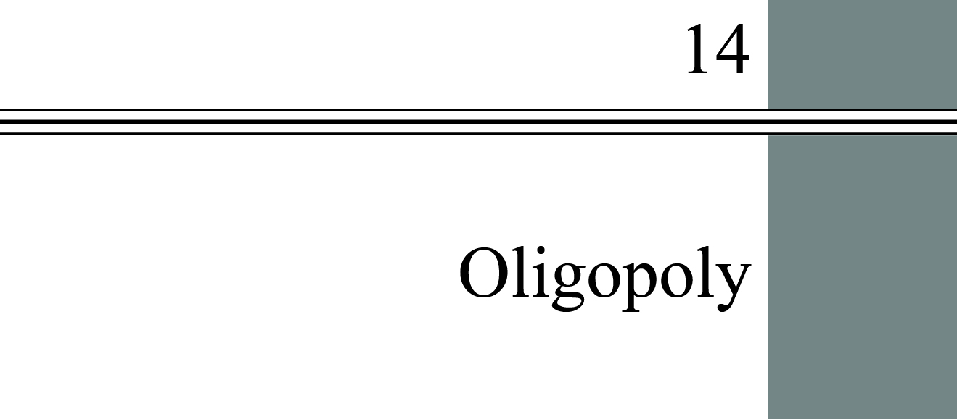

**chapter Outline AND LEARNING OBJECTIVES**

**Market Structure in an Oligopoly**

Describe the structure and characteristics of oligopolistic industries.

**Oligopoly Models**

Compare and contrast three oligopoly models.

**Game Theory**

Explain the principles and strategies of game theory.

**Oligopoly and Economic Performance**

Discuss the economic performance of oligopolies.

**The Role of Government**

Discuss the role of government in oligopolistic industries.

detailed chapter Outline

I. Introduction

A. Most industries in the United States fall between the two extremes of perfect competition and monopoly.

B. This chapter discusses *oligopoly*, a form of industry (market) structure characterized by a few dominant firms. Products may be homogenous or differentiated.

C. Chapter 15 covers monopolistic competition.

II. Market Structure in an Oligopoly

Learning Objectives: Describe the structure and characteristics of oligopolistic industries.

A. An oligopoly is an industry dominated by a few firms that, because of their sizes, are large enough to influence the market price.

1. In some oligopoly markets products are differentiated; in others they are nearly homogeneous. Some markets have only a few firms (a concentrated industry), whereas others have many firms but a few large ones dominate.

2. A complex interdependence exists among firms in these industries; the behavior of any one firm depends on the reactions it expects from the others.

B. Michael Porter’s *Five Forces model* helps us understand the five competitive forces that determine the level of competition and profitability in an industry. Figure 14.1 (following) is the standard presentation of Porter’s model.



1. The center box of the figure focuses on the competition among the existing firms in the industry. Perfectly competitive markets have many firms, while a monopoly has only one. In an oligopoly, there are a small number of firms and each of those firms will spend time thinking about how it can best compete against the other firms.

2. Consider the firms currently in the industry. How competitive is an industry likely to be?

a. One important structural feature is the number and size distribution of those firms. Do the top two firms have 90 percent of the market or only 20 percent? Is there one very large firm and a few smaller competitors, or are firms similar in size?

b. To measure the extent to which large firms dominate an industry, economists use a *concentration ratio*, the share of industry output in sales or employment accounted for by the top firms. The common concentration ratios are the sums of the market shares of the four largest

c. The extent of product differentiation in an industry is also important. Are the firms all making the same product, or are the products very different from one another? As the degree of product differentiation increases, each firm has more monopoly power.

3. The box above the competitive rivalry box in Figure 14.1 describes potential entrants.

a. When entry barriers are low, new firms can come in to compete away any excess profits that existing firms are earning. The threat of entry by new firms can play an important role in the extent of competition.

b. The threat alone may be enough to make an oligopoly behave like a perfectly competitive industry. *Contestable markets* are markets in which entry and exit are easy enough to hold prices to a competitive level even if no entry actually occurs*.*

4. The box below the competitive rivalry box in Figure 14.1 describes the number and closeness of substitute products. The availability of substitute products outside the industry will limit the ability of firms to earn high profits.

5. The box to the left of the competitive rivalry box in Figure 14.1 describes the market structure of the firm’s suppliers. If some input suppliers have market power, the ability of the firm to earn profits may be diminished.

6. The box to the right of the competitive rivalry box in Figure 14.1 describes the firm’s buyers. Economic analysis focuses on this box which we call demand. But market structure is also important here. If there are only a few buyers for the firm’s products, the buyers will have some market power (monopsony power).

III. Oligopoly Models

A. Because so many different types of oligopolies exist, a number of different oligopoly models have been developed:

B. The Collusion Model

1. When a group of profit-maximizing oligopolists colludes on price and output the result is exactly the same as it would be if a monopolist controlled the entire industry.

2. If a group of firms gets together and makes joint price and output decisions to maximize joint profits, it is a *cartel*.

3. There are two conditions for successful collusion.

a. Demand for the industry’s output must be inelastic. If close substitutes are available, attempts to raise price will probably reduce total revenue.

b. The cartel members must abide by their agreement. There is always a temptation to cheat by exceeding production quotas.

4. *Collusion* occurs when price- and quantity-fixing agreements among producers are explicit, as in a cartel. *Tacit collusion* occurs when such agreements are implicit.

C. The Price Leadership Model

1. *Price leadership* is a form of oligopoly in which one dominant firm sets prices and all the smaller firms in the industry follow its pricing policy.

2. The price-leadership model assumes one firm dominates and the others follow its pricing policy. The industry is often made up of one large firm and a number of smaller competitive firms. The dominant firm calculates the profit-maximizing price and quantity from the residual demand curve, the market demand remaining after the smaller firms have made their decisions.

3. The dominant firm may have an incentive to push the smaller firms out of the industry; one possible strategy is by temporarily selling at an artificially low price that the small firms can’t match (*predatory pricing*).

D. The Cournot Model

1. Now consider an oligopoly with no collusion and the size distribution of firms makes price leadership too costly. How might a firm in this sort of industry take its rival’s behavior into account when making its own decisions?

2. The original Cournot model assumed *duopoly*, a two-firm oligopoly.

3. Each firm takes the output of the other as given, and both seek to maximize profits.

4. Although its assumptions about strategy are naïve, it does illustrate the interdependence of decisions. And the model introduces the idea of reaction functions in Figure 14.2. The point at which the two reaction functions intersect is called the *best-response equilibrium*.

5. One point favoring the Cournot model is that the best-response equilibrium industry output quantity is between the competitive result and monopoly output.

IV. Game Theory

A. G*ame theory* analyzes the choices made by rival firms, people, and even governments when they are trying to maximize their own well-being while anticipating and reacting to the actions of others in their environment.

1. In conflict situations, there are decision makers (or players), rules of the game, and payoffs (or prizes).

a. Players choose strategies without knowing with certainty what strategy the opposition will use.

b. A player may be able to infer how their competitor(s) may be “leaning.”

c. Understanding that the other players are also trying to do their best will be helpful in predicting their actions.

2. A *dominant strategy* is a strategy that is best no matter what the opposition does.

a. A *prisoners’ dilemma* is a game in which the players are prevented from cooperating and in which each has a dominant strategy that leaves them both worse off than if they could cooperate.

b. A *Nash equilibrium* is the result of all players playing their best strategy given what their competitors are doing.

c. A *maximin strategy* is a strategy chosen to maximize the minimum gain that can be earned.

B. Repeated Games

1. In most cases firms in markets compete every day, not just one time. This repeated game give firms an avenue for signaling each other without explicitly communicating.

2. To help educate less knowledgeable competitors, a firm may use a *tit-for-tat strategy* in which a player responds in kind to an opponent’s play.

C. A Game with Many Players: Collective Action Can Be Blocked by a Prisoner’s Dilemma

1. A prisoner's dilemma can prevent collective action even when each person would be better off by taking the collective action.

2. The larger the group, the more difficult it becomes to enforce a collusive agreement. This problem is exacerbated when each person's action is kept private so monitoring is impossible.

V. Oligopoly and Economic Performance

A. With the exception of contestable markets, all oligopoly models lead to the conclusion that concentration results in pricing above marginal cost and output below the efficient level.

1. Entry barriers also prevent new capital and other resources from responding to profit signals.

2. If there are economies of scale in an industry, having only a few firms producing output may lead to the lowest-cost outcome.

B. Industrial Concentration and Technological Change

1. The evidence regarding the sources of innovation is mixed.

2. Most small businesses do not engage in research and development and most large firms do; firms in highly concentrated industries spend more on research and development than firms in industries with low concentration.

3. However, the “high-tech revolution” grew out of many tiny start-up operations. This is another case where there may be no right answer. Once upon a time—say the 1980s—Apple and Microsoft were tiny firms. And no one had heard of Facebook or Twitter.

VI. The Role of Government

A. Regulation of Mergers

1. The *Celler-Kefauver Act* (1950) extended the government’s authority to ban vertical and conglomerate mergers.

2. For many years the Antitrust Division of the U.S. Justice Department used the *Herfindahl-Hirschman Index (HHI)* to analyze proposed mergers. The *HHI* is an index of market concentration found by summing the square of percentage shares of firms in the market.

3. In 1982 the Antitrust Division issued a new set of more lenient guidelines; revised in 1984, they remain in place today. The standards are based on the Herfindahl-Hirschman Index. Figure 14.7 shows these guidelines.

  
Figure 14.7

4. In 1997 the FTC challenged the proposed merger between Office Depot and Staples. The FTC defined the market as office supply superstores. The only other serious competitor in this category was OfficeMax. Office Depot and Staples argued the market included any store that sold office supplies, such as Wal-Mart. Using the FTC market definition, the post-merger HHI would have been between 5,000 and 10,000. Using the Office Depot–Staples market definition, the HHI was well below 1,000. In the end the merger was disallowed.

5. In 1992 the Department of Justice and the FTC issued joint *Horizontal Merger Guidelines* updating and expanding the 1984 guidelines. The government will examine each potential merger to determine if it enhances the firms’ power to engage in “coordinated interaction” with other firms in the industry.

B. A Proper Role?

1. Economists no longer attack industry concentration as much as they once did for several reasons.

a. The theory of contestable markets shows that even firms in highly concentrated industries can be pushed to produce efficiently under certain market circumstances.

b. The benefits of product differentiation and product competition are real, at least in part.

c. The effects of concentration on the rate of research and development spending are, at worst, mixed.

d. Finally, in some industries, substantial economies of scale simply preclude a completely competitive structure.

2. There is also an ongoing debate about the role of government in regulating markets. Although one view is that high levels of concentration lead to inefficiency and hence the government should act to improve the allocation of resources, another view is that the clearest examples of effective barriers to entry are those actually created by the government.

3. Complicating the debate further is international competition; a firm may need to be dominant in the domestic market in order to be a strong global competitor.

****Extended Applications

Application 1: Collusion and Games Over Safety Advertising in the Automobile Industry

The text example shows how noncolluding oligopoly firms may be “forced” into advertising. You can take this example further in class to show how the presence or absence of certain types of advertising can provide evidence of tacit or explicit collusion under oligopoly.

Take the automobile industry as an example. Until the 1980s, none of the “big four” U.S. automobile manufacturers advertised the safety features of their automobiles. Consider how this state of affairs probably came about. To keep things simple, the analysis is limited to just two competitors: GM and Ford. Concerning the following payoff matrix:

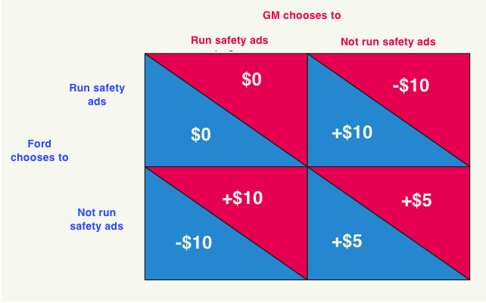

The payoff matrix incorporates the following assumptions: If one company advertises the safety features of its automobiles and the other does not, the advertising company will steal market share from the nonadvertising company. For simplicity, this is translated into high profits for the advertiser and losses for the nonadvertiser. It is also assumed that both companies do better if they both refrain from safety advertising than if they both engage in safety advertising. Heavy safety advertising is not only expensive, but also reminds the public that automobiles can be dangerous, and this harms sales of both companies. Again, to keep things simple, translate this into low profits if both companies run safety ads and medium profits if neither company runs them.

Assume no collusion and that each company acts in its own self-interest. From GM’s viewpoint, if Ford decides to run safety ads, it is better for GM to run them too. But if Ford decides not to run safety ads ... it’s still better for GM to run them! In other words, no matter what Ford does, GM should advertise the safety features of its cars. Using similar reasoning, we conclude that no matter what GM does, Ford should run safety ads as well. Thus, the “noncooperative solution” to this game is the upper right-hand corner: Both firms run safety ads, and both earn low profits.

Accepting the assumptions about profits in the payoff matrix, then the fact that auto companies did not advertise safety features for more than 50 years suggests there was some collusion going on. Indeed, the “cooperative” solution to this game is in the lower right-hand comer, where by agreeing (tacitly?) that neither company will advertise safety, both companies do better. This cooperative solution seemed to prevail well into the 1980s. Then things changed. Suddenly, automobile companies began touting air bags, cushioned dashboards, antilock brakes, and crash-test results. Perhaps this is because in the early 1980s, a new player—Volvo—refused to “play the game.” In a very effective advertising campaign aimed at the U.S. market, it strongly implied that its cars were safer than those of its competitors. Volvo took market share and profits away from U.S. firms who—predictably—responded with safety ads of their own.

Note: you may also want to ask students to consider the airline industry. Do the airlines tout their safety standards? (No!) Why not? (Most likely, tacit collusion. Advertising about safety would no doubt decrease the size of the air-travel market, to the detriment of all airlines.)

An additional note about airlines: the ongoing inspections by the Transportation Safety Administration at airports serves as a constant reminder of one of the hazards of flight. There are undoubtedly some people who now refuse to fly under almost any circumstances because of both the intrusive inspections and the perceived danger.

Application 2: Details of the Cournot Model

Assume two identical firms produce all the output in an industry. The market demand curve is *Qd*= 6,000 − 1,000*P*. Marginal cost is *MC*= $2, is constant and is the same for both firms. It's helpful to have the inverse market demand curve *P* = 6 − 0.001*Q* so *MR* = 6 − 0.002*Q*. First the competitive solution:



Next, monopoly:



And the Cournot solution. It saves considerable time to recognize that this market is completely symmetrical. First, develop the residual demand curve for each firm. Then use the reaction functions to calculate *q*. Use the market demand curve to calculate *P*,



The key is recognizing that the *MR* function will have twice the slope with respect to the firm's quantity, but still have the original slope with respect to the other firm's output. That is the key to the Cournot results.