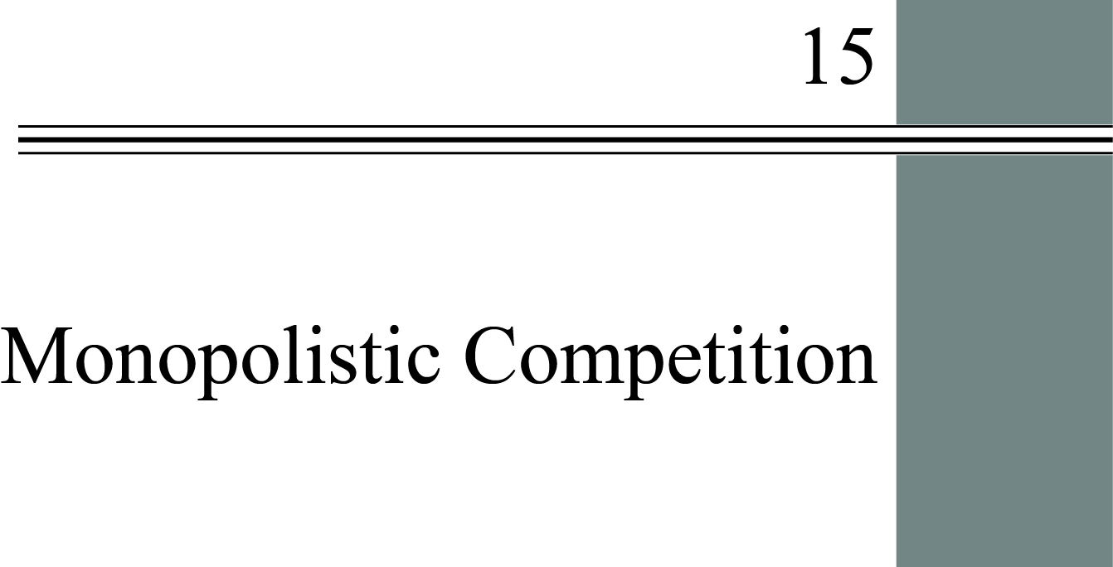

**chapter Outline**

**Industry Characteristics**

Identify the characteristics of a monopolistically competitive industry.

**Product Differentiation and Advertising**

Discuss the methods and implications of product differentiation and advertising in monopolistically competitive industries.

**Price and Output Determination in Monopolistic Competition**

Discuss price and output determination for monopolistically competitive firms.

**Economic Efficiency and Resource Allocation *p.***

Summarize the economic advantages and disadvantages of monopolistic competition

detailed chapter outline

I. Introduction

A. A monopolistically competitive industry is similar to a perfectly competitive industry in the following ways.

1. Many small sellers and many small buyers.

2. Low-cost entry and exit.

B. The key difference is non-homogeneous output.

1. Monopolistically competitive firms produce differentiated products that are similar, but not identical to each other.

2. Since products are differentiated, a firm can potentially raise the price being charged and still not lose too much business.

C. Questions we’d like answered:

1. Why do we see a dozen different types of shampoo in a store? Is a dozen too many, too few, or just the right amount?

2. Why are beverages and automobiles advertised a great deal but semiconductors and economics textbooks are not?

3. Advertising is expensive. Is it a waste of money, or does it serve some social function?

4. Can consumers ever be offered too many choices? Why does nutritional cereal sell better in the extra large size while candy sells better by the bar?

II. Industry Characteristics

A. *Monopolistic competition* is a common form of industry (market) structure characterized by a large number of firms, no barriers to entry, and product differentiation.

B A majority of businesses in the U.S. operate in monopolistically competitive industries.

1. There are many, many restaurants in the United States. With the exception of chains and franchises, these restaurants sell similar, but not identical, output.

2. Entry and exit are clearly possible at low cost as evidenced by the high turnover in the restaurant business. Entry and exit costs are reduced by the presence of an active secondary market for restaurant equipment. (A quick Google search on “used restaurant equipment” turned up many, many hits.)

3. Despite the large number of small firms, most output in the United States is produced by large businesses. Most firms in monopolistically competitive markets are very small.

III. Product Differentiation and Advertising

A. *Product differentiation* is a strategy that firms use to achieve market power. Differentiation is accomplished by producing goods that differ from others in the market.

B. How Many Varieties?

1. Why is most concrete gray? Why are different houses painted different colors? The answer is clear: there are huge economies of scale in concrete production *and* consumers are not willing to pay a higher price for concrete in other colors. There are no such economies of scale in house painting, meaning consumers will pay about the same price no matter which color they choose.

2. The concrete example is useful because it introduces *coordination needs*, the willingness to accept a product as a commodity because costs are lowered dramatically.

3. Naturally, network externalities can also reduce variety. The text’s example of word processing software is very good. *Coordination needs* can dramatically narrow product choice.

4. In markets that are functioning well, the level of product variety reflects the underlying heterogeneity of consumers’ tastes in that market, the gains if any from coordination, and cost economies from standardization.

C. How Do Firms Differentiate Products?

1. *Horizontal differentiation*means products differ in ways that make them better for some people and worse for others. Continuing the restaurant example, horizontal differentiation might be type of cuisine.

2. *Vertical differentiation* is a product difference that, from everyone’s perspective, makes a product better than rival products. The issue then becomes the consumer’s willingness and ability to pay for the improved product.

3. *Behavioral economics*is a branch of economics that uses the insights of psychology and economics to investigate decision making.

a. One of the key insights from this field is that too much variety may simply confuse consumers, causing them to refuse to make any choice at all.

b. A second insight is the notion of commitment. A *commitment device* is any action that individuals take in one period to try to control their behavior in a future period. For example, consumers often buy small containers of ice cream but large bottles of vitamins.

D. Advertising

1. Advertising can provide information about a product’s characteristics. Advertising can also create brand images, contributing to perceived product differentiation.

a. In 2016 U.S. companies spent about $190 billion on advertising. Television advertising is still the largest category of spending. The fastest-growth area was mobile, tablets, and smartphones.

b. The Internet is dramatically altering the advertising model. By allowing specific targeting of individual’s interests, advertisers hope to get more bang for their advertising buck.

c. Google’s YouTube lets advertisers actively interact with customers via online contests and brand channels. As a result advertising is moving toward a two-way communications model.

2. The Case for Advertising: For product differentiation to be successful consumers must have information about each product’s features and characteristics. Informational advertising supplies this. Advantages are variety, *innovation* (which improves the standard of living), and efficiency. Supporters of advertising argue that it promotes competition and that consumers seem willing to pay for product variety.

3. The Case against Product Differentiation and Advertising: They waste society’s scarce resources, their costs add to the prices consumers pay, advertising may be deceptive, and advertising competition can turn into unproductive warfare. Advertising may create a barrier to entry and imposes a cost on society. Do we really need 50 different kinds of soap? But, on the other side of the coin, we may need more than two brands of cola.

4. Open Questions: There are strong arguments on both sides, and even the

IV. Price and Output Determination in Monopolistic Competition

A. Product Differentiation and Demand Elasticity: Product differentiation makes demand less elastic. A monopolistically competitive firm faces a downward sloping demand curve. However, demand will be more elastic than the demand curve faced by a monopoly.

B. Price/Output Determination in the Short Run: The firm chooses the price/output combination that maximizes profit. This occurs where *MR* = *MC*. Price may or may not be above *ATC*. There is no guarantee of profits for either monopoly or monopolistically competitive firms.

C. Price/Output Determination in the Long Run: Firms earning profits provide an incentive for new firms to enter, which drives down demand for the existing firms. New firms enter until excess profits are eliminated; graphically this is the point at which the demand curve is tangent to the *ATC* curve. Firms now are just breaking even (earning zero economic profits).

V. Economic Efficiency and Resource Allocation

A. By holding production down and charging a price above marginal cost, monopolistically competitive firms prevent the efficient use of resources. In the final equilibrium, though firms break even, it is not at minimum *ATC*. Thus, in this industry we end up with many firms each producing a slightly different product at a scale that is less than optimal (excess capacity).

B. However, aggressive competition among products has benefits: introduction of new products, improvements in old products, and greater variety. This gain in economic welfare may counteract and even outweigh the loss of efficiency.