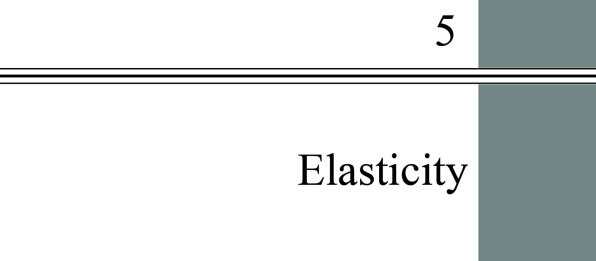

**chapter Outline**

**Introduction**

**Price Elasticity of Demand**

Understand why elasticity is preferable as a measure of responsiveness to slope and how to measure it.

**Calculating Elasticities**

Calculate elasticities using several different methods and understand the economic relationship between revenues and elasticity.

**The Determinants of Demand Elasticity**

Identify the determinants of demand elasticity.

**Other Important Elasticities**

Define and give examples of income elasticity, cross price elasticity, and supply elasticity.

**What Happens When We Raise Taxes: Using Elasticity**

Understand the way excise taxes can be shifted to consumers.

detailed chapter Outline

I. Introduction

A. How Much?

1. Elasticity helps us estimate how much quantity demanded, demand, quantity supplied, or supply will change in response to a change in some other variable.

2. Once we understand the relationship between the change in price and the change in quantity demanded, we can estimate the change in total expenditure.

B. *Elasticity* quantifies how sensitive one variable is to a change in a second. The elasticity of A with respect to B is %ΔA/%ΔB.

II. Price Elasticity of Demand

A. Slope and Elasticity

1. Slope is not a good measure of responsiveness. One important reason is that slope changes when the units of measurement on either axis change.

2. *Price elasticity of demand* is the ratio of the percentage of change in quantity demanded to the percentage of change in price; measures the responsiveness of quantity demanded to changes in price.



3. Price elasticity of demand is naturally negative. Since we know that, we often omit the minus sign.

B. Types of Elasticity

1. *Perfectly inelastic demand* is demand in which quantity demanded does not respond at all to a change in price. (The demand curve is vertical.) Example: insulin.

2. *Perfectly elastic demand* is demand in which quantity drops to zero at the slightest increase in price. (The demand curve is horizontal.).

3. The following descriptive text may help your students remember the difference.



4. *Elastic demand* is a demand relationship in which the percentage change in quantity demanded is larger than the percentage change in price in absolute value (a demand elasticity with an absolute value greater than 1.0). Example: bananas (elasticity = |–3| = 3).

5. *Inelastic demand* is demand that responds somewhat, but not a great deal, to changes in price. Inelastic demand always has a numerical value between zero and –1. Example: gasoline in the United States (0.2 in the short run).

6. *Unitary elasticity* is a demand relationship in which the percentage change in quantity of a product demanded is the same as the percentage change in price in absolute value (a demand elasticity of |–1.0| = 1.0). Example: beef.

7. Warning: economists often omit the minus sign when writing price elasticity of demand.

III. Calculating Elasticities

A. Calculating Percentage Changes

1. The percentage change in quantity demanded is equal to the change in quantity demanded divided by the first value of quantity. Here’s the calculation technique:



2. The percentage change in price is equal to the change in price divided by the first value of price. Here’s the calculation technique:



3. Defined this way, the value calculated for the percentage change depends on which of the two values is used in the denominator.

B. Elasticity Is a Ratio of Percentages

1.



2. Calculating price elasticity of demand from Figure 5.1:



C. The Midpoint Formula

1. For large changes in Q and/or P, the direction of the change makes a difference. Reversing the direction of movement from the previous example,

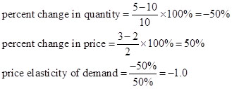

One reason we use elasticity is because it does not change when the units of measurement change. However, a variable whose value changes when the direction of movement changes is almost as bad. We have a solution: the midpoint formula.

2. Instead of having to select one or the other price-quantity pair for the denominators of the percentage change calculation, why not just use the average?

3. The *midpoint formula* is a more precise way of calculating percentages using the value halfway between *P1* and *P2* for the base in calculating the percentage change in price and the value halfway between *Q1* and *Q2* as the base for calculating the percentage change in quantity demanded.

4. The midpoint formula is calculated as:



5. Here’s how to calculate elasticity using the previous example with the midpoint formula:



6. *Point elasticity*  is a measure of elasticity that uses the slope measurement:



a. Point elasticity uses the reciprocal of the slope.

b. Point elasticity should only be used when the changes in Q and P are small relative to their sizes.

D. Elasticity Changes along a Straight-Line Demand Curve

1. The slope of a straight line is constant.

2. Elasticity is not the same thing as slope.

3. Demand is unit elastic halfway up a linear demand curve (Figure 5.4).

E. Elasticity and Total Revenue

1. Total revenue is the total amount sellers receive for their product. This is also the amount consumers spend on the product (total expenditure).

2. TR = PQ. Total revenue = price x quantity.

3. Any increase in P will cause Q to decrease. TR may rise, fall, or remain the same depending on the relative magnitudes of the changes in   
P and Q.

4. Price elasticity of demand tells us everything we need to know:

|  |  |  |
| --- | --- | --- |
| Elasticity | Demand is | Price and Total Revenue |
| between 0 and  –1 | inelastic | change in the same direction |
| less than –1 | elastic | change in opposite directions |
| equals –1 | unit elastic | small changes in price have no effect on total revenue |

IV. The Determinants of Demand Elasticity

A. Availability of Substitutes

1. Examples: demand for corn is elastic but demand for oil is inelastic.

2. How many substitutes are available? How close are the substitutes to the product in question?

B. The Importance of Being Unimportant

1. Products that don’t consume a very large part of our income also don’t command much of our attention.

2. Since we don’t pay much attention to their price, demand for these products tends to be inelastic.

C. Luxuries versus Necessities

1. Luxury goods tend to have relatively elastic demand. Example: the demand for yachts is likely to be elastic.

2. Necessities tend to have inelastic demand. Example: the demand for food is likely to be inelastic.

3. However, the demand for any individual food (such as bananas) is likely to be elastic.

**Unique *Economics in Practice: The Demand for Roses***

The demand for rose stems was estimated by Perloff. The price is in cents per stem and the quantity is billions of rose stems per year. Here’s the demand curve:



At a price of 30 cents per stem demand is 1.25 billion stems per year. If the price rises to 32 cents per stem, quantity demanded falls to 1.16 billion stems per year.

Question: Calculate the price elasticity of demand and total revenue at each price. You may use the point elasticity formula.

Answer:

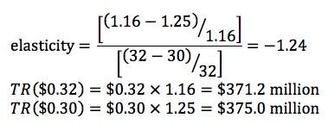

The point, of course, is that demand is elastic causing price and total revenue to change in opposite directions.

Source: Perloff, Jeffrey, and James Brander (2e) *Managerial Economics and Strategy*, Pearson Higher Education Publishing, 2017. Figure 8.10, p. 252.

***Economics in Practice: Elasticities at a Delicatessen   
in the Short Run and Long Run***

Leticia runs a corner delicatessen and decides one Monday morning to raise the prices of her sandwiches by 10 percent. Since Leticia knows a little economics, she expects that this price increase will cause her to lose some business, since demand curves slope down, but she decides to try it anyway. At the end of the day, Leticia discovers that her revenue has, in fact, gone up in the sandwich department. Feeling pleased with herself, Leticia hires someone to create signs showing the new prices for the sandwich department. At the end of the month, however, she discovers that sandwich revenue is way down. What is going on?

In this case, Monday’s price increase brings increases in revenue; therefore, this pattern tells us that the demand from Leticia’s customers appears to be inelastic. In the longer-term, however, demand appears to be more elastic (revenue is down after a month). Another way to pose this puzzle is to ask why the monthly demand curve might have a different elasticity than the daily demand.

Once you are in Leticia’s store, planning to buy a sandwich, your demand tends to be relatively inelastic because your ability to substitute by going elsewhere or choosing a different lunch item is relatively limited. You have already come to the part of town where Leticia’s Delicatessen is located, and you may already have chosen chips and a beverage to go along with your sandwich. Once you know that Leticia’s sandwiches are expensive, you can make different plans, and this broadening of your substitute choices increases your elasticity. In general, longer-term demand curves tend to be more elastic than shorter-term curves because customers have more choices.

D. The Time Dimension

1. The longer the time period the more elastic demand becomes.

2. People can find substitutes and change their behavior more over longer time periods.

3. Example: the long-run elasticity of demand for oil is about 0.7 while the short-run elasticity is about 0.2.

V. Other Important Elasticities

A. Income Elasticity of Demand

1. *Income elasticity of demand* is a measure of the responsiveness of demand to changes in income:



2. China’s economic growth has caused income to rise. One item now being demanded is clean air.

3. If the income elasticity of demand for housing is 0.8 then a 10 percent increase in income will cause housing demand to increase by 8 percent.

4. Income elasticity is positive for normal goods but negative for inferior goods.

B. Cross-Price Elasticity of Demand

1. *Cross-price elasticity of demand* is a measure of the response of the quantity of one good demanded to a change in the price of another good. It’s helpful to call these goods Y (percent change in quantity of Y) and X (percent change in price of X):



2. If cross-price elasticity is positive then X and Y are substitutes.

3. If cross-price elasticity is negative then X and Y are complements.

C. Elasticity of Supply

1. *Elasticity of supply* is a measure of the response of quantity of a good supplied to a change in price of that good:



2. Elasticity of supply is likely to be positive in most output markets.

3. The *elasticity of labor supply* is a measure of the response of labor supplied to a change in the price of labor. If the labor supply curve bends backward the elasticity of supply will be negative along that part of the supply curve. On the backward-bending segment, the worker has chosen to use part of the wage increase to “purchase” more leisure.

***Economics in Practice: Tax Rates and Migration in Europe,   
page 105***

Countries that are members of the European [Economic] Union agree to labor mobility. However, income tax rates vary among the different countries. What is the labor supply elasticity with respect to tax rates for highly skilled workers?

Denmark’s tax rate on incomes over €100,000 was 55 percent. In an attempt to attract highly skilled workers, Denmark offered them a flat 30 percent tax rate for 3 years. The elasticity of migration was found to be almost 2. After a few years the fraction of foreigners in the top 5 percent of Denmark’s income distribution increased from 4.0 percent to 7.5 percent. Taxes matter.

VI. What Happens When We Raise Taxes: Using Elasticity

A. A Tax on Avocados

1. A hypothetical city’s residents buy 1,000 avocados per day (365,000 per year). The mayor decides to impose a tax of $1 per avocado, expecting revenue of $365,000 per year.

2. The mayor has imposed an *excise tax*, a per unit tax on a specific good.

3. After 1 year the tax has raised $182,500, half what was expected.

4. The reason, of course, is the elasticity of demand.

5. Since the demand curve is not vertical, the equilibrium price rises to $2.50 and the equilibrium quantity falls to 500 avocados per day.

6. The burden of the tax is divided equally between buyers and sellers. The buyers pay $0.50 more and sellers receive $0.50 less.

****Extended Application

Application: Inflation Reforming Economies

Microeconomics can often help us understand macroeconomic events. For example, why has economic reform in former Communist bloc countries virtually always resulted in high rates of inflation? Certainly much of the explanation is macroeconomic (faster money supply growth, large and growing budget deficits, depreciating currencies), but microeconomics plays a major role as well.

Consider the market for a typical consumer good in a former Communist country. Under central planning, the quantity produced was fixed by the state, so we can draw the supply curve as the vertical line *S*1 in the diagram following. The demand curve, however, looked like demand curves everywhere: The higher the price, the less people would want to buy.



What about price? Under central planning, prices—like quantities—were simply set by the state. To keep things simple, let us assume that initially planners were wise enough to set the price at *P*1, where quantity supplied and quantity demanded were equal. (Central planners did indeed try to do this for many consumer goods.) At this price, everyone who wanted to buy the good at the going price could do so.

During the 1980s, for a variety of reasons, production of consumer goods decreased. This decrease in production can be shown as a leftward shift of the supply curve from *S*1 to *S*2 (see the following diagram). To avoid excess demand and shortages, central planners would have had to raise the price to *P*2. But throughout the 1980s, Communist governments steadfastly refused to raise consumer prices. There were three reasons for this policy:

1. It had long been a source of great pride that “Communism had put an end to inflation.” Rising consumer prices would have been seen as an admission of failure.
2. Higher prices would have made consumer goods less affordable to those with lower incomes and little wealth, which was viewed as unfair by the government and intolerable by much of the public.
3. Prices were set by a slow-moving bureaucracy that—even if it wanted to—could not have kept up with changing conditions in any meaningful way.

The result of this failure to raise prices was predictable. Consumer goods markets in the 1980s were plagued by excess demand. But there was more. With long lines forming at stores, many consumers found the shelves empty when they got inside. Some could go to the black market to buy goods, but not everyone could do this, and not everyone who went there could find what they needed. Thus, many consumers who had the income to buy goods were unable to do so. In fact, the typical Eastern European family during the 1980s found itself in an ironic situation: It had more income than it could spend! Year after year, this unspendable income was saved—Western economists called it “forced saving”—resulting in a steadily increasing stock of cash and savings deposits—an increase in wealth.

Now, an increase in wealth causes a rightward shift in the demand curve for normal goods (shown as a move from D1 to D2).



Demand shifts like this—with fixed prices—served only to worsen the shortages, leading to more forced saving, further increases in wealth, further shifts of the demand curve and still worse shortages.

By the time reform-minded leaders took power in these nations (1989 in Eastern Europe, 1991 and 1992 in the former Soviet republics), the shortages had grown intolerable. Something had to be done, and quickly. Because supplies of most goods would remain unchanged for some time (in the short run, production was constrained by the preexisting productive capacity of factories), the only option was to allow prices to rise closer to their equilibrium values. In many cases, this required price increases of hundreds or even thousands of percent.