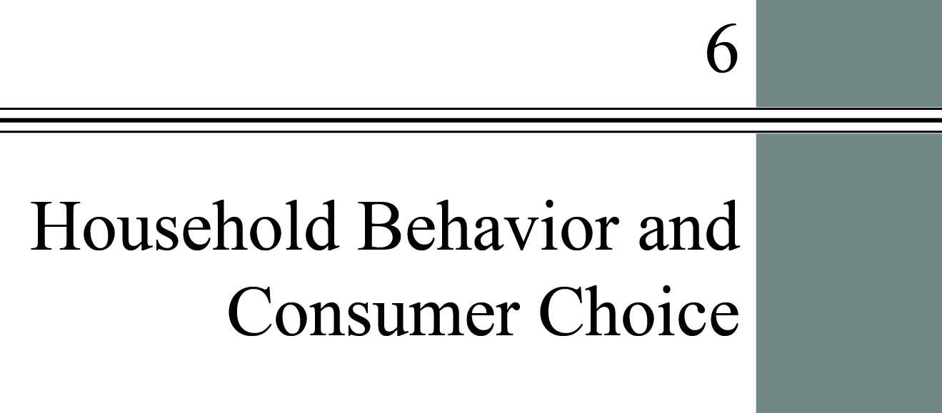

**chapter Outline**

**Introduction to part II: The Market System**

**Introduction**

**Household Choice in Output Markets**

Explain where the budget constraint comes from and the role it plays in household demand.

**The Basis of Choice: Utility**

Understand how the utility maximizing rule works in household choice of products.

**Income and Substitution Effects**

Describe the income and substitution effects of a decrease in the price of food.

**Household Choice in Input Markets**

Discuss factors that affect the labor and saving decisions of households.

**A Review: Households in Output and Input Markets**

**Appendix: Indifference Curves**

Understand how to derive a demand curve from indifference curves and budget constraints.

detailed chapter Outline

I. Introduction to Part II (The Market System: Choices Made by Households and Firms)

A. This chapter is the first of seven covering models of household and business behavior in perfectly competitive markets.

B. The Circular Flow of Production:

1. Households demand output and supply inputs (capital and labor).

2. Firms demand inputs and supply output.

C. The analysis describes both output and input markets.

D. Assumptions for Chapters 6 through 12

1. *Perfect knowledge* is the assumption that households possess a knowledge of the qualities and prices of everything available in the market and that firms have all available information concerning wage rates, capital costs, technology, and output prices.

2. *Perfect competition* is an industry structure in which there are many firms, each being small relative to the industry and producing virtually identical products, and in which no firm is large enough to have any control over prices.

3. *Homogeneous products* are undifferentiated outputs: products that are identical to or indistinguishable from one another. A homogeneous product is produced by an industry made up of many firms.

II. Introduction to Chapter 6

A. People make decisions about buying and selling every day.

1. Buying decisions may be as simple as bottled water versus soda or as complex as which make and model of car to purchase.

2. Selling decisions may involve the number of hours to work or whether to stay in school or get a job.

3. Many decisions involve time. Buying a high-end BMW today will constrain your future choices because your budget will be reduced.

B. Some examples

1. No professional sport is played year-round. How is this impacted by household decisions?

2. When the price of a product rises sharply there is a tendency for households to switch from name brands to generics.

C. *Constrained choice* describes decisions we make under constraints that exist in the marketplace. For example, household spending decisions are constrained by income, wealth, and existing prices.

III. Household Choice in Output Markets

A. Every household must make three basic decisions:

1. How much of each product, or output, to demand.

2. How much labor to supply.

3. How much to spend today and how much to save for the future.

B. The Determinants of Household Demand: The quantity of a given good or service demanded by a single household depends on many factors. The following are the factors most often found to have significant effects.

1. The price of the product.

2. The income available to the household.

3. The household’s amount of accumulated net wealth.

4. The prices of other substitutes and complements available to the household.

5. The household’s tastes and preferences.

C. The Budget Constraint

1. The *budget constraint* is the limits imposed on household choices by income, wealth, and product prices.

a. Prices of both the product being considered for purchase and related products must be taken into account.

b. The budget constraint tells us which combinations of goods and services are affordable and which are not. It defines a *choice set* or *opportunity set*, the set of options that is defined and limited by a budget constraint.

2. Preferences, Tastes, Trade-offs, and Opportunity Cost

a. As long as a household faces a limited budget the real cost of any good or service is the value of the other goods and services that could have been purchased with the same amount of money.

b. Once again the real cost of any decision is the value of what must be given up. Opportunity cost is everywhere.

c. A change in the price of any product changes the entire choice set because the entire budget constraint changes.

3. The Budget Constraint More Formally

a. A simple two-good budget constraint can be drawn as a two-dimensional graph.

b. *Real income* is the set of opportunities to purchase real goods and services available to a household as determined by prices and money income. A change in nominal income (I) holding prices constant or a change in any price holding nominal income constant causes real income to change.

D. The Equation of the Budget Constraint

1. Using Figure 6.1 the budget constraint can be written as   
$20 × number of Thai meals + $10 × number of jazz club visits ≤ $200.

a. The example in the text is 20*X* + 10*Y* = $200. Solving for *Y* gives  
*Y*= (200/10) – (20/10)*X* = 20 – 2*X*. This is the equation of the line connecting points *A* and *B* in Figure 6.1.

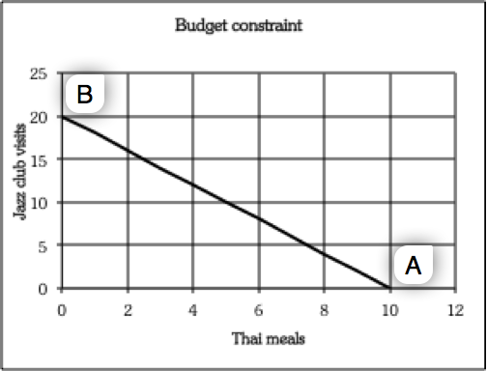

b. Naturally the budget constraint can also be stated algebraically as   
*I*= *PxX* + *PyY* with the obvious solution *Y*= (*I*/*Py*) – (*Px*/*Py*)*X*.

2. Budget Constraints Change When Prices Rise or Fall

a. A change in relative prices or income creates a new trade-off between the two goods and new consumption possibilities.

b. If the price of Thai meals falls from $20 to $10 the consumers will be able to afford more *of both goods*. (The one point that is the exception is when they do not purchase any Thai meals.) Figure 6.2 illustrates this point. The original budget constraint connects points *A* and *B*. After the decrease in the price of Thai meals, the new budget constraint connects points *C* and *B*.

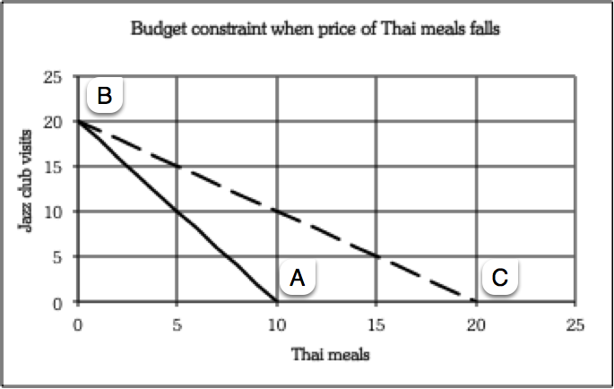

IV. The Basis of Choice: Utility

A. *Utility* is the satisfaction a product yields.

1. It is impossible to measure utility, and it is impossible to compare the utilities of different people.

2. However, we can use the concept to better understand the process of choice.

B. Diminishing Marginal Utility.

1. The *law of diminishing marginal utility* says the more of any one good consumed in a given period, the less satisfaction (utility) generated by consuming each additional (marginal) unit of the same good.

2. *Marginal utility* (*MU*) is the additional satisfaction gained by the consumption or use of *one more* unit of a good or service.

3. *Total utility* is the total amount of satisfaction obtained from consumption of a good or service.

C. Allocating Income to Maximize Utility.

1. A consumer should choose the product that gives the most utility for the money.

2. This means using the marginal utility per dollar spent as the correct measure for comparing the utility gained from various goods.

D. The Utility Maximizing Rule.

1. Consumers spread out their expenditures until the last dollar spent on each good or service yields the same marginal utility.

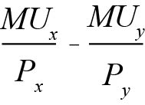

This must hold for all goods.

2. If this were not true, then the ratio of marginal utility to price would be greater for one product than for others, indicating that the consumer should buy more of that and less of the others.

3. If the ratios are all equal there is no way to rearrange spending and achieve more utility.

4. The *utility-maximizing rule* is to equate the ratio of the marginal utility of a good to its price for all goods.

5. The *diamond-water paradox* introduced by Adam Smith says:

a. the things with the greatest value in use frequently have little or no value in exchange and;

b. the things with the greatest value in exchange frequently have little or no value in use.

c. the point, of course, is that demand alone does not determine price. Supply is an equally important consideration.

E. Diminishing Marginal Utility and Downward-Sloping Demand

1. As the marginal utility falls consumers do not want to buy as large a quantity of any product.

2. Even if the product were free, consumers would eventually get so sick of it that there would be a limit to the amount consumed.

3. Since all demand curves intersect the horizontal axis, the curves must also slope downward.

V. Income and Substitution Effects

A. Income and substitution effects offer an explanation for downward sloping demand curves that does not rely on the concept of utility or the assumption of diminishing marginal utility.

B. The Income Effect

1. When the price of a product falls, the purchasing power of the consumer’s nominal income rises. The consumer will usually buy more of the good whose price has fallen. This is called the *income effect of a price change*.

2. The consumer can then buy more of any product. The consumer may also use some of the increased real income to buy other products.

3. The reverse is true for a price increase.

**Unique *Economics in Practice***

In many cities and towns newspapers are sold from vending machines, often located at train stations and bus stops. Most of these machines operate as follows: the purchaser deposits coins, the front door of the machine opens, and the purchaser can then remove a paper from a stack inside the machine. It is obviously easy for someone to remove more than one paper! But vending machines that dispense food or soda don’t work this way.

Question: What explains the difference?  
  
Answer: Newspapers have very low marginal cost and rapidly diminishing marginal utility. Once a customer has a copy of a newspaper, the marginal utility of a second newspaper is very low. And the price is also relatively low, making resale unprofitable. The marginal utility of food, however, does not diminish nearly as rapidly. If vending machines sold food the same way newspapers are sold, there would be many more consumers taking more than one energy bar (for example).

C. The Substitution Effect

1. A product whose price has fallen is now cheaper relative to other products.

2. The relatively lower-priced product becomes more attractive than other substitutes. The increase in quantity demanded caused by the change in relative price is called the *substitution effect of a price change*.

3. Again, the reverse is true for a price increase.

VI. Household Choice in Input Markets

A. The Labor Supply Decision

1. Most income in the United States is wage and salary income paid in compensation for labor.

2. Households must decide:

a. Whether to work

b. How much to work

c. What kind of a job to work at.

3. The household labor supply decision depends on:

a. Availability of jobs

b. Market wage rates

c. Skills they possess

d. The natural limit of 168 hours in a week.

B. The Price of Leisure

1. Buying more leisure means spending less time working and more time on nonwork activities.

2. For every hour of leisure consumed the individual gives up one hour’s wages.

3. The wage rate is the price of leisure time. Once again, opportunity cost gives the correct answer.

C. Income and Substitution Effects of a Wage Change

1. A *labor supply curve* is a graph that illustrates the amount of labor that households want to supply at each given wage rate.

2. An increase in wages has an income effect: If leisure is a normal good, an increase in income will increase their demand for leisure, thus somewhat reducing the labor they supply.

3. There is also a substitution effect: A higher wage means leisure is more expensive. This implies increasing labor hours supplied.

4. Thus, in the labor market the income and substitution effects work in opposite directions.

a. If the substitution effect is larger than the income effect, a higher wage will cause labor supply to increase.

b. If the substitution effect is smaller than the income effect, a higher wage will cause labor supply to decrease.

D. Saving and Borrowing: Present versus Future Consumption

1. Saving means using part of current income to finance future consumption. Borrowing finances current consumption with future income.

2. Household saving creates wealth. Households use their accumulated wealth to purchase assets that generate income, often in the form of interest payments.

3. Higher interest rates have a substitution effect on saving, as they raise the opportunity cost of spending, but can also have an income effect that may lead to less saving.

a. Higher interest rates mean more income can be earned from a given quantity of wealth.

b. Thus higher interest rates may have the income effect of *discouraging* saving.

4. The final impact of a change in interest rates on saving depends on the relative size of the income and substitution effects.

5. Empirically higher interest rates seem to increase saving. However (again, empirically) this effect is small. The interest-elasticity of saving is fairly small.

6. But interest rates are also the prices of borrowing. A car loan or mortgage will have higher monthly payments when the interest rate on the loan is higher.

7. Decisions about saving and allocating wealth involve a huge and complex set of institutions.

a. Suppliers of capital (savers or lenders) interact with borrowers of that capital (businesses looking to invest).

b. This is the *financial capital market*, the complex set of institutions in which suppliers of capital (households that save) and the demand for capital (firms wanting to invest) interact.

VII. A Review: Households in Output and Input Markets

A. Households try to maximize utility subject to a budget constraint.

1. The concept of utility helps explain how they do this.

2. The law of diminishing marginal utility explains the variety of goods and services people purchase.

B. Households also supply labor in return for income.

1. Preferences for labor and leisure as well as skills and abilities determine the quantity and quality of labor supplied.

2. These are also constraints on the household.

C. Households also face the tradeoff between consuming today and consuming tomorrow (saving).

D. Having sketched the factors that determine output demand and input supply, we next turn to firm behavior and explore in detail the factors that affect output supply and input demand.

Appendix: Indifference Curves

I. Why Indifference Curves?

A. Since we can’t measure utility, economists are reluctant to use the concept in their models.

B. Even those who don’t believe in utility and marginal utility admit that indifference curve analysis is persuasive.

II. Assumptions.

A. Marginal utility is positive (more is better).

B. The *marginal rate of substitution*, defined as the ratio of the marginal utility of *X* to the marginal utility of *Y,* diminishes.



C. Consumers are able to choose between various combinations of goods and services.

D. If *A*, *B*, and *C* are bundles of goods, and a consumer prefers *A* to *B*, and *B* to *C*, then the consumer prefers *A* to *C* (*rationality*). Formally this is called transitivity.

III. Deriving Indifference Curves.

A. An *indifference* curve is a set of points, each point representing a combination of goods X and Y, all of which yield the same total utility. An indifference curve is derived by plotting a consumer’s preferences.

B. The whole set of indifference curves is called the *preference map*.

C. Indifference curves that lie farther from the origin represent higher levels of satisfaction (like a topographical map).

IV. Properties of Indifference Curves.

A. Indifference curves are convex to the origin because of diminishing marginal utility.

1. *Convex to the origin* means that the slope decreases as we move down the curve from left to right.

2. But moving on the curve that way means combinations that have less Y, hence its MU increases, and more X, hence its MU decreases.

3. Because the slope is MUx/MUy, the slope must therefore be decreasing.

B. No two indifference curves can intersect.

V. Consumer Choice

A. Consumers will want to reach the indifference curve furthest from the origin given their budget constraint.

B. At the tangency of the budget constraint to an indifference curve, where the two slopes are equal, the marginal utility per dollar for the two goods is also equal:



VI. Deriving a Demand Curve from Indifference Curves and Budget Constraints

A. If we allow the price of one good to change, we can derive the new optimization point.

B. It is the set of such points that is the demand curve.