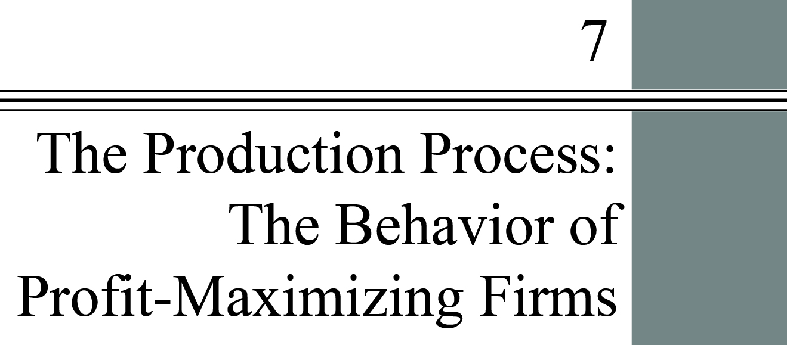

**chapter Outline**

**Introduction**

**The Behavior of Profit-Maximizing Firms**

Understand the importance of opportunity costs to economic profits and how these profits feed into firm decision making.

**The Production Process**

Be able to describe how total, marginal, and average products relate to one another.

**Choice of Technology**

Discuss the factors that firms consider when choosing among production techniques.

**Looking Ahead: Cost and Supply**

**Appendix: Isoquants and Isocosts**

Derive a cost curve from isoquants and isocost lines.

detailed chapter Outline

I. Introduction

A. The Behavior of Firms

1. Firms purchase inputs to produce and sell outputs. Firms demand factors of production in input markets and supply goods and services in output markets. Economists sometimes refer to the production process as transformation of inputs into outputs.

2. Although the analysis refers to the behavior of perfectly competitive firms, much of what is said also applies to firms that are not competitive.

B. Production Is Central

1. *Production* is the process that transforms scarce resources into useful goods and services.

2. A *firm* is an organization that comes into being when a person or group of people decides to produce a good or service to meet a perceived demand.

3. Firms engage in production because they believe they can sell their products at higher prices than it costs to produce them.

C. Production Is Not Limited to Firms

1. Households also engage in transforming factors of production into useful things.

2. Some government agencies also produce goods and/or services. For example, the Department of Motor Vehicles produces drivers’ licenses and vehicle license plates.

II. The Behavior of Profit-Maximizing Firms

Learning Objectives: Understand the importance of opportunity costs to economic profits and how these profits feed into firm decision making.

A. Three Decisions Every Firm Must Make

1. How much output to supply (quantity of product).

2. Which production technique/technology to use. Changing the *technology* of production changes the relationship between input and output quantities.

3. How much of each input to demand.

B. Profits and Economic Costs

1. *Profit* is the difference between total revenue and total cost. profit = total revenue—total cost.

a. *Total revenue* is total amount that a firm takes in from the sale of its product: the price per unit times the quantity of output the firm decides to produce.

b. *Total cost* is total fixed costs plus total variable costs.

c. *Economic profit* is profit that accounts for both explicit costs and opportunity costs.  
economic profit = total revenue − total economic cost.

i. Consider a family owned and operated business that pays no wages to family members. The economic cost of those employees is not zero. Their time has an opportunity cost. The wage they could earn working for another employer is a good measure of this cost.

ii. Most businesses use capital in their production process. The opportunity cost of that capital is the amount that could be earned on the cost of that capital adjusted for risk.

2. Normal Rate of Return.

a. Starting a firm means committing resources to the operation. Those resources usually include some form of physical capital (even if it’s only a notebook computer, a cell phone, and a website).

b. Those resources have an opportunity cost. Their market value could be earning interest if they were not being used in the business. The *rate of return* is the annual flow of net income generated by an investment expressed as a percentage of the total investment. (The rate of return on bonds is also called the *yield*.)

c. A *normal rate of return* is a rate of return on capital that is just sufficient to keep owners and investors satisfied. For relatively risk-free firms, it should be nearly the same as the interest rate on risk-free government bonds.

d. A normal rate of return on invested capital is part of the full economic costs of a business.

e. If a firm earns a zero economic profit it is earning enough accounting profit to yield a normal rate of return on its invested capital.

f. If the level of economic profit is positive, the firm is earning an above-normal rate of return.

C. Short-Run versus Long-Run Decisions

1. The *short run* is the period of time for which two conditions hold:

a. The firm is operating under a fixed scale (fixed factor) of production.

b. Firms can neither enter nor exit an industry.

2. The *long run* is that period of time for which there are no fixed factors of production:

a. Firms can increase or decrease the scale of operation.

b. New firms can enter and existing firms can exit the industry.

3. The difference between the short and long run is the difference between day-to-day operations and longer-term strategic planning.

D. The Bases of Decisions: Market Price of Outputs, Available Technology, and Input Prices

1. Any firm needs to know three things:

a. The market price of output

b. The available production technologies.

c. Input prices.

2. Firms will choose the *optimal method of production*, the production method that minimizes cost for a given level of output.

3. With cost determined and the market price of output known a firm will make a final judgment about the quantity of product to produce and the quantity of each input to purchase.

III. The Production Process

A. Production Technology

1. *Production technology* is the quantitative relationship between inputs and outputs.

2. *Labor-intensive technology* relies heavily on human labor instead of capital.

3. *Capital-intensive technology* relies heavily on capital instead of human labor.

4. Firms will choose the technology that minimizes costs.

B. Production Functions: Total Product, Marginal Product, and Average Product

1. The *production function* or *total product function* is a numerical or mathematical expression of a relationship between inputs and outputs. It shows units of total product as a function of units of inputs.

2. Marginal Product and the Law of Diminishing Returns.

a. *Marginal product* is the additional output that can be produced by adding one more unit of a specific input, *ceteris paribus*.

b. The *law of diminishing returns* states that when additional units of a variable input are added to fixed inputs, after a certain point, the marginal product of the variable input declines. This is also called as the *law of diminishing marginal product*.

c. Marginal product is a relationship between the quantity of output and the quantity of a variable input.

3. Marginal Product versus Average Product

a. *Average product* is the average amount produced by each unit of a variable factor of production.



b. Average product follows marginal product but does not change as fast.

c. The average product of labor is also called *labor productivity*.

C. Production Functions with Two Variable Factors of Production

1. Increasing the quantity of one input (say capital) will usually increase the average product of the other input (say labor). This happens if the two inputs are *complementary*.

2. Diminishing returns will not set in as quickly.

IV. Choice of Technology

A. Inputs can *substitute* for each other in addition to being complementary.

1. As the relative prices of inputs change, the cost-minimizing input combinations change.

2. Demand for inputs that have become relatively more costly will usually fall. Demand for inputs that have become relatively less costly will usually rise.

B. Two things determine the cost of production

1. Input prices.

2. Available technologies.

3. Firms will choose the technology that minimizes costs given current input prices.

Appendix: Isoquants and Isocosts

I. A New Look at Technology: Isoquants

A. An *isoquant* shows the various combinations of capital and labor that can be used to produce a given amount of output.

1. The slope of the isoquant is the *marginal rate of technical substitution* (*MRTS*)*.*

2. The MRTS is the rate at which the firm can substitute capital for labor holding the quantity of output constant.

3. The MRTS is equal to (minus) the ratio of the marginal product of labor to the marginal product of capital (as long as *K* is on the vertical axis and *L* is on the horizontal axis).

II. Factor Prices and Input Combinations: Isocosts

A. An *isocost line* is a graph that shows all the combinations of capital and labor that can be purchased for a given total cost.

1. The slope of the isocost line is the ratio of the price of labor to the price of capital.

2. The position of the isocost line is determined by the total amount available to spend.

B. A change in the price of either input changes the slope and one intercept of the isocost line. A change in the total available budget causes the isocost line to shift.

III. Finding the Least-Cost Technology with Isoquants and Isocosts

A. Two Versions of the Same Problem

1. The firm may choose to produce a given quantity of output at the lowest possible cost.

2. The firm may choose to produce the largest quantity of output given the available budget and input prices.

3. Either way the solution is the tangency of an isocost and isoquant.

IV. The Cost-Minimizing Equilibrium Condition

A. At the tangency the slopes of the isocost and isoquant are equal

1. That implies the marginal product per dollar for each of the inputs used is equal.

2. Mathematically, .



Extended Application



Application 1: *MP* and *AP* Curves for a Photocopy Service

Suppose you decide to open a photocopy service near campus. Your fixed inputs (in the short run) are office space and a single photocopying machine. Your only variable input is labor. (It is true that you also need paper to make copies, but we are viewing your “output” as a service—“turning blank pages into printed copies”—rather than a good—“paper copies.” In providing this service, labor is the only variable input.)

The following table illustrates output (thousands of copies per day) for each number of workers:

|  |  |  |  |
| --- | --- | --- | --- |
| **Labor** |  |  |  |
| 0 | 0 | — | — |
| 1 | 2,000 | 2,000 | 2,000 |
| 2 | 8,000 | 6,000 | 4,000 |
| 3 | 12,000 | 4,000 | 4,000 |
| 4 | 15,000 | 3,000 | 3,750 |
| 5 | 17,000 | 2,000 | 3,400 |
| 6 | 18,000 | 1,000 | 3,000 |
| 7 | 17,000 | –1,000 | 2,429 |

Note that one worker can produce 2,000 copies in one day. Add a second worker, however, and the number of copies rises dramatically to 8,000. This is an example of the gains from specialization. A single worker must divide his or her time between photocopying and taking orders; the constant back and forth gets in the way of making copies. Add a second worker, however, and both can specialize: One limits work time to copying, the other just takes orders. Add a third worker and there is someone to monitor the machines to be sure paper and toner are always in proper supply, reducing down time. The third worker can also occasionally take orders or run the copy machine, enabling the other two workers to take breaks, thus reducing worker fatigue and time-consuming mistakes.

Note, however, that the gains from the third worker (4,000) are smaller than the gains from the second (8,000). Diminishing returns to labor have set in: We are adding a variable input (labor) to fixed inputs (photocopying machines and office).

Diminishing returns continue as workers four through six are added, and after this negative returns set in: Adding the seventh worker actually makes output decrease, presumably because there is crowding around the single photocopying machine, and workers get in each other’s way. Perhaps also—with so many workers—supervision becomes more difficult, and workers can slack off more easily.

In the following diagram, we plot all of the information about marginal product found in the table. Note that as we change from one to two workers, we have increasing returns to labor and the marginal product curve slopes upward. From two through six workers, we have diminishing returns to labor, and the marginal product curve slopes downward. From six to seven workers, we have negative returns to labor, and marginal product has dropped below the horizontal axis.

What about the average product of labor? In the table, students can see that when going from one to two workers, marginal product is larger than average product, and so average product rises. A newly hired worker who adds more to output than the average output of all previous workers pulls the average up. In the graph, we can see that the *MP* curve rises above the *AP* curve when the second worker is hired, so the *AP* curve is rising.

The third worker, however, adds 4,000 to output, which is exactly equal to the preexisting average of all workers. Thus, adding the third worker should leave average product unchanged. In the graph, we see that at three workers, the average and marginal product curves intersect.

Finally, workers four through six add to total product, but each adds less than the preexisting average of all workers. Thus, as each of these workers is hired, the average is pulled down. In the graph, we see that the *MP* curve lies below the *AP* curve, and that *AP* is falling as the fourth, fifth, and sixth workers are hired.

The point to remember is this: The shapes of the marginal and average product curves are not arbitrary. These shapes are determined by how much production we can expect from different numbers of workers, based on technology and expected worker behavior. Remember too that in deriving average and marginal product curves, we always assume that other nonlabor inputs are fixed. In our example, office space and the number of photocopying machines are the fixed inputs.