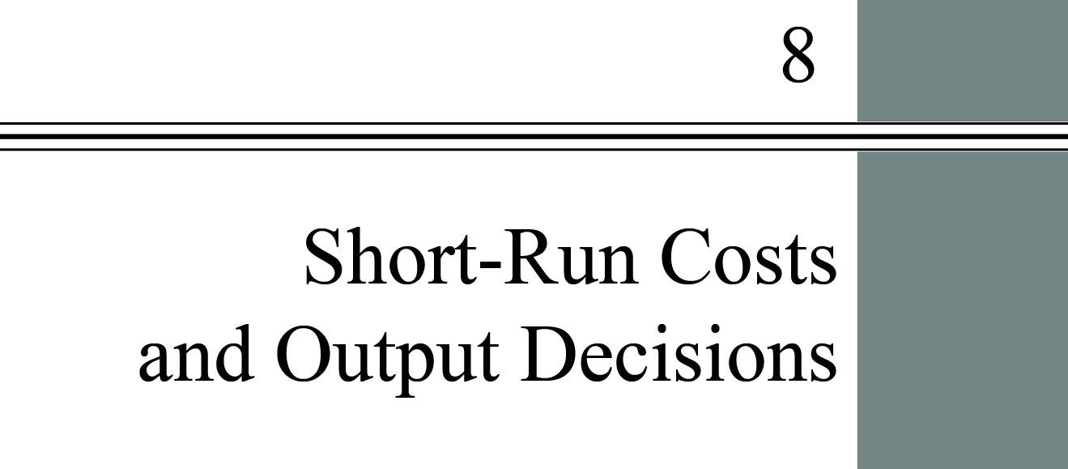

**chapter Outline**

**Introduction**

**Costs in the Short Run**

Be able to describe and graph the major components of firm cost.

**Output Decisions: Revenues, Costs, and Profit Maximization**

Discuss how revenues and costs affect the profit-maximizing levels of output in perfectly competitive firms.

**Looking Ahead**

detailed chapter Outline

I. Introduction

A. This chapter focuses on short-run production costs.

1. To calculate costs a firm must know the quantities and prices of inputs it needs to produce its output. The quantities of variable inputs and their prices determine short-run costs.

2. Figure 8.1 from the text (page 169, shown below) summarizes the distinction between revenue and cost.



II. Costs in the Short Run

A. Short-Run Cost

1. *Total cost* (*TC*) equals total fixed costs plus total variable costs:

*TC*= *TFC*+ *TVC*

2. A *fixed cost* is any cost that does not depend on the firm’s level of output. These costs are incurred even if the firm is producing nothing. There are no fixed costs in the long run.

3. A *variable cost* is a cost that depends on the level of production chosen. Variable costs rise when the rate of output rises and vice-versa.

B. Fixed Costs

1. *Total Fixed Costs* (*TFC*) or *overhead* is the total of all costs that do not change with output even if output is zero.

2. *Average Fixed Cost* (*AFC*) is total fixed cost divided by the number of units of output; a per-unit measure of fixed costs. *Spreading overhead* is the process of dividing total fixed costs by more units of output. Average fixed cost declines as output quantity rises.

3. Firms have no control over fixed costs in the short run.

C. Variable Costs

1. *Total Variable Cost* (*TVC*) is the total of all costs that vary with output in the short run.

a. Variable costs change as output changes because the cost of additional output depends directly on the additional input quantities that are required, the price of each input, and how the input price changes as the quantity demanded changes (the input supply function).

b. The *total variable cost curve* is a graph that shows the relationship between total variable cost and the level of a firm’s output. This graph is usually not linear, implying average variable cost changes as output changes.

2. *Marginal Cost* (*MC*) is the increase in total cost that results from producing one more unit of output. Marginal costs reflect changes in variable costs.

a. Marginal cost is the increase in total cost when output is increased by one unit.

b. Since fixed costs are fixed, marginal cost is also the increase in total variable cost when output is increased by one unit.

c. If *w* is constant, there is a direct relationship between MC and MPL:

*MC* = *w* / *MPL*

3. The Shape of the Marginal Cost Curve in the Short Run

a. The *MC* curve’s shape is caused by diminishing returns.

b. Marginal costs will eventually increase with the level of output produced in the short run.

4. Graphing Total Variable Costs and Marginal Costs

a. *MC* is the slope of *TVC*:



b. *MC* will be minimized at the point of inflection of the *TVC* curve.

5. Average Variable Cost (*AVC*)

a. *Average variable cost* (*AVC*) is total variable cost divided by the number of units of output.  


b. Marginal cost is the cost of one additional unit, but average variable cost is the average cost per unit of all the units being produced.

6. Graphing Average Variable Costs and Marginal Costs

a. AVC follows MC.

b. As diminishing returns take hold and MC rises, AVC will also increase.

c. This is the familiar relationship between marginal and average. When MC is above AVC, AVC is rising. When MC is below AVC, AVC is falling.

D. Total Costs

1. *Total cost* (*TC*) is total fixed costs plus total variable costs. *TC*= *TFC*+ *TVC*

2. *Average total cost* (*ATC*) is total cost divided by the number of units of output.

a. *ATC* is total cost per unit:  


b. *ATC* is also *AFC* + *AVC*. *ATC* = *AFC* + *AVC*.

3. The Relationship Between Average Total Cost and Marginal Cost

a. *ATC* also follows *MC* but lags behind it.

b. The reason is that *AFC* declines continuously as *q* increases. This makes the minimum point on the *ATC* curve occur at a higher *q* than the minimum *AVC*.

E. Short-Run Costs: A Review

1. Costs are half the profit equation.

2. To make decisions, firms need the other half: revenue.

III. Output Decisions: Revenues, Costs

A. Perfect Competition

1. *Perfect competition* is an industry structure in which there are many firms, each being small relative to the industry and producing virtually identical products, and in which no firm is large enough to have any control over prices.

2. Perfect competition requires firms to produce *homogeneous products* that are undifferentiated products; products that are identical to, or indistinguishable from, one another.

3. Firms in perfectly competitive markets are often called “price takers” because they take the market price as given. The demand curve faced by a firm in a perfectly competitive market will be horizontal.

4. Perfectly competitive markets allow firms to enter or leave the industry at zero cost.

B. Total Revenue and Marginal Revenue

1. *Total revenue* is the total amount that a firm takes in from the sale of its product: the price per unit times the quantity of output the firm decides to produce.

2. *Marginal revenue* is the additional revenue that a firm takes in when it increases output by one additional unit. In perfect competition, *P*= *MR*.

3.The *marginal revenue curve and the demand curve facing a competitive firm are identical*. *P\**= *d*= *MR*.

C. Comparing Costs and Revenues to Maximize Profits: We assume that the industry is perfectly competitive and that firms seek to maximize total profit.

1. The *Profit-Maximizing Level of Output* is where marginal cost equals marginal revenue.

a. Firms will continue to increase output as long as marginal revenue exceeds marginal cost because marginal profit (= *MR*– *MC*) is positive.

b. Since *MR*= *P* in perfectly competitive markets, a firm in such a market will produce the quantity of output that makes *MC*= *P*.

2. A Numerical Example

D. The Short-Run Supply Curve: For a competitive firm, the *short-run supply curve* is identical to the marginal cost curve. Because the demand curve is horizontal, shifts in the demand curve will simply trace the *MC* curve.