2.2

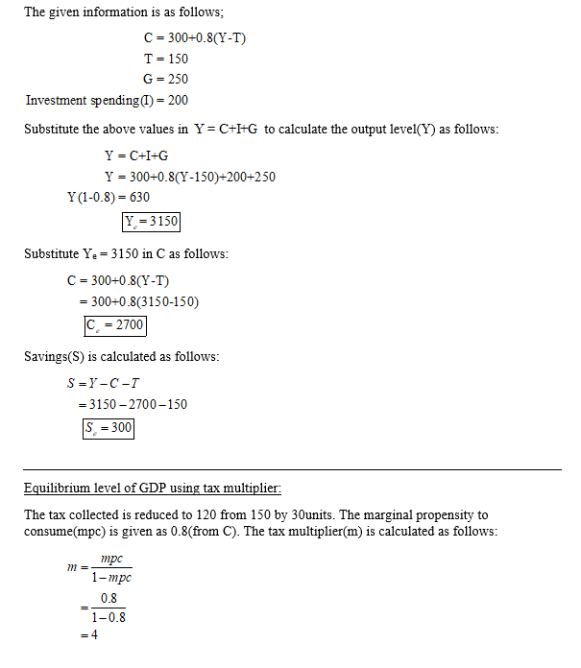

1A.1

Equilibrium income Y = 496.875

Net taxes = 74.375

Government budget surplus = 29.375