|  |
| --- |
|  |
| **Semester : Summer 2022** |
| ***Assignment No: 01*** |

Select a code translation tool of your choice, apply it on a code and analyze how it works. Write a paragraph along with the screenshots of implementation process. **(05 marks)**

ANS:

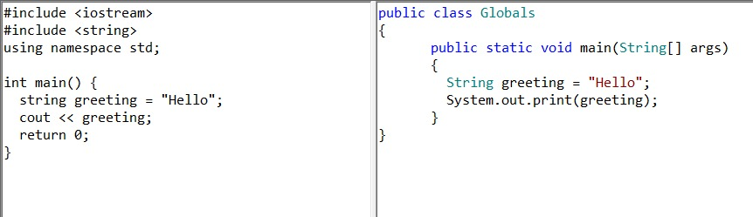

|  |
| --- |
| #include <iostream>  #include <string>  using namespace std;  int main() {  string greeting = "Hello";  cout << greeting;  return 0;  } |

|  |
| --- |
| public class Globals  {  public static void main(String[] args)  {  String greeting = "Hello";  System.out.print(greeting);  }  } |