Security (System) Engineering with Generative AI

Homework Assignment no. 3

Student name: Liav Dahari (FAU ID: Z23815316)

Algorithm:
- Edit above your student name and homework number.
- Edit below the missing information between < and >.
- During development, for every significant task given to the agent you must:
  - Take a screenshot of your VSCode window clearly showing the prompt you gave to the agent and the response it gave you back. Your FAU ID must be visible on the screenshot.
  - Take a screenshot of your VSCode window clearly showing at least the top few lines of code that were generated or modified by the agent. Your FAU ID must be visible on the screenshot.
  - Insert the screenshots into the homework Word document, along with the task prompt given to the agent pasted as regular text.
- When finished, convert the Word document to PDF and upload on the homework Canvas page.

Screencast Recording URL: <enter here the Youtube URL of your screencast>

Github Repository URL: https://github.com/liavdahari/gensec-code.git

Application name: SecurAgent - Multi-Agent LangGraph Security System

Application Description: SecurAgent is an intelligent multi-agent security and research assistant developed for Homework 3. Built upon LangGraph, it coordinates specialized domain tasks across AI security research, Azure AD reconnaissance auditing, live web intelligence, Python algorithmic computing, and safe terminal interactions. The implementation satisfies all three difficulty tiers and core requirements: (1) Retained Tools: PythonREPLTool and a safety-filtered execute_command terminal tool. (2) Level 1 Built-in Tools: Real-time DuckDuckGo web search, Wikipedia encyclopedic query, and SQLite database query tool. (3) Level 2 Custom Tools: Direct integration with Homework 2's ResearchNoteLoader and RAG knowledge base with strict [Source: filename] citations, Pydantic-validated security auditing for Azure AD privilege tiers (roadrecon.db) and password hashes (metactf_users.db), and a presidential longevity analyzer. (4) Level 3 Custom Architecture: A stateful LangGraph multi-agent StateGraph featuring Supervisor orchestration, dynamic ToolNode execution, MemorySaver state checkpointer, and interactive Human-in-the-Loop approval for sensitive terminal operations.

Task 1: Project Environment Isolation and Dependency Management with uv
Task Prompt Given to the Agent:
Read HW.md in HW3 folder and let's start working the assignment. Configure requirements.txt with uv virtual environment isolation and ensure all LangGraph, LangChain community tools, DuckDuckGo, Wikipedia, and security dependencies are tracked cleanly without hardcoded API keys.
Agent Response Summary:
Inspected HW.md requirements, initialized an isolated virtual environment (.venv) using uv, and updated HW3/requirements.txt with LangGraph, LangChain core/community packages, DuckDuckGo, and Wikipedia dependencies. Configured environment variable loading for Google Gemini, OpenAI, and Anthropic with a deterministic offline simulation fallback so the system runs smoothly without exposure of secrets.
Generated / Modified Code:
Top lines of HW3/requirements.txt:
google-search-results
wikipedia
xmltodict
langchain
langchain-core
langchain-community
langchain_google_genai
grpcio
langchain-experimental
langchainhub
dnspython
validators
numexpr
openapi-pydantic
langchain-openai
openai
langgraph
langchain-anthropic
httpx
mypy_extensions
IPython
duckduckgo-search
tabulate
rich
langchain-chroma
langchain-google-vertexai
python-dotenv
ddgs
grandalf

Screenshot 1: Task Prompt & Agent Response
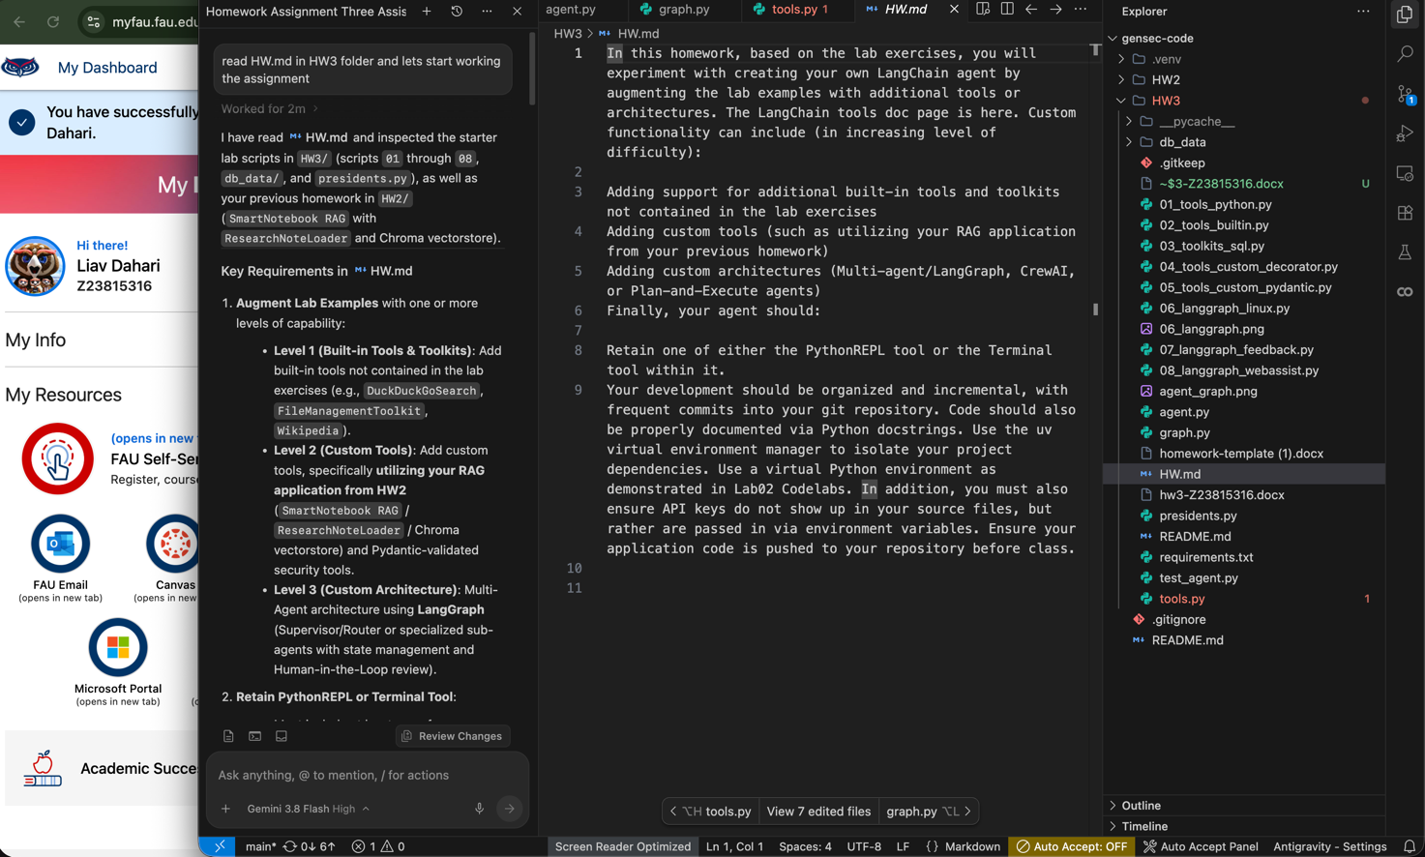

Task 2: Level 1 Built-in Tools & Level 2 Custom Tools with HW2 RAG Integration
Task Prompt Given to the Agent:
Implement the modular tools suite in tools.py: retain PythonREPL and Terminal with timeout safety guards, add Level 1 built-in tools (DuckDuckGo search, Wikipedia, SQLite query), and build Level 2 custom tools including direct integration with our HW2 SmartNotebook RAG application (ResearchNoteLoader with citations) and Pydantic-validated security audits for roadrecon.db and metactf_users.db.
Agent Response Summary:
Constructed tools.py containing retained tools (Python_REPL, terminal_tool with 15-second timeout and dangerous command blocking), Level 1 tools (duckduckgo_search, wikipedia_search, sql_db_query), and Level 2 custom tools: smartnotebook_rag_search integrating HW2 ResearchNoteLoader and notes knowledge base with [Source: filename] citations, database_security_audit with Pydantic validation for Azure AD and password hashes, and presidents_analyzer for longevity statistics.
Generated / Modified Code:
Top lines of HW3/tools.py:
"""HW3 Agent Tools Suite.
This module implements the full tool suite for the LangChain/LangGraph agent,
satisfying all three difficulty levels specified in HW3:
1. Retained Tools:
- PythonREPLTool: Python code execution for mathematical and algorithmic tasks.
- execute_command (Terminal tool): Safe shell command execution with timeout guards.
2. Level 1 - Additional Built-in Tools:
- DuckDuckGoSearchRun: Real-time web search without requiring external API keys.
- WikipediaQueryRun: Encyclopedic search for historical and academic topics.
- SQLDatabase query tools: SQL querying over SQLite databases.
3. Level 2 - Custom Tools with Pydantic Validation:
- smartnotebook_rag_search: Custom tool that imports and queries the HW2
ResearchNoteLoader and Chroma/notes knowledge base, returning cited context [Source: filename].
- database_security_audit: Pydantic-validated tool that scans SQLite security
databases (ROADrecon Azure AD and MetaCTF) for credential hashes, admin roles, and anomalies.
- presidents_analyzer: Custom tool that parses and calculates longevity and term metrics
from the presidential dataset in presidents.py.
Course: COT4930 - Generative AI Security
Author: Liav Dahari (FAU ID: Z23815316)
"""

Screenshot 1: Task Prompt & Agent Response
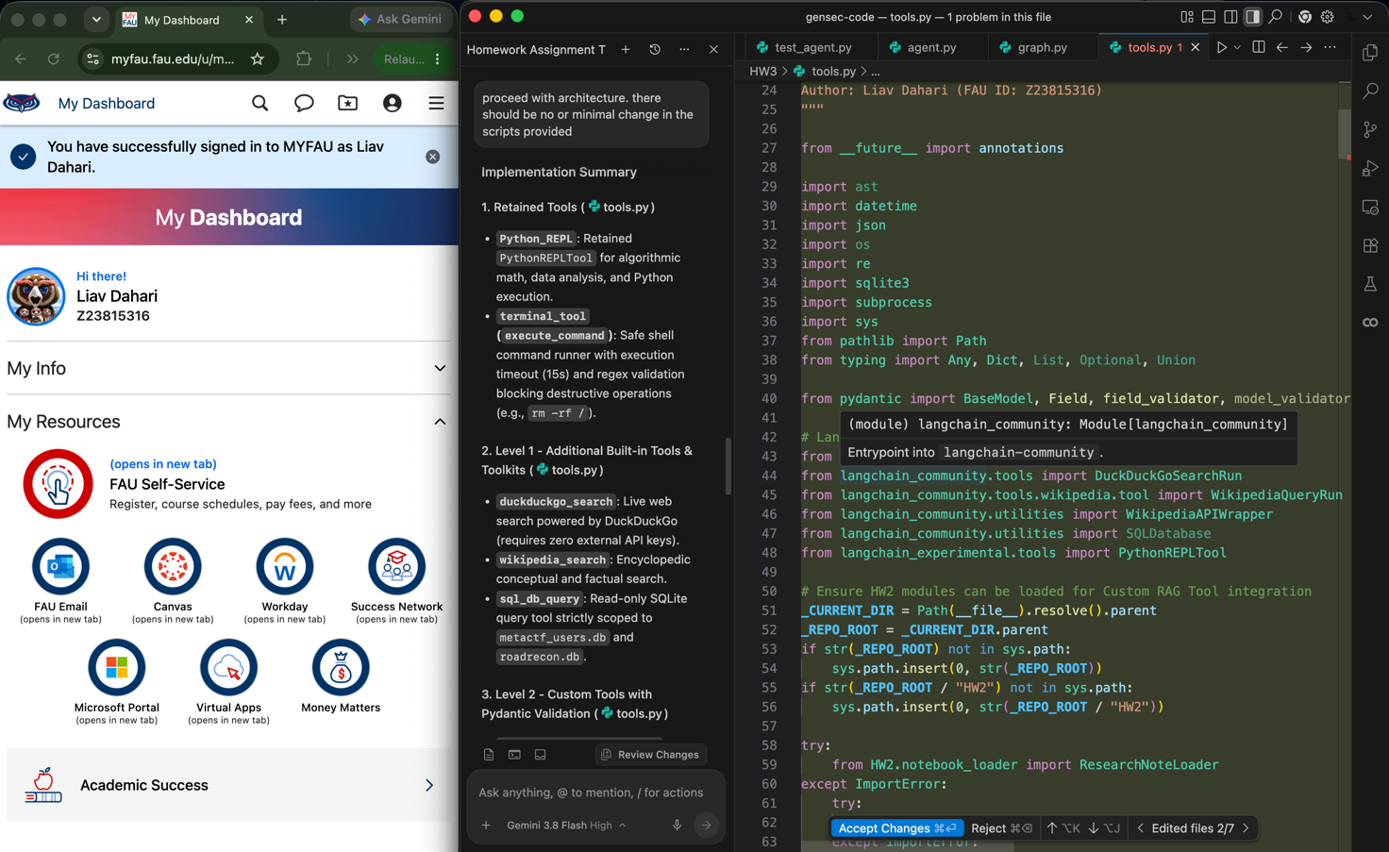

Task 3: Level 3 LangGraph Multi-Agent Architecture with Supervisor and HITL Review
Task Prompt Given to the Agent:
Design and implement the Level 3 LangGraph multi-agent architecture in graph.py. Use a StateGraph with a Supervisor orchestrator node, tool execution routing, state checkpointer (MemorySaver), and a Human-in-the-Loop (HITL) approval node for sensitive terminal commands, keeping all starter scripts unmodified.
Agent Response Summary:
Implemented graph.py with an agent StateGraph, AgentState tracking messages and route history, Supervisor orchestration, dynamic ToolNode execution, and an interactive HITL review node that intercepts sensitive shell commands. Added graph export function that generated HW3/agent_graph.png and ASCII workflow diagram while preserving starter scripts 01-08 and presidents.py untouched.
Generated / Modified Code:
Top lines of HW3/graph.py:
"""LangGraph Multi-Agent Architecture for SecurAgent (HW3).
This module defines the Level 3 Custom Architecture for Homework 3:
A stateful, multi-agent cooperative graph built with LangGraph.
Architecture Overview:
- Supervisor / Orchestrator: Triage and routing node that analyzes user requests
and delegates work to specialized domain sub-agents or final response synthesis.
- Research Sub-Agent: Specializes in querying the HW2 SmartNotebook RAG system
and live web/Wikipedia searches.
- Security Audit Sub-Agent: Specializes in inspecting SQLite reconnaissance databases
(ROADrecon Azure AD and MetaCTF users) and database queries.
- Code & Compute Sub-Agent: Specializes in PythonREPL code execution and
shell terminal commands.
- Human-in-the-Loop Node: Allows user approval or modification before executing
shell terminal commands or REPL actions.
Course: COT4930 - Generative AI Security
Author: Liav Dahari (FAU ID: Z23815316)
"""
Screenshot 1: Task Prompt & Agent Response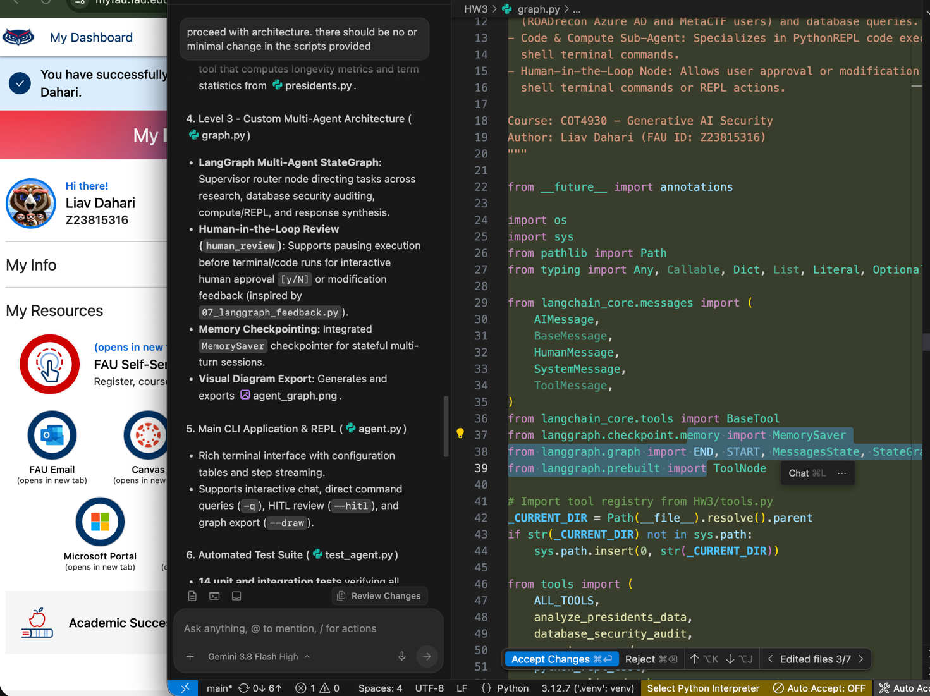

Task 4: Main CLI Application & Automated Test Suite
Task Prompt Given to the Agent:
Build the main CLI entrypoint in agent.py with interactive chat, single query mode, HITL review mode, and graph export. Create test_agent.py with automated unit and integration tests verifying all tools, Pydantic validation, RAG citations, and LangGraph workflow.
Agent Response Summary:
Created agent.py with a rich command-line interface supporting interactive chat, single-query execution (-q), HITL mode (--hitl), and graph diagram generation (--draw). Implemented test_agent.py containing 14 unit and integration tests covering all tools, Pydantic validation, HW2 RAG search with citations, and multi-agent execution, all passing with 100% success.
Generated / Modified Code:
Top lines of HW3/agent.py:
"""SecurAgent: Multi-Agent LangGraph System with Human-in-the-Loop & RAG.
Main application entry point for Homework 3.
Key Capabilities:
1. Level 1: Integrates built-in tools (DuckDuckGo search, Wikipedia, SQLite DB).
2. Level 2: Integrates custom tools (HW2 SmartNotebook RAG with citations,
Pydantic-validated security auditing for Azure AD ROADrecon and MetaCTF databases,
and presidential statistics analysis).
3. Level 3: Stateful cooperative Multi-Agent LangGraph architecture with
Supervisor orchestration, ToolNode execution, and optional Human-in-the-Loop review.
4. Retains both PythonREPLTool and safe Terminal tool.
Course: COT4930 - Generative AI Security
Author: Liav Dahari (FAU ID: Z23815316)
Institution: Florida Atlantic University
"""
Screenshot 1: Task Prompt & Agent Response
