Online Social Bookstore Application
Sprint Report
Aspiring CSE Diploma Holders

Kondylia Vergou, 4325
Panagiotis Vouzalis, 2653
Panagiotis Paraskevopoulos, 2905

Versions History
Date | Version | Description | Author
10/03/2024 | 1.0 | Definition of User Stories and  Use Cases | Lia Vergou
22/03/2024 | 2.0 | CRC cards for Sprint 1 | Lia Vergou
04/04/2024 | 2.1 | CRC cards for Sprint 2 | Lia Vergou
19/04/2024 | 2.2 | CRC cards for Sprint 3 | Lia Vergou
01/05/2024 | 2.3 | CRC cards for Sprint 4 | Lia Vergou
20/05/2024 | 2.4 | CRC cards for Sprint 5 | Lia Vergou

Introduction
The objective of this project is to develop an online social bookstore application that allows individuals to exchange used books for free.

Purpose
This document provides information concerning the last sprint of this project.

Document Structure
The rest of this document is structured as follows:
- Section 2 describes our Scrum team and specifies the Sprint's backlog.
- Section 3 specifies the main design concepts for this release of the project.

Scrum team and Sprint Backlog

Scrum team
Product Owner | Kondylia Vergou
Scrum Master | Panagiotis Vouzalis
Development Team | Kondylia Vergou, Panagiotis Vouzalis, Panagiotis Paraskevopouls

Sprints

Sprint No | Begin Date | End Date | Number of weeks | User stories
1 | 11/03/2024 | 22/03/2024 | 2 | US1, US2
2 | 25/03/2024 | 04/04/2024 | 2 | US3, US4
3 | 08/04/2024 | 19/04/2024 | 2 | US5, US6, US7
4 | 22/04/2024 | 01/05/2024 | 1.5 | US8, US9
5 | 08/05/2024 | 20/05/2024 | 1.5 | US10, US11

User Stories
US ID | AS A  <USER TYPE> | I WANT TO  <AN ACTION> | IN ORDER TO  <A BENEFIT/VALUE>
US1 | User | Create a new account | Access the functionalities of the social bookstore application
US2 | User | Login to my account | Access the functionalities of the social bookstore application
US3 | User | Logout from my account | Terminate my interaction with the social bookstore application
US4 | User | Create a profile that includes my full name, address, age, phone number, preferred book categories and favorite authors | Facilitate the search/recommendation of books that may be interesting for me
US5 | User | Add a book offer in personal list of book offers with a description that includes the book title, the author(s), the category that the book belongs to and a summary of the book | Facilitate the search/recommendation of books by/to other users
US6 | User | Browse a list of requests from other users who are interested in a book offer that I have made | Decide to whom I shall give the book
US7 | User | Select a user who requested a book from my list and notify him that he can take the book.  Notify the rest of the users who requested the book that the book has been taken by another user | Initiate the book exchange with the selected user
US8 | User | Access to the contact information of a selected user who requested a book that I offer | Contact the selected user to arrange the delivery of the book
US9 | User | Remove a book that is no longer available from my personal list of book offers and from the book request lists of other users who requested for this book | Enable the accurate book search/recommendation

US10 | User | Search for book offers with a certain title and authors to find interesting books  Choose between an exact or an approximate search strategy  Make a request for a book that is included in the search results to the user who offers the book | Make the user that offers the book aware of the request
US11 | User | Browse a list of recommended book offers from the social bookstore application, to find interesting books  Choose among various recommendation strategies that consider information given in my profile  Make a request for a recommended book to the user who offers the book so | Make the user that offers the book aware of the request

Use Cases

1: UML USE CASE DIAGRAM
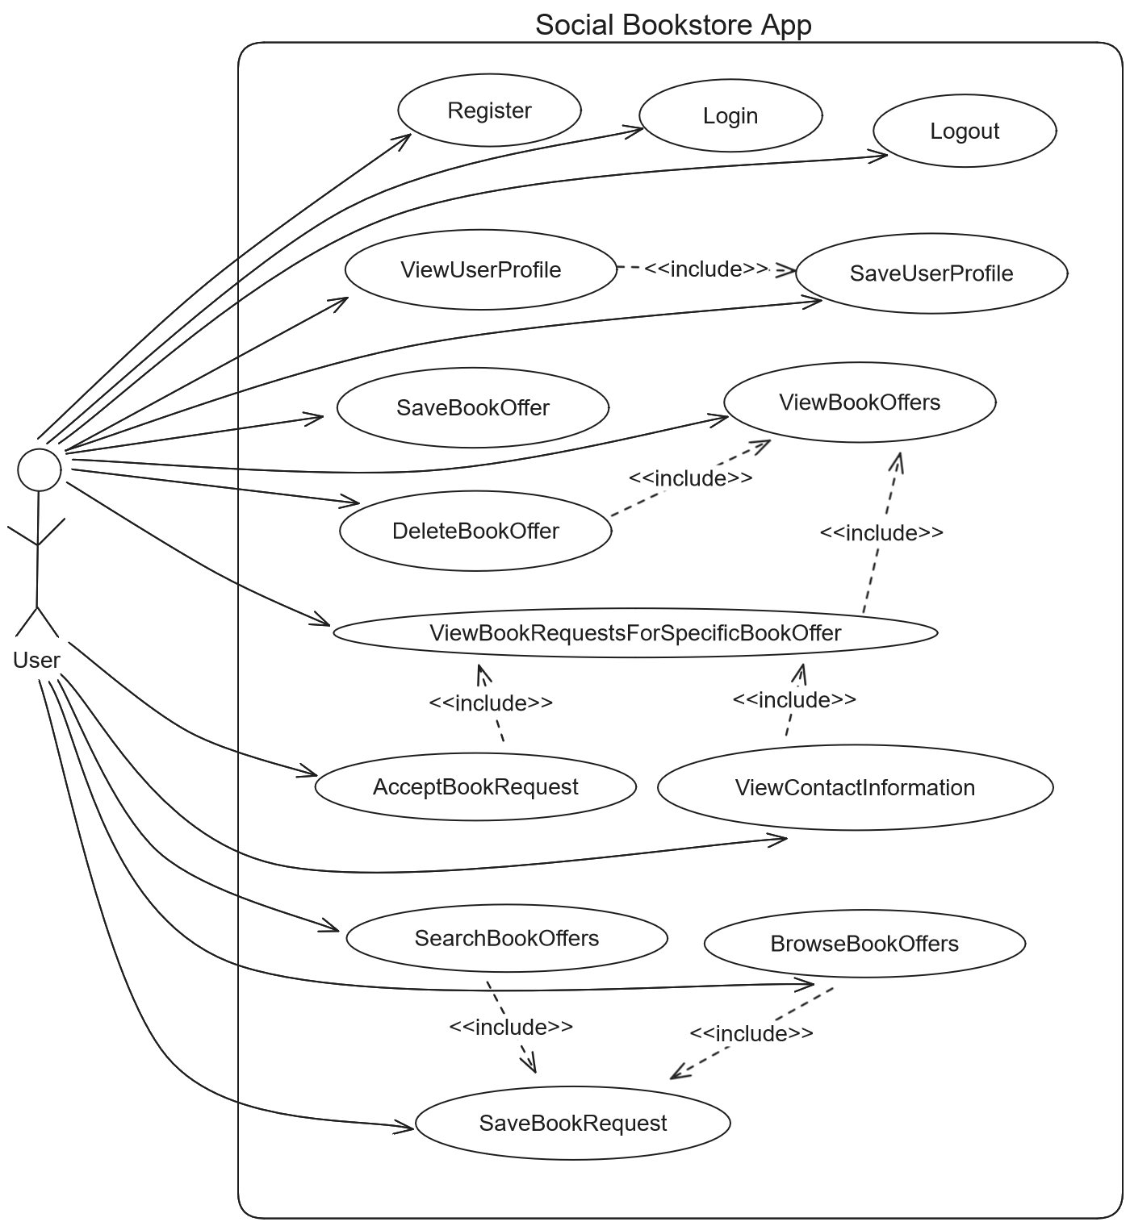

UC01: Register
Use case name | Register
Use case ID | 01
Actors | User
Preconditions | -
Main flow of events | - The use case starts when the user chooses to register.  - The user provides their username and password.  - The system validates that the username isn’t taken.  - The system registers the user.  - The system redirects the user to the login page.
Alternative flow | If in step 3 the username is taken, then the system displays an error message and cancels the registration process.
Post conditions | The user is successfully registered.

UC02: Login
Use case name | Login
Use case ID | 02
Actors | User
Preconditions | -
Main flow of events | - The use case starts when the user chooses to login.  - The user provides their username and password.  - The system validates the credentials.  - The system logs in the user.
Alternative flow | If in step 3 the credentials are wrong (Username Doesn’t Exist or Wrong Password), then the system displays an error message and cancels the login process.
Post conditions | The user is successfully logged in.

UC03: Logout
Use case name | Logout
Use case ID | 03
Actors | User
Preconditions | The user is logged in.
Main flow of events | - The use case starts when the user chooses to logout.  - The system logs out the user.
Post conditions | The user is successfully logged out.

UC04: SaveUserProfile
Use case name | SaveUserProfile
Use case ID | 04
Actors | User
Preconditions | The user is logged in.
Main flow of events | - Include(ViewUserProfile)  - The user changes their full name, address, age, phone number, favorite book categories and favorite authors.  - The system saves the profile details provided.
Post conditions | The user profile details are saved.

UC05: ViewUserProfile
Use case name | ViewUserProfile
Use case ID | 05
Actors | User
Preconditions | The user is logged in.
Main flow of events | - The use case starts when the user selects their profile.  - The system displays their full name, address, age, phone number, favorite book categories and favorite authors.
Post conditions | The user profile details are displayed.

UC06: SaveBookOffer
Use case name | SaveBookOffer
Use case ID | 06
Actors | User
Preconditions | The user is logged in.
Main flow of events | - The use case starts when the user selects to add a book offer.  - The user provides the book title, the author(s), the category that the book belongs to and a summary of the book.  - The system records the book offer.
Post conditions | A book offer is saved.

UC07: ViewBookRequestsForSpecificBookOffer
Use case name | ViewBookRequestsForSpecificBookOffer
Use case ID | 07
Actors | User
Preconditions | The user is logged in.
Main flow of events | - Include(ViewBookOffers)  - The user selects one of their book offers.  - The system displays a list of requests from other users for the specific book offer.
Alternative flow | If in step 1 the system displays the message “No Book Offers Found”, then the use case is terminated.
Post conditions | The book requests for the specific book offer are listed.

UC08: ViewBookOffers
Use case name | ViewBookOffers
Use case ID | 08
Actors | User
Preconditions | The user is logged.
Main flow of events | - The use case starts when the user selects to view their book offers.  - The system displays a list of their book offers.
Alternative flow | If in step 2 the system doesn’t find any book offers, then it displays the message “No Book Offers Found”.
Post conditions | The book offers of the specific user are listed.

UC09: AcceptBookRequest
Use case name | AcceptBookRequest
Use case ID | 09
Actors | User
Preconditions | The user is logged in, has made at least one book offer and there is at least one book request for the specific offer.
Main flow of events | - Include(ViewBookRequestsForSpecificBookOffer)  - The user selects one of the book requests.  - The user approves the request.  - The system notifies the user of the selected book request that their request has been approved.  - The system notifies the users of the rest book request that their requests have been denied.
Post conditions | The selected book request is approved and the rest are denied.

UC10: ViewContactInformation
Use case name | ViewContactInformation
Use case ID | 10
Actors | User
Preconditions | The user is logged in, has made at least one book offer and there is at least one book request for the specific offer.
Main flow of events | - Include(ViewBookRequestsForSpecificBookOffer)  - The user selects one of the book requests.  - The user chooses to view the contact information of the requestee.  - The system displays the contact information.
Post conditions | The contact information of the selected book request is displayed.

UC11: DeleteBookOffer
Use case name | DeleteBookOffer
Use case ID | 11
Actors | User
Preconditions | The user is logged in and has made at least one book offer.
Main flow of events | - Include(ViewBookOffers)  - The user selects one of their book offers and deletes it.  - The system deletes the book offer.
Post conditions | The book offer is deleted.

UC12: SearchBookOffers
Use case name | SearchBookOffers
Use case ID | 12
Actors | User
Preconditions | The user is logged in.
Main flow of events | - The use case starts when the user chooses to search for book offers.  - The user provides a certain title and authors.  - The user selects an exact or an approximate search strategy.  - The system displays the list of book offers that fit the criteria.
Alternative flow | If in step 4 the system doesn’t find any book offers, then it display the message “No Book Offers Were Found”.
Post conditions | A list of book offers is displayed.

UC13: BrowseBookOffers
Use case name | BrowseBookOffers
Use case ID | 13
Actors | User
Preconditions | The user is logged in.
Main flow of events | - The use case starts when the user chooses to browse the book offers.  - The user selects one of the recommendation strategies that utilize their profile details.  - The system displays the list of book offers according to the strategy.
Alternative flow | If in step 4 the system doesn’t find any book offers, then it displays the message “No Book Offers Were Found”.
Post conditions | A list of book offers is displayed.

UC14: SaveBookRequest
Use case name | SaveBookRequest
Use case ID | 13
Actors | User
Preconditions | The user is logged in.
Main flow of events | - Include(SearchBookOffers) or Include(BrowseBookOffers)  - The user selects a specific book offer.  - The user makes a book request.  - The system records the book request.
Alternative flow | If in step 1 the system displays the message “No Book Offers Were Found”, then the use case is terminated.
Post conditions | The book request is saved.

//TODO Some extra use cases are:
- Delete Book Request
- ViewBookRequests (που εχει κανει ο χρηστης)
<Use Case 2>
Use case ID | Unique ID for the the use case
Actors | Actor(s) related to the use case
Preconditions | [pre conditions for the correct execution of the use case]  ......
Main flow of events | [Main flow of events that describes the interaction between the user and the application]  - The use case starts when the user ....  - ...  - ...  - ...  - ....
Alternative flow 1 | [Alternative flow of events IF ANY that takes place in case of an exception]
Alternative flow 2 | .......
Post conditions | [Consequences on the state of the application after the correct execution of the use case]

Design

Architecture
<Specify the overall architecture for this release in terms of a UML package diagram.>

Design
PACKAGE UML DIAGRAM
UML DIAGRAM OF PACKAGE CONFIG
UML DIAGRAM OF PACKAGE SERVICES with collaborating classes
UML DIAGRAM OF MAPPERS with collaborating classes
UML DIAGRAM OF DOMAIN

Figure 2: UML DiaGram Of package controllers with collaborating classes
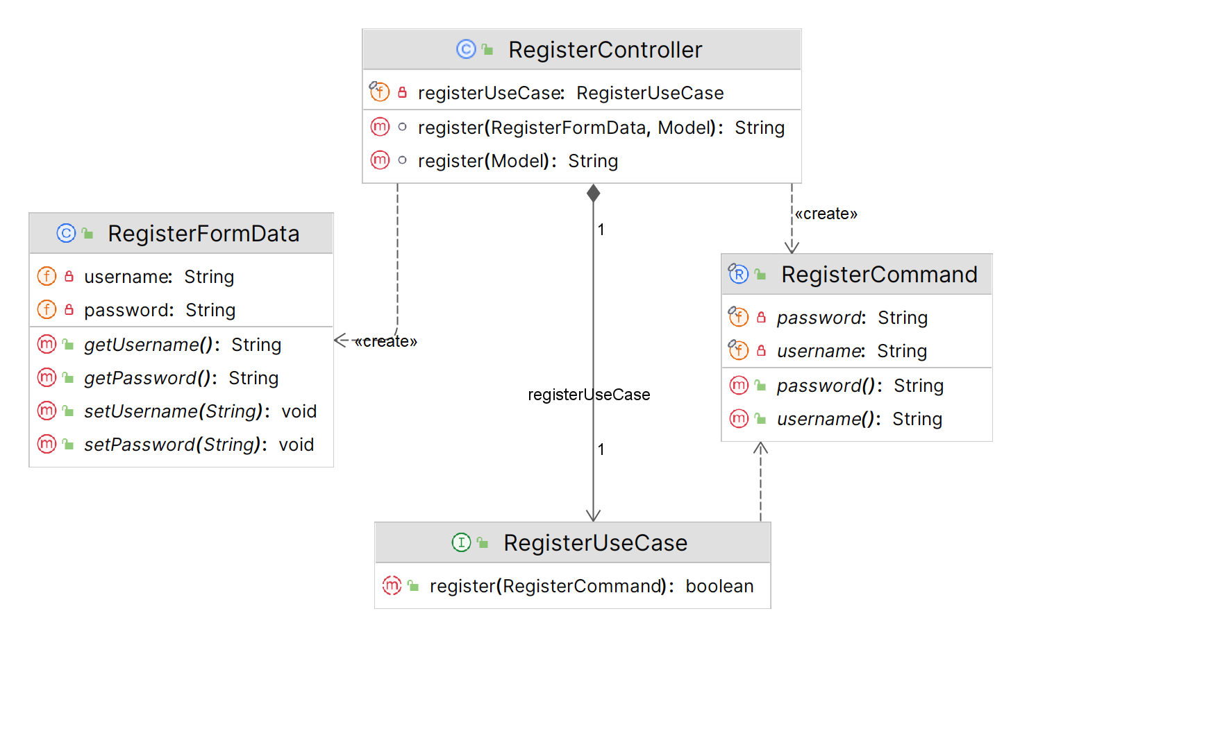

Class Name: | RegisterController
Responsibilities:  - Handles incoming HTTP requests related to user registration.  - Invokes the necessary business logic for user registration.  - Directs users to pages according to the registration result. |  | Collaborations:  - RegisterFormData  - Model  - RegisterCommand  - RegisterUseCase

Class Name: | RegisterFormData
Responsibilities:  - Transfers data from the register view page to the RegisterController |  | Collaborations:  - RegisterController

Class Name: | RegisterCommand
Responsibilities:  - Transfers data from the RegisterController to the services layer |  | Collaborations:  - RegisterController  - RegisterUseCase

Class Name: | RegisterService
Responsibilities:  - Checks if user exists in database  - Encodes the user’s password  - Registers the user in the database if user doesn’t already exist |  | Collaborations:  - RegisterUseCase  - RegisterCommand  - PasswordEncoder  - UserMapper  - User  - Role

Class Name: | UserMapper
Responsibilities:  - Define methods for accessing and manipulating user data in the database. |  | Collaborations:  - JpaRepository  - User

Tests
Tests have been created for the controllers, services, and mappers of the application.
- The controllers are tested with integration tests in order to verify the interactions between the different components and all three layers, the web, services and database layer.
- The services are tested with unit tests to focus on the functionality and logic.
- The mappers are tested with integration tests since they interact with the database.

The acceptance tests for each use case have been performed through the UI.

Thank you Note!
Thank you for reading our Report!
Lia Vergou
Notis Vouzalis
Panagiotis Paraskevopoulos



