Online Social Bookstore Application
Sprint Report
Aspiring CSE Diploma Holders

Kondylia Vergou, 4325
Panagiotis Vouzalis, 2653
Panagiotis Paraskevopoulos, 2905

Versions History
Date | Version | Description | Author
10/03/2024 | 1.0 | Definition of User Stories and  Use Cases | Lia Vergou
22/03/2024 | 2.0 | CRC cards for Sprint 1 | Lia Vergou
04/04/2024 | 2.1 | CRC cards for Sprint 2 | Lia Vergou
19/04/2024 | 2.2 | CRC cards for Sprint 3 | Lia Vergou
01/05/2024 | 2.3 | CRC cards for Sprint 4 | Lia Vergou
20/05/2024 | 2.4 | CRC cards for Sprint 5 | Lia Vergou

Introduction
The objective of this project is to develop an online social bookstore application that allows individuals to exchange used books for free.

Purpose
This document provides information concerning the last sprint of this project.

Document Structure
The rest of this document is structured as follows:
- Section 2 describes our Scrum team and specifies the Sprint's backlog.
- Section 3 specifies the main design concepts for this release of the project.

Scrum team and Sprint Backlog

Scrum team
Product Owner | Kondylia Vergou
Scrum Master | Panagiotis Vouzalis
Development Team | Kondylia Vergou, Panagiotis Vouzalis, Panagiotis Paraskevopoulos

Sprints

Sprint No | Begin Date | End Date | Number of weeks | User stories
1 | 11/03/2024 | 22/03/2024 | 2 | US1, US2
2 | 25/03/2024 | 04/04/2024 | 2 | US3, US4
3 | 08/04/2024 | 19/04/2024 | 2 | US5, US10, US11
4 | 22/04/2024 | 01/05/2024 | 1.5 | US6, US7,
5 | 08/05/2024 | 20/05/2024 | 1.5 | US8, US9

User Stories
US ID | AS A  <USER TYPE> | I WANT TO  <AN ACTION> | IN ORDER TO  <A BENEFIT/VALUE>
US1 | User | Create a new account | Access the functionalities of the social bookstore application
US2 | User | Login to my account | Access the functionalities of the social bookstore application
US3 | User | Logout from my account | Terminate my interaction with the social bookstore application
US4 | User | Create a profile that includes my full name, address, age, phone number, preferred book categories and favorite authors | Facilitate the search/recommendation of books that may be interesting for me
US5 | User | Add a book offer in personal list of book offers with a description that includes the book title, the author(s), the category that the book belongs to and a summary of the book | Facilitate the search/recommendation of books by/to other users
US6 | User | Browse a list of requests from other users who are interested in a book offer that I have made | Decide to whom I shall give the book
US7 | User | Select a user who requested a book from my list and notify him that he can take the book.  Notify the rest of the users who requested the book that the book has been taken by another user | Initiate the book exchange with the selected user
US8 | User | Access to the contact information of a selected user who requested a book that I offer | Contact the selected user to arrange the delivery of the book
US9 | User | Remove a book that is no longer available from my personal list of book offers and from the book request lists of other users who requested for this book | Enable the accurate book search/recommendation

US10 | User | Search for book offers with a certain title and authors to find interesting books  Choose between an exact or an approximate search strategy  Make a request for a book that is included in the search results to the user who offers the book | Make the user that offers the book aware of the request
US11 | User | Browse a list of recommended book offers from the social bookstore application, to find interesting books  Choose among various recommendation strategies that consider information given in my profile  Make a request for a recommended book to the user who offers the book so | Make the user that offers the book aware of the request

Use Cases

1: UML USE CASE DIAGRAM
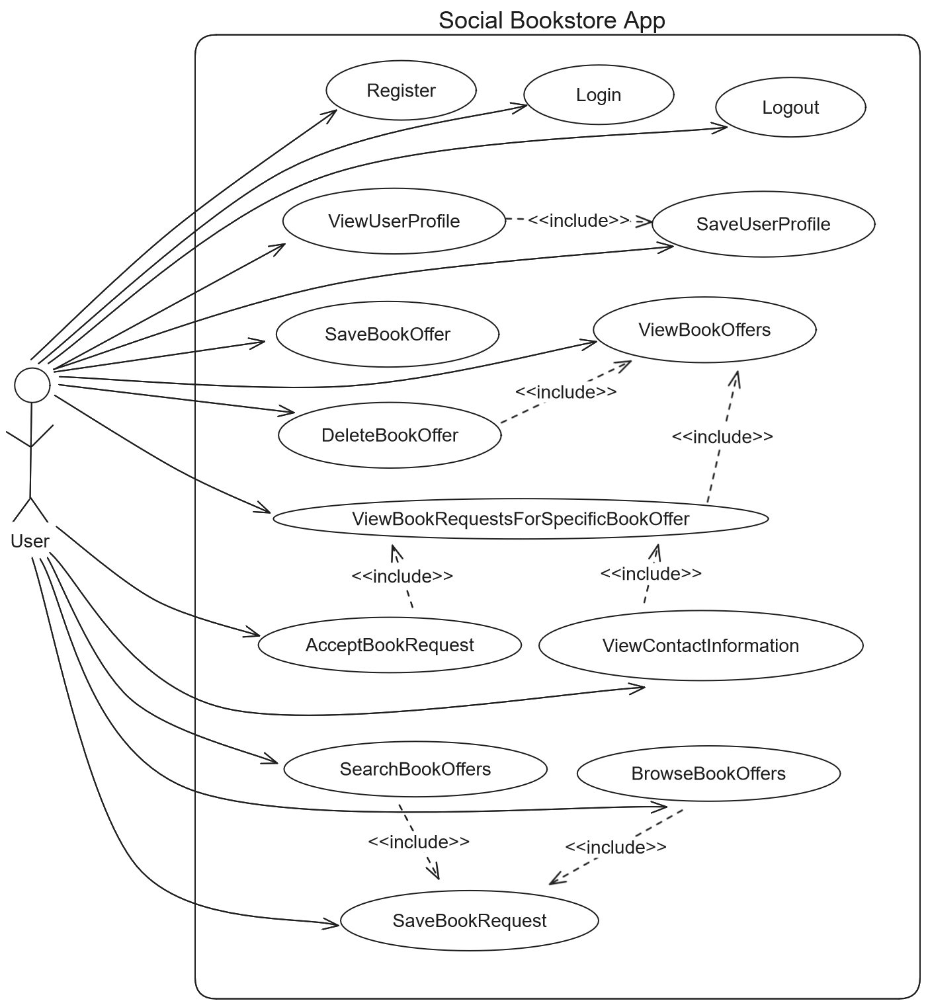

UC01: Register
Use case name | Register
Use case ID | 01
Actors | User
Preconditions | -
Main flow of events | - The use case starts when the user chooses to register.  - The user provides their username and password.  - The system validates that the username isn’t taken.  - The system registers the user.  - The system redirects the user to the login page.
Alternative flow | If in step 3 the username is taken, then the system displays an error message and cancels the registration process.
Post conditions | The user is successfully registered.

UC02: Login
Use case name | Login
Use case ID | 02
Actors | User
Preconditions | -
Main flow of events | - The use case starts when the user chooses to login.  - The user provides their username and password.  - The system validates the credentials.  - The system logs in the user.
Alternative flow | If in step 3 the credentials are wrong (Username Doesn’t Exist or Wrong Password), then the system displays an error message and cancels the login process.
Post conditions | The user is successfully logged in.

UC03: Logout
Use case name | Logout
Use case ID | 03
Actors | User
Preconditions | The user is logged in.
Main flow of events | - The use case starts when the user chooses to logout.  - The system logs out the user.
Post conditions | The user is successfully logged out.

UC04: SaveUserProfile
Use case name | SaveUserProfile
Use case ID | 04
Actors | User
Preconditions | The user is logged in.
Main flow of events | - Include(ViewUserProfile)  - The user changes their full name, address, age, phone number, favorite book categories and favorite authors.  - The system saves the profile details provided.
Post conditions | The user profile details are saved.

UC05: ViewUserProfile
Use case name | ViewUserProfile
Use case ID | 05
Actors | User
Preconditions | The user is logged in.
Main flow of events | - The use case starts when the user selects their profile.  - The system displays their full name, address, age, phone number, favorite book categories and favorite authors.
Post conditions | The user profile details are displayed.

UC06: SaveBookOffer
Use case name | SaveBookOffer
Use case ID | 06
Actors | User
Preconditions | The user is logged in.
Main flow of events | - The use case starts when the user selects to add a book offer.  - The user provides the book title, the author(s), the category that the book belongs to and a summary of the book.  - The system records the book offer.
Post conditions | A book offer is saved.

UC07: ViewBookRequestsForSpecificBookOffer
Use case name | ViewBookRequestsForSpecificBookOffer
Use case ID | 07
Actors | User
Preconditions | The user is logged in.
Main flow of events | - Include(ViewBookOffers)  - The user selects one of their book offers.  - The system displays a list of requests from other users for the specific book offer.
Alternative flow | If in step 1 the system displays the message “No Book Offers Found”, then the use case is terminated.
Post conditions | The book requests for the specific book offer are listed.

UC08: ViewBookOffers
Use case name | ViewBookOffers
Use case ID | 08
Actors | User
Preconditions | The user is logged.
Main flow of events | - The use case starts when the user selects to view their book offers.  - The system displays a list of their book offers.
Alternative flow | If in step 2 the system doesn’t find any book offers, then it displays the message “No Book Offers Found”.
Post conditions | The book offers of the specific user are listed.

UC09: AcceptBookRequest
Use case name | AcceptBookRequest
Use case ID | 09
Actors | User
Preconditions | The user is logged in, has made at least one book offer and there is at least one book request for the specific offer.
Main flow of events | - Include(ViewBookRequestsForSpecificBookOffer)  - The user selects one of the book requests.  - The user approves the request.  - The system notifies the user of the selected book request that their request has been approved.  - The system notifies the users of the rest book request that their requests have been denied.
Post conditions | The selected book request is approved and the rest are denied.

UC10: ViewContactInformation
Use case name | ViewContactInformation
Use case ID | 10
Actors | User
Preconditions | The user is logged in, has made at least one book offer and there is at least one book request for the specific offer.
Main flow of events | - Include(ViewBookRequestsForSpecificBookOffer)  - The user selects one of the book requests.  - The user chooses to view the contact information of the requestee.  - The system displays the contact information.
Post conditions | The contact information of the selected book request is displayed.

UC11: DeleteBookOffer
Use case name | DeleteBookOffer
Use case ID | 11
Actors | User
Preconditions | The user is logged in and has made at least one book offer.
Main flow of events | - Include(ViewBookOffers)  - The user selects one of their book offers and deletes it.  - The system deletes the book offer.
Post conditions | The book offer is deleted.

UC12: SearchBookOffers
Use case name | SearchBookOffers
Use case ID | 12
Actors | User
Preconditions | The user is logged in.
Main flow of events | - The use case starts when the user chooses to search for book offers.  - The user provides a certain title and authors.  - The user selects an exact or an approximate search strategy.  - The system displays the list of book offers that fit the criteria.
Alternative flow | If in step 4 the system doesn’t find any book offers, then it display the message “No Book Offers Were Found”.
Post conditions | A list of book offers is displayed.

UC13: BrowseBookOffers
Use case name | BrowseBookOffers
Use case ID | 13
Actors | User
Preconditions | The user is logged in.
Main flow of events | - The use case starts when the user chooses to browse the book offers.  - The user selects one of the recommendation strategies that utilize their profile details.  - The system displays the list of book offers according to the strategy.
Alternative flow | If in step 4 the system doesn’t find any book offers, then it displays the message “No Book Offers Were Found”.
Post conditions | A list of book offers is displayed.

UC14: SaveBookRequest
Use case name | SaveBookRequest
Use case ID | 13
Actors | User
Preconditions | The user is logged in.
Main flow of events | - Include(SearchBookOffers) or Include(BrowseBookOffers)  - The user selects a specific book offer.  - The user makes a book request.  - The system records the book request.
Alternative flow | If in step 1 the system displays the message “No Book Offers Were Found”, then the use case is terminated.
Post conditions | The book request is saved.

//TODO Some extra use cases are:
- Delete Book Request
- ViewBookRequests (που εχει κανει ο χρηστης)

Design

Architecture
<Specify the overall architecture for this release in terms of a UML package diagram.>

Design
PACKAGE UML DIAGRAM
UML DIAGRAM OF PACKAGE CONFIG
UML DIAGRAM OF PACKAGE SERVICES with collaborating classes
UML DIAGRAM OF MAPPERS with collaborating classes
UML DIAGRAM OF DOMAIN

Figure 2: UML DiaGram Of package controllers with collaborating classes
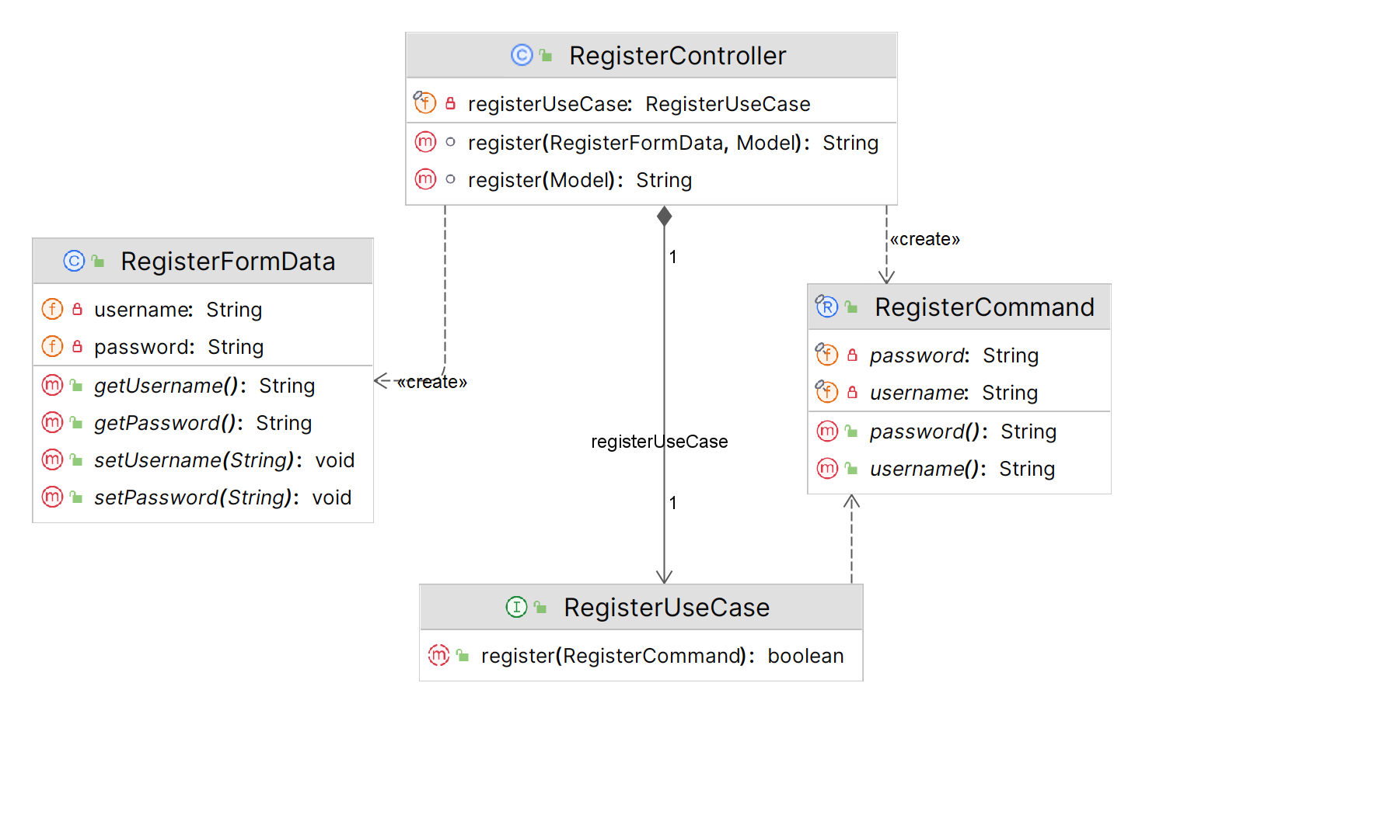

Config
package com.myy803.social_bookstore.config
Class Name: | WebSecurityConfig
Responsibilities:  - Configures web security for the application. |  | Collaborations:  - PasswordEncoder  - UserDetailsService  - CustomSecuritySuccessHandler  - EndpointConfig

package com.myy803.social_bookstore.config
Class Name: | CustomSecuritySuccessHandler
Responsibilities:  - Handle successful authentication by redirecting users to a specific target URL. |  | Collaborations:  - EndpointConfig

package com.myy803.social_bookstore.config
Class Name: | WebMvcConfig
Responsibilities:  - Configures MVC (Model-View-Controller) for web application. |  | Collaborations:  - ViewControllerRegistry

package com.myy803.social_bookstore.config
Class Name: | PasswordEncoderConfig
Responsibilities:  - Configures a bean for password encoding. |  | Collaborations:  None

package com.myy803.social_bookstore.config
Class Name: | EndpointConfig
Responsibilities:  - Define constants for endpoint paths used in the application. |  | Collaborations:  None

package com.myy803.social_bookstore.config
Class Name: | ThymeleafUtil
Responsibilities:  - Extracts a list of IDs from a list of View objects. |  | Collaborations:  - BookCategoryView  - AuthorView

Controllers
package com.myy803.social_bookstore.controllers
Class Name: | RegisterController
Responsibilities:  - Handles incoming HTTP requests related to user registration. |  | Collaborations:  - EndpointConfig  - RegisterFormData  - Model  - RegisterCommand  - RegisterUseCase

package com.myy803.social_bookstore.controllers
Class Name: | LoginController
Responsibilities:  - Handles HTTP GET requests for the login page. |  | Collaborations:  - EndpointConfig

package com.myy803.social_bookstore.controllers
Class Name: | HomepageController
Responsibilities:  - Handles HTTP GET requests for the homepage. |  | Collaborations:  - EndpointConfig

package com.myy803.social_bookstore.controllers
Class Name: | ViewUserProfileController
Responsibilities:  - Handles HTTP GET requests for viewing user profile. |  | Collaborations:  - EndpointConfig  - ViewUserProfileUseCase  - ViewBookCategoriesUseCase  - ViewAuthorsUseCase  - Principal  - Model

package com.myy803.social_bookstore.controllers
Class Name: | SaveUserProfileController
Responsibilities:  - Handles HTTP requests for saving user profile data. |  | Collaborations:  - EndpointConfig  - SaveUserProfileUseCase  - UserProfileFormData  - Principal

package com.myy803.social_bookstore.controllers
Class Name: | SaveBookOfferController
Responsibilities:  - Handles HTTP requests for saving book offers |  | Collaborations:  - EndpointConfig  - ViewBookCategoriesUseCase  - ViewAuthorsUseCase  - BookFormData

Services
package com.myy803.social_bookstore.services
Class Name: | RegisterUseCase
Responsibilities:  - Defines the contract for registering a user. |  | Collaborations:  - RegisterCommand

package com.myy803.social_bookstore.services
Class Name: | RegisterService
Responsibilities:  - Implements the RegisterUseCase interface to handle user registration. |  | Collaborations:  - RegisterCommand  - PasswordEncoder  - UserMapper  - User  - Role

package com.myy803.social_bookstore.services
Class Name: | UserDetailsServiceImp
Responsibilities:  - Implements the UserDetailsService interface to load user details by username. |  | Collaborations:  - UserMapper

package com.myy803.social_bookstore.services
Class Name: | ViewUserProfileUseCase
Responsibilities:  - Defines the contract for viewing a user profile. |  | Collaborations:  None

package com.myy803.social_bookstore.services
Class Name: | ViewUserProfileService
Responsibilities:  - Implements the ViewUserProfileUseCase interface to map the UserProfile domain model to the UserProfileView view object. |  | Collaborations:  - UserMapper  - UserProfileMapper  - UserProfileView  - BookCategoryView  - AuthorView

package com.myy803.social_bookstore.services
Class Name: | ViewBookCategoriesUseCase
Responsibilities:  - Defines the contract for viewing all the book categories. |  | Collaborations:  None

package com.myy803.social_bookstore.services
Class Name: | ViewBookCategoriesService
Responsibilities:  - Implements the ViewBookCategoriesUseCase interface to map the BookCategory domain model to the BookCategoryView view object. |  | Collaborations:  - BookCategoryMapper

package com.myy803.social_bookstore.services
Class Name: | ViewAuthorsUseCase
Responsibilities:  - Defines the contract for viewing all the authors. |  | Collaborations:  None

package com.myy803.social_bookstore.services
Class Name: | ViewAuthorsService
Responsibilities:  - Implements the ViewAuthorsUseCase interface to map the Author domain model to the AuthorView view object. |  | Collaborations:  - AuthorMapper

package com.myy803.social_bookstore.services
Class Name: | SaveUserProfileUseCase
Responsibilities:  - Defines the contract for saving user profile data. |  | Collaborations:  - SaveUserProfileCommand

package com.myy803.social_bookstore.services
Class Name: | SaveUserProfileService
Responsibilities:  - Implements the SaveUserProfileUseCase interface to save the user profile data. |  | Collaborations:  - UserMapper  - UserProfileMapper  - BookCategoryMapper  - AuthorMapper

package com.myy803.social_bookstore.services
Class Name: | SaveBookOfferUseCase
Responsibilities:  - Defines the contract for saving book offers. |  | Collaborations:  - SaveBookOfferCommand

package com.myy803.social_bookstore.services
Class Name: | SaveBookOfferService
Responsibilities:  - Implements the SaveBookOfferUseCase interface to save book offers. |  | Collaborations:  - UserMapper  - UserProfileMapper  - BookCategoryMapper  - AuthorMapper  - BookMapper

New table here

Mappers
package com.myy803.social_bookstore.mappers
Class Name: | UserMapper
Responsibilities:  - Define methods for accessing and manipulating user data in the database |  | Collaborations:  - JpaRepository  - User

package com.myy803.social_bookstore.mappers
Class Name: | UserProfileMapper
Responsibilities:  - Define methods for accessing and manipulating user profile data in the database. |  | Collaborations:  - JpaRepository  - UserProfile

package com.myy803.social_bookstore.mappers
Class Name: | BookCategoryMapper
Responsibilities:  - Define methods for accessing and manipulating book category data in the database. |  | Collaborations:  - JpaRepository  - BookCategory

package com.myy803.social_bookstore.mappers
Class Name: | AuthorMapper
Responsibilities:  - Define methods for accessing and manipulating author data in the database. |  | Collaborations:  - JpaRepository  - Author

package com.myy803.social_bookstore.mappers
Class Name: | BookMapper
Responsibilities:  - Define methods for accessing and manipulating book data in the database. |  | Collaborations:  - JpaRepository  - Book

New table here

Domain Formsdata
package com.myy803.social_bookstore.domain.formsdata
Class Name: | RegisterFormData
Responsibilities:  - Transfers data from the register view page to the RegisterController. |  | Collaborations:  None

package com.myy803.social_bookstore.domain.formsdata
Class Name: | UserProfileFormData
Responsibilities:  - Transfers data from the user profile view page to the ViewUserProfileController and SaveUserProfileController. |  | Collaborations:  None

package com.myy803.social_bookstore.domain.formsdata
Class Name: | BookFormData
Responsibilities:  - Transfers data from the save book offer view page to the SaveBookOfferController. |  | Collaborations:  None

Domain Views
package com.myy803.social_bookstore.domain.views
Class Name: | UserProfileView
Responsibilities:  - Transfers user profile data from the services layer to the ViewUserProfileController. |  | Collaborations:  - BookCategoryView  - AuthorView

package com.myy803.social_bookstore.domain.views
Class Name: | BookCategoryView
Responsibilities:  - Transfers book data from the services layer to the ViewUserProfileController. |  | Collaborations:  None

package com.myy803.social_bookstore.domain.views
Class Name: | AuthorView
Responsibilities:  - Transfers author data from the services layer to the ViewUserProfileController. |  | Collaborations:  None

Domain Commands
package com.myy803.social_bookstore.domain.commands
Class Name: | RegisterCommand
Responsibilities:  - Transfers data from the RegisterController to the services layer. |  | Collaborations:  None

package com.myy803.social_bookstore.domain.commands
Class Name: | SaveUserProfileCommand
Responsibilities:  - Transfers data from the SaveUserProfileController to the services layer. |  | Collaborations:  None

package com.myy803.social_bookstore.domain.commands
Class Name: | SaveBookOfferCommand
Responsibilities:  - Transfers data from the SaveBookOfferController to the services layer. |  | Collaborations:  None

Domain Models
package com.myy803.social_bookstore.domain.models
Class Name: | User
Responsibilities:  - Represents a user entity with attributes such as username, password, and role.  - Implements the UserDetails interface, providing user authentication and authorization details. |  | Collaborations:  - Role  - GrantedAuthority  - UserProfile

package com.myy803.social_bookstore.domain.models
Class Name: | Role
Responsibilities:  - Represents the role of a user. |  | Collaborations:  None

package com.myy803.social_bookstore.domain.models
Class Name: | UserProfile
Responsibilities:  - Represents the user profile data. |  | Collaborations:  - User  - BookCategory  - Author

package com.myy803.social_bookstore.domain.models
Class Name: | BookCategory
Responsibilities:  - Represents the book category data. |  | Collaborations:  None

package com.myy803.social_bookstore.domain.models
Class Name: | Author
Responsibilities:  - Represents the author data. |  | Collaborations:  None

package com.myy803.social_bookstore.domain.models
Class Name: | Book
Responsibilities:  - Represents a book entity with its properties. |  | Collaborations:  None

Tests
Tests have been created for the controllers, services, and mappers of the application.
- The controllers are tested with integration tests to verify the interactions between the different components and all three layers, the web, services and database layer.
- The services are tested with unit tests to focus on the functionality and logic.
- The mappers are tested with integration tests since they interact with the database.

The acceptance tests for each use case have been performed through the UI.

Thank you Note!
Thank you for reading our Report!
Lia Vergou
Notis Vouzalis
Panagiotis Paraskevopoulos



