Changes required for presentation (click through)

**Administrator / Facility Manager Sign in**

1. Dashboard
   1. Main Title to be allocated alias. Such as “Telstra Managers Office Level 9”  
      below this as with quick links in smaller text the resource name “Level 9, Zone 1, North Tower AHAC” excluding the tenant name. (this is because tenant names will change)



* 1. When the above is clicked it should take the user straight to the add schedule form. With the resource auto form filled.



* 1. Quick links need to work (link to appropriate page). Currently they do not.



* 1. Grey in doughnut chart is too light. Increase grey by 10%. Make sure this grey not as dark as the buttons to the left. This doughnut grey needs a slight adjustment so it is not lost on some computer screens.

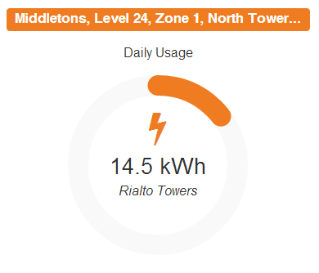

* 1. Title of charts need to be aliases if available else resource name (as per 1a)
  2. Show the target as a tool tip when roll over.
  3. Alternative logo for water and gas.
  4. Activity feed must be sorted according to next operation from the top down

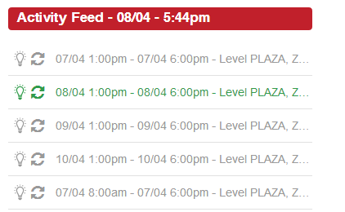

* 1. Old activity should have already dropped off… in this example all from 07/04
  2. In order to read full description ad a rollover tool tip with the full resource information
  3. As per discussion with matt please setup these as predominately a/c resources with a couple of lighting resources. Also schedule the dates to show a few active (green) schedules at 11am on the 16th of April.

1. Schedule
   1. Please either remove this or assign a tenant name  
      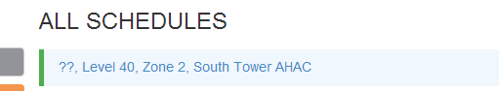
   2. This button is lost. Needs to be more obvious as a drop down menu. Perhaps make it a darker colour. We don’t want to make a feature of this however it’s currently lost.  
      
   3. Some of these examples need to show the resources as not on (mid blue colour). When hover over it should show the tool tip explaining status i.e schedule active  
      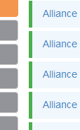
   4. Incorporate alias if available else resource name  
      
   5. Add schedule button needs to be in the top left hand corner. Not the right!
   6. Device needs to be on the opposite side and replaced with the actual schedule name according to what was clicked.  
      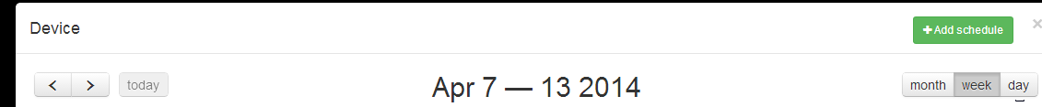

* 1. Device needs to be replaced in this instance with resource. Then the default selection should be as per what was clicked.  
     
  2. Remove action at this stage as requests will be on off only. This may be brought back in future versions.  
     
  3. Clicking the arrows to adjust the time currently closes the box for no reason. Please adjust so this does not happen.
  4. AM/PM is the exact same as above. Box just closes this needs correcting as above.

!!! after the “starts at” is confirmed OK. Immediately the default entry for “ends at” should be 1 hour exactly from the start time nominated.  
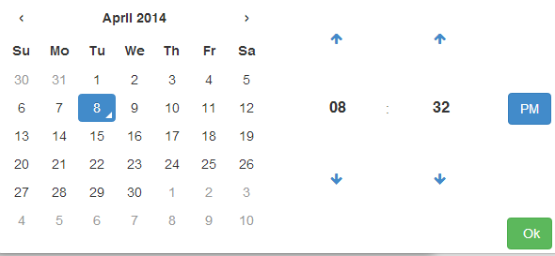

* 1. Default ” none” needs to be replaced with “Once only”   
     
  2. Repetition “daily” ” weekly” etc form is not right. We don’t require functioning demo. Just the input titles as per matts suggestions.  
     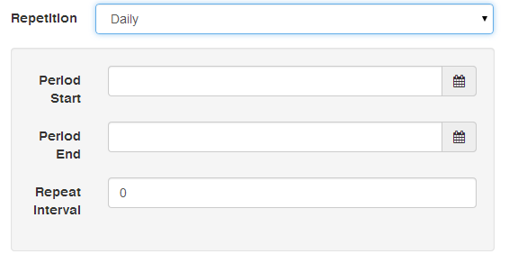
  3. Add in an example comment in light grey in the input box “e.g. Sales Meeting”. And when you click on it , it auto deletes ready for a USER ENTRY. If the box is not clicked for comment, no notation should be recorded. (we don’t want 500 “e.g Sales meetings” that never happened).  
     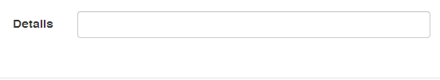
  4. Please add time and date stamp to the “Last Edited by Joe Random – 08/11/14 4:52pm”  
     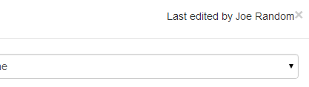
  5. Base building hours should be on each calendar. The base building hours should be set from 8am to 6pm. The colour of the box representing the base building hours should be a light transparent grey. This should not be an overriding visual feature in every schedule. But should be there never the less.  
     Always position calendar relevant to the login time of day. If tis 6pm – 6pm should be in the middle of the screen.   
     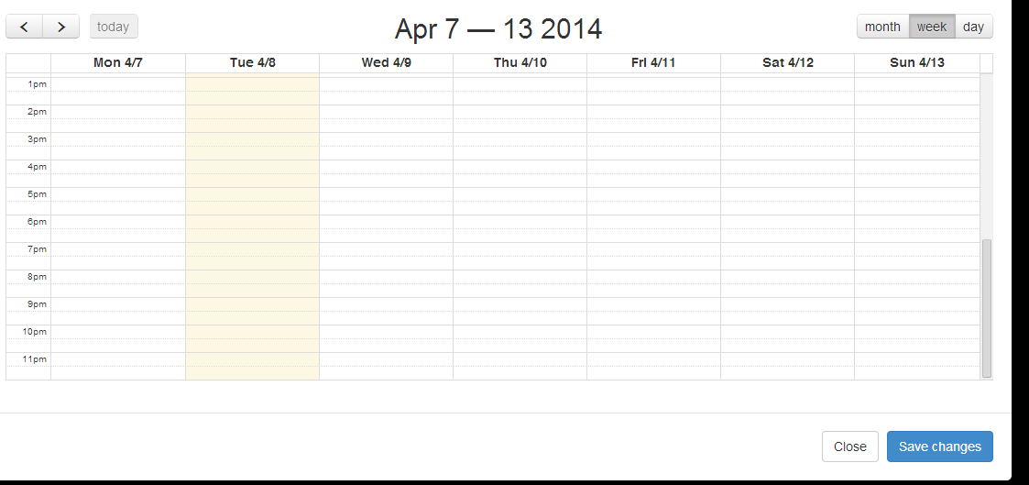
  6. Change DCU title Status

Options are on green, off is grey, fault is red

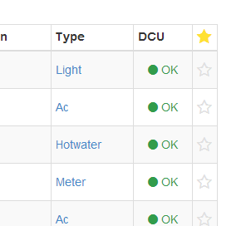

* 1. Ensure filter works for reports section  
     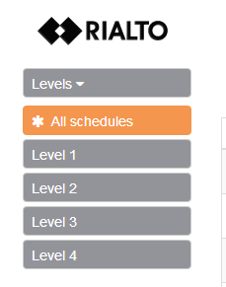
  2. Reports default screen should be the report generator.  
     Additional buttons required for generating a report.  
     View Report | CSV download | PDF Generator  
     we need an example of each of these items for the presentation. Only need one set of tenant data which can be made up.  
     These buttons need to work.  
       
       
     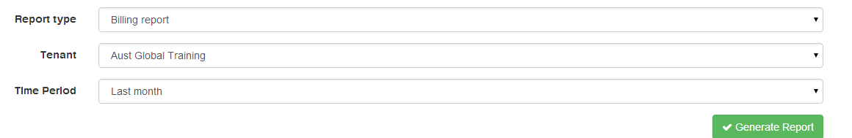

* 1. First up change “text” to “Description”  
     Also we need some relevant data for the presentation such as “Scheduled AHAC for Minter Ellison Level 14 Zone 1”  
       
     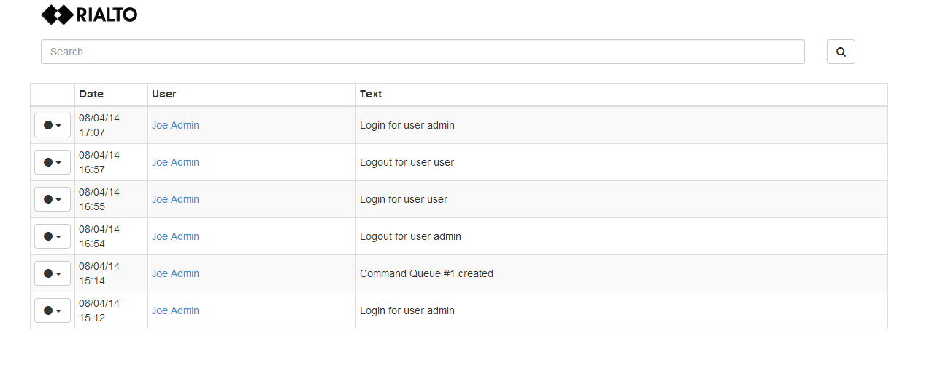

**User Sign in**

1. All the above changes relevant to the user interface should be applied also.
2. Should have a forgot password option. – emails current password to users email address. Does not reset.  
   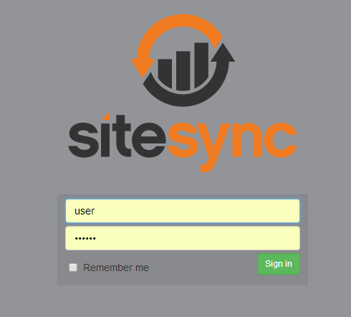
3. Remove meters from user platform  
   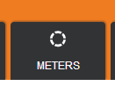
4. Remove the configure from user platform

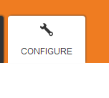

1. Remove this meter quick link

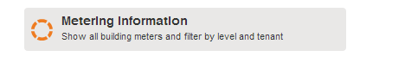

1. Dashboard gap in middle needs to be eliminated.  
   Activity feed should go over to the middle.   
   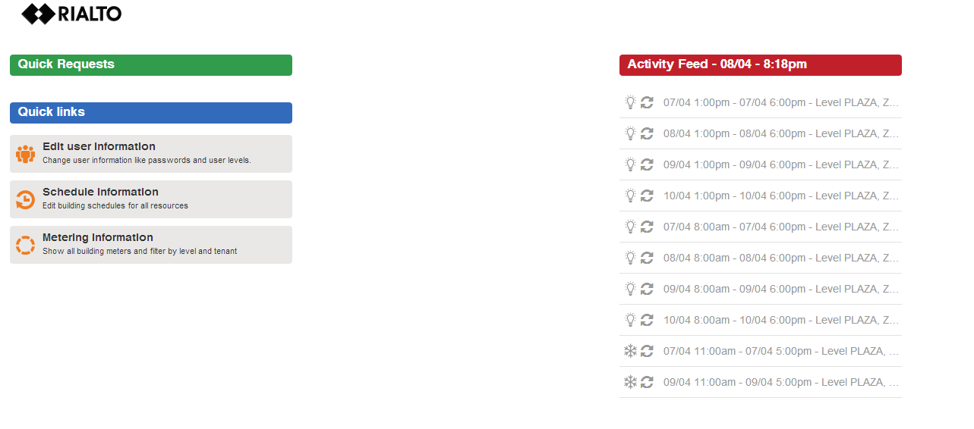
2. Base the user on **Minter** tenancy. Therefore a favourite should be applicable to a few of their tenanted areas.
3. Based on the Minter user profile all reports etc should work and have examples as previous
4. Eveytime you log out there is page errors.