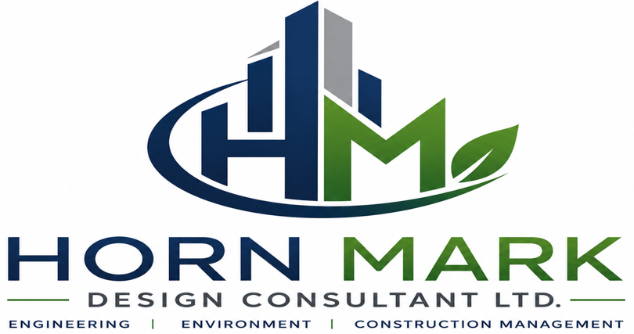

HORN MARK DESIGN CONSULTANT LTD.
Engineering, Environmental & Construction Management Consultants

Horn Mark Design Consultant Ltd. (HMD) is a multidisciplinary engineering and consulting firm headquartered in Mogadishu, Somalia. Established in 2018, the firm provides integrated professional services in engineering consultancy, environmental and social assessment, construction management, infrastructure development, project supervision, and monitoring and evaluation.
With a team of experienced engineers, planners, environmental specialists, architects, and project management professionals, HMD delivers innovative, sustainable, and cost-effective solutions for public institutions, development partners, NGOs, private sector clients, and international organizations operating throughout Somalia and the Horn of Africa.
Our approach combines international best practices, advanced engineering technologies, local expertise, and a strong understanding of Somalia's operating environment to ensure successful project delivery from concept to completion.

Our Vision
To become the leading engineering, environmental, and construction management consulting firm in Somalia and the Horn of Africa, delivering sustainable infrastructure solutions that contribute to economic growth and community development.

Our Mission
To provide high-quality engineering, environmental, and project management services through innovation, technical excellence, integrity, and client-focused solutions that create lasting value for our stakeholders.

Core Service Areas
1. Engineering Consultancy Services
Horn Mark Design provides comprehensive engineering consulting services covering all phases of project development, including:
- Feasibility Studies
- Preliminary Engineering Design
- Detailed Engineering Design
- Technical Due Diligence
- Infrastructure Planning
- Value Engineering
- Cost Estimation and Budgeting
- Preparation of Tender Documents
- Bill of Quantities (BoQ)
- Technical Specifications Development
- Contract Documentation
Sectors Served
- Roads and Transport Infrastructure
- Water Supply Systems
- Wastewater and Sanitation Systems
- Buildings and Urban Infrastructure
- Telecommunications Infrastructure
- Energy and Power Systems
- Industrial Facilities
- Public Infrastructure Projects

2. Environmental and Social Impact Assessment (ESIA)
HMD supports sustainable development through comprehensive environmental and social advisory services, including:
- Environmental Impact Assessment (EIA)
- Environmental and Social Impact Assessment (ESIA)
- Strategic Environmental Assessment (SEA)
- Environmental Audits
- Environmental Management Plans (EMP)
- Environmental and Social Management Frameworks (ESMF)
- Resettlement Action Plans (RAP)
- Stakeholder Engagement and Public Consultation
- Climate Change Risk Assessment
- Biodiversity Assessment
- Environmental Compliance Monitoring
Our assessments comply with national environmental regulations and international standards including World Bank Environmental and Social Framework (ESF), IFC Performance Standards, and African Development Bank safeguards.

3. Construction Management and Supervision
HMD provides independent supervision and construction management services to ensure projects are delivered safely, efficiently, within budget, and according to specifications.
Services include:
- Construction Supervision
- Resident Engineering Services
- Quality Assurance and Quality Control (QA/QC)
- Contract Administration
- Progress Monitoring and Reporting
- Claims and Variation Management
- Site Inspection and Certification
- Health, Safety and Environmental (HSE) Monitoring
- Defects Liability Management
- Project Close-Out and Handover Support

4. Project Management Services
Our project management team applies internationally recognized methodologies to deliver successful projects.
Services include:
- Project Planning and Scheduling
- Resource Planning
- Cost Control and Financial Monitoring
- Risk Management
- Procurement Support
- Stakeholder Coordination
- Performance Monitoring
- Project Reporting
- Program Management
- Portfolio Management

5. Monitoring, Evaluation and Learning (MEL)
HMD supports governments, NGOs, and development partners through results-based monitoring and evaluation services.
Services include:
- Baseline Studies
- Mid-Term Evaluations
- End-Line Evaluations
- Impact Assessments
- Performance Monitoring Frameworks
- Results Measurement Systems
- Data Collection and Analysis
- GIS-Based Monitoring
- Third-Party Monitoring
- Learning and Knowledge Management

6. Risk Assessment and Management
We assist clients in identifying, evaluating, and mitigating risks throughout project lifecycles.
Our expertise covers:
- Project Risk Assessment
- Construction Risk Analysis
- Environmental Risk Assessment
- Operational Risk Management
- Health and Safety Risk Assessments
- Climate Risk Assessments
- Security Risk Assessments
- Business Continuity Planning

Building Information Modelling (BIM)
Horn Mark Design embraces Building Information Modelling (BIM) as a core component of modern engineering and construction project delivery.
Through BIM-enabled workflows, we provide:
- 3D Digital Engineering Models
- Architectural Modelling
- Structural Modelling
- MEP (Mechanical, Electrical & Plumbing) Modelling
- Clash Detection and Coordination
- Quantity Take-Offs
- Construction Sequencing (4D BIM)
- Cost Planning and Estimation (5D BIM)
- Asset Information Management
- Digital Twin Development
- Facility Management Integration
The adoption of BIM allows clients to improve project coordination, reduce construction risks, enhance cost control, minimize design conflicts, and optimize asset lifecycle management.

Competitive Advantages
Why Choose Horn Mark Design
✓ Multidisciplinary Technical Expertise
✓ Strong Understanding of Local Conditions
✓ International Standards and Best Practices
✓ BIM-Enabled Engineering Solutions
✓ Proven Construction Supervision Experience
✓ Environmental and Social Safeguards Expertise
✓ Results-Based Project Management
✓ Commitment to Quality, Integrity, and Accountability
✓ Strong Network Across Government, Private Sector, and Development Partners

Core Values
- Integrity
- Professionalism
- Accountability
- Innovation
- Excellence
- Sustainability
- Transparency
- Client Satisfaction

Our Commitment
At Horn Mark Design Consultant Ltd., we are committed to delivering innovative engineering solutions, sustainable environmental practices, and professional project management services that contribute to the successful development of infrastructure and communities across Somalia and the Horn of Africa.

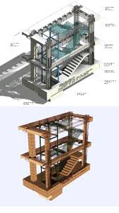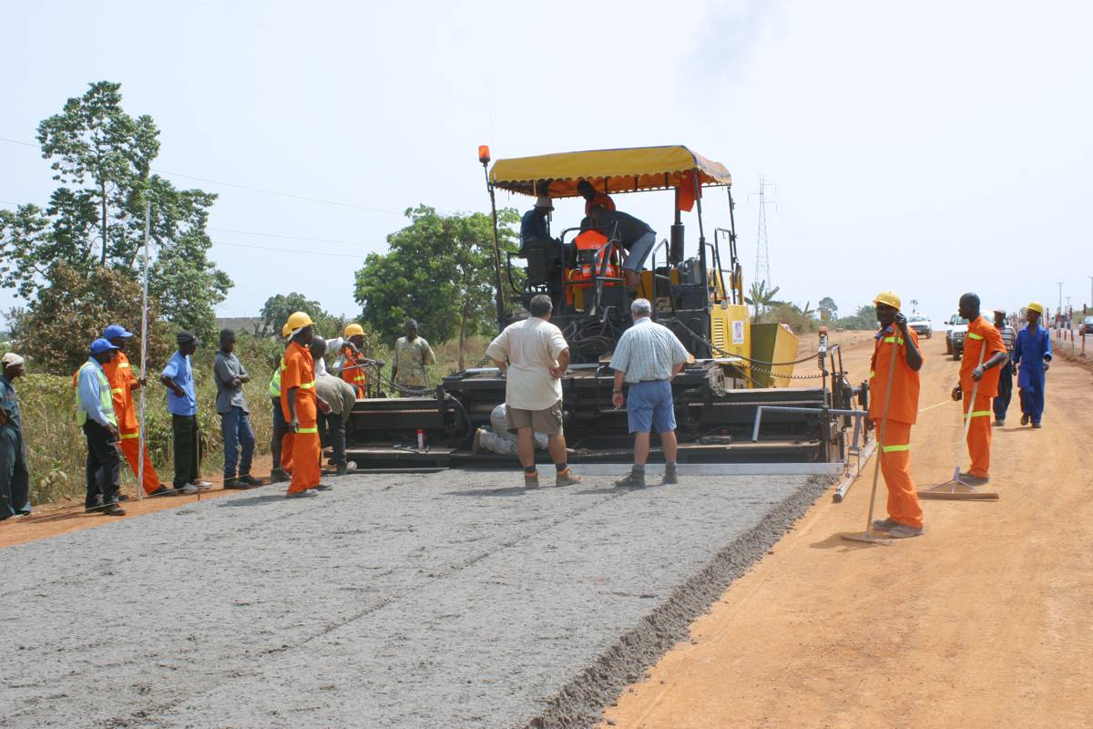
BIM Road construction
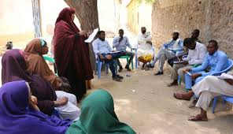
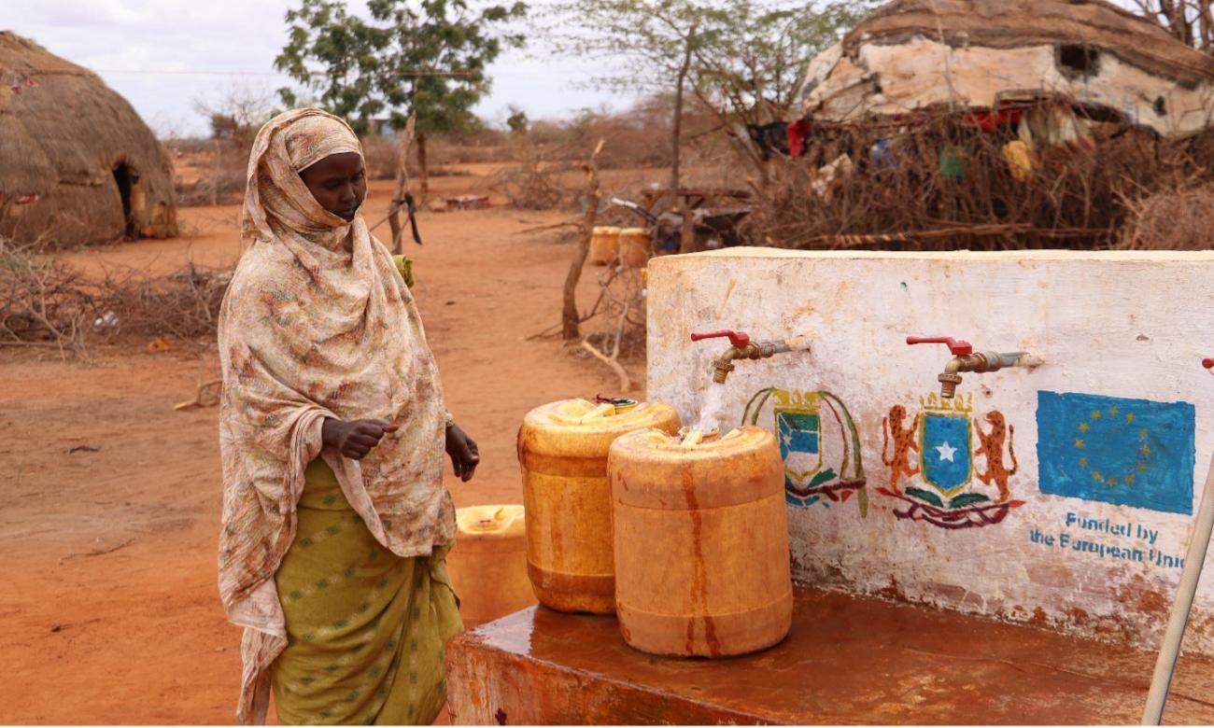
Water infrastucture community consultations

