Residential Instability and Childhood Wellbeing
Libby Kramer¹
¹ University of Minnesota

Author note
Thank you!
The authors made the following contributions. Libby Kramer: Conceptualization, Writing - Original Draft Preparation, Writing - Review & Editing.
Correspondence concerning this article should be addressed to Libby Kramer, Elliott Halll 75 E River Parkway, Minneapolis MN. E-mail: krame937@umn.edu

Abstract
This study looks at the relationship between the residential stability and child well-being using data from the Survey of Income and Program Participants. This data is from the United States and is conducted through the Census Bureau. This report looks at 6691 participants and compares their score on the child well-being scale to two residential stability measures. Using a t-test and Cohen’s D to measure the p-value and get the effect size. The results of this study were consistent with the other finds in the research around where people are living and how that is connected to their health. There is strong evidence that suggests that the stability of a child’s residence contributes to their well-being score. There should be more reseearch done.
Keywords: housing, residential stability, childhood wellbeing, health, social determinants of health
Word count: X

Residential Instability and Childhood Wellbeing

Introduction
The current research suggests that the quality of housing is a social determinant of health. Social determinants have become a more focal point of public health as more understanding grows about the impacts of social forces on our autonomy to access health. Additionally, using Survey of Income and Program Participants, Kantz, Enah, and Abdallah (2023) found residential stability to be a factor for low income older adult’s health. The authors of this paper came to the conclusion that housing assistance is falling short among the demographic they focused on. This report will look more specifically at the relationship between residential stability and childhood well-being, asking what impact residential stability has on well being? SIPP data has also been used to look at quality of housing and health of children, but not specifically residential stability Boch, Chisolm, Kaminski, and Kelleher (2021). This article found that poorer housing quality was associated with poorer health for child. By looking at residence and health the research can guide how we approach housing policy specifically for families. As housing is not guaranteed in the United States evidence on the impacts of this can be apart of ensuring children all have a stable place to live. The purpose of the present study is to better understand what is affecting childhood well-being and if frequent moving is contributing to their well-being.

Method
The current study was not preregistered. Data and code are available on Github click here Data retrieved from the 2024 Survey of Income and Program Participation (Bureau (n.d.)). https://www.census.gov/programs-surveys/sipp/data/datasets/2024-data/2024.html
The data used is publicly available and de-identified so the ethical considerations for using this data were low risk.

Participants and Procedure
The sample size after omitting the missing values, due to the vast amount of missing, was 6691. The average age of the respondents was 45.01 with a standard deviation of 26.68. The participants were 89.8% female. The percentage breakdown for race is included in the figure below. This sample size has some significant bias around sex and race. There answer options for the demographics were very binary and lacking in self-description options.
Table 1
dem_2_sim | Percentage
1 | 44.97
2 | 6.34
3 | 5.83
4 | 2.87
NA | 39.99
Note. 1 = White, 2 = Black, 3 = Asian, 4 = Residual, 5 = NA

Measures

Childhood well-being scale.
Using simulated data this report analysised the relationship between childhood well-being and residential stability. The childhood well-being scale was created using select objects from the SIPP section on child well-being. For this report there were only four true or false questions used to create the cwb_scale which stands for the childhood well-being scale. This was also reported data from the parents about children at a variety of ages. The Cronbach’s alpha for this scale was -0.02. This is a very low alpha, probably due to the few number of items and the randomness in selection of the items.

Residential Stability.
The residential stability measures are two questions from the residential section of the SIPP questionnaire. The questions ask about reason for moving and also if they were renting, owned, or were occupying without payment.
The residential stability measures were tested with a Cronbach’s alpha to measure internal consistency of the measures. For residential stability the alpha value was 0.02. This is very low for internal consistency and demonstrates the lack of reliability when only using two measures to determine a complex idea like the amount of residential stability in someone’s life.

Material
The childhood well-being scale was made up of four different questions. The first varibale, cwb_1, asks about child participation in any clubs or organizations after school. The second variable, cwb_2, asked parents to report on if their child had ever been suspended or expelled from school. The third varibale, cwb_3, was in regards to if the child had ever repeated a grade or been held back. The last varibale, cwb_4 was in regards to if the child played on a sports team. All of these varibales were yes or no. The cwb_2 and cwb_3 were both reverse coded.
The first residential stability questions asked about the type of occupancy, owning, renting, or occupying without pay. The second residential question was in regards to reason for moving with 16 potential answers. These are: 1 Change in marital/relationship status 2 To move into own apartment or house 3 Other family-related reason 4 New job or job transfer 5 To look for work or lost job 6 To be closer to work or school 7 Other job-related reason 8 Wanted to own home, not rent 9 Wanted a better quality apartment or house 10 Wanted a better neighborhood 11 Cheaper housing 12 Other housing-/neighborhood-related reason 13 Disaster loss (fire, flood, hurricane, etc.) 14 Eviction/foreclosure 15 Always lived here (never moved) 16 Other reason (specify).
The demographic questions included were age, race, and sex. The answer options were non-specific and did not allow for self-report.

Procedure
The SIPP dataset is a longitudinal study that is collected through surveys. The methodology includes interviews as well as paper surveys that are mailed to participants houses. They use the Master Address File which is updated through the United States Postal Service. The Census Bureau also completes two rounds of sampling, the first one is for primary sample units and the selection of addresses.

Data analysis
We used R (Version 4.5.0; R Core Team, 2025) and the R-packages bit (Version 4.6.0; Chirico & Oehlschlägel, 2025a, 2025b), bit64 (Version 4.6.0.1; Chirico & Oehlschlägel, 2025b), data.table (Version 1.17.8; Barrett et al., 2025), dplyr (Version 1.1.4; Wickham, François, Henry, Müller, & Vaughan, 2023), forcats (Version 1.0.1; Wickham, 2025), ggplot2 (Version 4.0.1; Wickham, 2016), groundhog (Version 3.2.3; Simonsohn & Gruson, 2025), labelled (Version 2.16.0; Larmarange, 2025), lsr (Version 0.5.2; Navarro, 2015), lubridate (Version 1.9.4; Grolemund & Wickham, 2011), missMethods (Version 0.4.0; Rockel, 2022), papaja (Version 0.1.4; Aust & Barth, 2025), psych (Version 2.5.6; William Revelle, 2025), purrr (Version 1.2.0; Wickham & Henry, 2025), readr (Version 2.1.6; Wickham, Hester, & Bryan, 2024), stringr (Version 1.6.0; Wickham, 2023), tibble (Version 3.3.0; Müller & Wickham, 2023), tidyr (Version 1.3.1; Wickham, Vaughan, & Girlich, 2024), tidyverse (Version 2.0.0; Wickham et al., 2019), and tinylabels (Version 0.2.5; Barth, 2025) for all our analyses.

Results
(#tab:descriptive table
plots) Descriptives for Childhood Wellbeing Scale Items
Item | Mean | SD
CWB Item 1 | 1.60 | 0.49
CWB Item 2 | 1.90 | 0.31
CWB Item 3 | 1.95 | 0.21
CWB Item 4 | 1.50 | 0.50
Note. True or false questions keyed 1 as postive and 2 as negative

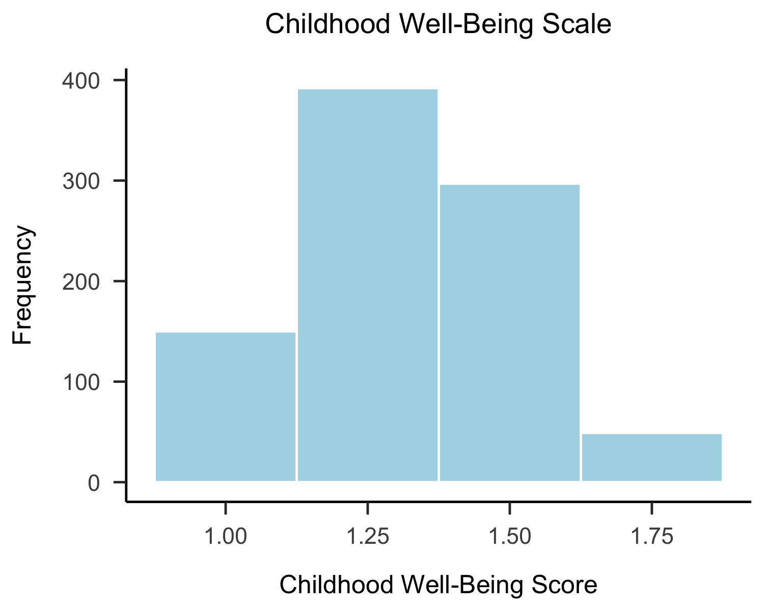
The p-value when comparing residential stability marker 1 and the cwb_scale was very small, < .001. This compared the child well-being score to if the child was living in a home that was owned, rented, or if they were not paying. Since the p-value was significant I also ran a Cohen’s D test to measure the effect size. The Cohen’s D was 0.90. This value tells us that the impact of the type of housing was responsible for 90% of the variability in child well-being score.
These results show that the type of housing a child is living in has a significant effect on their well-being. This demonstrates residential stability as renting or not paying is less stable than owning the home. Further research with more robust analysis needs to be done.

References
Aust, F., & Barth, M. (2025). papaja: Prepare reproducible APA journal articles with R Markdown. https://doi.org/10.32614/CRAN.package.papaja
Barrett, T., Dowle, M., Srinivasan, A., Gorecki, J., Chirico, M., Hocking, T., … Krylov, I. (2025). Data.table: Extension of ‘data.frame‘. https://doi.org/10.32614/CRAN.package.data.table
Barth, M. (2025). tinylabels: Lightweight variable labels. https://doi.org/10.32614/CRAN.package.tinylabels
Boch, S. J., Chisolm, D. J., Kaminski, J. W., & Kelleher, K. J. (2021). Home quality and child health: Analysis of the Survey of Income and Program Participation. Journal of Child Health Care, 25(4), 603–615. https://doi.org/10.1177/1367493520975956
Bureau, U. C. (n.d.). 2024 SIPP Data.
Chirico, M., & Oehlschlägel, J. (2025a). Bit: Classes and methods for fast memory-efficient boolean selections. https://doi.org/10.32614/CRAN.package.bit
Chirico, M., & Oehlschlägel, J. (2025b). bit64: A S3 class for vectors of 64bit integers. https://doi.org/10.32614/CRAN.package.bit64
Grolemund, G., & Wickham, H. (2011). Dates and times made easy with lubridate. Journal of Statistical Software, 40(3), 1–25. Retrieved from https://www.jstatsoft.org/v40/i03/
Kantz, M. E., Enah, C., & Abdallah, L. M. (2023). The relationship between health and housing in low-income older adults: A secondary analysis of survey data. Public Health Nursing, 40(6), 931–939. https://doi.org/10.1111/phn.13248
Larmarange, J. (2025). Labelled: Manipulating labelled data. https://doi.org/10.32614/CRAN.package.labelled
Müller, K., & Wickham, H. (2023). Tibble: Simple data frames. https://doi.org/10.32614/CRAN.package.tibble
Navarro, D. (2015). Learning statistics with r: A tutorial for psychology students and other beginners. (Version 0.6). Sydney, Australia: University of New South Wales. Retrieved from https://learningstatisticswithr.com
R Core Team. (2025). R: A language and environment for statistical computing. Vienna, Austria: R Foundation for Statistical Computing. Retrieved from https://www.R-project.org/
Rockel, T. (2022). missMethods: Methods for missing data. https://doi.org/10.32614/CRAN.package.missMethods
Simonsohn, U., & Gruson, H. (2025). Groundhog: Version-control for CRAN, GitHub, and GitLab packages. https://doi.org/10.32614/CRAN.package.groundhog
Wickham, H. (2016). ggplot2: Elegant graphics for data analysis. Springer-Verlag New York. Retrieved from https://ggplot2.tidyverse.org
Wickham, H. (2023). Stringr: Simple, consistent wrappers for common string operations. https://doi.org/10.32614/CRAN.package.stringr
Wickham, H. (2025). Forcats: Tools for working with categorical variables (factors). https://doi.org/10.32614/CRAN.package.forcats
Wickham, H., Averick, M., Bryan, J., Chang, W., McGowan, L. D., François, R., … Yutani, H. (2019). Welcome to the tidyverse. Journal of Open Source Software, 4(43), 1686. https://doi.org/10.21105/joss.01686
Wickham, H., François, R., Henry, L., Müller, K., & Vaughan, D. (2023). Dplyr: A grammar of data manipulation. https://doi.org/10.32614/CRAN.package.dplyr
Wickham, H., & Henry, L. (2025). Purrr: Functional programming tools. https://doi.org/10.32614/CRAN.package.purrr
Wickham, H., Hester, J., & Bryan, J. (2024). Readr: Read rectangular text data. https://doi.org/10.32614/CRAN.package.readr
Wickham, H., Vaughan, D., & Girlich, M. (2024). Tidyr: Tidy messy data. https://doi.org/10.32614/CRAN.package.tidyr
William Revelle. (2025). Psych: Procedures for psychological, psychometric, and personality research. Evanston, Illinois: Northwestern University. Retrieved from https://CRAN.R-project.org/package=psych

