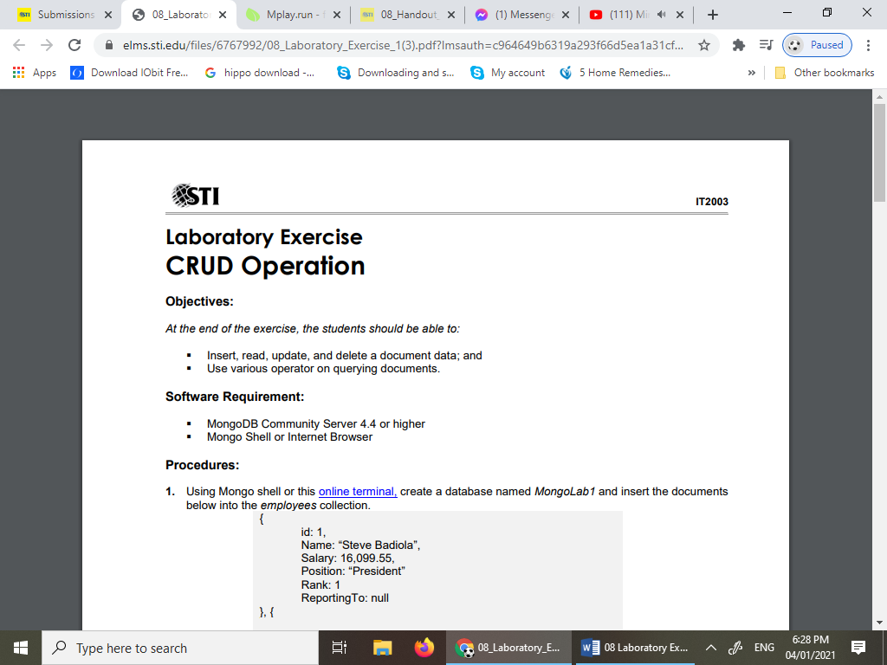

**Objectives:**

*At the end of the exercise, the students should be able to:*

Insert, read, update, and delete a document data; and

Use various operator on querying documents.

**Software Requirement:**

* MongoDB Community Server 4.4 or higher
* Mongo Shell or Internet Browser

**Procedure:**

1. Using Mongo shell or this online terminal, create a database named *MongoLab1* and insert the documents below into the *employees* collection.

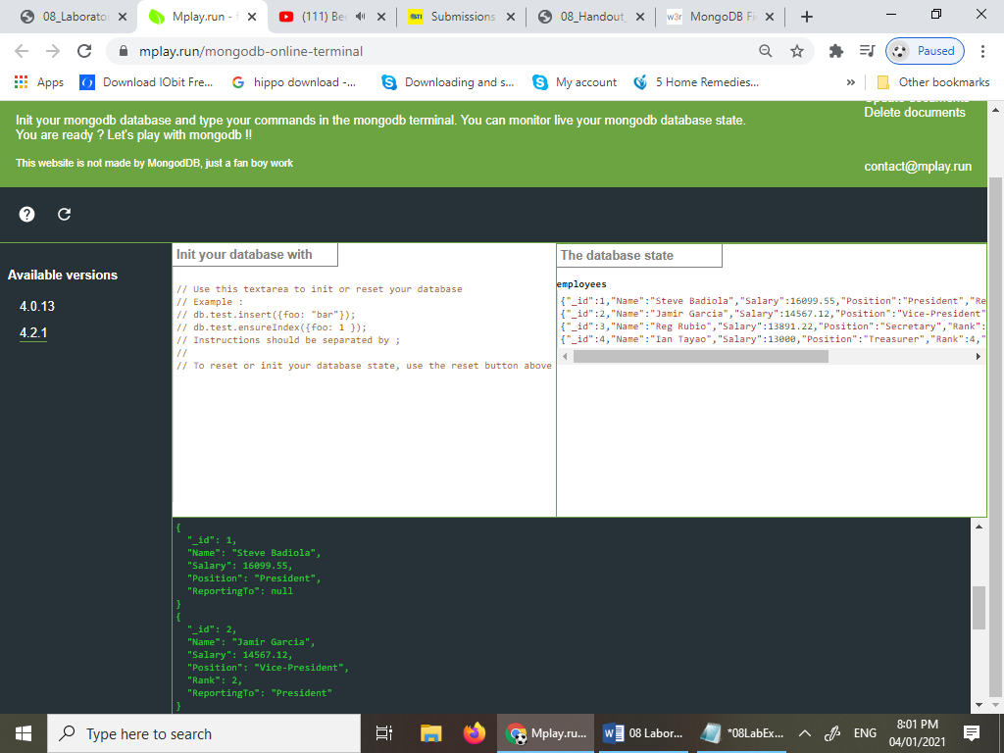

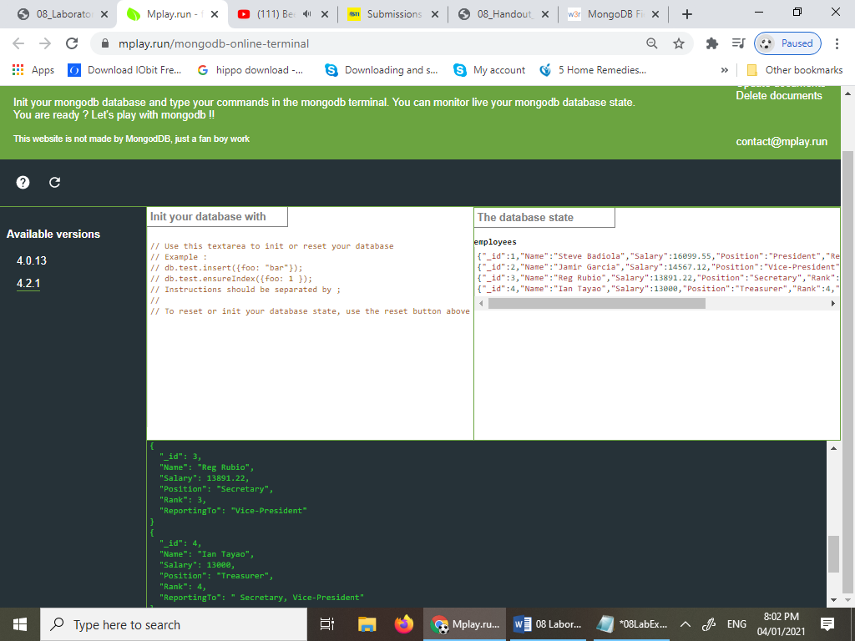

1. **Remove** all the “ReportingTo” field in *employees* collection where its value is null.

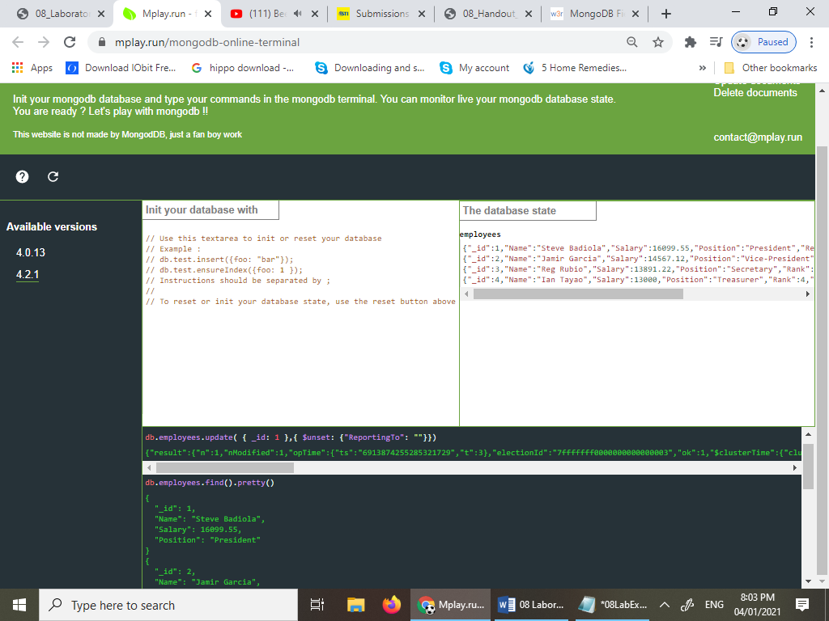 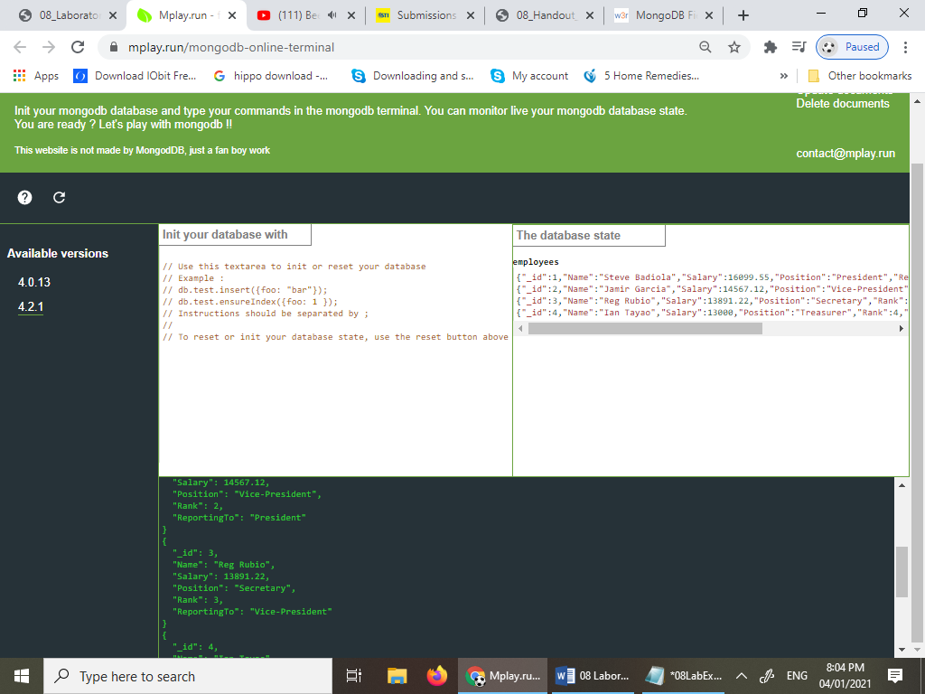 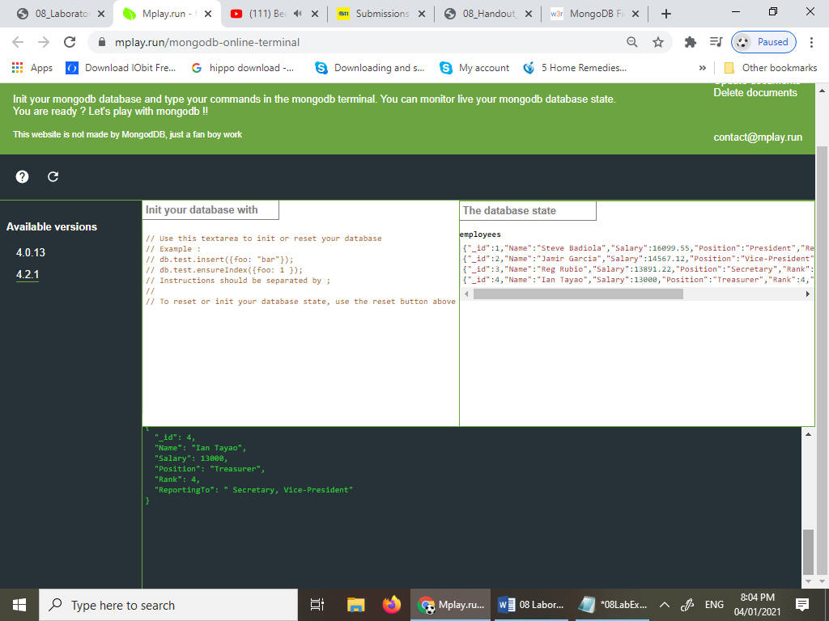

1. Using the ***$inc*** operator, **update** all the documents by increasing their salary by 5000.

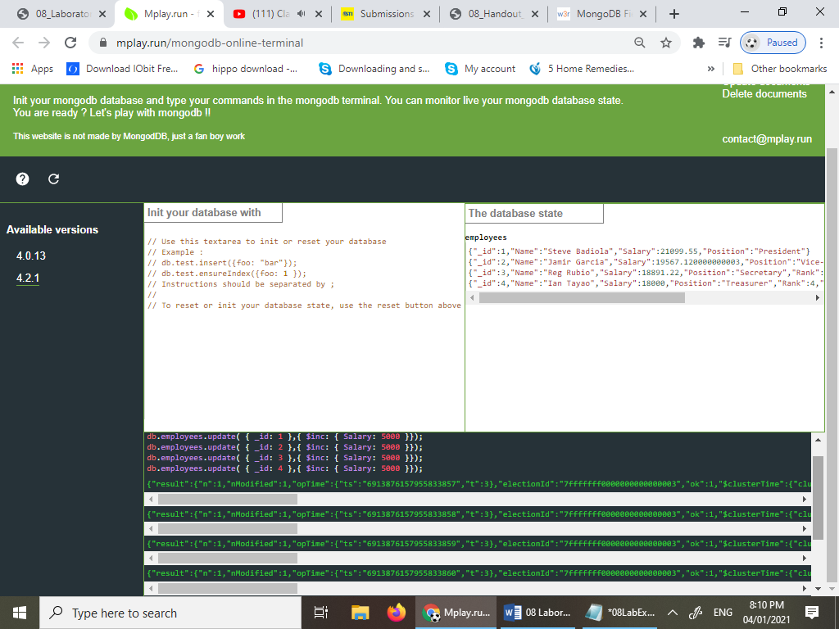 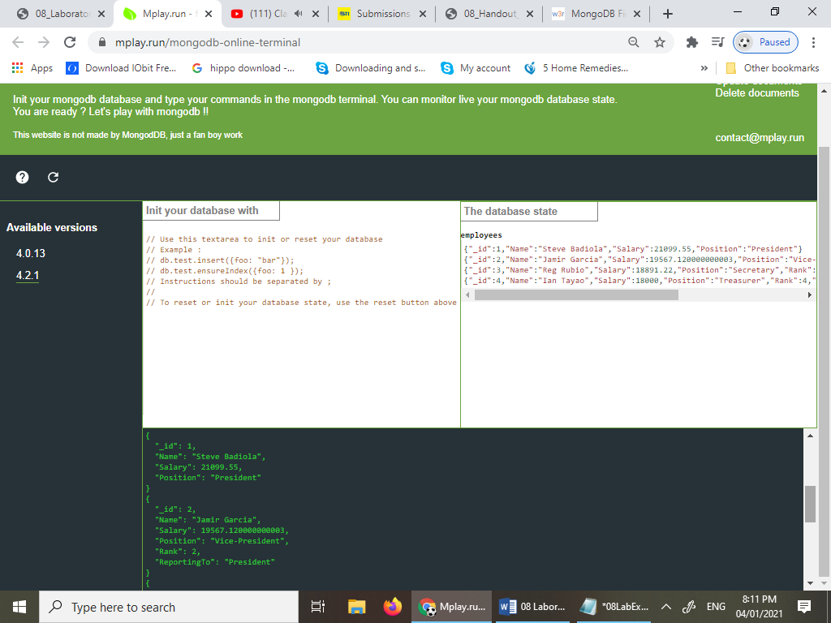 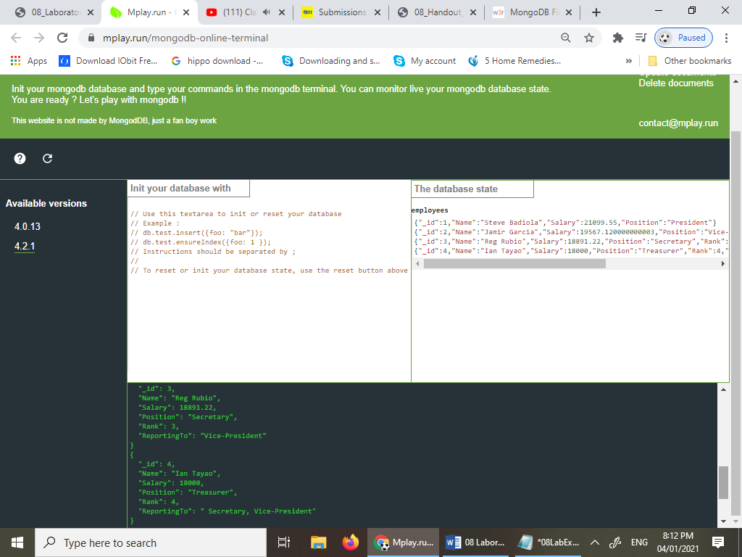

1. **Update** the document of “*Reg Rubio*” and “*Ian Tayao*” by adding the “*President*” to their Reporting field.

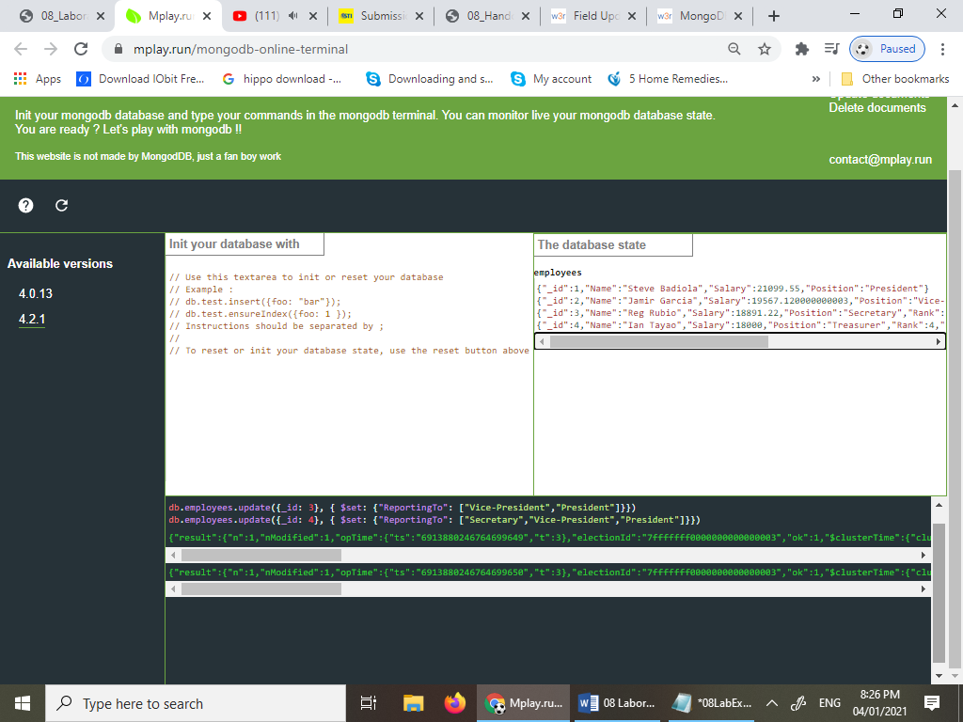 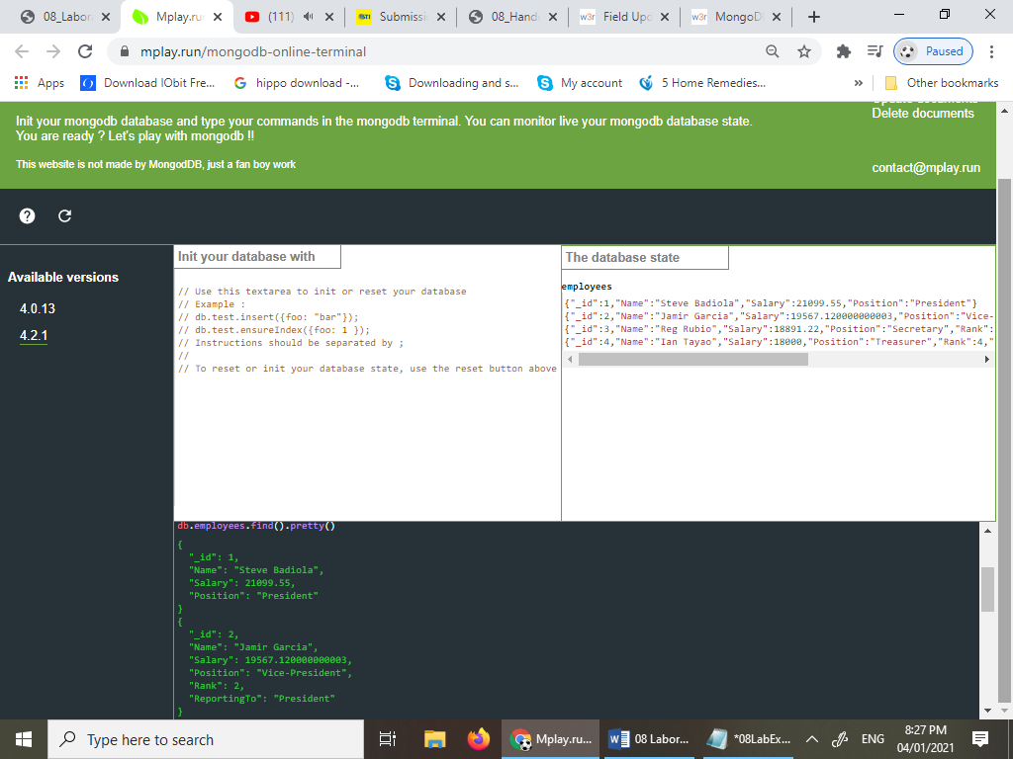 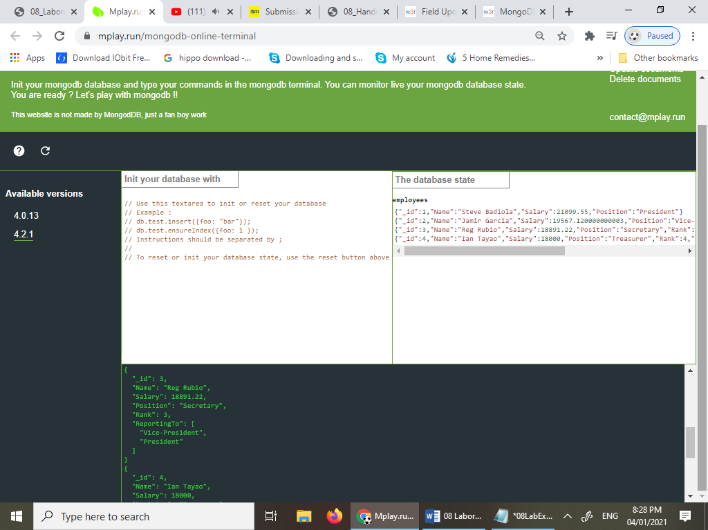 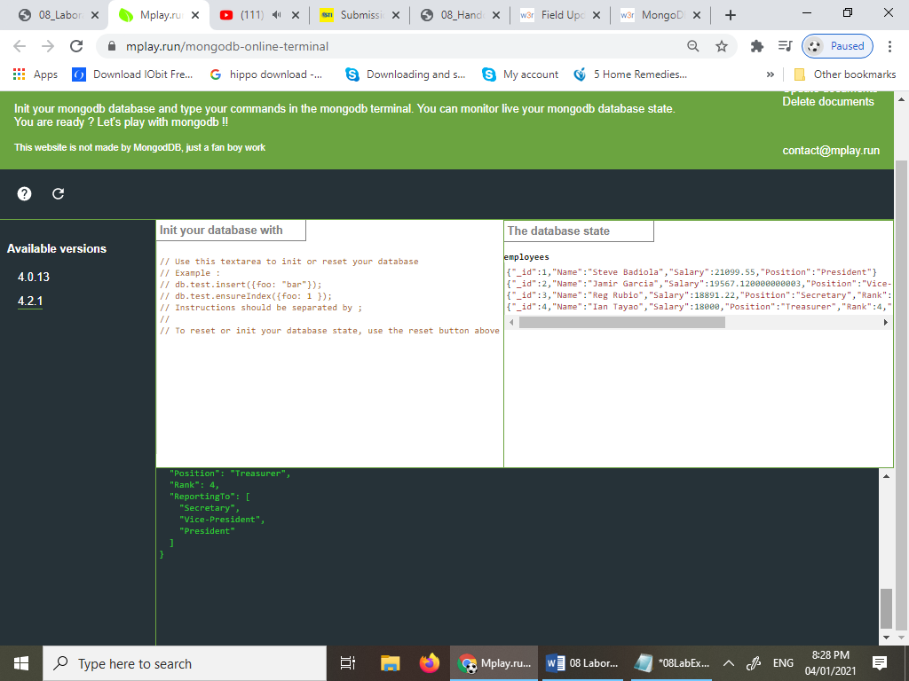

1. **Find** the document where their salary is above “*21,000.00*”.

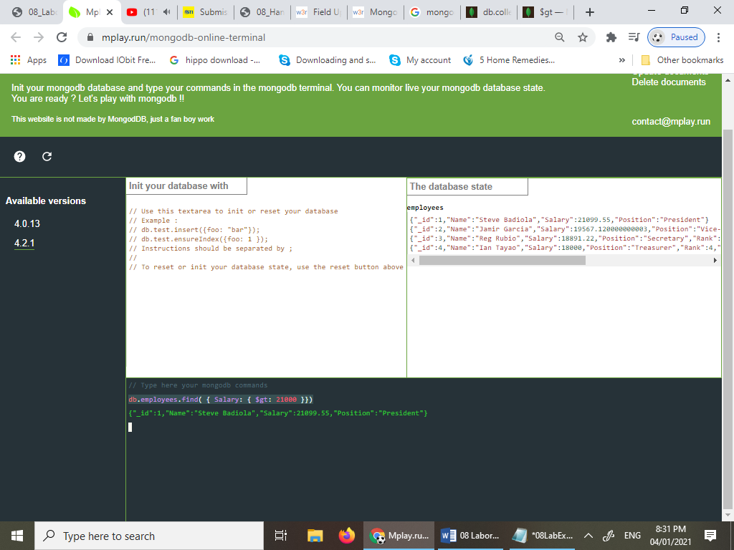

1. **Find** the document where their name starts with “*S*” and “*R”.*

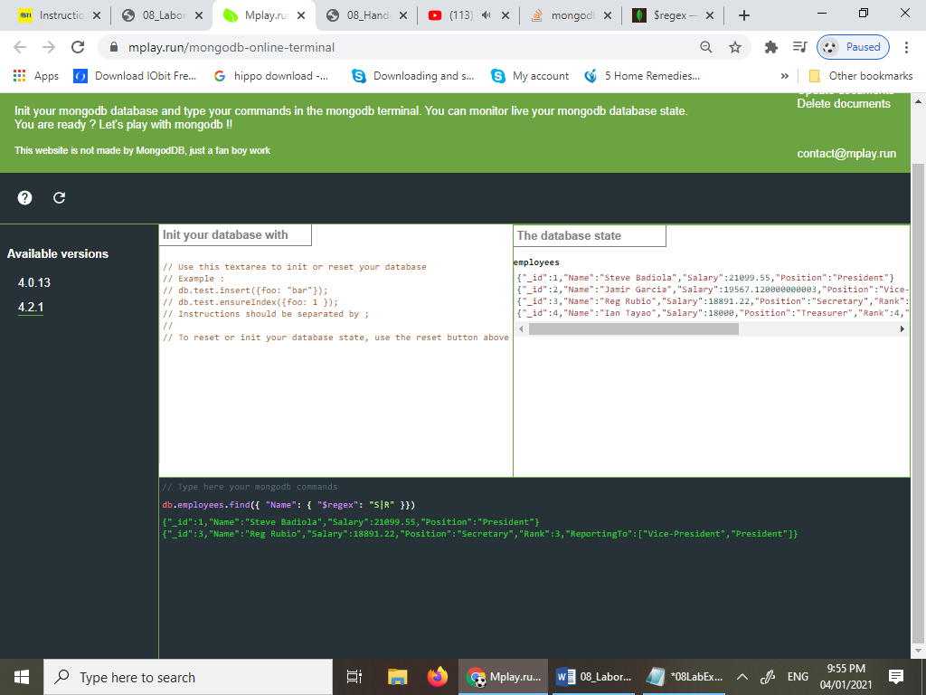

1. **Find** the document that is not reporting to the “*President*”.

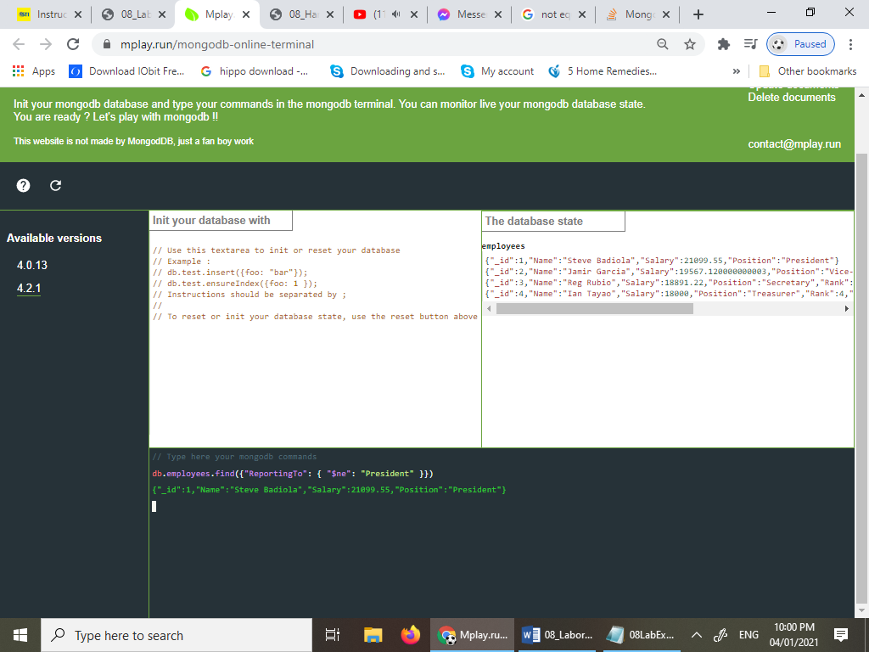

1. **Update** all the document by adding a sub-document named “*contact*” with a key-value, “*email*”: “*name@gov.ph*” (Example: steve.badiola@gov.ph) and “*phone*”: “+1 *1234567*” (note: +1 value should depend on their rank number).

