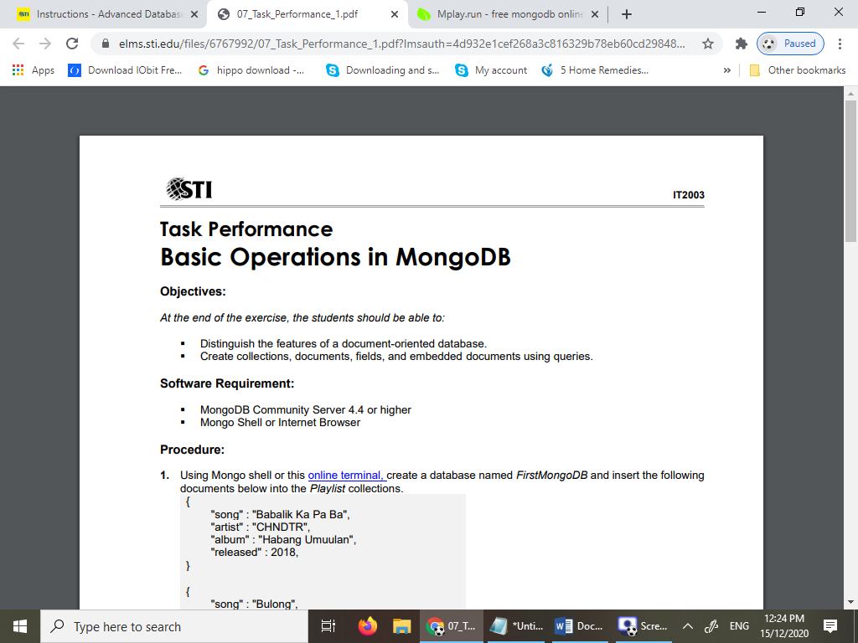

**Objectives:**

*At the end of the exercise, the students should be able to:*

* Distinguish the features of a document-oriented database.
* Create collections, documents, fields, and embedded documents using queries.

**Software Requirement:**

* MongoDB Community Server 4.4 or higher
* Mongo Shell or Internet Browser

**Procedure:**

1. Using Mongo shell or this online terminal, create a database named FirstMongoDB and insert the following documents below into the Playlist collections.

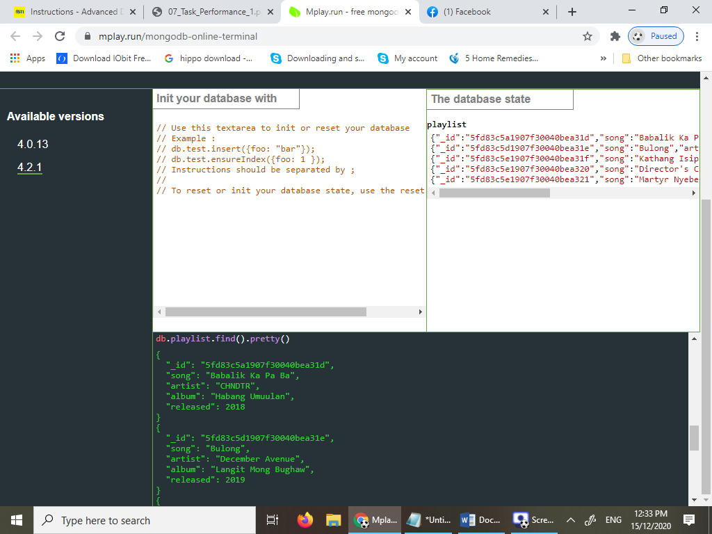

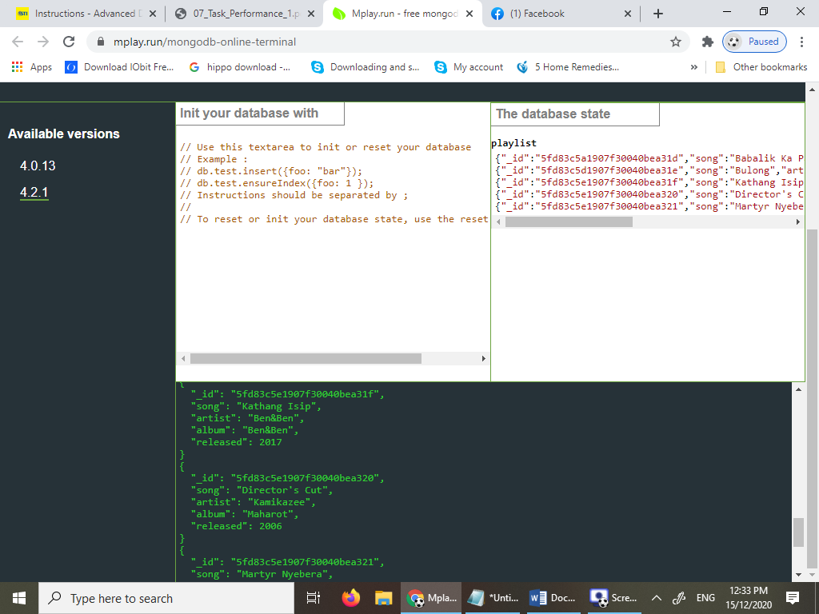

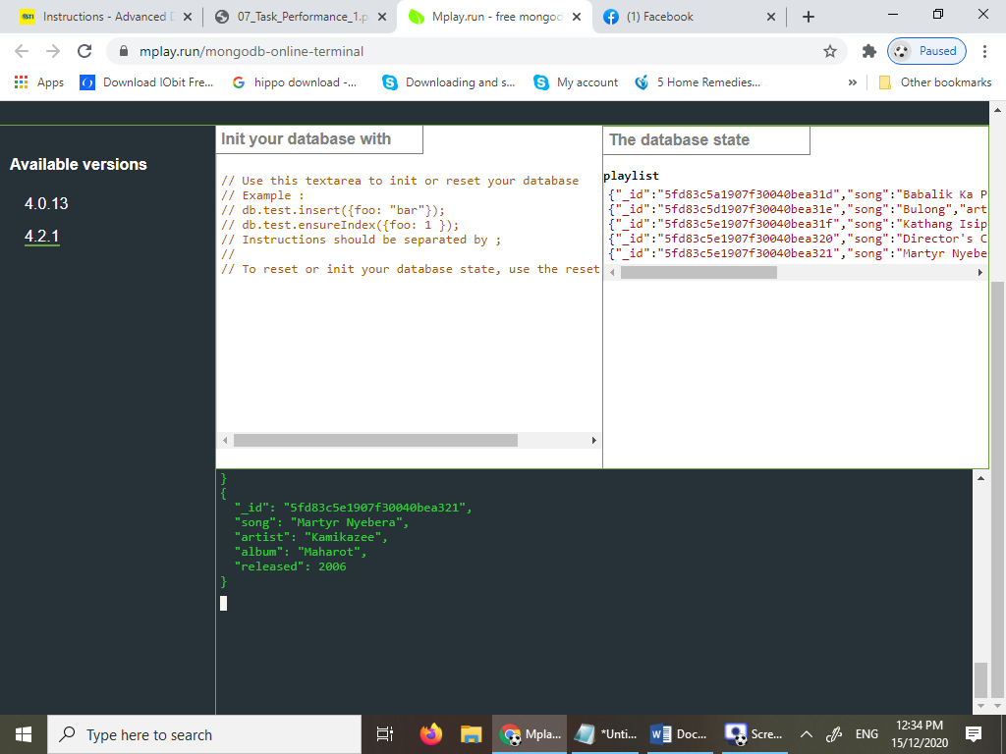

1. Find the documents or songs that were released in the years **2006** and **2017**.

**Note:**

a. Use the pretty() function to display the documents in an organize list. (db.playlist.find().pretty()

b. ids are automatically created by Mongo shell.

**OUTPUT 2006:**

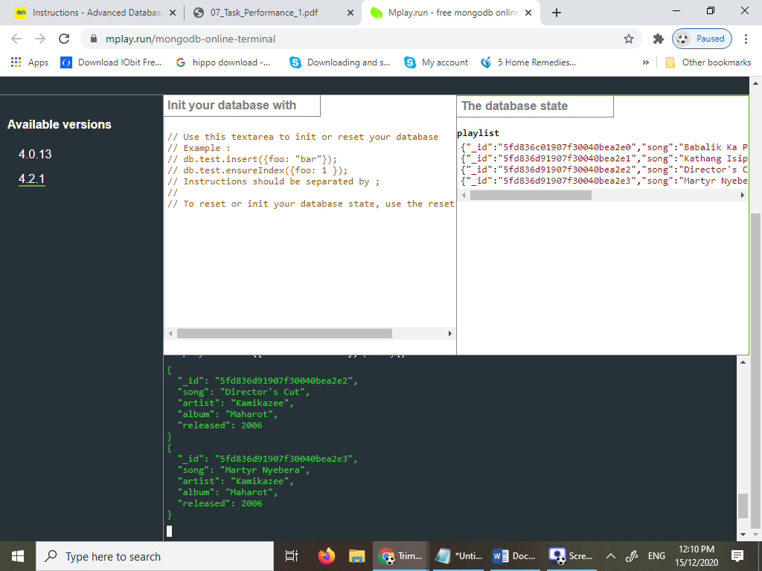

**OUTPUT 2017:**

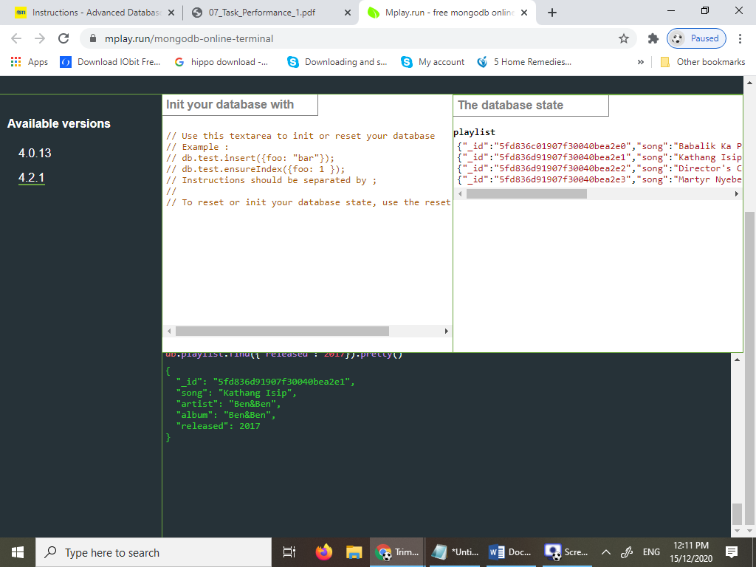

1. Using the deleteOne command, remove the document which contains the song "Martyr Nyebera".

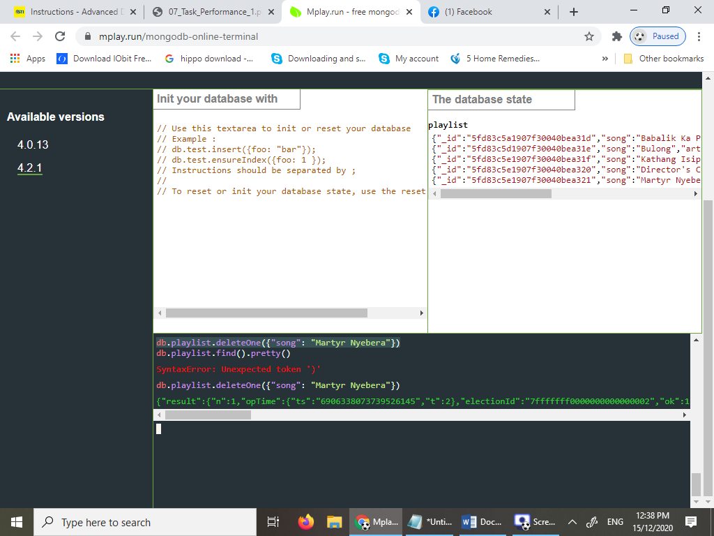

1. Find the document that has a value of "Bulong".

