Overherd screenshots

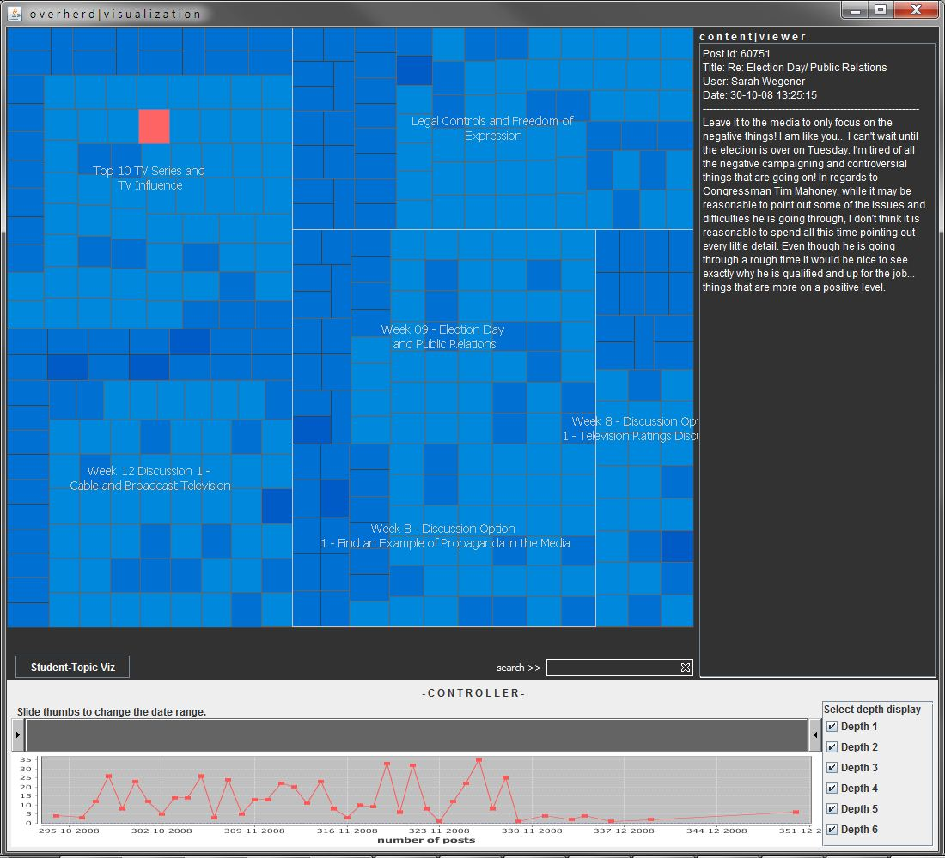
1
3
2
5
4
Figure 1 Main view
- Tree map view of the discussion thread. Each rectangle represents a leaf node (the last post) in the tree structure. The underlying graph library (prefuse) only allows clicking of a leaf node, not any post above in the tree structure, so I added a custom interaction method that allows a user to mouse-wheel move and select parent node and show its content as well. This still needs a bit more work, though.
- Content view of a clicked post.
- Date range setter. You can change the date range of the tree map view to show posts within certain period. This helps to see how posts were added chronologically. (see the next screenshot.)
- A graph showing the number of posts added in a time period. The date values on the x-axis has a bug at the moment that shows the date a bit incorrectly.
- Button for showing the student-topic view. (see figure ).

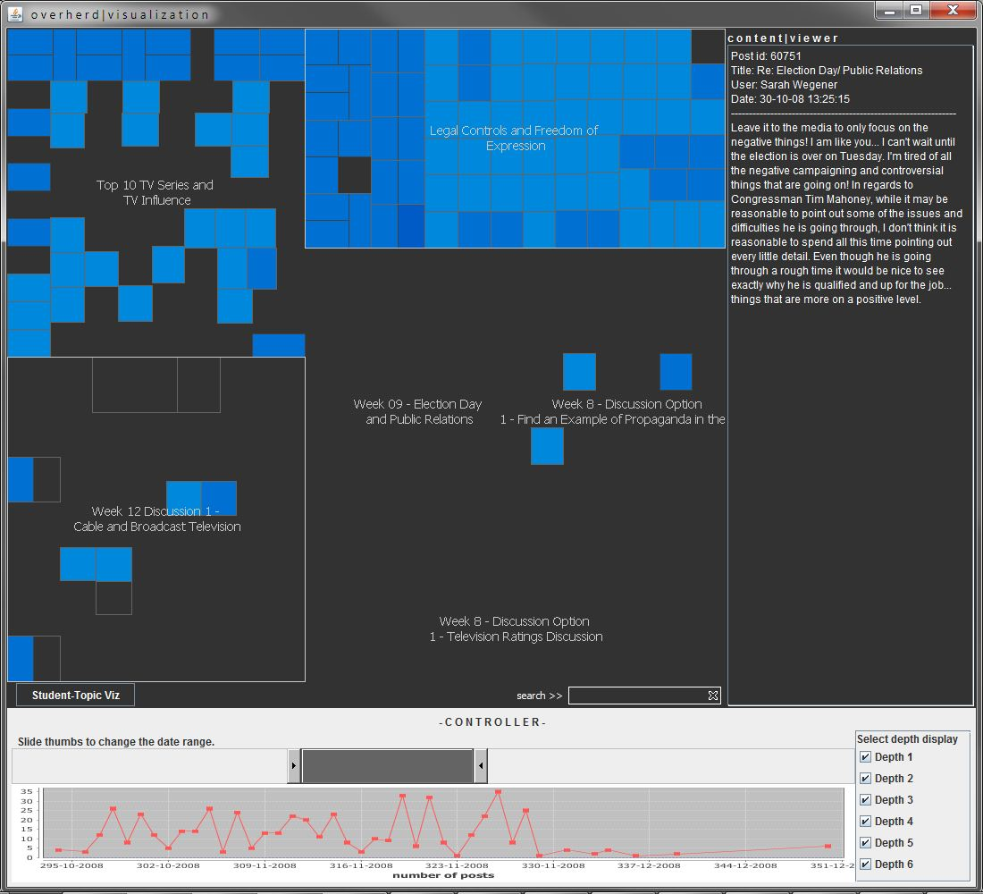
Figure 2 Showing data only in certain period.

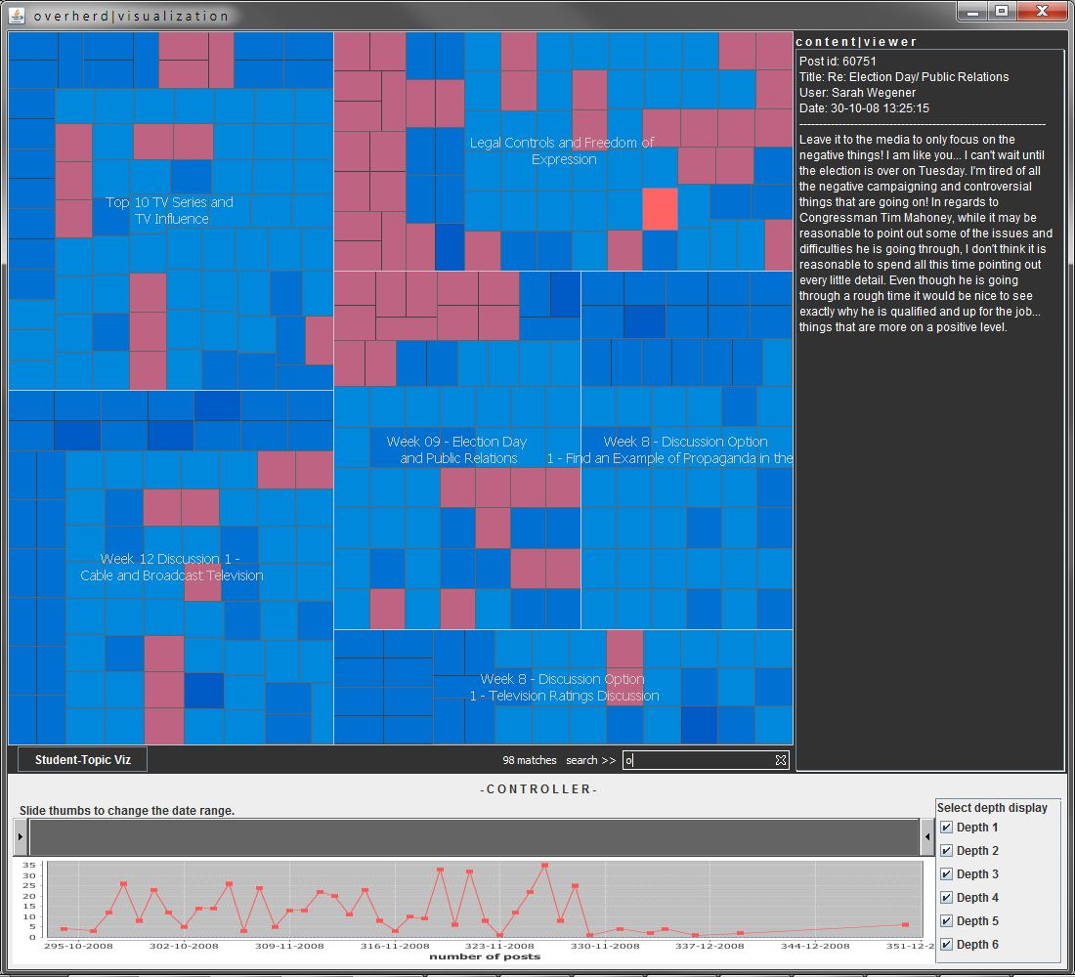
Figure 3 Searching highlights the result.

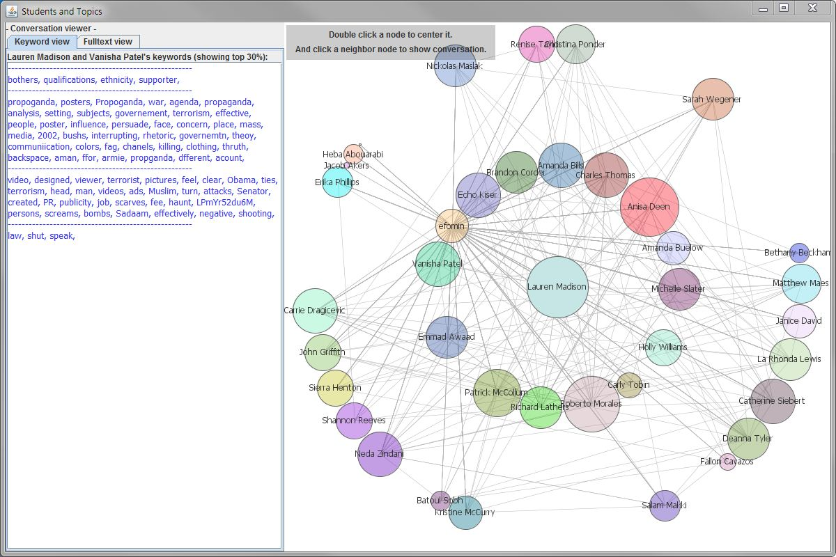
4
2
3
1
Figure 4 Student - topic view
- Visualization of student-student graph. Each circle represents a student. The size of a circle represents the number of posts he/she left. A link between two students represents they had a conversation (i.e., replied to the post). Right now the link does not indicate the number of conversations between two students, but I will vary the thickness to show it later.
- Currently centered student. Double click a student to center the node and redraw the graph accordingly. Viewing of the conversation content is centered on the center student. For example, if student A is currently centered, you can see the content of posts between A and its neighbor B, A and C, A and D, and so on. To center another student, just double click a different node.
- Direct neighbors of the center node. They are the ones that had a conversation with the center student. Other nodes represent students that did not talk to the center student.
- Keyword viewer and text viewer. I calculated the TF-IDF value for each keyword, and it’s showing top 30% of the entire keywords in each post. Text viewer shows the actual content of the posts with keywords highlighted. (see figure 5.)

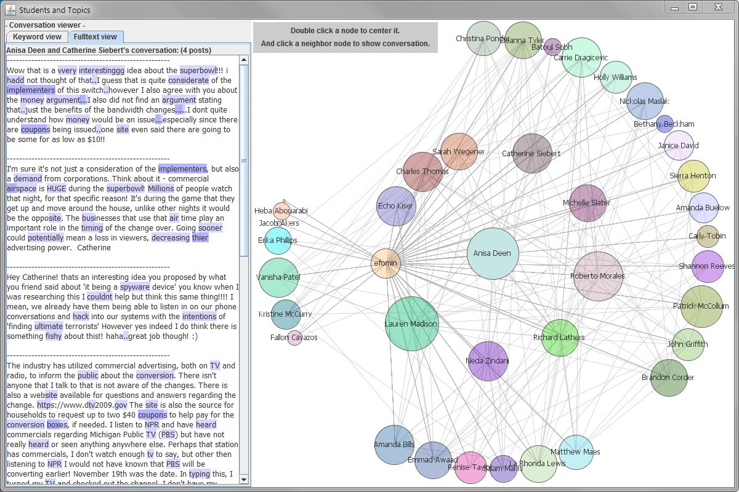
Figure 5 Full text view with keywords highlighted

