**Testimonials**

Vishnuvardan:

"I really enjoyed working with Liberalty Constructions Pvt Ltd. Their designs are strong, practical, and easy to understand. They carefully look at every detail and turn ideas into safe and useful structures. I highly suggest them for planning and design work."

Vivek M

"We hired Liberalty Constructions for our housing project, and they did a great job. They are professional, always kept us updated, and made sure everything went smoothly. Their knowledge gave us confidence during the whole process."

Venumadhav:

"The team at Liberalty Constructions is careful and dependable. Their reports and plans are clear and complete, which made working with contractors easier. They know the challenges of building and give good advice to solve problems."

Suresh:

"The team at Liberalty Constructions stands out for their precision and reliability. Their structural assessments and planning documents are comprehensive and clearly presented, which made coordination with contractors and other stakeholders much easier. They truly understand the practical challenges of construction and provide smart solutions."

Chandrappa K C:

"I approached Liberalty Constructions for designing the structure of my new home, and I couldn’t be happier with the outcome. They patiently understood my needs and provided thoughtful suggestions that optimized space and safety. Their team was approachable, knowledgeable, and always available for support. I’m grateful for their outstanding service."

VHomes  
  
Liberalty Constructions delivered exceptional service for our apartment project. Their team showed professionalism, expertise, and attention to detail from design to completion. They brought our vision to life with precision, communicated excellently, and exceeded expectations. We highly recommend Liberalty Constructions for civil engineering consultancy and look forward to future collaborations.

Tag Lines – Need to choose one from this – suggestions and modifications are welcome.  
  
• **“Smart Designs. Reliable Projects. Trusted Management.”**

• **“Engineering Solutions for Structures, Water, and Growth.”**

• **“Your Partner in Design, Infrastructure, and Project Success.”**

**The description.  
From private residences to vital infrastructure and irrigation projects, we bring your visions to life. With our expert team and innovative solutions, we're not just building structures - we're shaping the future of civil engineering for a better world.**

**About US / Company**  
This is the background of the company, Can take some points from this.

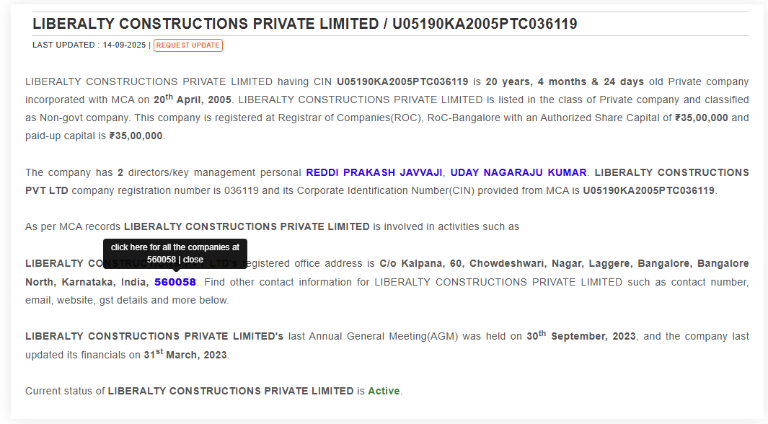  
  
**About Us**  
Liberalty Constructions Pvt Ltd is a trusted name in engineering solutions, offering expert services in structural design, project consulting, irrigation, infrastructure development, and project management. With a focus on precision, reliability, and innovation, we help bring your projects to life — from planning to execution. Our team of experienced professionals works closely with clients to deliver smart, efficient, and sustainable solutions that meet safety standards, budgets, and timelines. Whether it’s designing a strong structure, managing large infrastructure projects, or providing expert advice, we are committed to building a better future, one project at a time.

**Our Services**

**Architectural & Structural Design**

* Floor Plans and Approvals
* Elevation Designs
* Interior Designs & Execution
* Structural Designs
* Layout Plans
* All kinds of 2D & 3D Drawings
* Estimation & Costing
* Project Management & Support

**Surveying & Mapping**

* Survey and Mapping Services for Projects of All Scales

**Irrigation & Water Resource Projects**

* Lift Irrigation Projects
* Tank Filling Projects
* Water Supply Projects
* Bridges and Barrages Projects
* Similar Major and Minor Irrigation Projects

**Infrastructure Development**

* Roads and Highways
* Project Management Services for Infrastructure Projects

At **Liberalty Constructions**, we are dedicated to offering expert solutions across architectural planning, structural engineering, irrigation development, and infrastructure management. Our team focuses on delivering accurate designs, cost-effective planning, and timely execution to ensure the success of every project.  
  
  
  
  
  
  
  
  
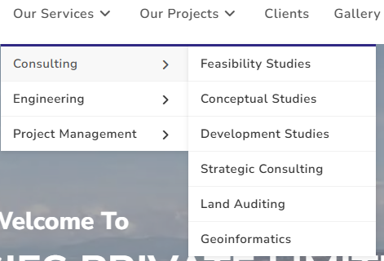

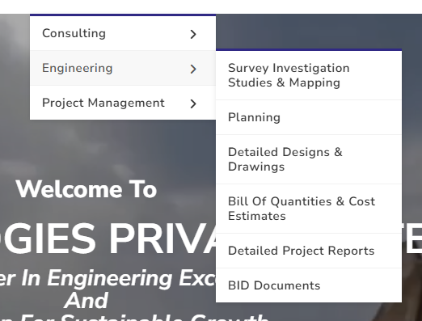

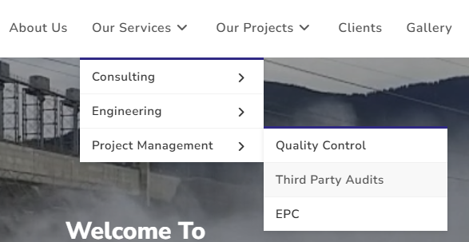  
  
  
Use the same branching but change the order of the items.

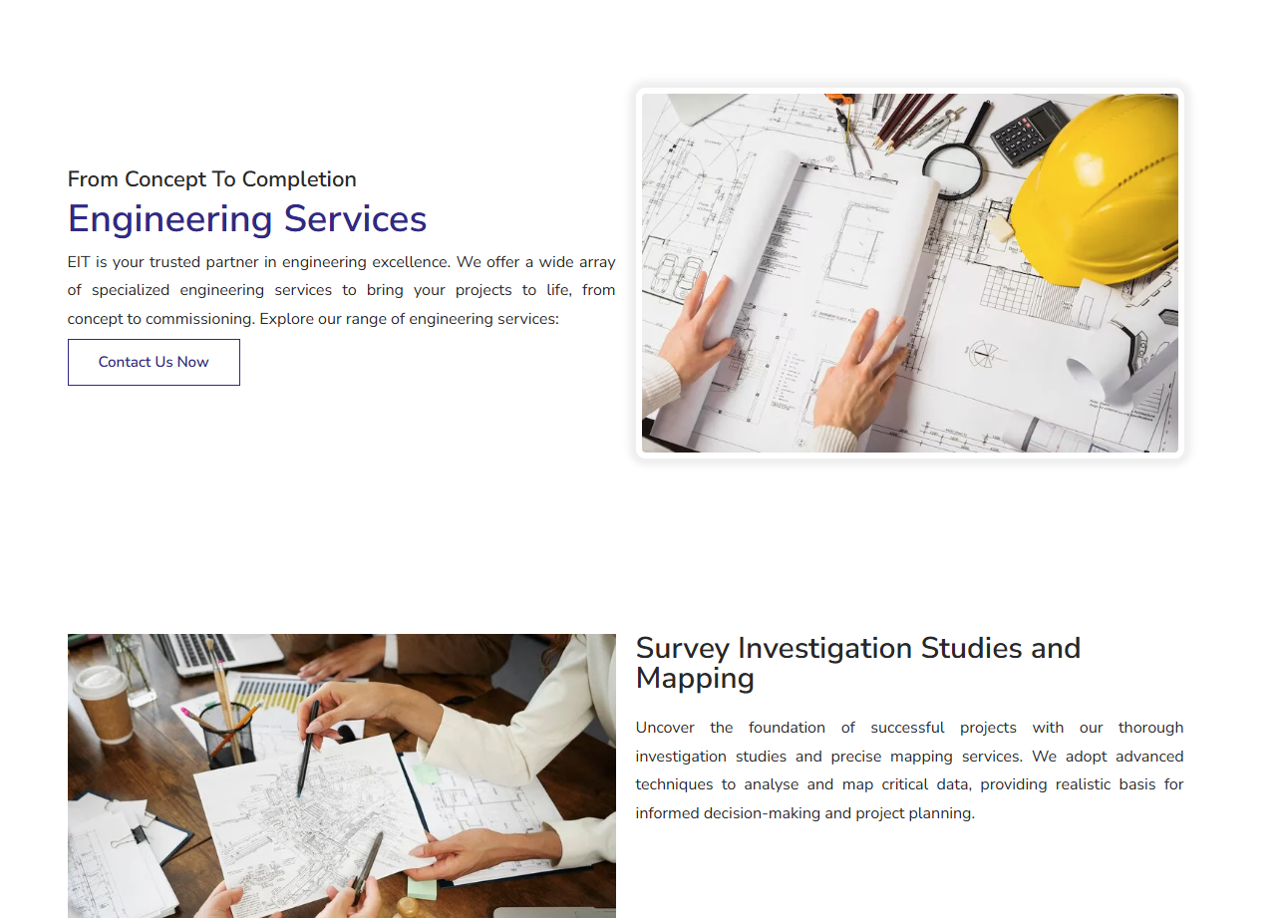  
Use this type of short descriptions about each item