

CSF303: Competitive Programming
Software Engineering

Assignment 1 & 2

Submitted by
Student No: 02230300
Github link: https://github.com/liberationzany/SS2026_CSF303.git

Royal University of Bhutan, College of Science and Technology
Assignment 1

1. STL usage

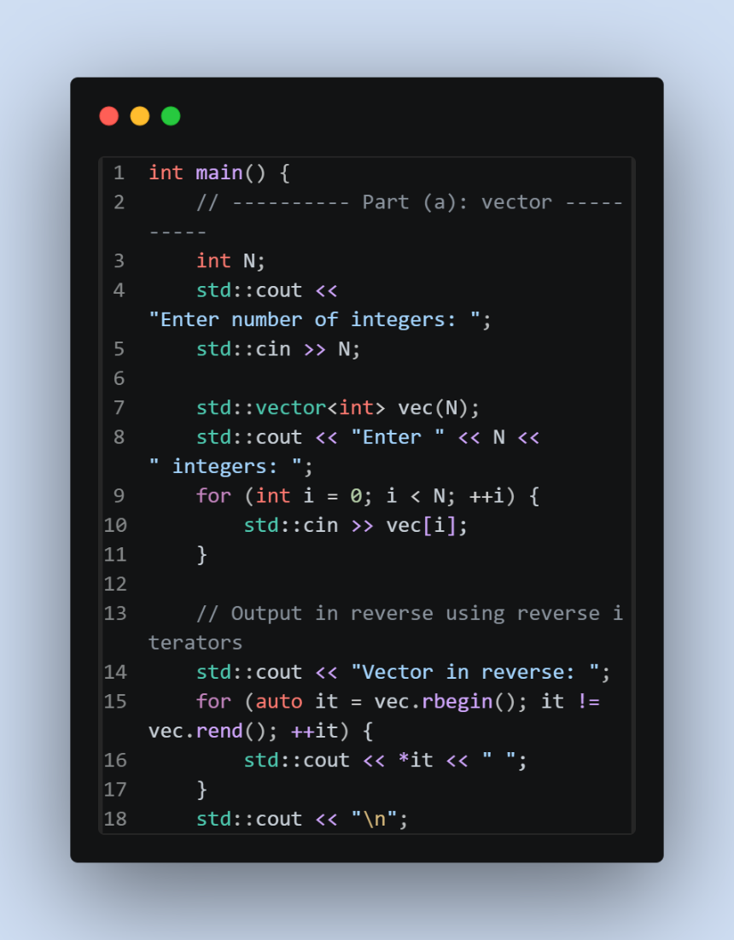

In this implementation, it asks for N number of integers and store them in a vector. Instead of using a standard for loop I have implemented a vec.rbegin() and vec.rend(). rbegin() points to the last element in the array and we increment the iterator backwards toward the start of the vector as we are starting from the end.

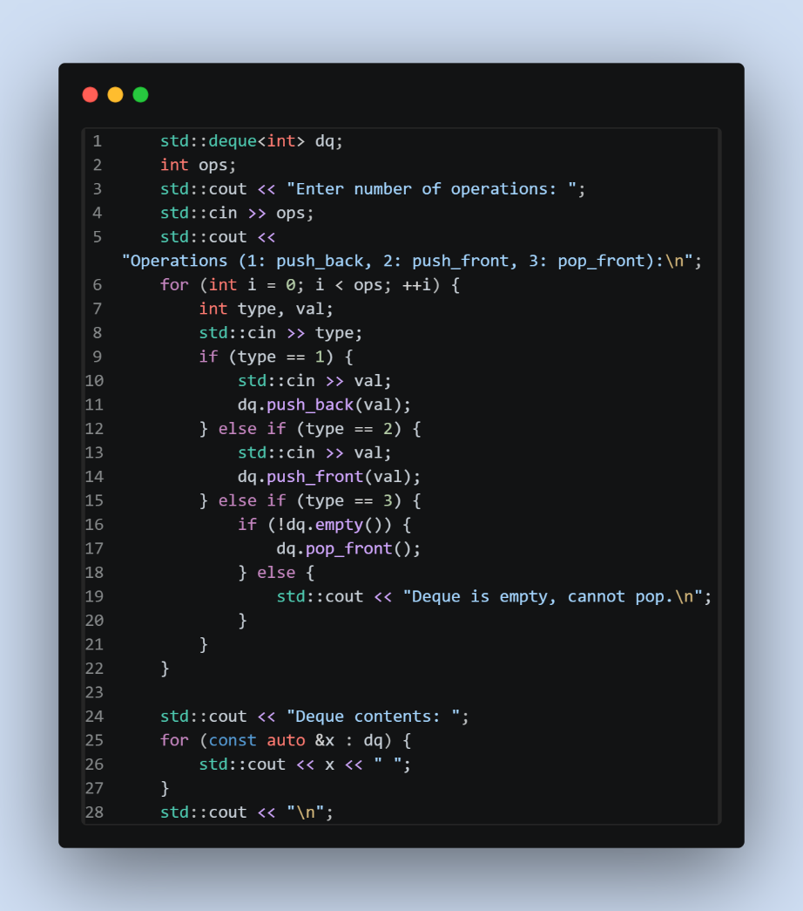

This implementation provides a small interactive menu where a user can push_back elements to the end, push_front which adds element in the front or pop_front which removes the first element. This is an ideal container if one is building something like a undo/redo buffer or a job queue.

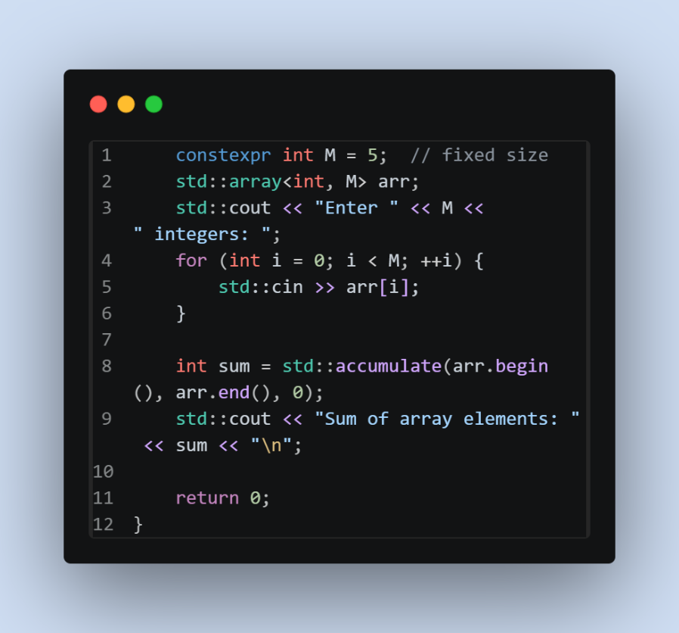

This implementation iterates through the array and sums all the value starting from the index 0.

2. Bellman Ford

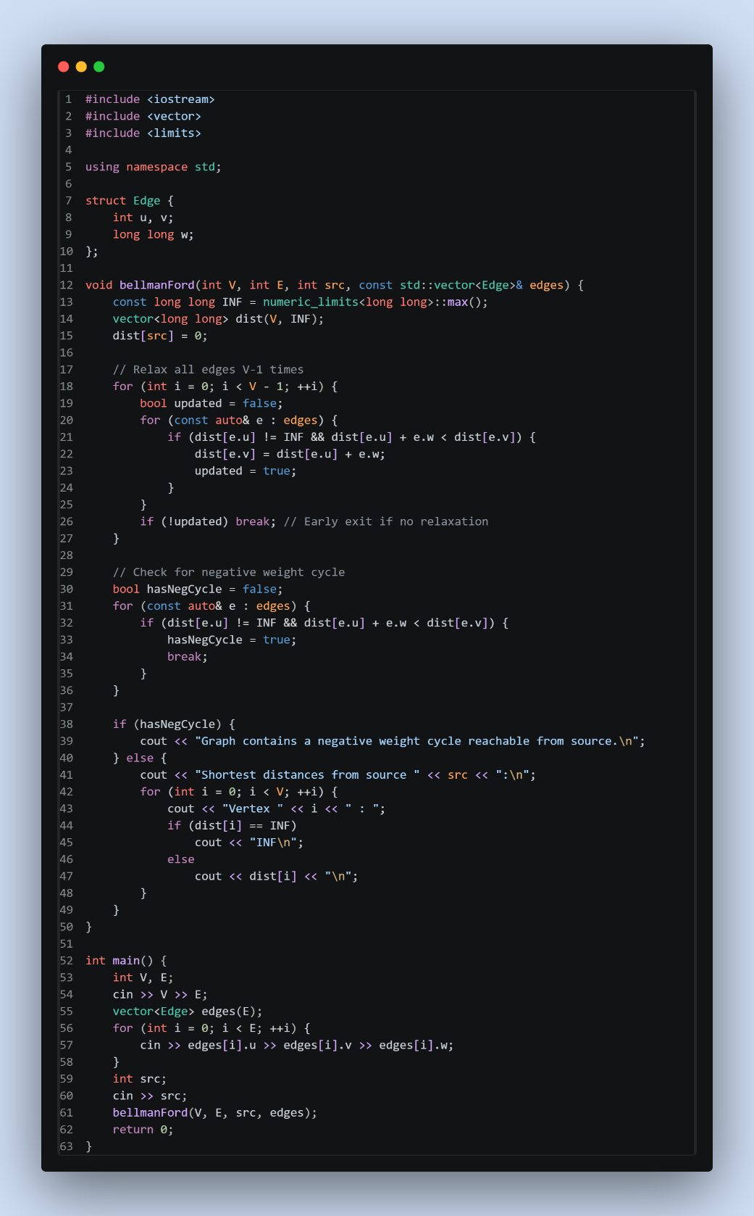

3. Floyd-Warshall

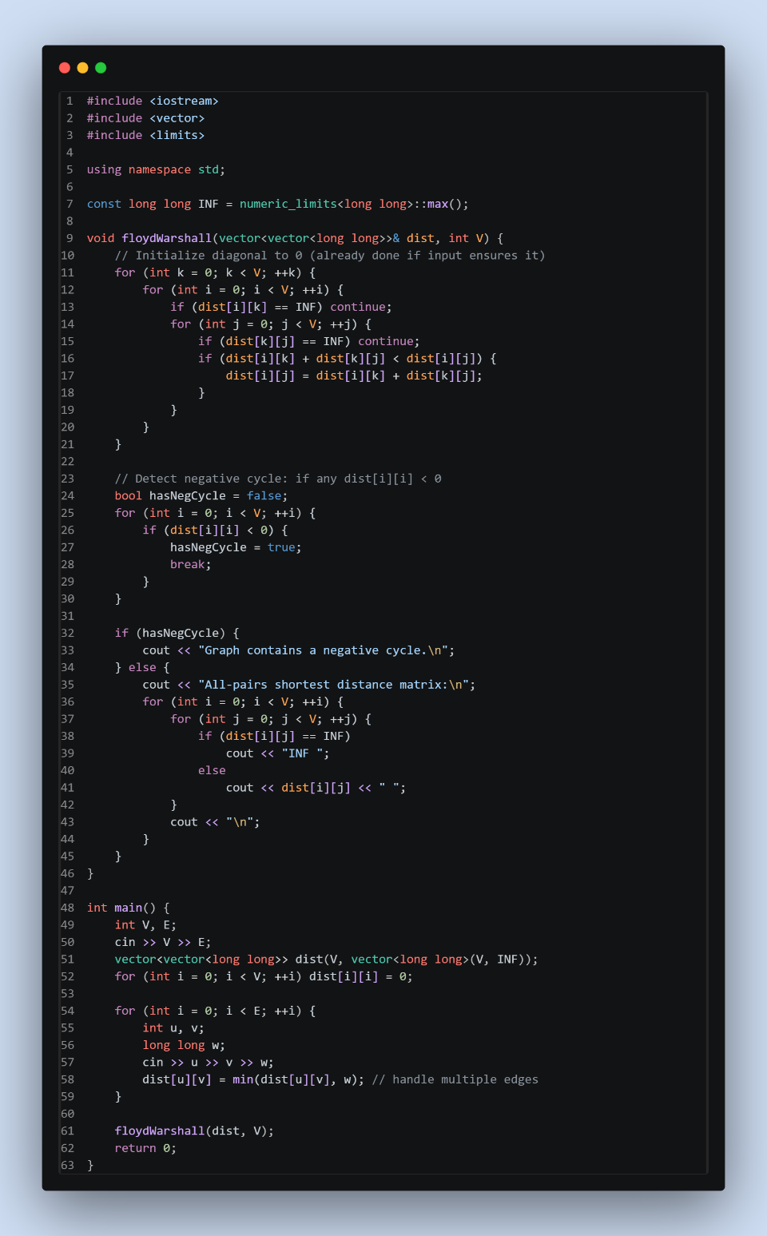

This algorithm relies on dynamic programming and relaxation. Floyd-Warshall algorithm can handle negative weights because we consider all the intermediate vertices and the algorithm itself does not assume non-negative weights. However, the presence of a negative cycle means the shorted distance can be made small or undefined. That’s why in presence of negative cycle, it fails.

Assignment 2

1. Bitmasking

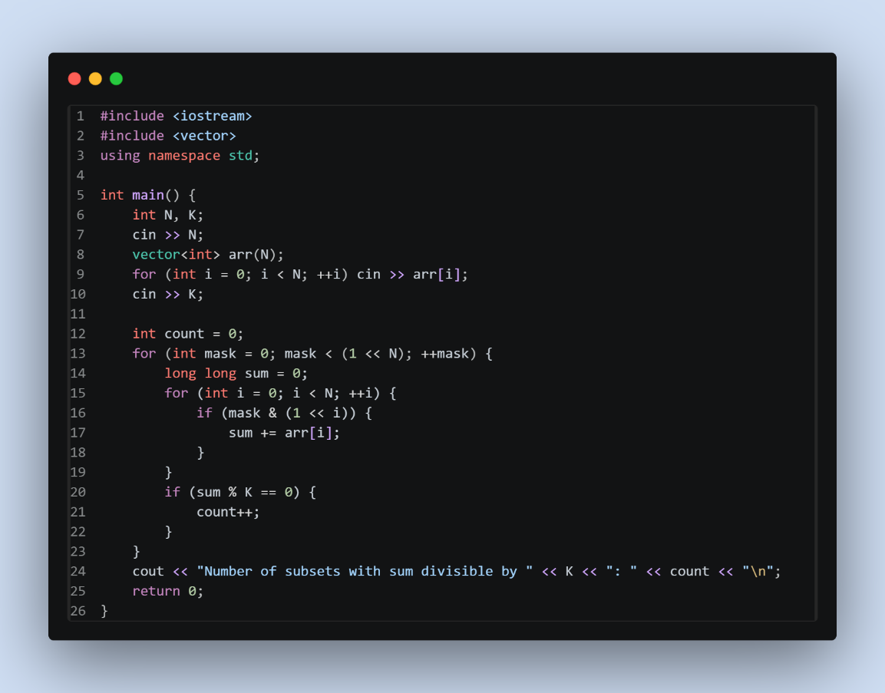

2. Johnson’s Algorithm

Johnson’s algorithm runs in O(V²logV+VE) when it uses Fibonacci heap and O(VElogV) with binary heap which compared to Floyd-warshall’s O(V³) when E is much smaller than V². There, Johnson’s algorithm is better for sparse graph.

Reweighting transforms edge weights to non-negative values so that Dijkstra's algorithm can be used. This is done by adding a dummy node connected to all vertices with zero weight, running Bellman-Ford to compute potential values $h(v)$ for each vertex, and then reweighting each edge $\left(u , v , w\right)$ to $w^{'}=w+h(u)-h(v)≥0$. Bellman-Ford detects any negative cycles before reweighting.

3. Arbitrage Detection in Currency Exchange

The vertices represent the currencies and the directed edge u → v with weight w represents the value of u when exchanging to v from u. A cycle $c_{1}→c_{2}→⋯→c_{k}→c_{1}$ with product of rates > 1 represents an arbitrage opportunity.

First, we take the logarithm of each exchange rate which is -log (rate). If the product of exchange rate is greater than 1, and we take log on both the side and multiply it by -1 then the sum of negative logs becomes less than 0 indicating a negative weight cycle. Hence, this is how arbitrage detection reduces to negative cycle detection

Bellman Ford is used to detect negative cycles after the log transformation. It can find a negative cycle reachable from any source by adding a super-source connecting every vertex.

4. Edmond’s Algorithm

Edmond’s algorithm is used for finding a minimum weight directed spanning at r, where every vertex in the graph can be reached from r via directed edges and the total cost of the selected edges is as minimum as possible.

4. String Matching Algorithms

Index (i) | Pattern[0..i] | LPS[i] | Reason
0 | A | 0 | No proper prefix = suffix
1 | AB | 0 | No match
2 | ABA | 1 | Prefix "A" = suffix "A"
3 | ABAB | 2 | Prefix "AB" = suffix "AB"
4 | ABABC | 0 | No match
5 | ABABCA | 1 | "A" = "A"
6 | ABABCAB | 2 | "AB" = "AB"
7 | ABABCABA | 3 | "ABA" = "ABA"
8 | ABABCABAB | 2 | "AB" = "AB" (longest proper)

When the hash of a pattern matches the hash of a text window, a character by character verification is performed to confirm the match because different strings can have the same hash.

Complexities:
Average case: O(N+M) where $N$ is text length and $M$ is pattern length
Worst case: O(NM) when many spurious hash collisions force verification each time.

