Stress Analysis Report_Traffic_Light_without_Motor_ABS

Analyzed File: | TLA_without_motor.ipt
Autodesk Inventor Version: | 2027 (Build 310192000, 192)
Creation Date: | 2026-08-14, 오후 1:05
Study Author: | Kwon_Doyeong
Summary:

Static Analysis:1
General objective and settings:
Design Objective | Single Point
Study Type | Static Analysis
Last Modification Date | 2026-08-14, 오후 1:00
Model State | [Primary]
Detect and Eliminate Rigid Body Modes | No

iProperties

Summary
Title
Subject
Author | Kwon

Project
Part Number | TLA_without_motor
Designer | Kwon

Physical
Material | Generic
Density | 1 g/cm^3
Mass | 0.115262 kg
Area | 44260.2 mm^2
Volume | 115262 mm^3
Center of Gravity | x=-17.0088 mm  y=30.4949 mm  z=5.28203 mm
Note: Physical values could be different from Physical values used by FEA reported below.
Mesh settings:
Avg. Element Size (fraction of model diameter) | 0.1
Min. Element Size (fraction of avg. size) | 0.2
Grading Factor | 1.5
Max. Turn Angle | 60 deg
Create Curved Mesh Elements | Yes

Material(s)
Name | ABS Plastic
General | Mass Density | 1.06 g/cm^3
General | Yield Strength | 20 MPa
General | Ultimate Tensile Strength | 29.6 MPa
Stress | Young's Modulus | 2.24 GPa
Stress | Poisson's Ratio | 0.38 ul
Stress | Shear Modulus | 0.811594 GPa
Part Name(s) | TLA_without_motor.ipt

Operating conditions

Gravity
Load Type | Gravity
Magnitude | 9810.000 mm/s^2
Vector X | -0.000 mm/s^2
Vector Y | -9810.000 mm/s^2
Vector Z | -0.000 mm/s^2

Selected Face(s)
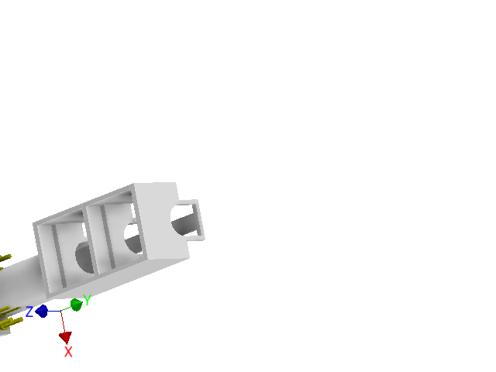

Bearing Load:1
Load Type | Bearing Load
Magnitude | 8.000 N
Vector X | 0.000 N
Vector Y | -8.000 N
Vector Z | 0.000 N

Selected Face(s)

Bearing Load:2
Load Type | Bearing Load
Magnitude | 8.000 N
Vector X | 0.000 N
Vector Y | -8.000 N
Vector Z | 0.000 N

Selected Face(s)

Pressure:1
Load Type | Pressure
Magnitude | 10.000 MPa

Selected Face(s)

Fixed Constraint:1
Constraint Type | Fixed Constraint

Selected Face(s)
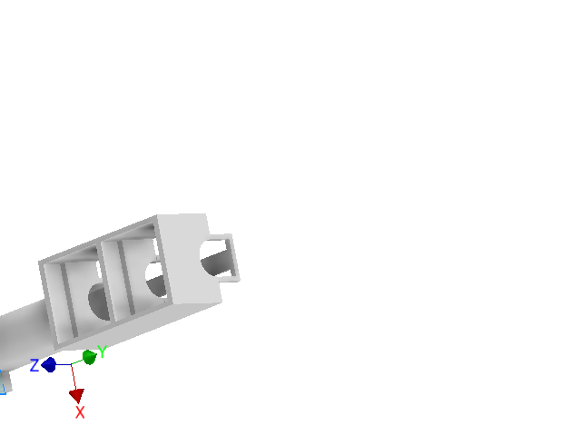

Results

Reaction Force and Moment on Constraints
Constraint Name | Reaction Force |  | Reaction Moment
Constraint Name | Magnitude | Component (X,Y,Z) | Magnitude | Component (X,Y,Z)
Fixed Constraint:1 | 742.761 N | 0 N | 2.27841 N m | 2.27841 N m
Fixed Constraint:1 | 742.761 N | 742.761 N | 2.27841 N m | 0 N m
Fixed Constraint:1 | 742.761 N | 0 N | 2.27841 N m | 0 N m

Result Summary
Name | Minimum | Maximum
Volume | 31208.1 mm^3
Mass | 0.0330806 kg
Von Mises Stress | 0.0000289497 MPa | 14.6725 MPa
1st Principal Stress | -10.1656 MPa | 7.69009 MPa
3rd Principal Stress | -25.6316 MPa | 2.94668 MPa
Displacement | 0 mm | 0.0258059 mm
Safety Factor | 1.3631 ul | 15 ul

Figures

Von Mises Stress
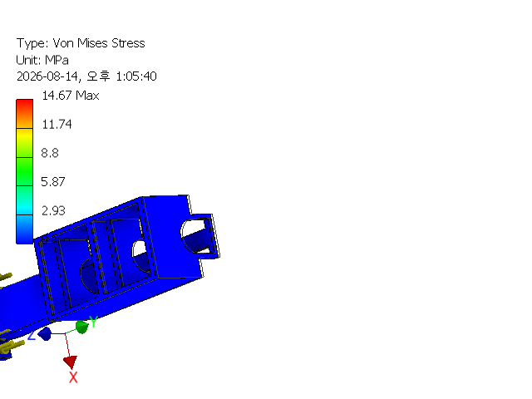

1st Principal Stress
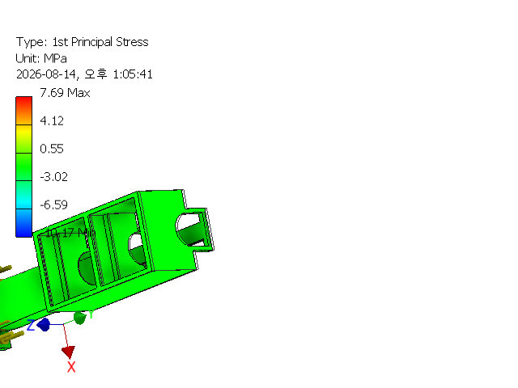

3rd Principal Stress
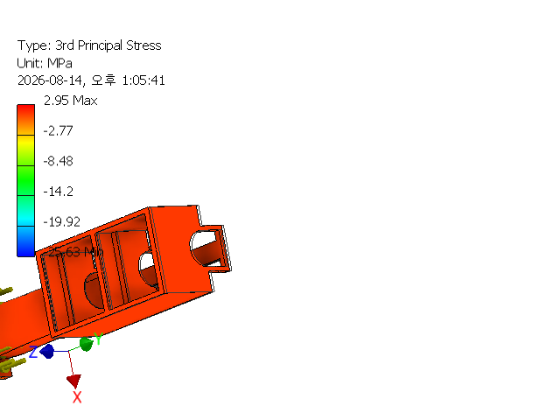

Displacement
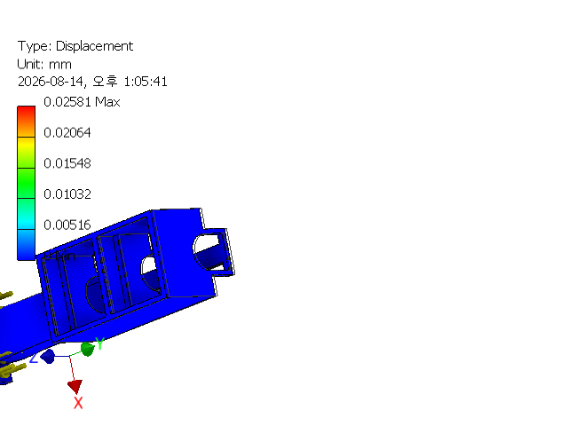

Safety Factor
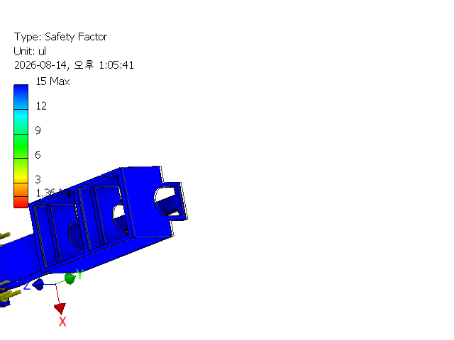
C:\Users\Kwon\OneDrive\바탕 화면\CAD_projects\3D\FEA\TLA_without_motor.ipt

