

**UNIVERSITY OF RWANDA**

**NYARUGENGE CAMPUS**

**ICT/CSE**

**MODULE: SOFTWARE DESIGN AND DEVELOPMENT**

**PROJECT PARTNERS: -AMIZERO SIFA 221011109**

**-UWIMANA LIBERTHA 221006043**

**DATE: JANUARY 19, 2024**

**PROJECT NAME: E-SHOP**

**TABLE OF CONTENTS**

* + PURPOSE
  + SCOPE
  + OVERVIEW
  + REFERENCES

**TABLE OF FIGURES**

# **LIST OF ABBREVIATIONS**

**Chapter 1. Introduction**

1.1 Historical background of the case study: …………………………………….....................................

1.2 Problem Statement ……………………………..…………………

1.3 Objectives of my project: …………………………………………..

**Chapter 2. System analysis and design**

### 2.1 System analysis: …………………………………………….

2.1.1 Functional requirement of project: ……………………….

2.1.2 Intended users of project…………………………………

2.1.3 Intended system partner…………………………………

**2.2 System design……………………………………………….**

2.2.1 Database design with ERD and relationship………………….

**Chapter 4. Implementation**

4.1 All screenshots with captions and discussion

**4.2 Recommendation: Link for project**

**4.3 CONCLUSION**

**PURPOSE OF THE E-SHOP**

The **E-Shop** platform is developed with the overarching purpose of creating a versatile and efficient online marketplace that facilitates seamless transactions between buyers and sellers.

**SCOPE**

The scope of the **E-Shop** platform encompasses a comprehensive set of features and functionalities designed to create a robust and user-friendly online shopping experience. The platform caters to both customers and administrators, offering a diverse range of capabilities to facilitate seamless e-commerce operations.

**DOCUMENT OVERVIEW**

The next paragraphs of the document has described structure of the **E-SHOP**. The high level components and their interactions, physical arrangement of components and design decisions applied to the whole system. Others of the System is on Component and detailed design. Includes database design in detail and user interface design with screen shots of the interfaces.

**Chapter 1. Introduction**

**1.1 Historical background of project**

The historical background of the E-Shop platform provides context for its development, tracing the evolution of online shopping and e-commerce. Understanding the journey and milestones in the history of the E-Shop contributes to a comprehensive view of its inception and growth

**1.2 Problem statement**

Challenge: Users faced a fragmented and inconsistent experience while navigating various online shopping platforms. The lack of a unified design and user interface across devices resulted in confusion and hindered user engagement.

**1.3 Objective of project**

The E-Shop focused on fostering user engagement by introducing features like wishlists, allowing users to bookmark and share their favorite products. The integration of social media logins and sharing options aimed to create a more interactive and socially connected shopping experience.

**FEASIBILITY ANALYSIS**

The feasibility analysis of the E-Shop platform involves examining both technical and economic aspects to determine its viability and potential success.

**TECHNICAL FEASIBILITY:** The E-Shop's use of the Laravel PHP framework provides a solid foundation. Laravel's MVC architecture supports modular development, ensuring scalability and maintainability.

**ECONOMICAL FESIBILITY:** Utilizing open-source technologies like Laravel can reduce development costs. However, initial investments in skilled developers and technology infrastructure are necessary for successful implementation.

**Chapter 2. System Analysis and Design**

**2.1 System Analysis**

**2.1.1 Functional requirement of project**

**Requirement Definition**

Functional requirements define the specific features and capabilities that the E-Shop platform must possess to meet the needs of its users and administrators.

The functional requirements outlined above provide a detailed specification of the features and capabilities that the E-Shop platform must deliver. These requirements serve as a foundation for the design and development phases, ensuring that the platform meets user expectations and business objectives.

1. **User requirements**

Screenshots Understanding and addressing these user requirements is essential for the successful development and adoption of the E-Shop platform. The platform's design and features should align closely with these expectations to ensure user satisfaction and engagement.

**2. Functional requirement**

Functional requirements specify the fundamental functionalities and features that a system or software application must provide to meet the needs of its users and achieve its intended purpose.

1. Functional requirement of project Product Browsing and Selection
2. Shopping Cart Management
3. Wishlist Creation and Management
4. Product Reviews and Ratings
5. Social Media Integration

**2.1.2 Intended users of project**

1. shoppers

2. Reviewers

3. administrators

4. general users

5. wishlistcreators

6. system partners

**2.2 System design**

**2.2.1 Database design with ERD and relationship**

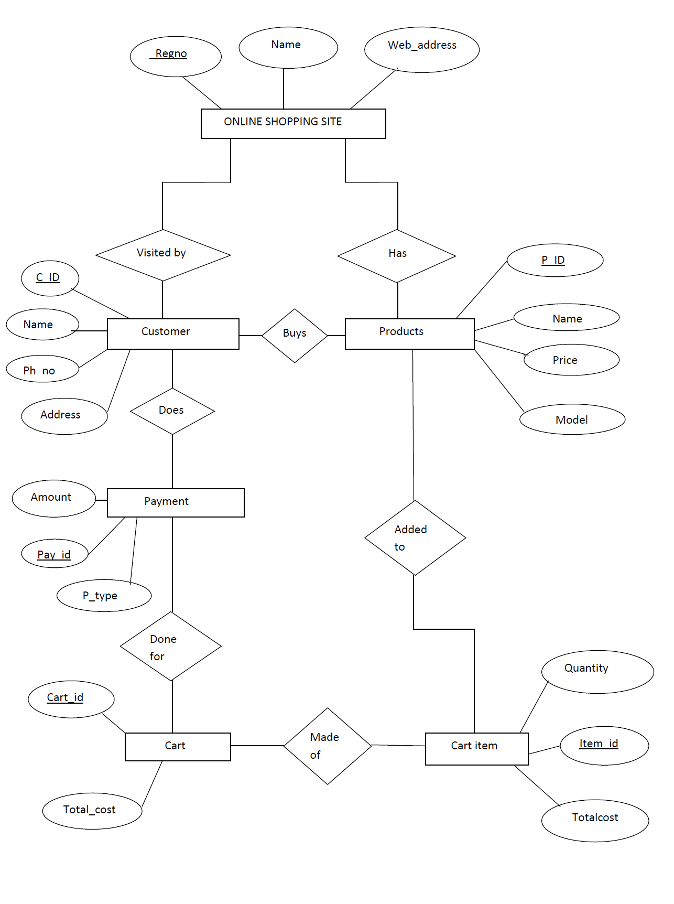

**E-SHOP**

**Chapter 4. Implementation**

**4.1 ALL THE SCREENSHOTS**

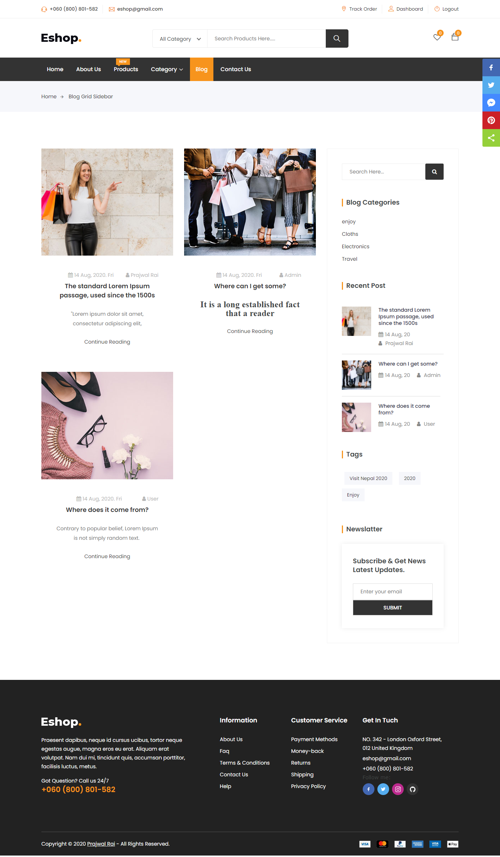

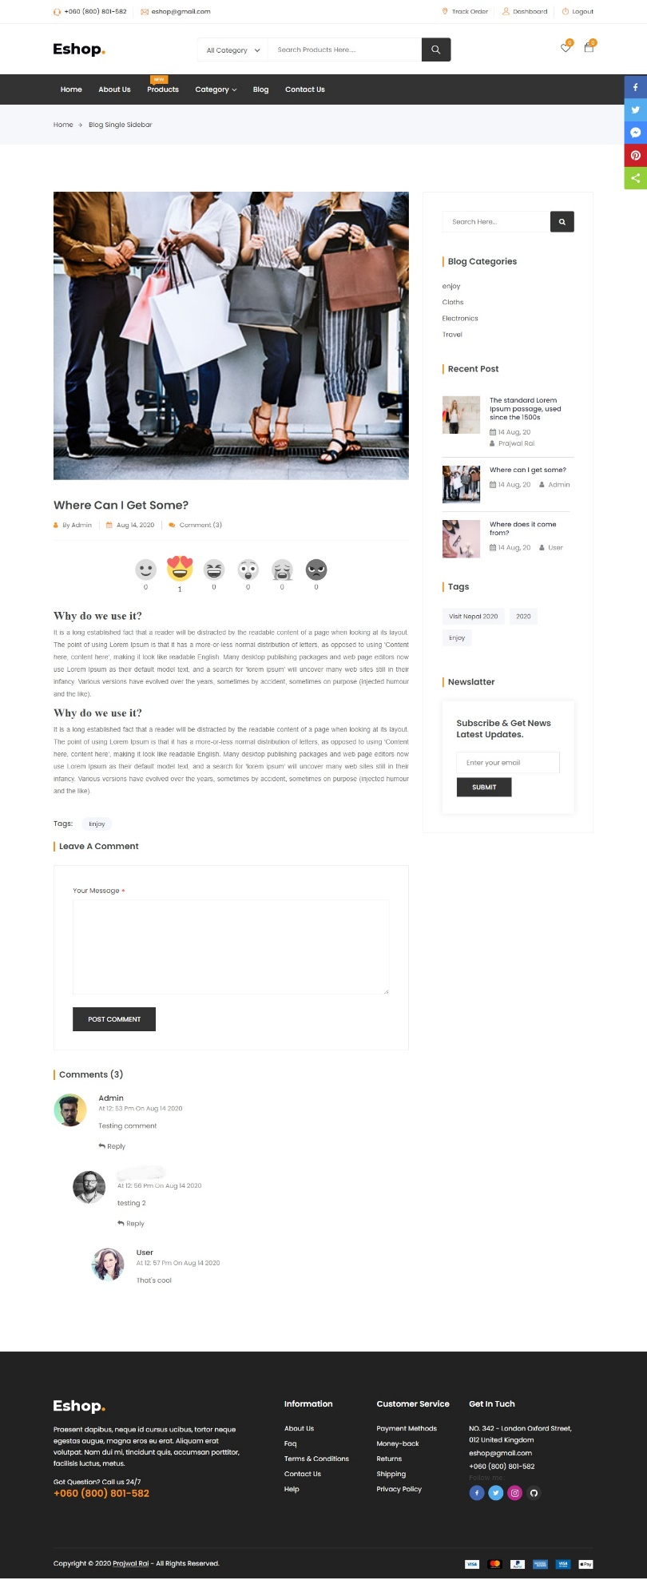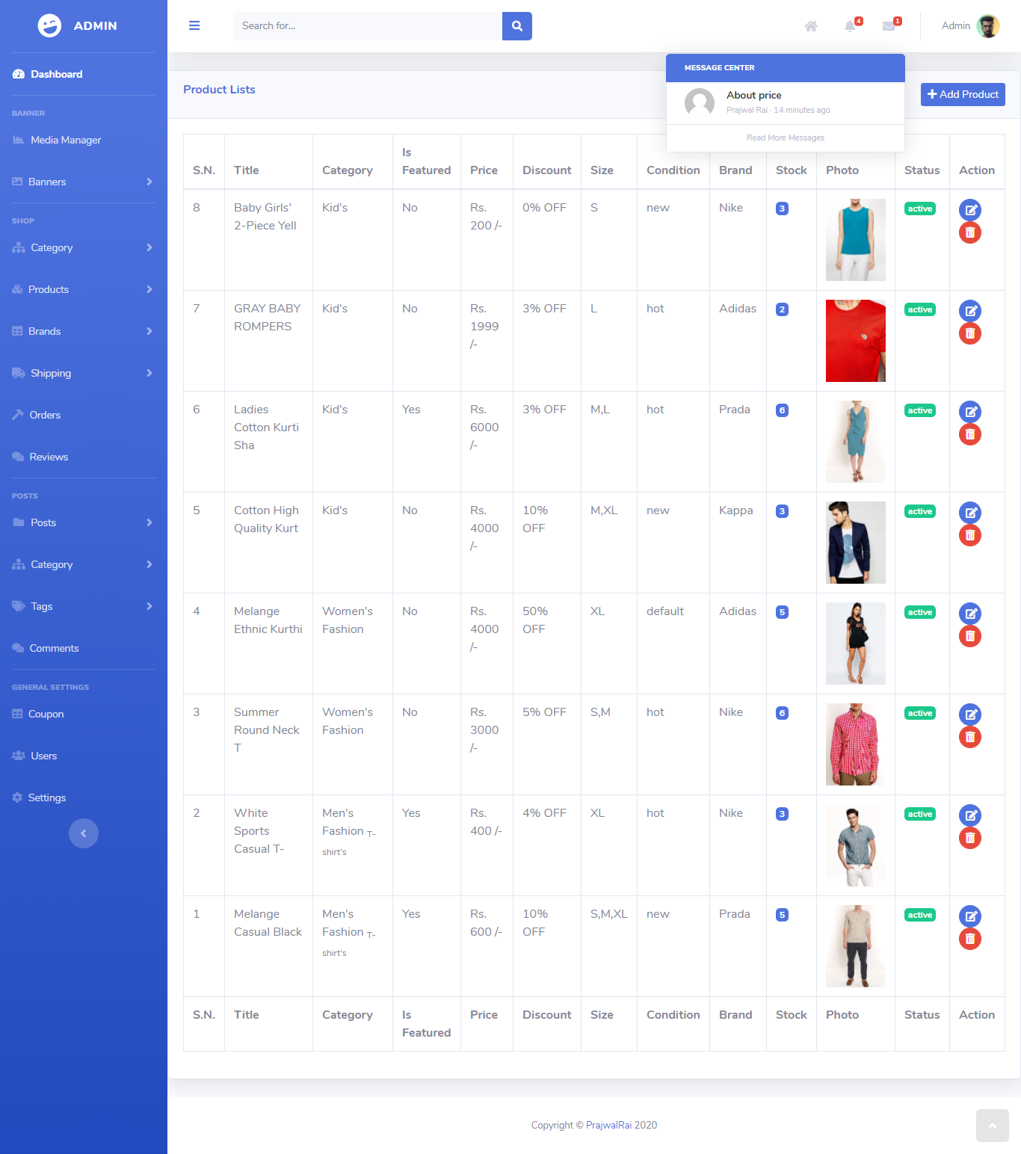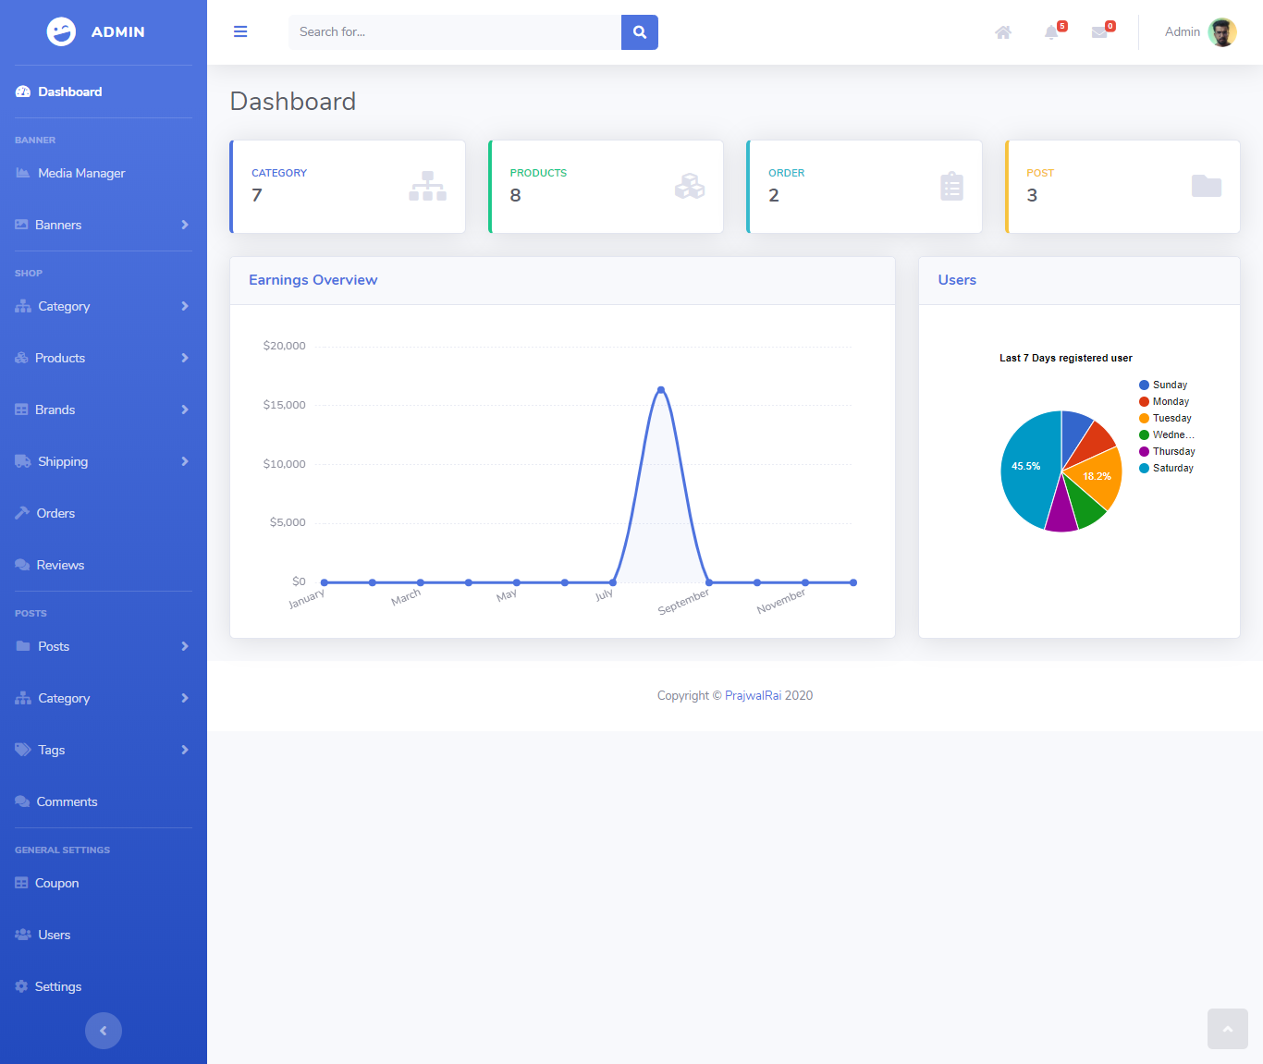

**4.3 Conclusion**

In conclusion, the E-Shop platform stands as a testament to the synergy of thoughtful design, robust development, and a commitment to creating a user-friendly and efficient e-commerce experience. As the platform enters the hands of users and administrators, we eagerly anticipate its growth and success in the dynamic landscape of online commerce.**Top of Form**

The development journey of the E-Shop platform has been a collaborative effort, involving meticulous planning, innovative design, and dedicated implementation**.**

**4.4 recommendation**

**4.4.1 project link**

[*https://github.com/liberee1/eshop.git*](https://github.com/liberee1/eshop.git)