Team Poffertjes

*Poffertjes: Dutch Mini Pancakes. Children are crazy for them and plenty of adults as well. I’ve always gotten them from street carts in the busier cities or markets.*

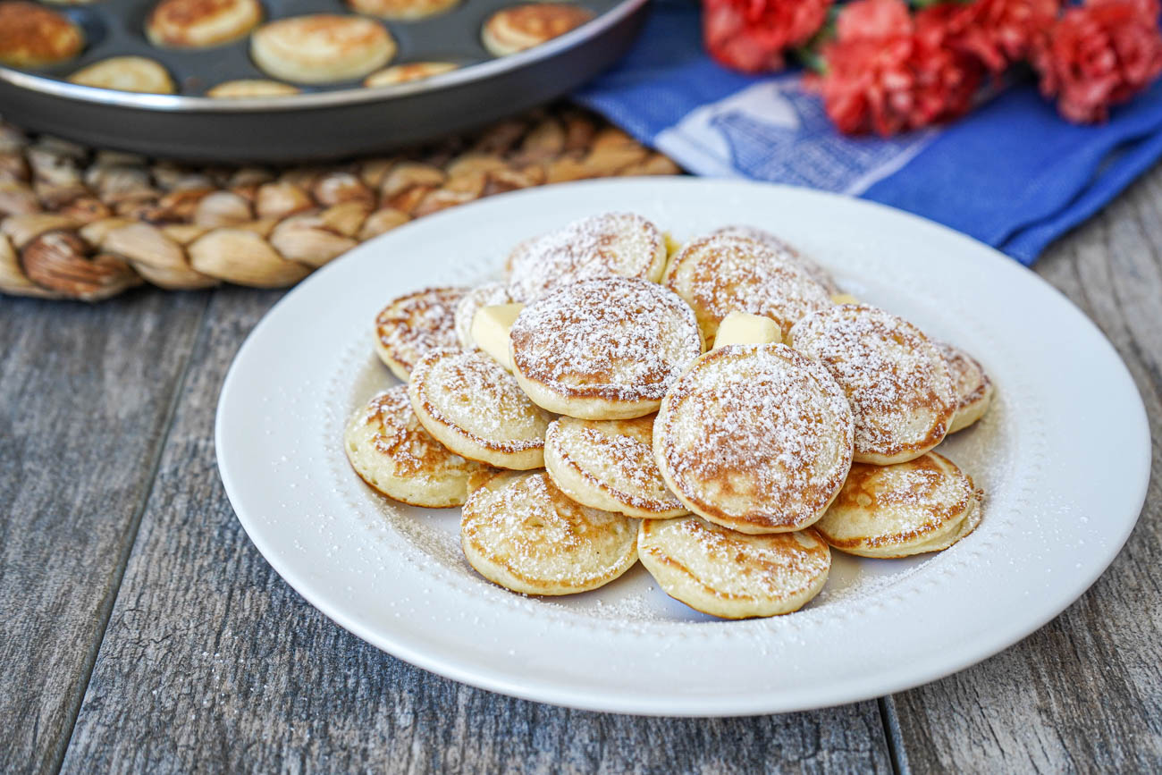

# Link Back To The Main Doc

<https://tinyurl.com/liber-dslib-doc>

# Roles

*Please take a few minutes to assign the roles of timekeeper, moderator, notetaker, and reporter.*

*Of course, everyone can and should share the tasks associated with the roles - but it’s nice to*

* **Timekeeper:**
* **Moderator:**
* **Notetaker:**
* **Reporter:**

# Real-Life Breakout Session 1: DSLib Activities

**What are some examples of data science activities you (wish to) carry out at your library?**

✏ **Draw them on the flashcards!**

* Draw on one side, just have fun with it.
  + *This can be anything! You can show activities taking place between different people. Or a flowchart-style data workflow right from input (obtaining the data) to output (results or outcome) and all the steps in between. Or even just one or two data workflow steps. You can draw objects or scenarios. No need to overthink it, just have fun!*
* Put a caption/explainer on the other side.
* In pairs, try to interpret each other’s masterpieces.

🗨 **Discuss with your subgroup as you go. Add your notes/points below.**

* **Social Media: How to collect/archive data? (License /ownerships?)**
* **Use data to improve services in the library**

📝**Provide a summary below and use it when you report back to the whole group.**

………….

# Real-Life Breakout Session 2: DSLib Categories

**Categorize your own DS activities + the examples!**

**Tag the flashcards with stickers. More than one category is possible!**

🟢 Collections as Data

🔵 Library Intelligence

🟡 Research Support

🔴 Research Intelligence

🗨 **Discuss with your subgroup as you go. Add your notes/points below.**

* **Agreed on LIbrary Intelligence on the first card / topic**
* **Agreed on LIbrary Intelligence on the second card / topic**

📝**Provide a summary below and use it when you report back to the whole group.**

“”Collections” might not be the appropriate term, cause they are not owned by the library

# Real-Life Breakout Session 3: Landscape Analysis

**The WG needs your input to develop the landscape analysis!**

🧠 **Some discussion prompts to get things going (you’re not limited to these questions):**

1. What are the opportunities and challenges with respect to carrying out data science in libraries?
2. If the WG works on a landscape analysis/report/advice/recommendation:
   1. What kind of information would you like to see?
   2. What kind of information do you think all libraries would benefit from?
3. What kind of data do you (wish to) work with?
4. What tools/software/programming languages do you (wish to) work with?
5. What are the typical roles/functions in the library associated with data science?
6. What is the background/training for individuals doing data science in libraries?
7. What else would you want out of our WG’s activities? Where can we provide the most valuable input?

🗨 **Discuss with your subgroup as you go**. ✏ **Add your notes/points below.**

* Guiding frame about collections. Structured data collection.
* What is meant by data "science"? Analytics, Engineering, etc.
* What is the landscape for?
* The range of the landscape.

📝 **Provide a summary below and use it when you report back to the whole group.**

…………

# Real-Life Breakout Session 4: DSLib Survey

**Link to (draft) DSLib Survey:**<https://survey.uu.nl/jfe/form/SV_eswlDMEJuaf9nGS>

👁‍🗨 **Skim through the survey and imagine filling it out yourself/for your library.**

What are the points for improvement? What is missing?

🗨 **Discuss with your subgroup as you go. Add your notes/points below.**

* **…..**
* **…..**

📝**Provide a summary below and use it when you report back to the whole group.**

………….

# Closing

* **Would you be open to being contacted for the survey?** 
  + [Name/ Yes/No]
* **Would you like to join our WG or contribute in any other way?**
  + [Name, …..]
* **Links:**
  + WG website:
  + <https://libereurope.eu/working-group/liber-data-science-in-libraries-working-group/>

* + WG open notes: <https://hackmd.io/@nehamoopen/liber-dslib/>