Team Stroopwafels

*Stroopwafel: The one and only Dutch Syrup Waffle/Cookie. The best ones are baked fresh on market days or in busy areas. Today, you get the supermarket version - still good!*

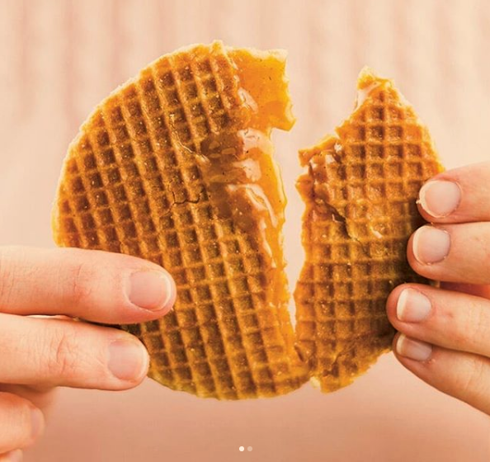

# Link Back To The Main Doc

<https://tinyurl.com/liber-dslib-doc>

# Roles

*Please take a few minutes to assign the roles of timekeeper, moderator, notetaker, and reporter.*

*Of course, everyone can and should share the tasks associated with the roles - but it’s nice to*

* **Timekeeper: Karoline**
* **Moderator: Stéphanie**
* **Notetaker: Athanasia**
* **Reporter: Kamran**

# Real-Life Breakout Session 1: DSLib Activities

**What are some examples of data science activities you (wish to) carry out at your library?**

✏ **Draw them on the flashcards!**

* Draw on one side, just have fun with it.
  + *This can be anything! You can show activities taking place between different people. Or a flowchart-style data workflow right from input (obtaining the data) to output (results or outcome) and all the steps in between. Or even just one or two data workflow steps. You can draw objects or scenarios. No need to overthink it, just have fun!*
* Put a caption/explainer on the other side.
* In pairs, try to interpret each other’s masterpieces.

🗨 **Discuss with your subgroup as you go. Add your notes/points below.**

* **Data science in our institutions : search engine, oa data via data studio, teaching and mixing methods making understandable to non-data science related fields of study, coding approach more focused on researchers**
* **Data science based on perspectives of every-day use of the library, making data science understandable to everyone on how it can be implemented in every study field, making results available and understandable to public, text and data mining**
* **Sustainability in all resources – collecting related data**

📝**Provide a summary below and use it when you report back to the whole group.**

………….

# Real-Life Breakout Session 2: DSLib Categories

**Categorize your own DS activities + the examples!**

**Tag the flashcards with stickers. More than one category is possible!**

🟢 Collections as Data

🔵 Library Intelligence

🟡 Research Support

🔴 Research Intelligence

🗨 **Discuss with your subgroup as you go. Add your notes/points below.**

* **Student focused teaching activities: can be on collection as data category, research support category and library intelligence category**
* **Data mining can be implemented in every category**
* **Every-day use of library: collection as data its giving details about the library and its feeding into the research support and library intelligence and the data can be used for research intelligence as well**
* **Making data available and understandable to public can be implemented into the collection as data category in means of of including activities that ensure the quality and clarity of the data, in order to analyze it and make it available to public**
* **…..**

📝**Provide a summary below and use it when you report back to the whole group.**

………….

# Real-Life Breakout Session 3: Landscape Analysis

**The WG needs your input to develop the landscape analysis!**

🧠 **Some discussion prompts to get things going (you’re not limited to these questions):**

1. What are the opportunities and challenges with respect to carrying out data science in libraries?
2. If the WG works on a landscape analysis/report/advice/recommendation:
   1. What kind of information would you like to see?
   2. What kind of information do you think all libraries would benefit from?
3. What kind of data do you (wish to) work with?
4. What tools/software/programming languages do you (wish to) work with?
5. What are the typical roles/functions in the library associated with data science?
6. What is the background/training for individuals doing data science in libraries?
7. What else would you want out of our WG’s activities? Where can we provide the most valuable input?

🗨 **Discuss with your subgroup as you go**. ✏ **Add your notes/points below.**

* What tools to use when publishing data and other information resources for more transparency
  + What existing tools used
  + Course of action
  + Newly developed tools
* One challenge is becoming discipline specific, focusing on one are more than the others. One problem would be stepping on other territories or sometimes doing something that has already been done.
* Transparency of on-going or past projects
  + Avoiding overlapping and nervousness bringing up new projects.

📝 **Provide a summary below and use it when you report back to the whole group.**

…………

# Real-Life Breakout Session 4: DSLib Survey

**Link to (draft) DSLib Survey:**<https://survey.uu.nl/jfe/form/SV_eswlDMEJuaf9nGS>

👁‍🗨 **Skim through the survey and imagine filling it out yourself/for your library.**

What are the points for improvement? What is missing?

🗨 **Discuss with your subgroup as you go. Add your notes/points below.**

* **…..**
* **…..**

📝**Provide a summary below and use it when you report back to the whole group.**

………….

# Closing

* **Would you be open to being contacted for the survey?** 
  + [Name/ Yes/No]
* **Would you like to join our WG or contribute in any other way?**
  + [Name, …..]
* **Links:**
  + WG website:
  + <https://libereurope.eu/working-group/liber-data-science-in-libraries-working-group/>

* + WG open notes: <https://hackmd.io/@nehamoopen/liber-dslib/>