DPOW Studio

Description
DPOW Studio is a complete editor for PES graphics layout files (DPOW). It allows you to modify any aspect of a DPOW file, which means creating your own unique animations and layouts. With DPOW Studio, all DPOW aspects are fully editable.

DPOW Structure
DPOW consists of animations (or layers) that are rendered into time. Each animation, is actually a timeline with keyframes (elements) on specifc time positions. Each element, contains graphic objects: images (textures), strings (texts) and icons (flags). In addition, there are several events that are fired through time, from the game. Each events declares the amount of frames that is going to be played for an animation, from the game.

Animations
Animations can be considered as layers. They exist in a tree structure, having a parent-child relationship with each other. The tree is one way, for the game, to pick the animations that are going to run in the game. It also takes part on the way the game fills certain dynamic contents (to strings or icons) for objects. For instance, during the game entrance the game may render a team logo on a specific icon at a specific child of a tree. Animation names, doesn't seem to affect the way the game finds those objects, it's the exact position in the tree that matters for that.
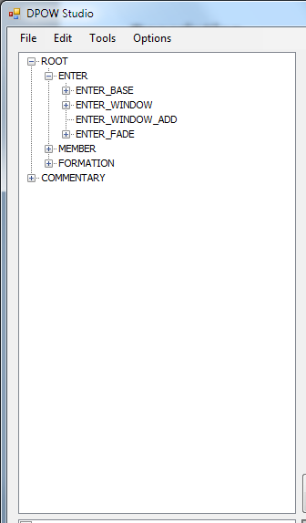Image 1: Tree view for animations

Keyframes (elements)
Formerly known as elements, keyframes set the positions and attributes of the graphic objects (images, strings and icons) for specified time positions in an animation. It makes good sense to have the same number of objects on all keyframes of the same animation, otherwise the game will crash when trying to move from an element with, e.g., 2 images to another with 3 images.
The game automatically interpolates values for attributes between 2 keyframes. That means, that if you set an image on a keyframe at frame 0 and another on frame 10, when the intermediate frames are shown into the game, the attributes of the image shown will be interpolation from image on frame 0 to image on frame 10. For instance, you may set a starting position on one frame and a final position on another frame and the game will move the object from one place to another, using linear interpolation. Notice that this won't apply on the preview: this editor's graphics preview doesn't interpolate values for intermediate frames and will only show objects of existing keyframes.

Graphics objects (Images / Strings / Icons)
Graphics objects are already known. They consist of several attributes which are different for each kind of those objects and are fully editable.

Events
Events are the second factor that the game uses to decide which frame is going to be shown. There is a list of events available in the DPOW, but there is no way to set which event is going to be fired, this is handled by the game's code. Each animation, has a list of event definition: the eventid, the start and end frame. That means, that when the event with the specific id is fired, an animation will start from the starting frame time position and the animation will end on the specified end frame. There is also another attribute on event definitions, which decides weither this is a reverse animation or not (reverse means that the animation will go from the end frame to the start frame, besides normal).
In the editor, events are handled more like variables. This means that when you move the time bar, on the preview you will only see the keyframes from events that are enabled (checked) on the events control.

