FS10-ATMEGA32U4
Programming Guide
Physical connection, Arduino build, and upload reference
Firmware source | firmware/FS10-ATMEGA32U4/FS10-ATMEGA32U4.ino
Controller | ATmega32U4, 5 V, 16 MHz
Release status | Company review programming procedure

Purpose
Use this guide to connect an approved ISP programmer to the FS10 board, build the current Arduino firmware, upload it, and complete a basic post-programming check. The photographs show the actual ICSP1 programming connection used with the FS10 board.
Important — The photographs are visual aids, not a substitute for verified pinout information. Do not rely on wire color or connector orientation alone. Confirm target power, common ground, ICSP1 pin 1, and ribbon orientation against the approved schematic or programming fixture before applying power or uploading firmware.

Before you begin
- Approved FS10 unit and its current hardware documentation.
- Approved ISP programmer and correctly keyed programming ribbon/adapter.
- USB cable for the ISP programmer and a computer with Arduino IDE installed.
- Current firmware release folder, including FS10-ATMEGA32U4.ino.
- The required Arduino libraries: Adafruit GFX Library; Adafruit ST7735 and ST7789 Library; and built-in SPI.

1. Connect the programmer
With the FS10 unpowered unless the approved programming procedure specifies otherwise, locate the board header marked ICSP1. Connect the approved ISP ribbon/adapter to that header. Ensure the connector is fully seated without forcing it.
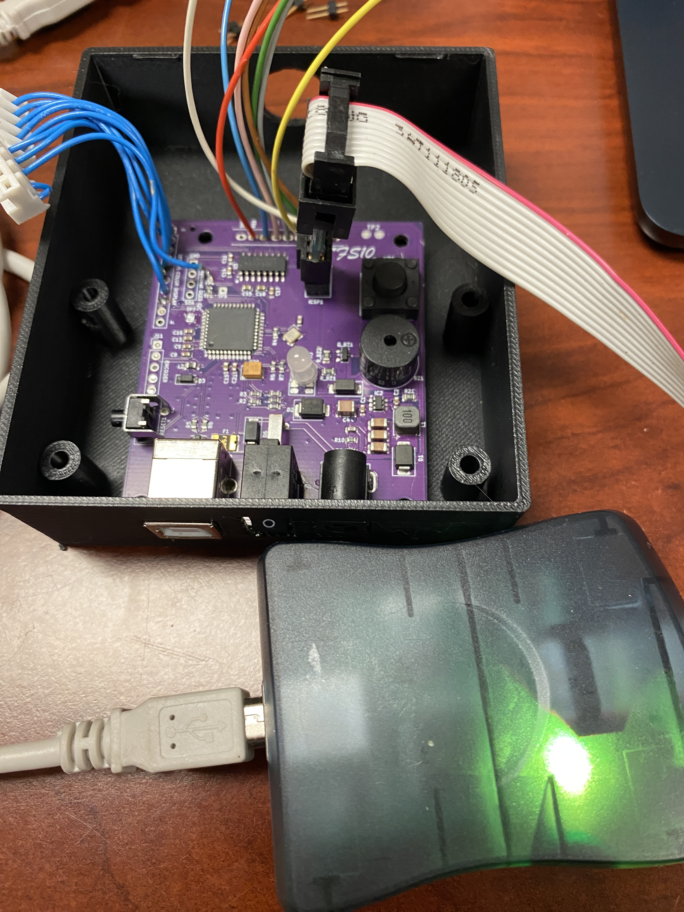
Figure 1. FS10 board in enclosure with the programming ribbon connected to the header labeled ICSP1. The external programmer is shown in the foreground.
Connection check — Before proceeding, inspect that the ribbon is seated, the cable is not strained, the FS10 has a valid ground path, and the connector orientation has been verified against the approved board documentation.

2. Verify the close-up connection
The close-up below shows the ISP adapter seated at ICSP1. Use it to confirm the physical location of the header and the seated connection. It does not establish pin numbering or permit reversing the connector.
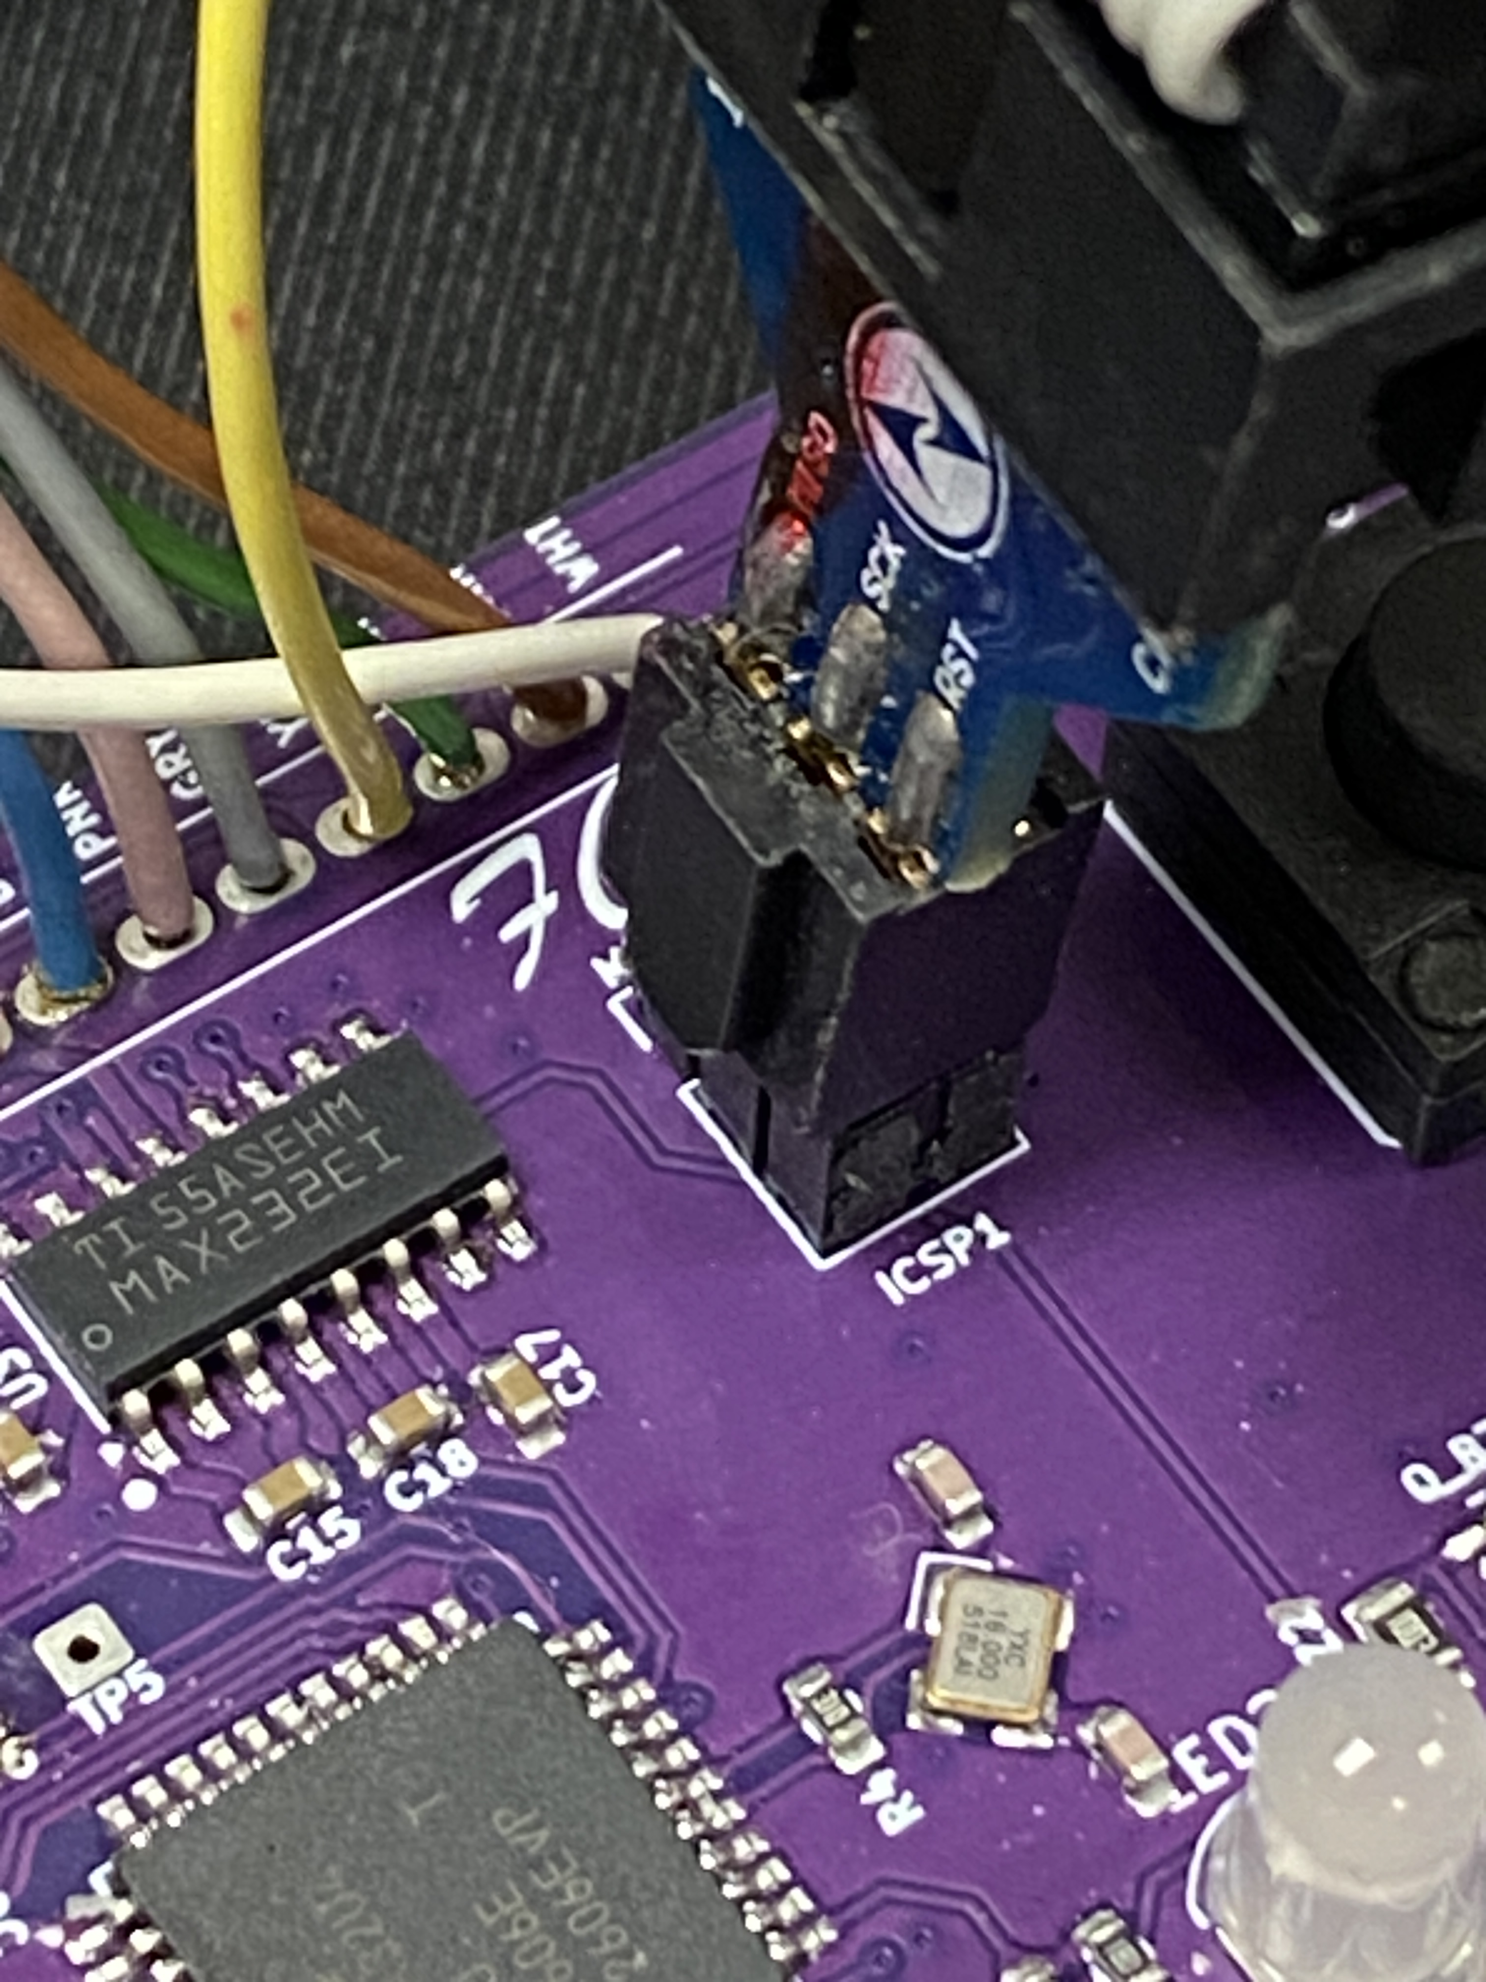
Figure 2. Close-up of the ICSP1 programming connection on the FS10 board.

3. Build the firmware in Arduino IDE
- Open firmware/FS10-ATMEGA32U4/FS10-ATMEGA32U4.ino in Arduino IDE.
- Install the required libraries through Library Manager. Record the approved library versions in the release notes.
- In Tools > Board > Arduino AVR Boards, select Arduino Leonardo. This is the compatible standard Arduino profile for the FS10 ATmega32U4, 5 V, 16 MHz hardware. No FS10-specific board-definition file is required.
- If the AVRISP mkII is plugged into USB and the Arduino IDE top board selector is unavailable, select Arduino Leonardo before connecting the programmer, or use the full Tools > Board menu. The FS10 board does not need a serial port selected for ISP programming.
- With the AVRISP mkII connected by USB, select Tools > Programmer > AVRISP mkII. This selection should remain available while the programmer is connected.
- Leave Tools > Port unselected for ISP programming. The AVRISP mkII communicates directly with the ICSP1 header; it is not the FS10 serial port.
- Select Verify and resolve any errors before connecting the target for upload.

4. Upload the firmware
- Confirm the ISP programmer is recognized by the computer and the FS10 target has the approved power condition.
- Recheck ICSP1 connector orientation and the common ground path.
- Use Sketch > Upload Using Programmer. Do not use the normal Upload button; it expects a bootloader or serial-upload path.
- Wait for the upload and verification to complete. Do not disconnect the cable or remove power during programming.
- Disconnect the programmer only after the tool reports completion.
CDC compatibility note — The current firmware documentation records a local Arduino AVR core CDC.cpp behavior dependency for the FS10 PC software. Before a release build, confirm whether the local DTR-gate patch is required, the exact Arduino AVR Boards version, and the patch location. Core updates can overwrite local changes.

5. Post-programming check
- Power the FS10 using its approved normal operating method.
- Confirm the expected display startup/status behavior.
- Confirm USB connection and the 9600-baud FS10 serial bridge behavior with the approved host software.
- Note the release version at the bottom of the screen. The format is: FW build YYYY-MM-DD HH:MM.

6. Troubleshooting
Symptom | What to check
Programmer not detected | Check the AVRISP mkII USB cable and computer connection. Reconnect the programmer, then restart Arduino IDE if required.
Target-voltage or connection fault | Verify target power, ribbon seating, ICSP1 orientation, and ground. Seeing the programmer in USB devices does not prove the FS10 target is powered.
Device signature mismatch | Stop programming. Check ICSP1 orientation, RESET, MOSI, MISO, SCK, ground, and target power. Do not override the signature; the expected ATmega32U4 signature is 1E 95 87.
Missing library or header | Install Adafruit GFX Library and Adafruit ST7735 and ST7789 Library through Arduino Library Manager, then run Verify again.
Normal Upload fails | Use Sketch > Upload Using Programmer, not the standard Upload button, and confirm Tools > Programmer > AVRISP mkII.

7. Safe disconnect
- Wait until Arduino IDE reports that programming and verification have completed.
- Disconnect the USB cable from the AVRISP mkII.
- Remove the ICSP1 ribbon by gripping the connector body, not the cable wires.
- Inspect the header and cable before returning the board to normal test or production use.

