**Experiment 1**

**Index.html**

<!DOCTYPE html>

<html lang="en">

<head>

<meta charset="UTF-8">

<meta name="viewport" content="width=device-width, initial-scale=1.0">

<title>Document</title>

<link rel="stylesheet" href="style.css">

</head>

<body>

<form>

<div id="watermark">

<img src="https://upload.wikimedia.org/wikipedia/en/thumb/f/ff/Amity_University_logo.png/180px-Amity_University_logo.png" alt="Amity University Raipur">

</div>

<div style="display: flex; grid-column: 1 / 3; gap: 2rem; place-self: center; margin-top: 1em;">

<img src="https://upload.wikimedia.org/wikipedia/en/thumb/f/ff/Amity_University_logo.png/180px-Amity_University_logo.png" alt="Amity University Raipur">

<h1>Student Registration Form</h1>

</div>

<label for="fname">

<p>First Name</p>

<input type=text name="fname" id="fname">

</label>

<label for="lname">

<p>Last Name</p>

<input type=text name="lname" id="lname">

</label>

<label for="fathername">

<p>Father Name</p>

<input type=text name="fathername" id="fathername">

</label>

<label for="address">

<p>Address</p>

<input type=text name="address" id="address">

</label>

<label for="gender">

<p>Gender</p>

<div>

<div>

<p>Male</p>

<input type="radio" name="gender" value="male">

</div>

<div>

<p>Female</p>

<input type="radio" name="gender" value="Female">

</div>

</div>

</label>

<label for="">

<p>City</p>

<select name="City">

<option value="-1" selected>select..</option>

<option value="RAIPUR">RAIPUR</option>

<option value="KOLKATA">KOLKATA</option>

<option value="CHENNAI">CHENNAI</option>

<option value="PUNE">PUNE</option>

<option value="JAIPUR">JAIPUR</option>

<option value="PATNA">PATNA</option>

</select>

</label>

<label for="">

<p>Course</p>

<select name="Course">

<option value="-1" selected>select..</option>

<option value="B.Tech">B.TECH</option>

<option value="MCA">MCA</option>

<option value="MBA">MBA</option>

<option value="BCA">BCA</option>

</select>

</label>

<label for="">

<p>State</p>

<select Name="State">

<option value="-1" selected>select..</option>

option value="Chhattisgarh">Chhattisgarh</option>

<option value="New Delhi">NEW DELHI</option>

<option value="Mumbai">MUMBAI</option>

<option value="Goa">GOA</option>

<option value="Bihar">BIHAR</option>

</select>

</label>

<label for="">

<p>District</p>

<select name="District">

<option value="-1" selected>select..</option>

<option value="Raipur">Raipur</option>

<option value="Nalanda">NALANDA</option>

<option value="UP">UP</option>

<option value="Goa">GOA</option>

<option value="Patna">PATNA</option>

</select>

</label>

<label for="">

<p>PinCode</p>

<input type="text" name="pin_code" id="pincode">

</label>

<label for="">

<p>Student Email</p>

<input type="text" name="email_id" id="emailid">

</label>

<label for="">

<p>Date Of Birth</p>

<input type="text" name="date_of_birth" id="dob">

</label>

<label for="">

<p>Mobile Number</p>

<input type="text" name="mobilenumber" id="mobile_no">

</label>

<div id="btns">

<button type="reset">Reset</button>

<button type="submit">Submit</button>

</div>

</form>

</body>

</html>

**Style.css**

@import url('https://fonts.googleapis.com/css2?family=Poppins:ital,wght@0,100;0,200;0,300;0,400;0,500;0,600;0,700;0,800;0,900;1,100;1,200;1,300;1,400;1,500;1,600;1,700;1,800;1,900&display=swap');

* {

font-family: "Poppins", sans-serif;

margin: 0;

padding: 0;

}

body {

height: 100svh;

background-color: #ccffaa;

color: #0c2b27;

}

form {

position: relative;

z-index: 50;

display: grid;

grid-template-columns: repeat(2, minmax(200px, 1fr));

gap: 1rem 2rem;

place-content: center;

margin: 1rem auto;

max-width: 736px;

border: 2px solid #0c2b27;

border-radius: 0.5rem;

padding: 1rem 2rem;

background-color: #fff;

box-shadow: 0 0 20px rgba(0, 0, 0, 0.6);

}

h1, img {

grid-column: 1 / 3;

place-self: center;

margin: 0 0.5em 0.3em 0.5em;

}

img {

aspect-ratio: 1 / 1.2;

width: 8rem;

}

input:not(input[type="radio"]), select {

width: 100%;

padding: 0.25rem 0.5rem;

border-radius: 0.5rem;

border: 1px solid black;

background: transparent;

}

input[type="radio"] {

accent-color: #0c2b27;

aspect-ratio: 1 / 1;

width: 1.25rem;

}

label[for="gender"] {

display: flex;

flex-direction: column;

align-items: start;

justify-content: start;

}

label[for="gender"] > div {

display: flex;

justify-content: space-between;

width: 100%;

align-items: center;

}

label[for="gender"] > div > div {

width: 100%;

display: flex;

align-items: center;

justify-content: start;

gap: 1rem;

}

#btns {

grid-column: 1 / 3;

place-self: center;

}

button {

display: inline-flex;

align-items: center;

justify-content: center;

padding: 5px 20px;

height: 2rem;

border: 0;

border-radius: 5px;

background-color: #1e5b53;

color: white;

}

#watermark {

position: absolute;

font-size: 50px;

letter-spacing: 5px;

font-weight: bolder;

inset: 0;

display: flex;

align-items: center;

justify-content: center;

color: #0c2b2748;

user-select: none;

z-index: -1;

}

#watermark > img {

opacity: 0.5;

width: 40%;

}

**Output:**

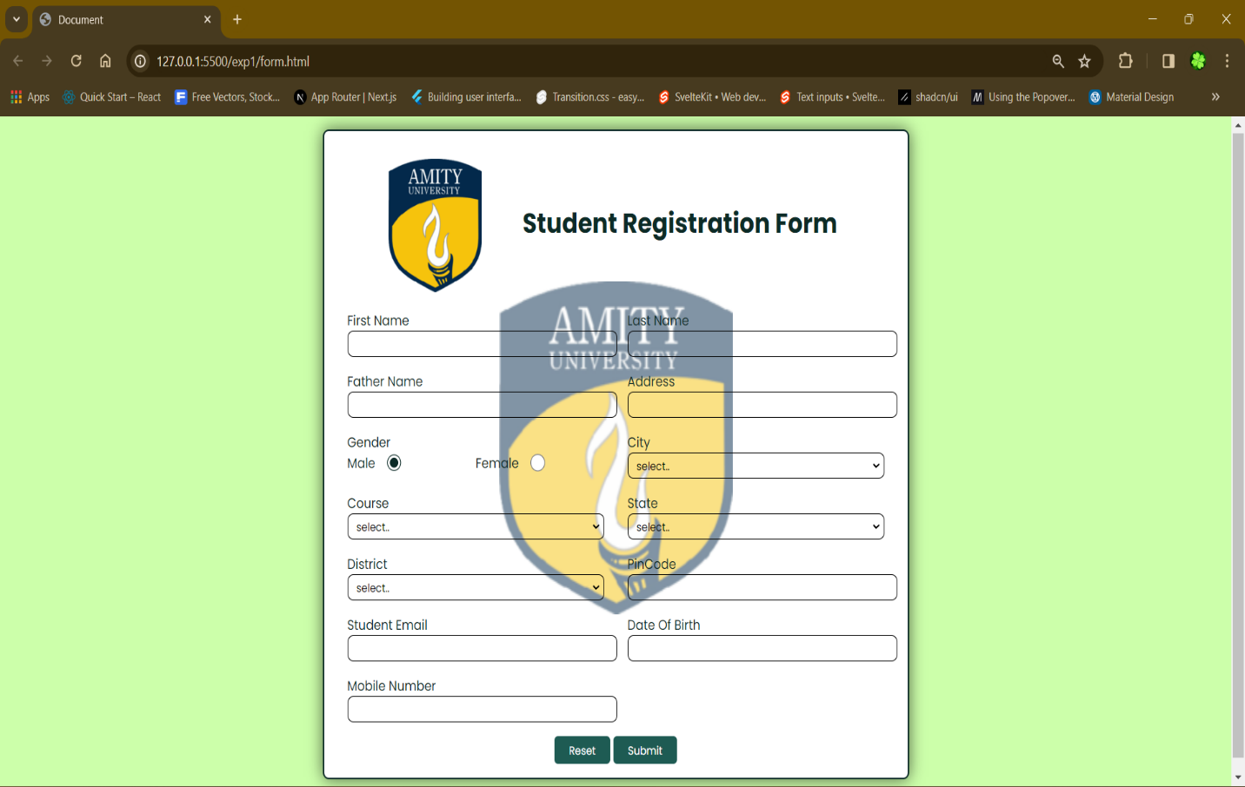

**Experiment 2**

**Part: 1**

**Index.html**

<!DOCTYPE html>

<html lang="en">

<head>

<meta charset="UTF-8">

<meta name="viewport" content="width=device-width, initial-scale=1.0">

<title>Document</title>

<style>

* {

font-family: system-ui, -apple-system, BlinkMacSystemFont, 'Segoe UI', Roboto, Oxygen, Ubuntu, Cantarell, 'Open Sans', 'Helvetica Neue', sans-serif;

}

</style>

</head>

<body>

<h3>Time Watcher</h3>

<div>

<span>The time is: </span>

<input type="text" id="time" readonly>

</div>

<script>

function setTime() {

const date = new Date();

const hrs = date.getHours();

const mins = date.getMinutes();

const sec = date.getSeconds();

document.getElementById("time").value = `${hrs}:${mins}:${sec.toLocaleString('en-US', {

minimumIntegerDigits: 2,

})} ${hrs < 12 ? 'AM' : 'PM'}`;

}

setTime();

setInterval(() => {

setTime();

}, 1000);

</script>

</body>

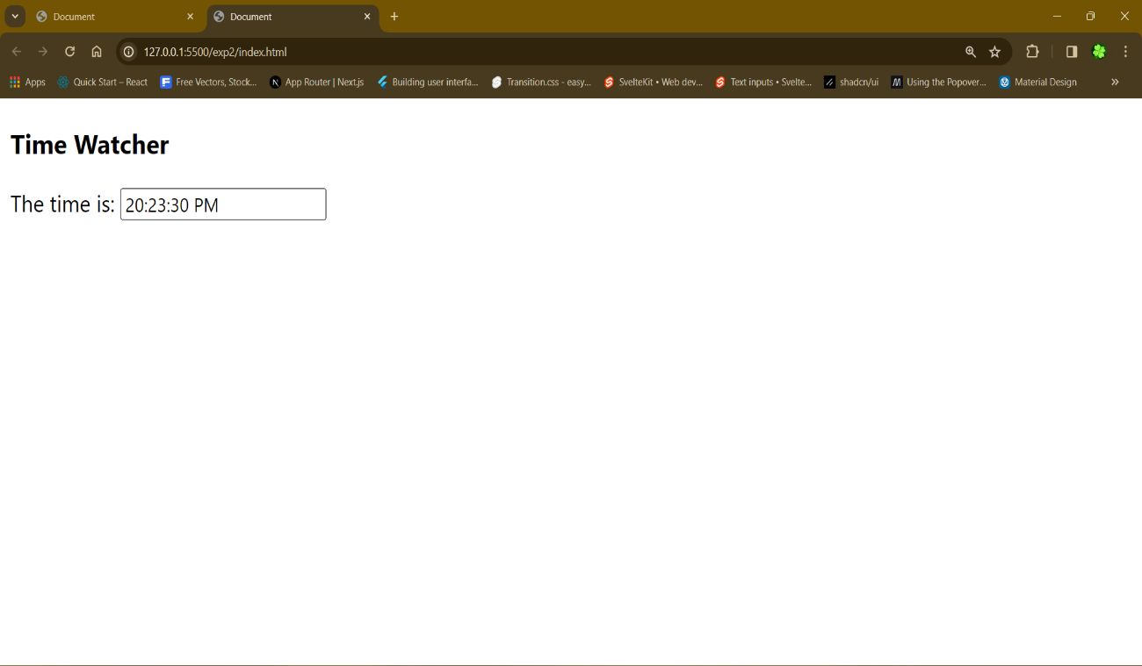</html>

**Output:**

**Part: 2**

**Index.html**

<!DOCTYPE html>

<html lang="en">

<head>

<meta charset="UTF-8">

<meta name="viewport" content="width=device-width, initial-scale=1.0">

<title>Document</title>

</head>

<body>

<form>

<select name="select" multiple>

<option value="First Option">First Option</option>

<option value="Second Option">Second Option</option>

<option value="Third Option">Third Option</option>

<option value="Fourth Option">Fourth Option</option>

</select>

<div>

<button type="submit">Check Selection</button>

<button type="reset">Reset</button>

</div>

</form>

<script>

let data = {

select: []

};

function handleChange(e) {

data[e.target.name] = [...data[e.target.name], e.target.value];

}

function handleSubmit(e) {

e.preventDefault();

console.log(data);

let m = "You have selected\n";

for (const e of data.select) {

m += e + "\n";

}

alert(m);

}

document.querySelector('form').addEventListener('submit', handleSubmit);

document.querySelector('form').addEventListener('change', handleChange);

</script>

</body>

</html>

**Output:**

**Part: 3**

**Index.html**

<!DOCTYPE html>

<html lang="en">

<head>

<meta charset="UTF-8">

<meta name="viewport" content="width=device-width, initial-scale=1.0">

<title>Document</title>

<link rel="stylesheet" href="style.css">

</head>

<body>

<dialog>

<section style="position: relative;">

<button id="close" style="position: absolute; right: 0; background: white; border: 0; cursor: pointer;">

<svg xmlns="http://www.w3.org/2000/svg" width="30" height="30" fill="currentColor" class="bi bi-x"

viewBox="0 0 16 16">

<path

d="M4.646 4.646a.5.5 0 0 1 .708 0L8 7.293l2.646-2.647a.5.5 0 0 1 .708.708L8.707 8l2.647 2.646a.5.5 0 0 1-.708.708L8 8.707l-2.646 2.647a.5.5 0 0 1-.708-.708L7.293 8 4.646 5.354a.5.5 0 0 1 0-.708" />

</svg>

</button>

<div>

<img src="https://upload.wikimedia.org/wikipedia/en/thumb/2/2d/The_Fate_of_The_Furious_Theatrical_Poster.jpg/220px-The_Fate_of_The_Furious_Theatrical_Poster.jpg"

alt="Poster" style="width: 100%;

height: 100%;

object-fit: cover;

object-position: center;">

</div>

<div>

<div>

<h1>THE FATE OF THE FURIOUS</h1>

<button class="trailer">

<svg xmlns="http://www.w3.org/2000/svg" width="30" height="30" fill="currentColor"

class="bi bi-play-fill" viewBox="0 0 16 16">

<path

d="m11.596 8.697-6.363 3.692c-.54.313-1.233-.066-1.233-.697V4.308c0-.63.692-1.01 1.233-.696l6.363 3.692a.802.802 0 0 1 0 1.393" />

</svg>

Play trailer

</button>

</div>

<h3>Release Date: 2017-04-12</h3>

<p>Lorem ipsum dolor sit, amet consectetur adipisicing elit. Quod cupiditate hic placeat. Illo quam

possimus

facilis voluptate. Iusto natus, omnis autem corrupti tempora, deleniti, similique ullam fuga quod

aliquid

iste. Recusandae ex libero dolorum veniam nemo architecto maxime, possimus autem quo repudiandae

omnis

perspiciatis cum unde nisi eius, qui laudantium!</p>

<h3>Rating: 6.9/10</h3>

<div class="time-container">

<button class="outline">8:30 AM</button>

<button class="outline">10:00 AM</button>

<button class="outline">12:30 AM</button>

<button class="outline">3:00 PM</button>

<button class="outline">4:10 PM</button>

<button class="outline">5:30 PM</button>

<button class="outline">8:00 PM</button>

<button class="outline">10:30 PM</button>

</div>

</div>

</section>

</dialog>

<button id="modelBtn">Open Modal</button>

<script src="script.js"></script>

</body>

</html>

**Style.css**

* {

font-family: system-ui, -apple-system, BlinkMacSystemFont, 'Segoe UI', Roboto, Oxygen, Ubuntu, Cantarell, 'Open Sans', 'Helvetica Neue', sans-serif;

}

dialog {

max-width: 600px;

width: 100%;

border: 1px solid black;

border-radius: 10px;

max-height: 100svh;

box-shadow: 0 0 10px rgba(0, 0, 0, 0.5);

inset: 0;

}

dialog::backdrop {

background-color: rgba(0, 0, 0, 0.26);

backdrop-filter: blur(2px);

}

dialog > section {

width: 100%;

height: 100%;

display: grid;

grid-template-columns: 0.7fr 1fr;

gap: 1rem;

}

.time-container {

display: grid;

grid-template-columns: 1fr 1fr 1fr;

gap: 0.5rem;

}

.outline {

padding: 0.5rem;

background: white;

border: 2px solid rgb(0, 162, 255);

color: rgb(0, 162, 255);

border-radius: 10px;

font-weight: 500;

font-size: medium;

transition: background 0.2s ease;

}

.outline:hover {

background: rgba(0, 162, 255, 0.1);

}

.trailer {

background: white;

border: 0;

color: rgb(0, 162, 255);

font-size: medium;

font-weight: 600;

display: inline-flex;

align-items: center;

justify-content: center;

gap: 0.5rem;

transition: background 0.2s ease;

border-radius: 5px;

padding: 0.2rem;

cursor: pointer;

}

.trailer:hover {

background: rgba(0, 162, 255, 0.1);

}

**Script.js**

document.getElementById("modelBtn").onclick = () => {

document.querySelector("dialog").showModal();

}

document.getElementById("close").onclick = () => {

document.querySelector("dialog").close();

}

**Output:**

