【感知机模型 】

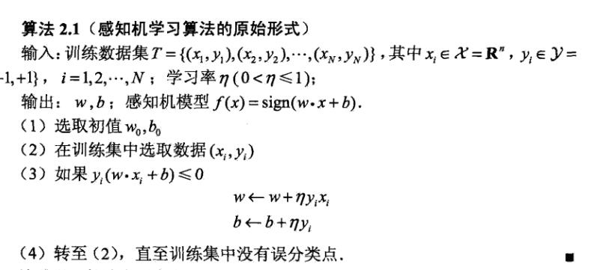

【HOG特征提取】

Python提取特征需要调用opencv2，代码如下所示

hog = cv2.HOGDescsriptor(‘../hog.xml’)

img = np.reshape(img,(28,28))

cv_img = img.astype(np.uint8)

hog_fearture = hog.compute(cv_img)

【代码】

1）sklearn.model_selection.train_test_split随机划分训练集和测试集

* 一般形式

train_test_split是交叉验证中常用的函数，功能是从样本中随机的按比例选取train data和testdata，形式为：

X_train,X_test, y_train, y_test =

cross_validation.train_test_split(**train_data**,**train_target**,**test_size**=0.4, **random_state**=0)

* 参数解释

**train_data**：所要划分的样本特征集

**train_target**：所要划分的样本结果

**test_size**：样本占比，如果是整数的话就是样本的数量

**random_state**：是随机数的种子。

随机数种子：其实就是该组随机数的编号，在需要重复试验的时候，保证得到一组一样的随机数。比如你每次都填1，其他参数一样的情况下你得到的随机数组是一样的。但填0或不填，每次都会不一样。

随机数的产生取决于种子，随机数和种子之间的关系遵从以下两个规则：种子不同，产生不同的随机数；种子相同，即使实例不同也产生相同的随机数。

2）

>>> from sklearn.metrics import accuracy_score

accuracy_score(y_true, y_pred[, normalize, …])

http://scikit-learn.org/stable/_images/math/cd4bea15b385d15cceb8e24f68976da7d8510290.png

# normalize=False 则返回总数

【感知机代码】

import pandas as pd

import numpy as np

import cv2

import random

import time

from sklearn.cross_validation import train_test_split

from sklearn.metrics import accuracy_score

# 利用opencv获取图像hog特征

def get_hog_features(trainset):

features = []

hog = cv2.HOGDescriptor('../hog.xml')

for img in trainset:

img = np.reshape(img,(28,28))

cv_img = img.astype(np.uint8)

hog_feature = hog.compute(cv_img)

# hog_feature = np.transpose(hog_feature)

features.append(hog_feature)

features = np.array(features)

features = np.reshape(features,(-1,324))

return features

def Train(trainset,train_labels):

# 获取参数

trainset_size = len(train_labels)

# 初始化 w,b

w = np.zeros((feature_length,1))

b = 0

study_count = 0 # 学习次数记录，只有当分类错误时才会增加

nochange_count = 0 # 统计连续分类正确数，当分类错误时归为0

nochange_upper_limit = 100000 # 连续分类正确上界，当连续分类超过上界时，认为已训练好，退出训练

while True:

nochange_count += 1

if nochange_count > nochange_upper_limit:

break

# 随机选的数据

index = random.randint(0,trainset_size-1)

img = trainset[index]

label = train_labels[index]

# 计算yi(w*xi+b)

yi = int(label != object_num) * 2 - 1 # 如果等于object_num, yi=-1, 否则yi=1

result = yi * (np.dot(img,w) + b)

# 如果yi(w*xi+b) <= 0 则更新 w 与 b 的值

if result <= 0:

img = np.reshape(trainset[index],(feature_length,1)) # 为了维数统一，需重新设定一下维度

w += img*yi*study_step # 按算法步骤3更新参数

b += yi*study_step

study_count += 1

if study_count > study_total:

break

nochange_count = 0

return w,b

def Predict(testset,w,b ):

predict = []

for img in testset:

result = np.dot(img,w) + b

result = result > 0

predict.append(result)

return np.array(predict)

study_step = 0.0001 # 学习步长

study_total = 10000 # 学习次数

feature_length = 324 # hog特征维度

object_num = 0 # 分类的数字

if __name__ == '__main__':

print('Start read data')

time_1 = time.time()

raw_data = pd.read_csv('../data/train_binary.csv',header=0)

data = raw_data.values

imgs = data[0::,1::]

labels = data[::,0]

features = get_hog_features(imgs)

# 选取 2/3 数据作为训练集， 1/3 数据作为测试集

train_features, test_features, train_labels, test_labels = train_test_split(features, labels, test_size=0.33, random_state=23323)

# print(train_features.shape)

# print(test_features.shape)

time_2 = time.time()

print('read data cost ', '{} '.format(time_2 - time_1) , ' second','\n')

print('Start training')

**w,b = Train(train_features,train_labels)**

time_3 = time.time()

print 'training cost ',time_3 - time_2,' second','\n'

print('Start predicting ')

**test_predict = Predict(test_features,w,b)**

time_4 = time.time()

print 'predicting cost ',time_4 - time_3,' second','\n'

**score = accuracy_score(test_labels,test_predict)**

print "The accruacy socre is ", score