Logistic回归是统计学中的经典分类方法，最大熵是概率模型学习的一个准则，将其推广到分类问题得到最大熵模型，logistic回归模型与最大熵模型都是对数线性模型。

**【Logistic回归-算法】**

**可参考博客**

《统计学习方法》简述<http://blog.csdn.net/BOBOyspa/article/details/78247157>

讲解+代码

<http://blog.csdn.net/zouxy09/article/details/20319673?locationNum=6&fps>=1

**基本讲解**

如下图，logistic（逻辑斯谛）回归模型的引入、模型的参数估计（极大对数似然估计以及梯度下降法）：

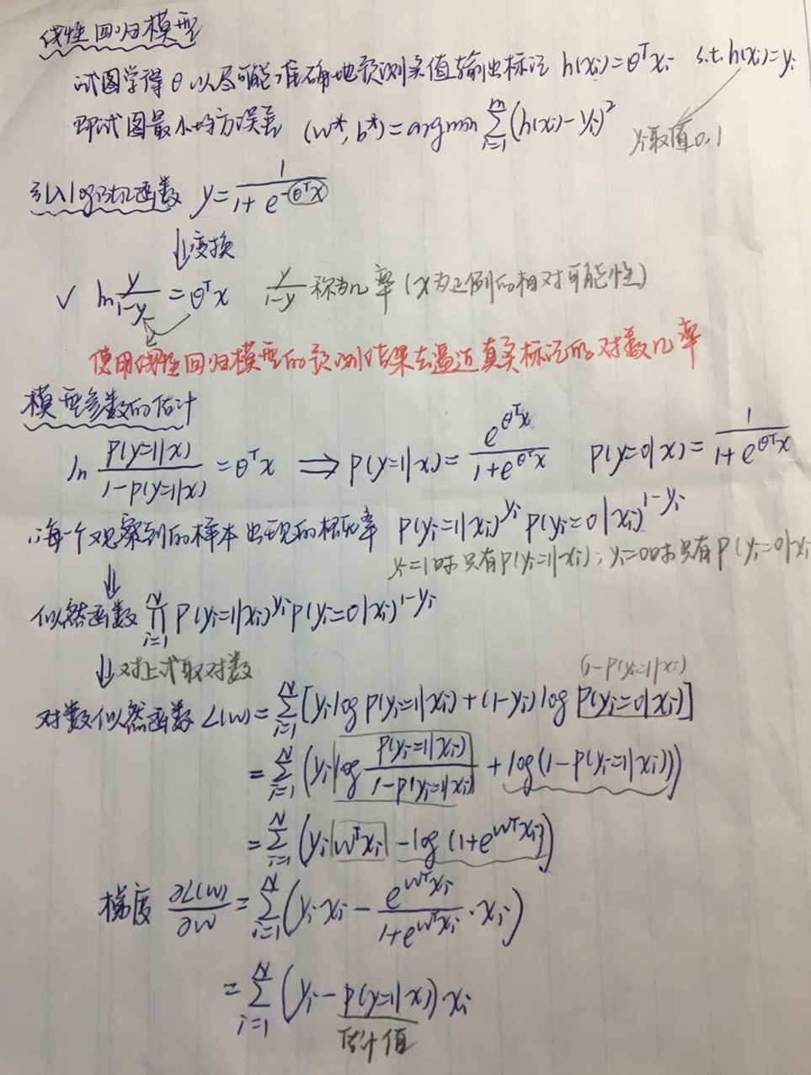

**最终类别的判定**

对于给定的样本x，利用二项逻辑斯蒂回归模型计算该样本类别为1和0的概率，然后，将样本x分类到概率较大的那一类。

将h=0.5作为一个阀值，当估计值大于0.5时把样本分为1类，估计值小于0.5时把样本分为0类。

**\* logistic回归 VS logistic回归：**

logistic回归实际上就是对线性回归多增加了一个函数映射，使其值域由无穷区间映射到[0,1]区间。实现此功能需要在输出加一个logistic函数。

**算法流程如下：**

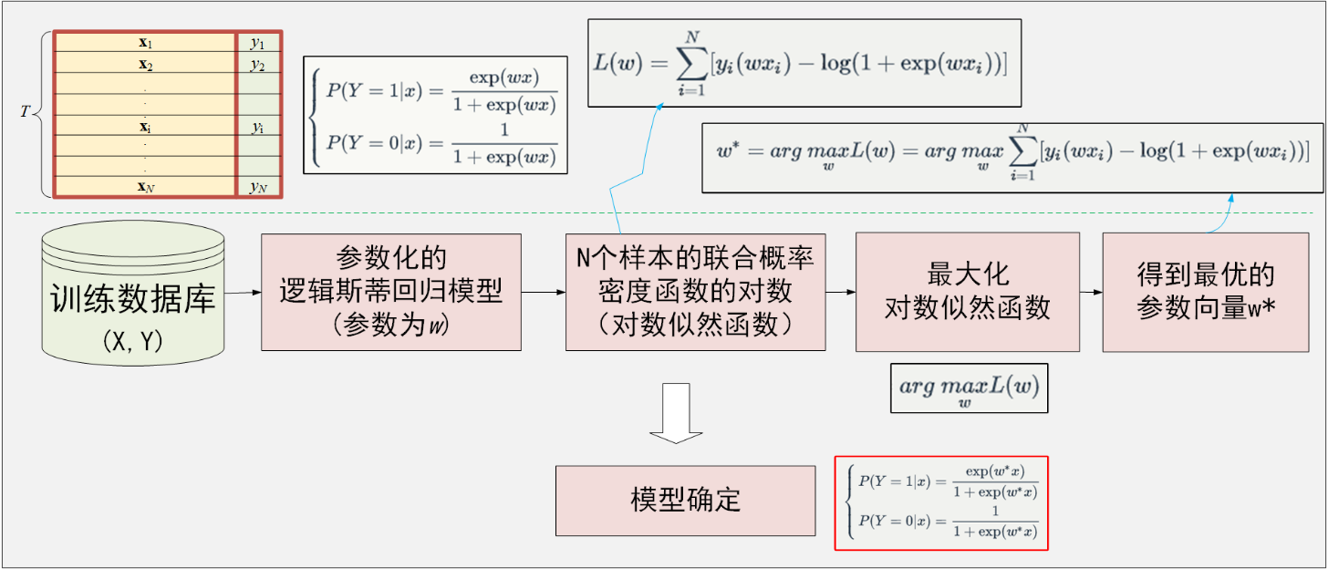

**书上算法：**

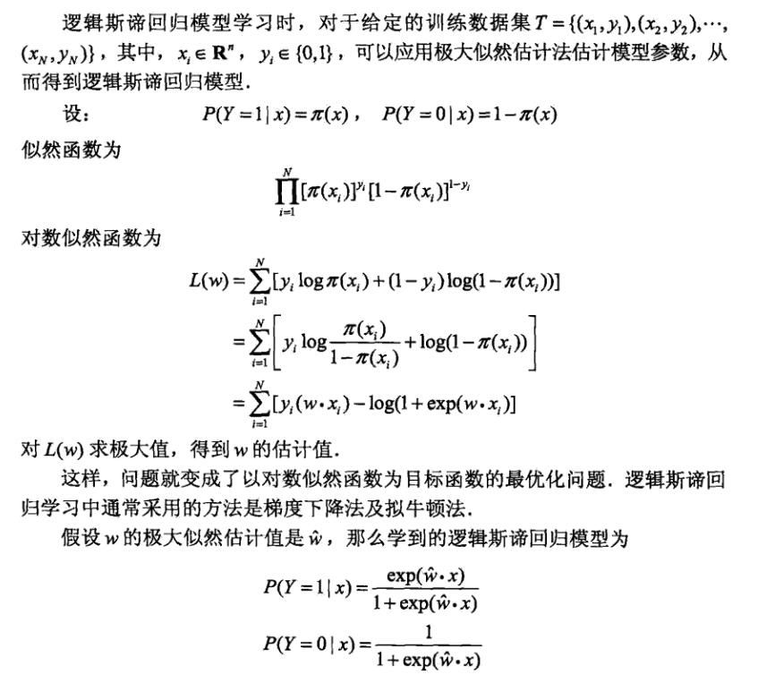

**参数估计：**

对数似然函数，将L(w)作为损失函数，用随机梯度下降的方法求解；每次随机选取一个误分类点，用上述梯度对w进行更新。

**【代码】** from机器学习实战

可参考的另一个博客 <http://blog.csdn.net/wds2006sdo/article/details/53084871>

逻辑斯谛回归模型正确率maybe优于感知器模型的，原因浮点数精度等问题。

**Step1：载入数据**

def loadData():

train_x = []

train_y = []

with open('test_set.txt') as f:

text = f.readlines()

for line in text:

train_x.append([1] + line.split()[:-1])

train_y.append([line.split()[-1]]) #此处[[ ]]是为了方便转为数组

return np.mat(train_x).astype(float),np.mat(train_y).astype(float) #此处float便于后续计算

*Note1:

当对array进行约简运算时,经常二维数组变成一维array;运算时会broadcast效果,可能报错;所以此处用matrix类型。

**Step2：训练**

1）计算sigmoid function

def sigmoid(z):

return 1 / (1 + np.exp(-z))

2）训练

def trainLogRegres(train_x,train_y,opts):

numSample,numFeature = train_x.shape #样本数numSample,特征数numFeature

weights = np.ones((numFeature,1))

maxIter = opts['maxIter']

alpha = opts['alpha']

for k in range(maxIter):

if opts['optimizeType'] == 'gradDescent': ## gradient descent algorilthm

output = sigmoid(train_x * weights) #train_x:(numSample,numFeature)

error = train_y - output #error:(numSample,1)

weights += alpha * train_x.transpose() * error

elif opts['optimizeType'] == 'stocGradDescent': #stochastic gradient descent

for i in range(numSample):

alpha = 4 / (10 + k + i) #约束

output = sigmoid(train_x[i] * weights) #train_x[i]:(1,numFeature) weights:(numFeature,1)

error = train_y[i] - output #error：(1,1)

weights += alpha * train_x[i].transpose() * error

elif opts['optimizeType'] == 'min-batch-gradDescent': #set b = 10

b = 10

for i in range(0,b,numSample):

output = sigmoid(train_x[i:i+b] * weights) #train_x[i]:(b,numFeature)

error = train_y[i:i+b] - output #error:(numSample,1)

weights += alpha * train_x[i:i+b].transpose() * error

else:

raise NameError('Not support optimize method type!')

return weights

**Step3：测试**

def testLogRegres(weights, test_x, test_y):

output = sigmoid(test_x * weights)

predict = output > 0.5

accuracy = sum(predict == test_y)/len(test_y)

return accuracy

**Step4：可视化**

def showLogRegres(weights, train_x, train_y):

for i in range(len(train_y)):

if train_y[i] == 1:

plt.plot(train_x[i,1], train_x[i,2],'or')

else:

plt.plot(train_x[i,1], train_x[i,2],'ob')

min_x = float(min(train_x[:,1]))

max_x = float(max(train_x[:,1]))

min_y = (- weights[0,0] - weights[1,0] * min_x) / weights[2,0] #注意此处x2和x1的关系

max_y = (- weights[0,0] - weights[1,0] * max_x) / weights[2,0]

plt.plot([min_x,max_x],[min_y,max_y],'g-') #绘制分割线

plt.xlabel('x1')

plt.ylabel('x2')

**主函数**

import time

import numpy as np

import matplotlib.pyplot as plt

from sklearn.cross_validation import train_test_split

if __name__ == '__main__':

##step1：load data

print('step1:Start loading data...')

time_1 = time.time()

**train_set,train_label = loadData()**

train_x,test_x,train_y,test_y = train_test_split(train_set,train_label,test_size=0.33, random_state=23323)

time_2 = time.time()

print(' Loading data costs %f seconds.\n'%(time_2 - time_1))

##step2：training...

print('step2:Start training...')

**opts = {'alpha': 0.01, 'maxIter': 100, 'optimizeType': 'stocGradDescent'}**

**optimalWeights = trainLogRegres(train_x,train_y,opts)**

time_3 = time.time()

print(' Training data costs %f seconds.\n'%(time_3 - time_2))

##step3：testing...

print('step3:Start testing...')

**accuracy = testLogRegres(optimalWeights, test_x, test_y)**

print(' accuracy:%f'%accuracy)

time_4 = time.time()

print(' Testing data costs %f seconds.\n'%(time_4 - time_3))

##step4：plot the figure...

print('step4:Start plotting the figure...')

**showLogRegres(optimalWeights, train_x, train_y)**

time_4 = time.time()

print(' Plotting the figure costs %f seconds.\n'%(time_4 - time_3))

**输出**

step1:Start loading data...

Loading data costs 0.001000 seconds.

step2:Start training...

Training data costs 0.057000 seconds.

step3:Start testing...

accuracy:0.969697

Testing data costs 0.001000 seconds.

step4:Start plotting the figure...

Plotting the figure costs 0.112000 seconds.

