Assessment (Weeks 1 & 2)

### Data : Table format

The flowing is Employee data given. Note that Equipment and Training has multiple entries showing the need for normalisation.

|  |  |  |  |  |  |  |
| --- | --- | --- | --- | --- | --- | --- |
| **Name** | **PhoneNumber** | **Address** | **HireDate** | **Equipment** | **Department** | **Training** |
| Andy Wong [1] | (603) 555-6880 | 345 South Street | January 15, 2001 | Notebook Computers [1] | Production [2] | Code of Conduct Training [2]; Safety Traning [3] |
| Vivek Pandey [3] | (603) 555-4420 | 15 Mineral Drive | November 15, 2003 | Notebook Computers [1]; Headsets [2]; Computer Monitor [3] | IT Support [3] | Code of Conduct Training [2]; Microsoft Certifications [6]; Security and Privacy [7] |
| Kathy Cooper [5] | (212) 555-9630 | 15 Hatter Drive | November 18, 2011 | Notebook Computers [1]; Headsets [2]; Computer Monitor [3] | Human Resource Management [8] | Code of Conduct Training [2]; Employee Relations [10] |
| John Wilson [2] | (518) 555-6690 | 560 Broadway | March 19, 2017 | Notebook Computers [1]; Computer Monitor [3] | Research & Development [1] | Code of Conduct Training [2]; Intro to Python 4]; Machine Learning [5] |
| Nola Davis [4] | (478) 555-8822 | 15 Long Ave | March 23, 2016 | Notebook Computers [1]; Headsets [2] | Sales & Marketing [7] | Code of Conduct Training [2]; Product Knowledge [8]; Sales Skills [9] |
| Tom Harper [6] | (212) 555-7755 | 64 Highland Street | April 11, 2010 | Notebook Computers [1]; Computer Monitor [3] | Accounting and Finance [9] | Code of Conduct Training [2]; Travel and Expense Management [11] |

#### Assumptions/Observations as per given data:

1. There are 6 Employees given in data. It is not clear which are required fields. We can assume Name, Phone Number, Hire Date and Functional Business Unit to be mandatory. But other fields may or may not be required.
2. There are departments(Functional Business Unit) which do not have an employee in given data.
3. There are Equipment which is not requested by any of the given employee,
4. There are Training which is not needed by any of the given employee.
5. More than one employee may work for the same business unit
6. Trainers are NOT considered as employees of the Business
7. A Training can have multiple Trainers.
8. There is no Trainer who does not have a Training

##### Open ended questions from the data:

1. Can there be an employee who do not need any Equipment ?
2. Can there be an employee who do not need any Training ?

Because of open ended questions, I can have two answers. I give them as two cases for the sake of simplicity.

# CASE 1: Employee should have at least one Equipment and Training need.

## Q1. Conceptual Model

Build Conceptual Model as per understanding of the data ---> (a) Add entities (b) Add Relationships

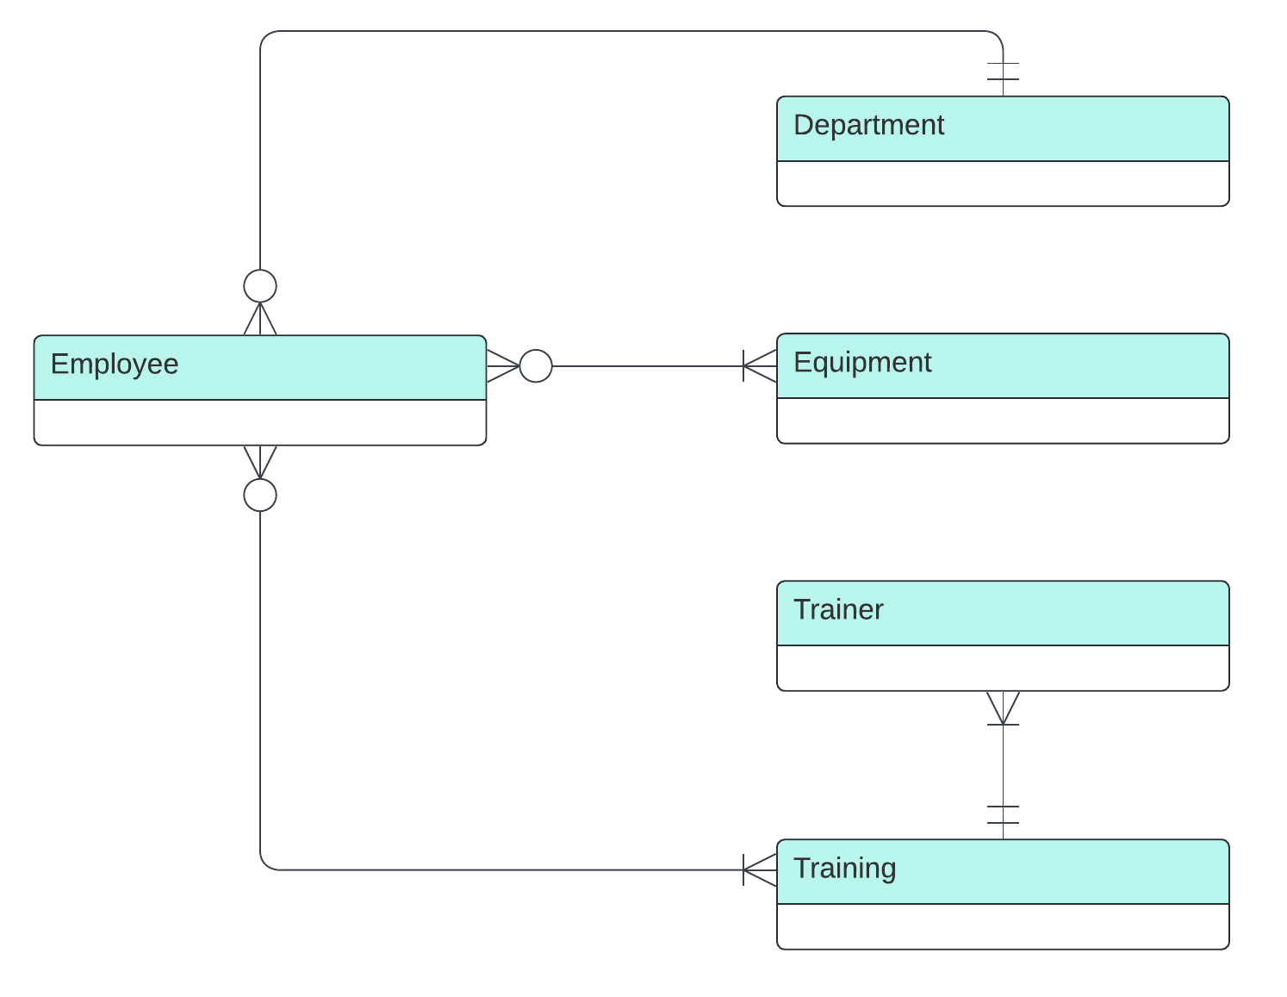

## Q2. Logical Model

Build Logical Model on top of the Conceptual Model built in Q1. ---> (a) Add Non-key Attributes (b) Add Primary/Foreign Key Attributes wheresoever needed (c) Add Junction tables to resolve many-many relationships if existing. *** Note: (I.) Comply with the Normalization Process (II.) Use proper names to identify attributes and entities ***

Here **EmployeeEquipment** and **EmployeeTraining** are Junction tables.

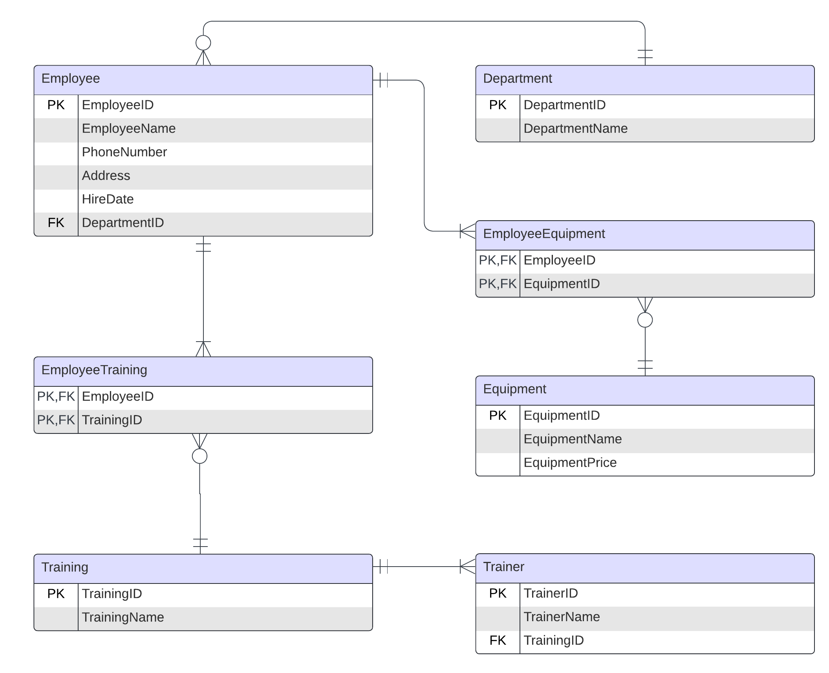

## Q3. Physical Model

Build Physical Model on top of the Logical Model built in Q2. ---> (a) Add datatypes (b) Add constraints if any (c) Use proper naming convention to format names of entities and attributes.

# CASE 2: Employee can be without any of Equipment and Training need.

## Q1. Conceptual Model

Build Conceptual Model as per understanding of the data ---> (a) Add entities (b) Add Relationships

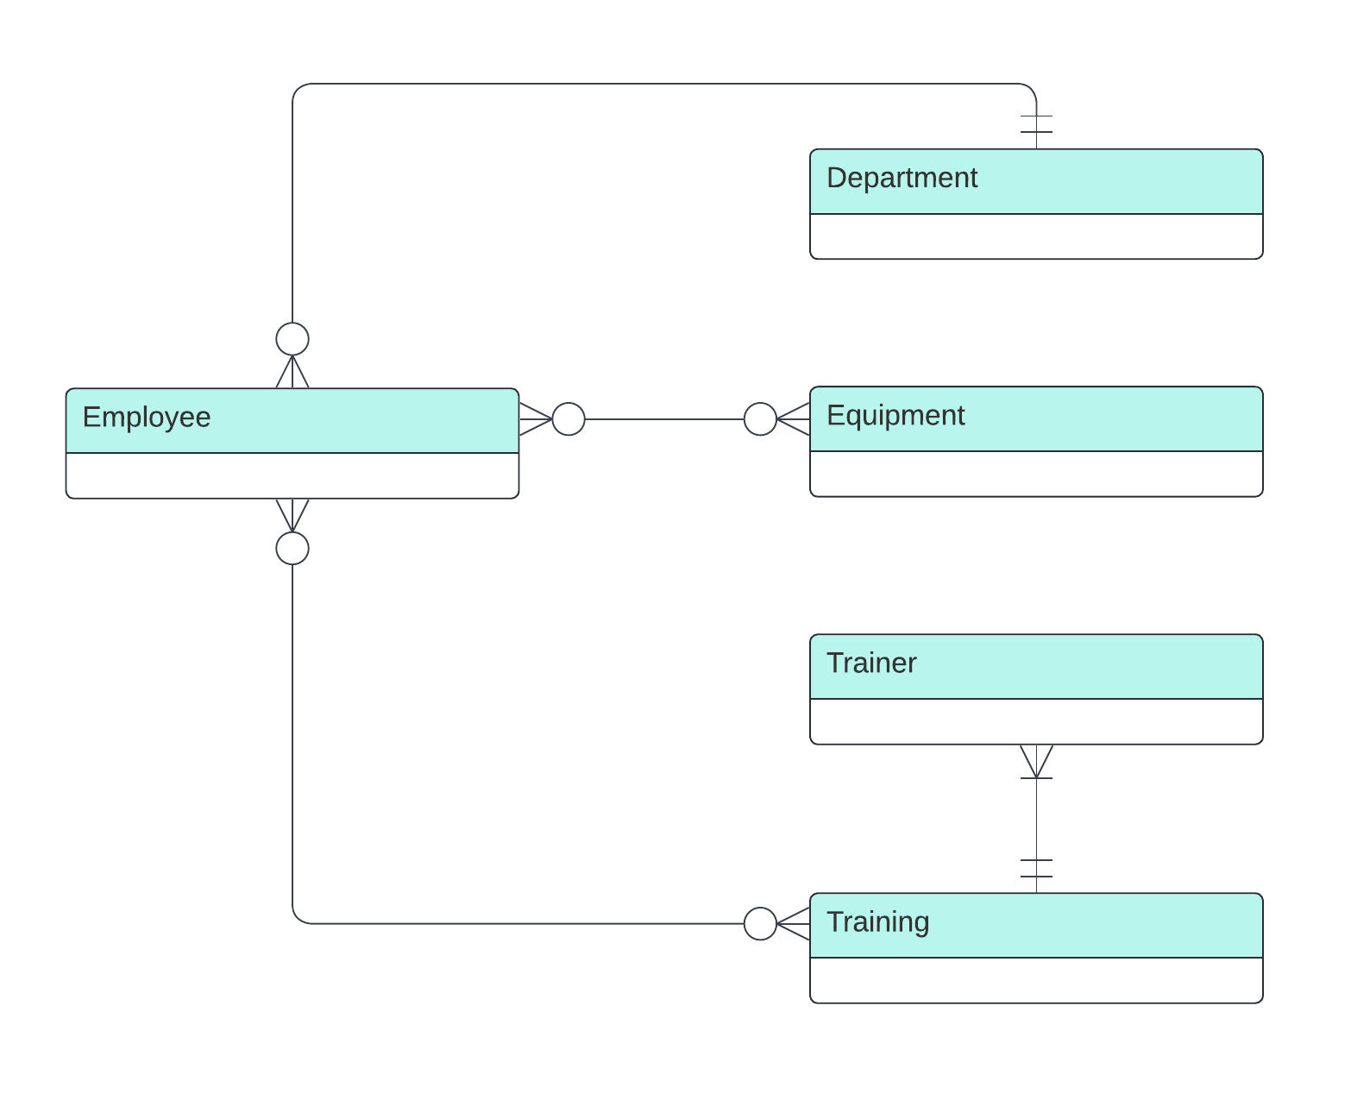

## Q2. Logical Model

Build Logical Model on top of the Conceptual Model built in Q1. ---> (a) Add Non-key Attributes (b) Add Primary/Foreign Key Attributes wheresoever needed (c) Add Junction tables to resolve many-many relationships if existing. *** Note: (I.) Comply with the Normalization Process (II.) Use proper names to identify attributes and entities ***

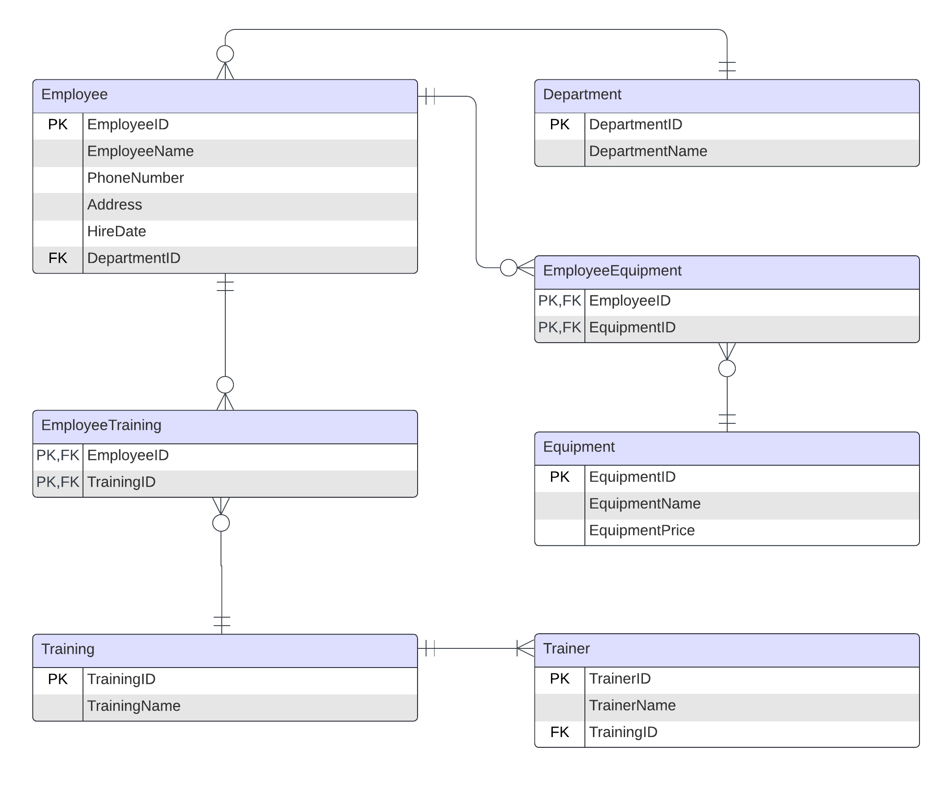

## Q3. Physical Model

Build Physical Model on top of the Logical Model built in Q2. ---> (a) Add datatypes (b) Add constraints if any (c) Use proper naming convention to format names of entities and attributes.

