LAB 7
LIBIN N GEORGE
111501015
PART A
1) Imported database “largeRelationsInsertFile.sql”
2)
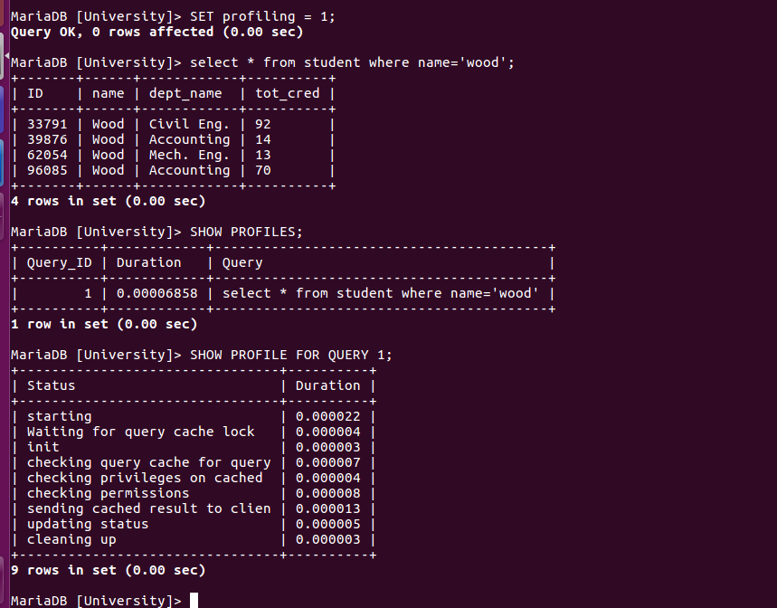
Thus the bottleneck is for starting and then comes the sending cached results

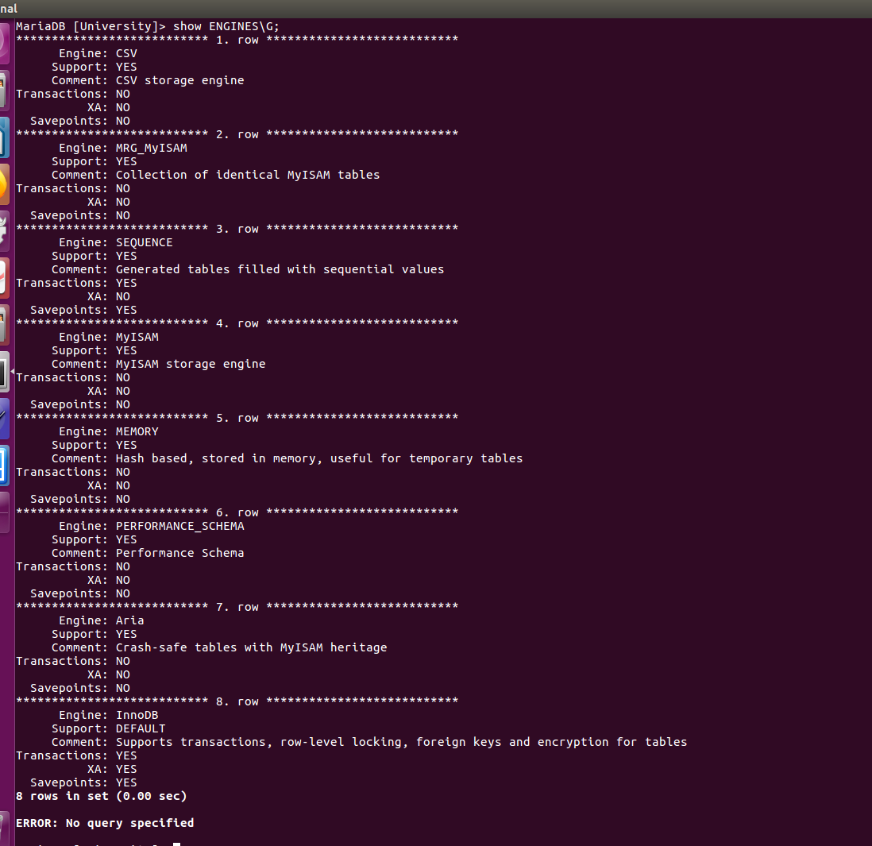
Default storage machine is InnoDB
Engine MEMORY is Hash based hence support Hash Index
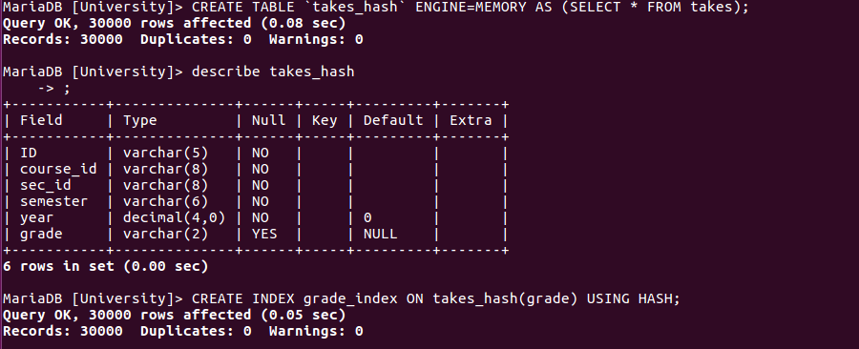
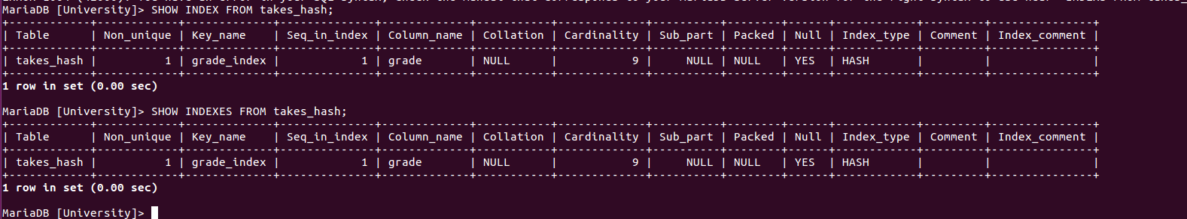
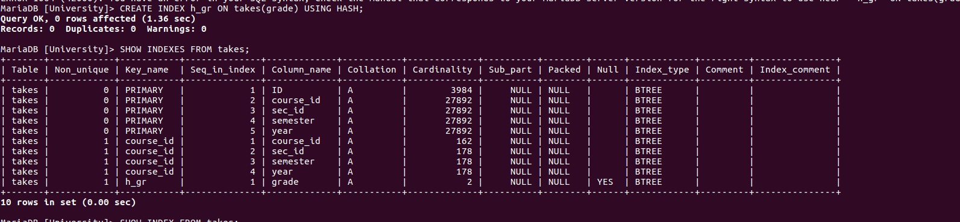
Thus hash is not used instead it uses a Btree index type which is nullable
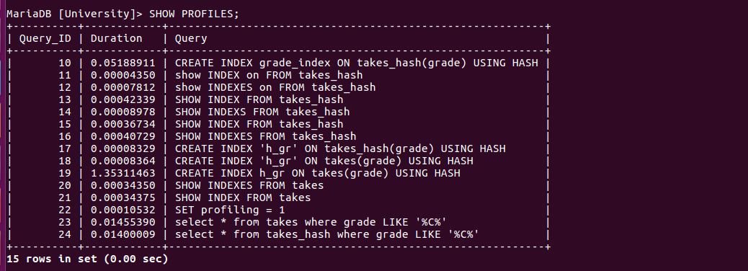
That is hash takes less time than B tree Indexing.
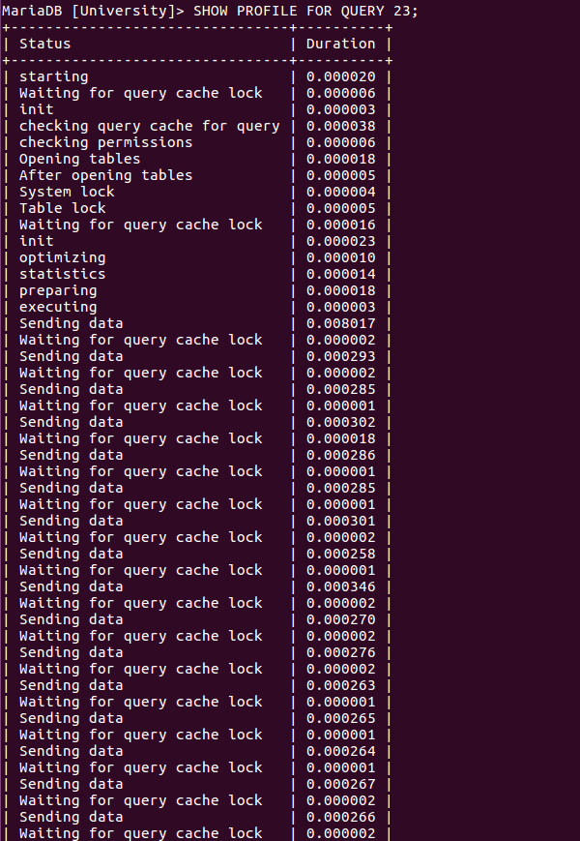
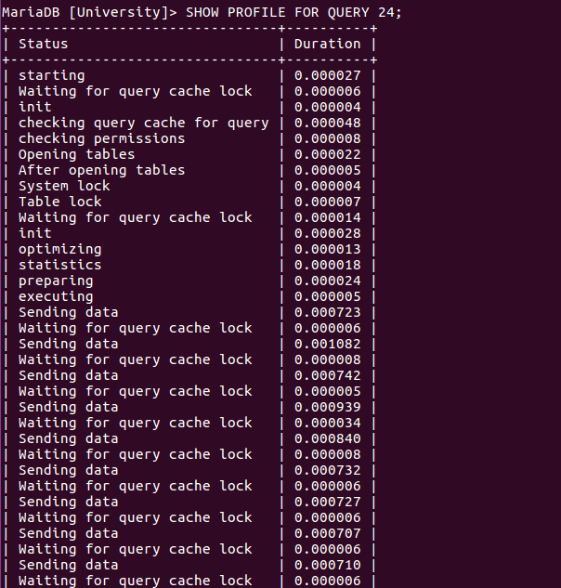
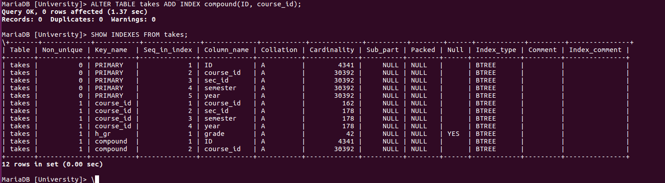

4)
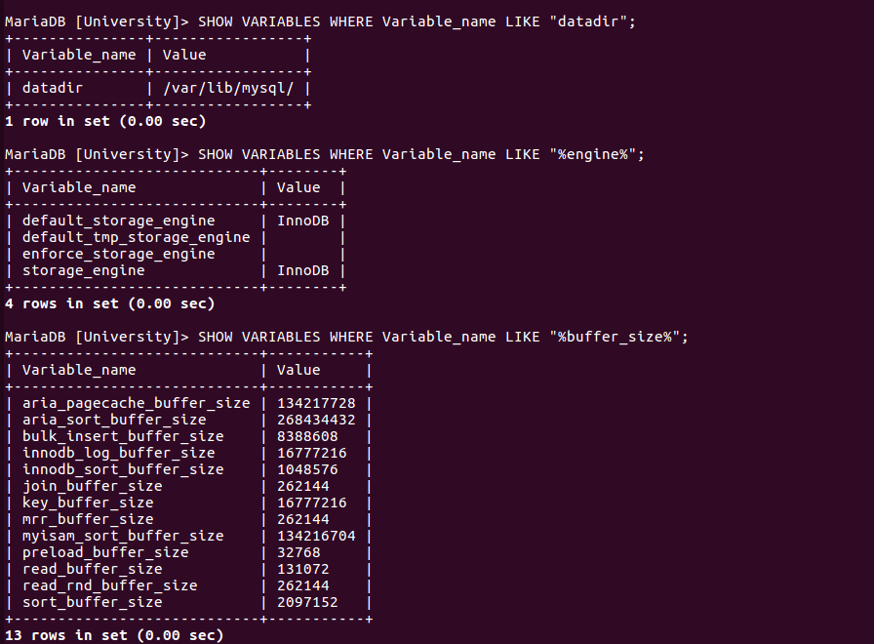
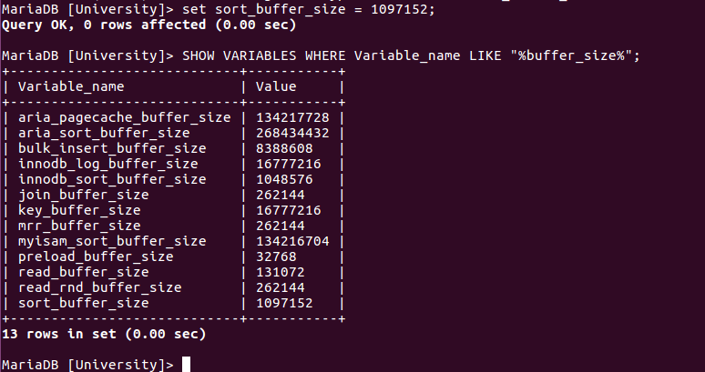

We can see each database as a inode/directory

