SQL LAB 4
LIBIN N GEORGE
111501015
A)
CREATE USER coordinator identified by 'abc';

CREATE ROLE reader;

GRANT SELECT ON University.* TO reader ;

GRANT reader TO coordinator;

CREATE ROLE writer;

GRANT INSERT ON University.* TO writer ;

CREATE USER datamaster;

GRANT writer TO datamaster;

CREATE USER moderator;

GRANT writer TO moderator;

GRANT reader TO moderator;
MariaDB [University]> Query OK, 0 rows affected (0.00 sec)

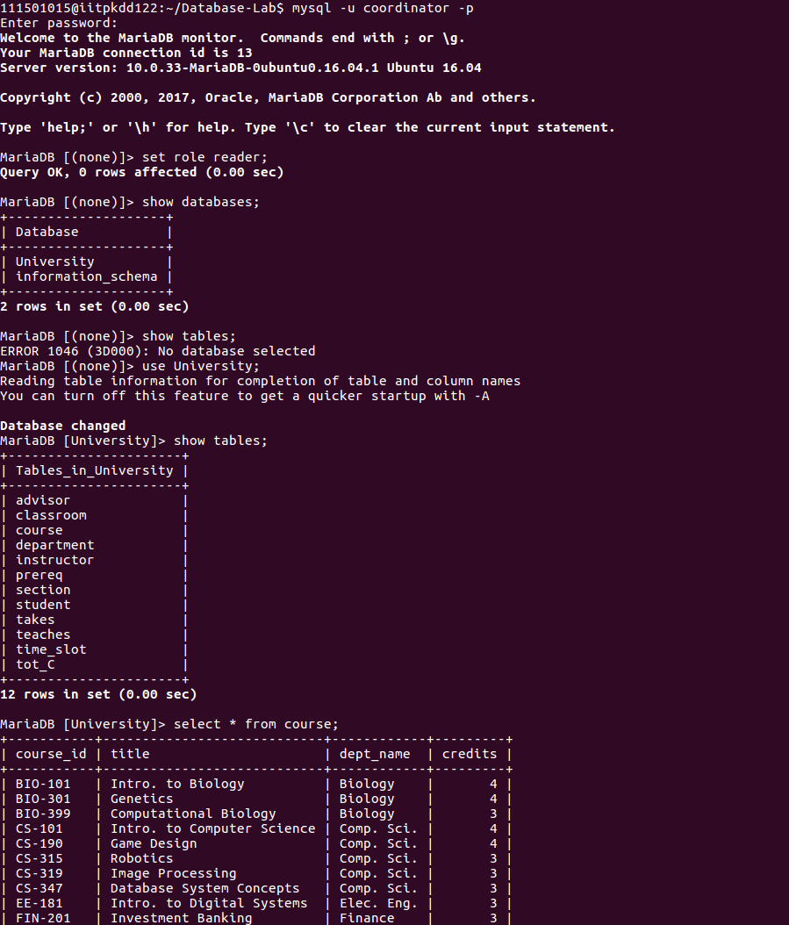

MariaDB [(none)]> Query OK, 0 rows affected (0.00 sec)

MariaDB [(none)]> MariaDB [(none)]> Query OK, 0 rows affected (0.00 sec)

MariaDB [(none)]> MariaDB [(none)]> Query OK, 0 rows affected (0.00 sec)

MariaDB [(none)]> MariaDB [(none)]> MariaDB [(none)]> Query OK, 0 rows affected (0.00 sec)
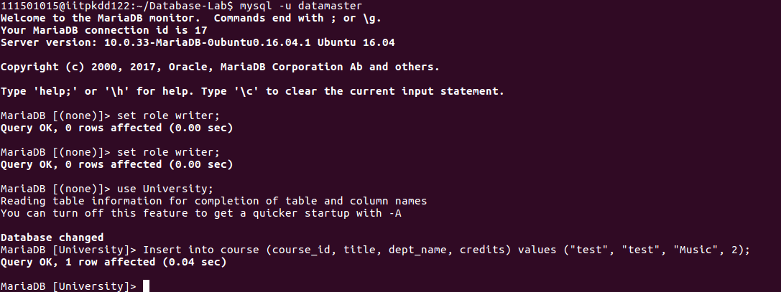

MariaDB [University]> MariaDB [University]> Query OK, 0 rows affected (0.00 sec)

MariaDB [University]> MariaDB [University]> Query OK, 0 rows affected (0.00 sec)

MariaDB [University]> Query OK, 0 rows affected (0.00 sec)

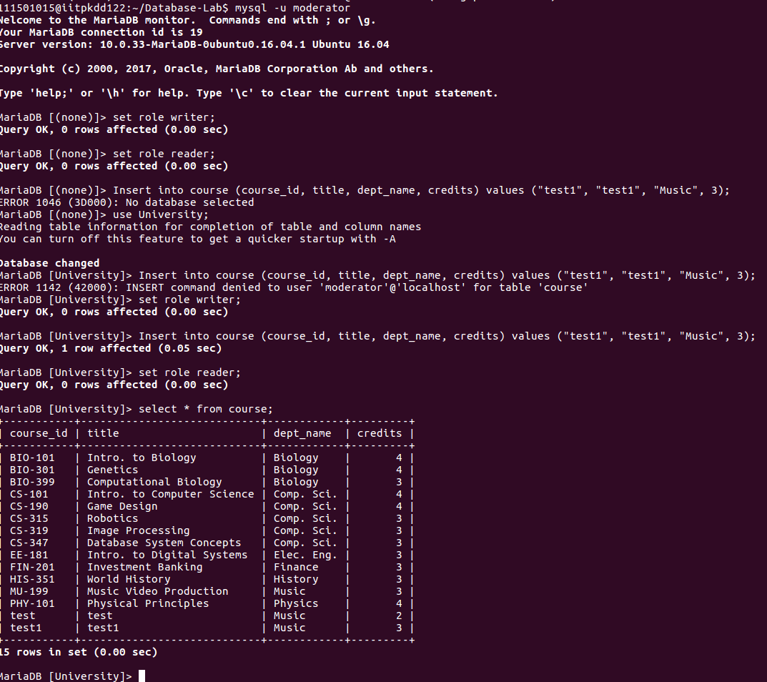

C)
SET @avg_cred = 0;
MariaDB [University]> Query OK, 0 rows affected (0.00 sec)
SET @avg_cred = (select AVG(tot_cred) FROM student);
MariaDB [University]> Query OK, 0 rows affected (0.00 sec)

SELECT @avg_cred;
MariaDB [University]> +-------------+
| @avg_cred |
+-------------+
| 5.384615384 |
+-------------+
1 row in set (0.00 sec)

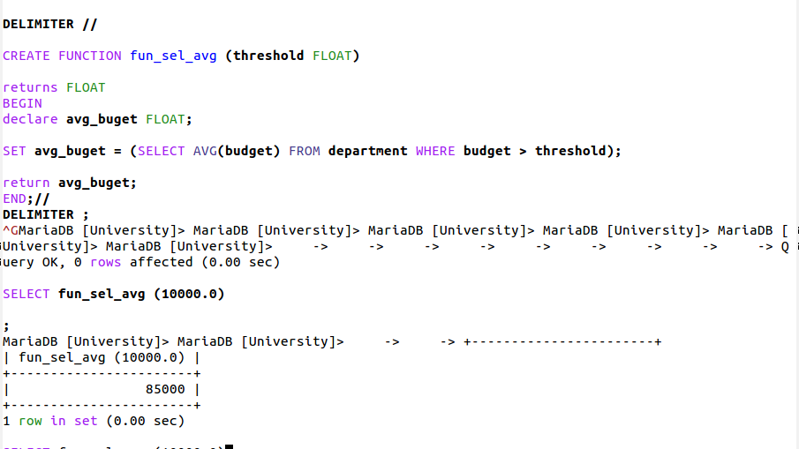
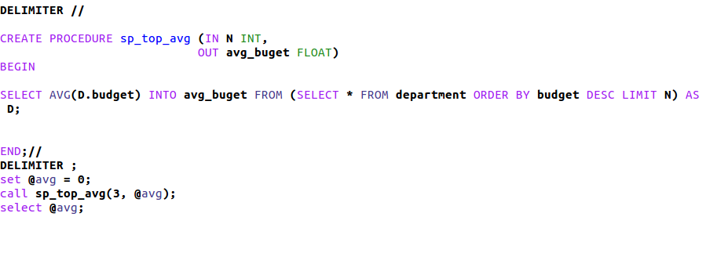

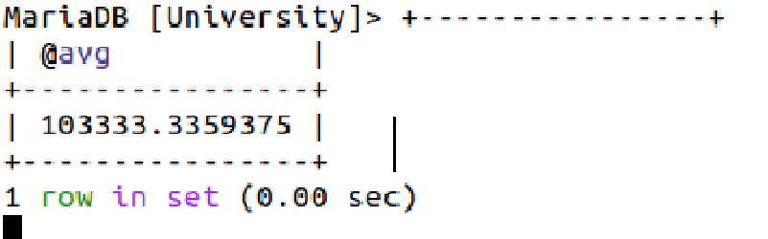

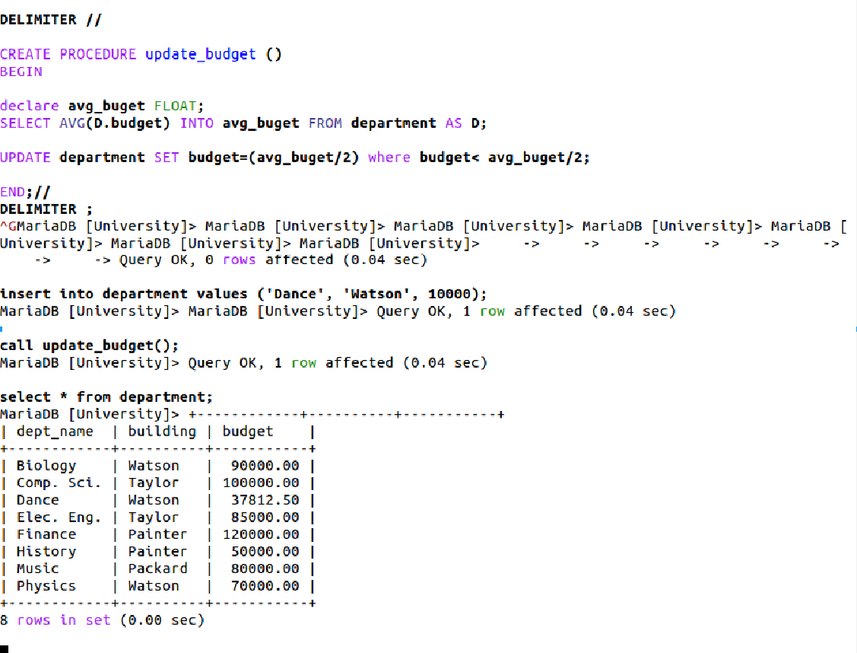
drop database canteen;
create database canteen;
use canteen;
create table menu (
id int not null,
name varchar(50) not null,
type enum('healthy','unhealthy'),
PRIMARY KEY(id)
);
create table `order`(
id INT not null,
count int not null,
PRIMARY KEY(id)
);
Create table price(
id INT not NULL,
amount float,
FOREIGN KEY (id) REFERENCES menu(id)
);
MariaDB [(none)]> Query OK, 1 row affected (0.01 sec)

MariaDB [(none)]> Database changed
MariaDB [canteen]> -> -> -> -> -> Query OK, 0 rows affected (0.29 sec)

MariaDB [canteen]> -> -> -> -> Query OK, 0 rows affected (0.29 sec)

MariaDB [canteen]> -> -> -> -> Query OK, 0 rows affected (0.33 sec)
