LAB 9
LIBIN N GEORGE
111501015
PART A

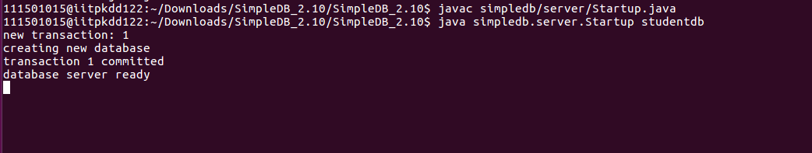
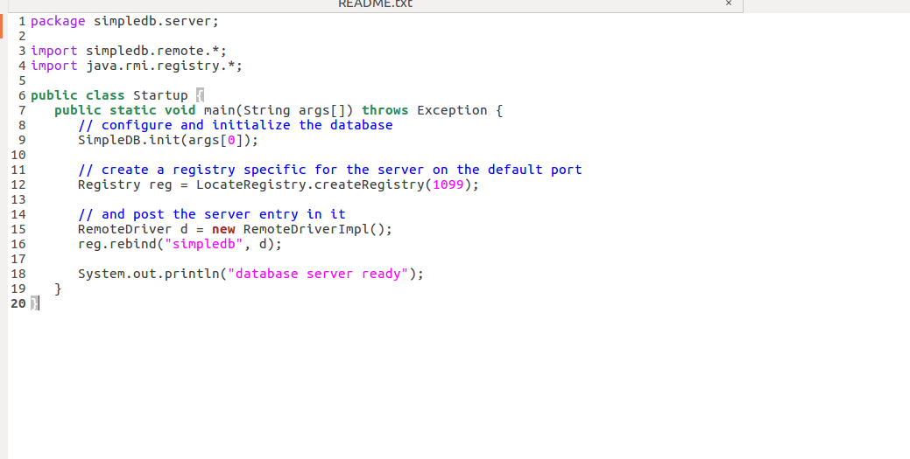
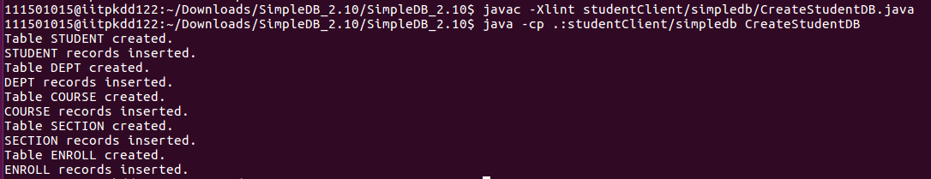
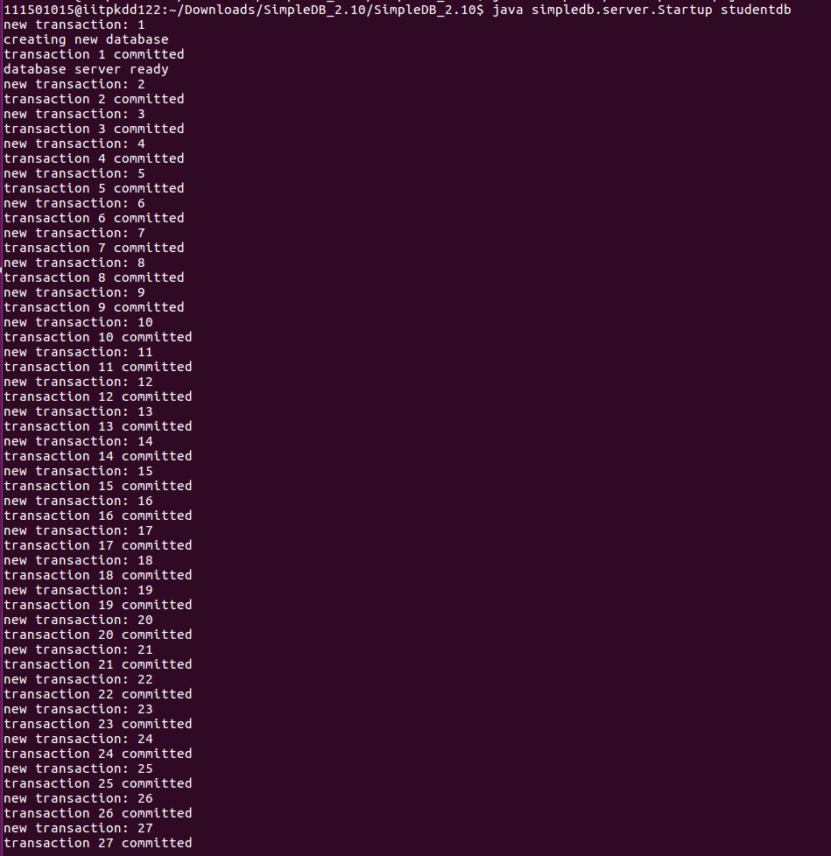
Each insertion in for creating records to Studentdb is executed as a transaction. Hence we get transaction for each statement.
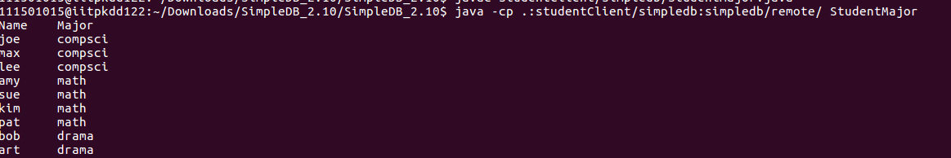
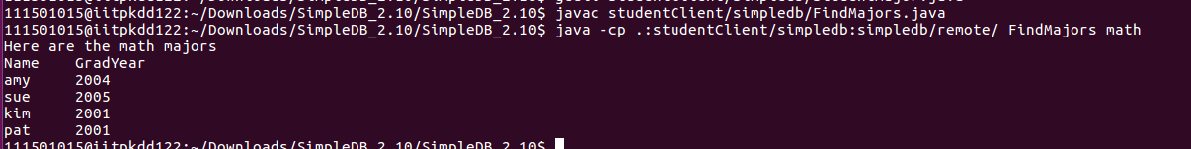
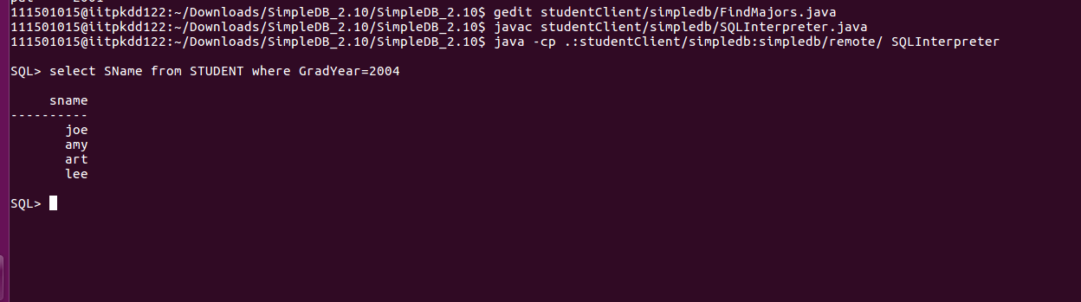
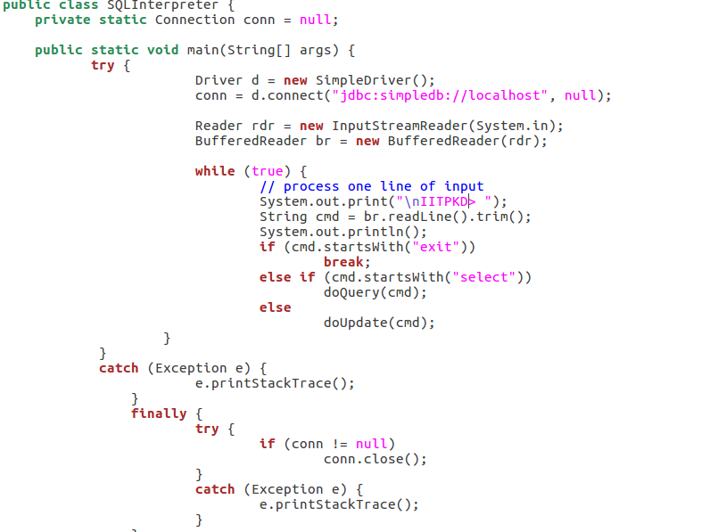
Below files show the files(functions) which is used to run select query.
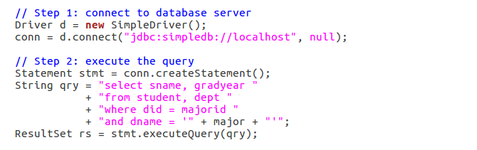
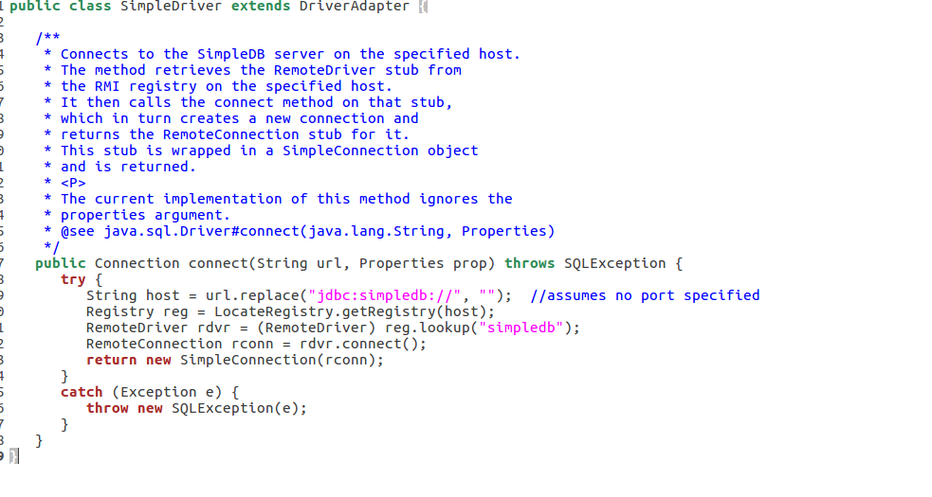
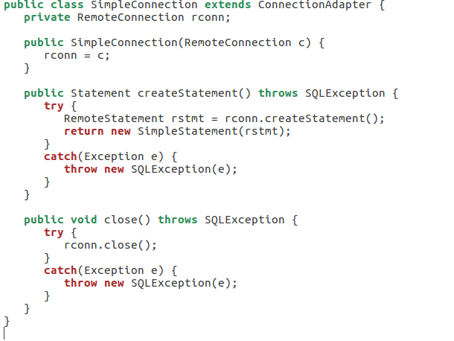
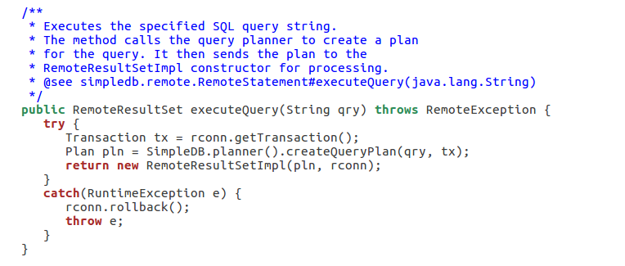
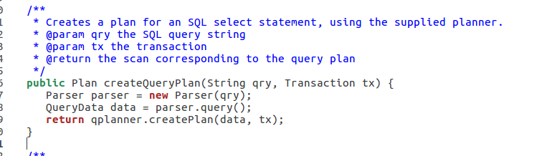
Calles parser from transaction class .

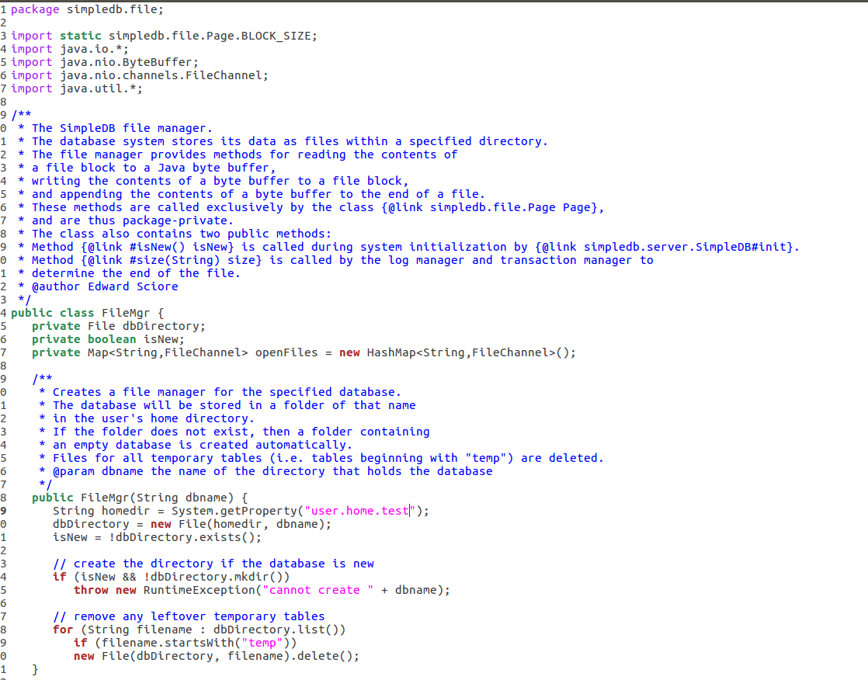
User.home is changed to change the location (here changed to user.home.test)
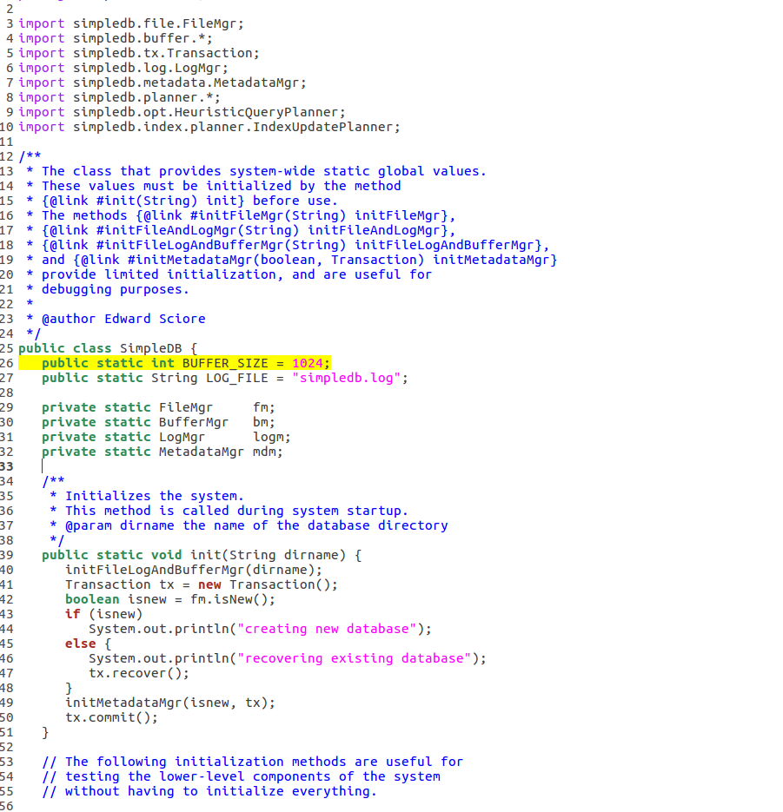
Buffer size is changed from 8 to 1024
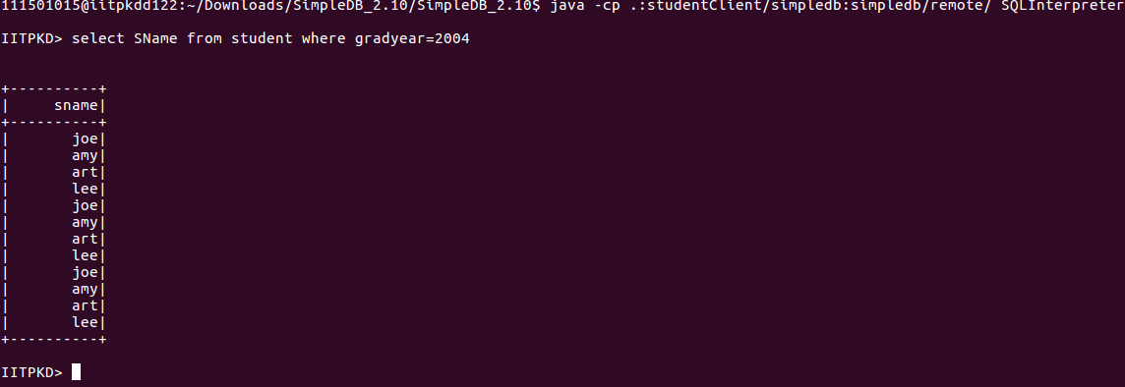
TO change the formating we have to edit SQLInterpeter.java (edited file given below)
import java.sql.*;
import simpledb.remote.SimpleDriver;
import java.io.*;

public class SQLInterpreter {
private static Connection conn = null;

public static void main(String[] args) {
try {
Driver d = new SimpleDriver();
conn = d.connect("jdbc:simpledb://localhost", null);

Reader rdr = new InputStreamReader(System.in);
BufferedReader br = new BufferedReader(rdr);

while (true) {
// process one line of input
System.out.print("\nIITPKD> ");
String cmd = br.readLine().trim();
System.out.println();
if (cmd.startsWith("exit"))
break;
else if (cmd.startsWith("select"))
doQuery(cmd);
else
doUpdate(cmd);
}
}
catch (Exception e) {
e.printStackTrace();
}
finally {
try {
if (conn != null)
conn.close();
}
catch (Exception e) {
e.printStackTrace();
}
}
}

private static void doQuery(String cmd) {
try {
Statement stmt = conn.createStatement();
ResultSet rs = stmt.executeQuery(cmd);
ResultSetMetaData md = rs.getMetaData();
int numcols = md.getColumnCount();
int totalwidth = 0;

System.out.print("\n+");
for(int i=1; i<=numcols; i++)
{
int width = md.getColumnDisplaySize(i);
for(int j=0; j<width; j++)
System.out.print("-");
System.out.print("+");
}
System.out.print("\n");

// print header
for(int i=1; i<=numcols; i++) {
System.out.print("|");
int width = md.getColumnDisplaySize(i);
totalwidth += width;
String fmt = "%" + width + "s";
System.out.format(fmt, md.getColumnName(i));
System.out.print("|");
}

System.out.print("\n+");
for(int i=1; i<=numcols; i++)
{
int width = md.getColumnDisplaySize(i);
for(int j=0; j<width; j++)
System.out.print("-");
System.out.print("+");
}
System.out.print("\n");

// print records
while(rs.next()) {
for (int i=1; i<=numcols; i++) {
System.out.print("|");
String fldname = md.getColumnName(i);
int fldtype = md.getColumnType(i);
String fmt = "%" + md.getColumnDisplaySize(i);
if (fldtype == Types.INTEGER)
System.out.format(fmt + "d", rs.getInt(fldname));
else
System.out.format(fmt + "s", rs.getString(fldname));
System.out.print("|");
}
System.out.print("\n");

}
System.out.print("+");
for(int i=1; i<=numcols; i++)
{
int width = md.getColumnDisplaySize(i);
for(int j=0; j<width; j++)
System.out.print("-");
System.out.print("+");
}
System.out.print("\n");
rs.close();
}
catch (SQLException e) {
System.out.println("SQL Exception: " + e.getMessage());
e.printStackTrace();
}
}

private static void doUpdate(String cmd) {
try {
Statement stmt = conn.createStatement();
int howmany = stmt.executeUpdate(cmd);
System.out.println(howmany + " records processed");
}
catch (SQLException e) {
System.out.println("SQL Exception: " + e.getMessage());
e.printStackTrace();
}
}
}

B.
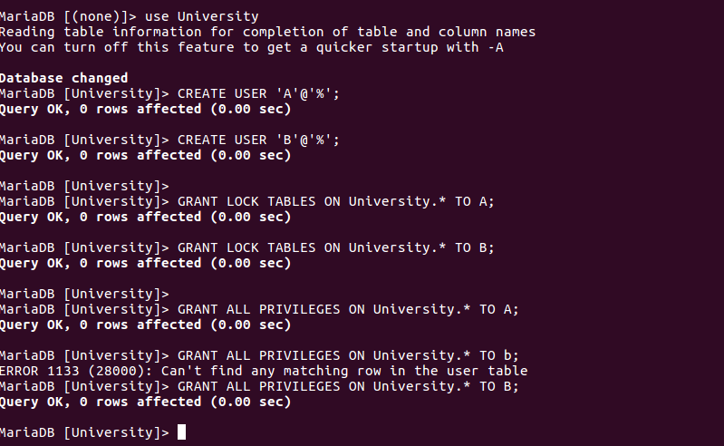
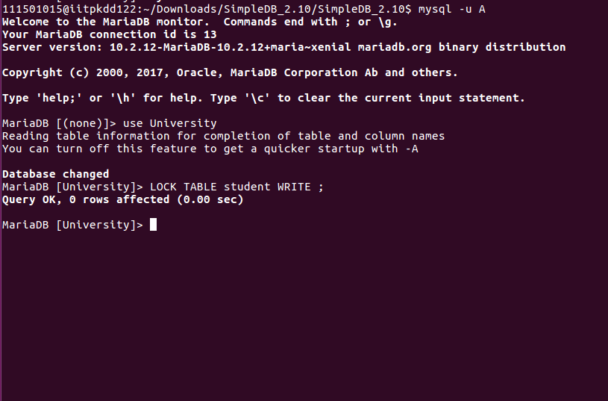
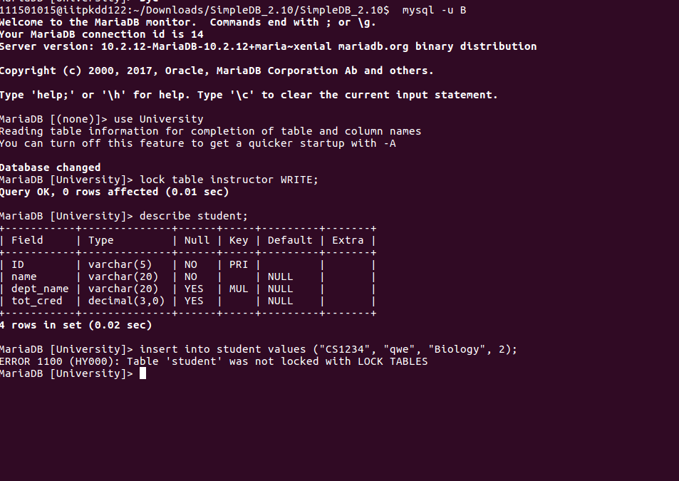
We cannot insert data as the table is already LOCKED hence mariadb was unable to LOCK the table before insertion. Hence aborted
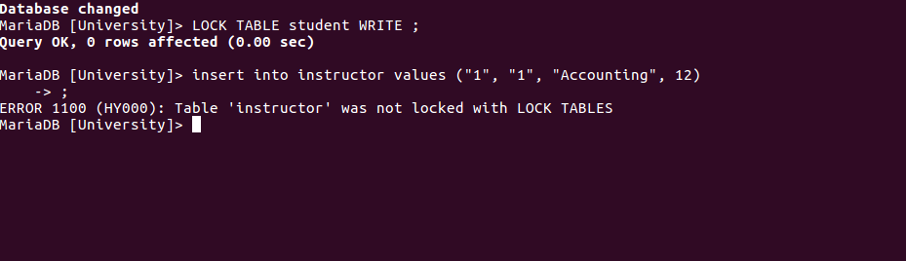
We cannot insert data as the table is already LOCKED hence mariadb was unable to LOCK the table before insertion. Hence aborted
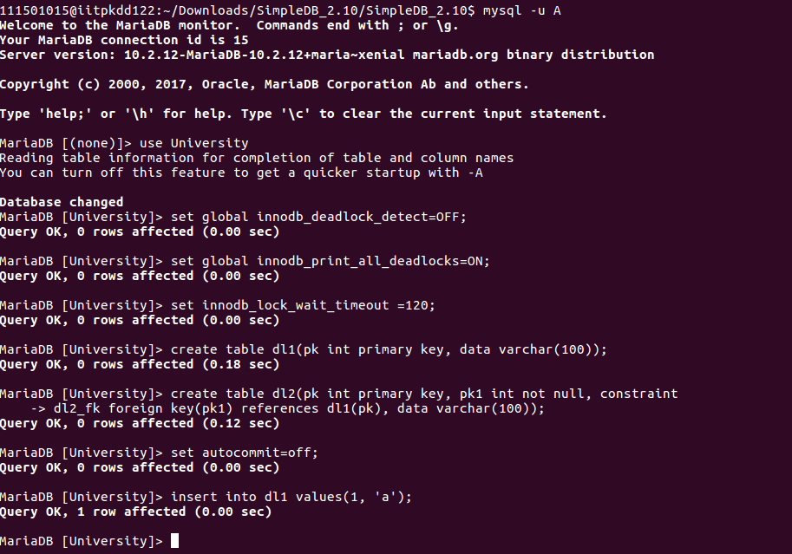

innodb_deadlock_detect
Description: By default, the InnoDB deadlock detector is enabled. If set to off, deadlock detection is disabled and MariaDB will rely on innodb_lock_wait_timeout instead. This may be more efficient in systems with high concurrency as deadlock detection can cause a bottleneck when a number of threads have to wait for the same lock.

innodb_lock_wait_timeout
Description: Time in seconds that an InnoDB transaction waits for an InnoDB row lock (not table lock) before giving up with the error ERROR 1205 (HY000): Lock wait timeout exceeded; try restarting transaction. When this occurs, the statement (not transaction) is rolled back. The whole transaction can be rolled back if the innodb_rollback_on_timeout option is used. Increase this for data warehousing applications or where other long-running operations are common, or decrease for OLTP and other highly interactive applications. This setting does not apply to deadlocks, which InnoDB detects immediately, rolling back a deadlocked transaction.

innodb_print_all_deadlocks
If set to 1 (0 is default), all XtraDB/InnoDB transaction deadlock information is written to the error log.
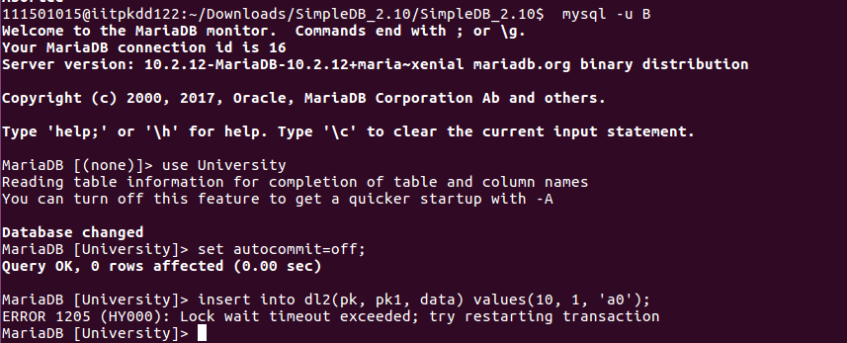
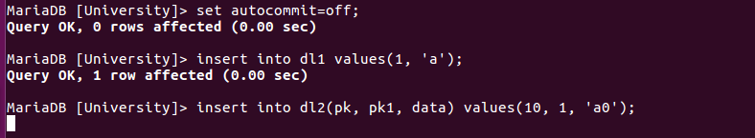
User A
USER A => Locks dl1 (because of insert )
USER B => insert to dl2 depends on foreign key of dl1. It locks dl2 but waits for lock in dl1.
USER A => tries to insert to dl2 but unable to get a lock on dl2. (dl2 lock with USER B)
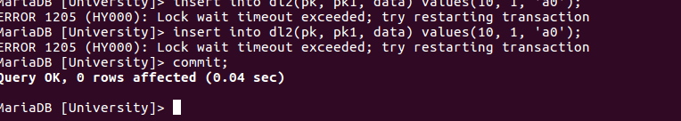
As it is commited now User B can get the lock hence complete the transaction
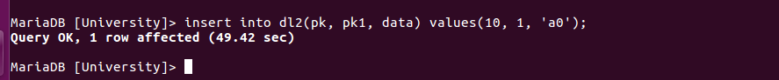
USER B
WHEN set global innodb_deadlock_detect=ON;, we get the above error when dead lock is created.

