Lab Report
Date: 2 February 2018
LIBIN N GEORGE
111501015

INITIAL MODEL
For generating points for a Gaussian Mixture having three clusters closer cluster and one cluster which have larger variance and also away from other clusters. The first model was a simple Gaussian Mixture Model which generates mean for four clusters and generate the points.
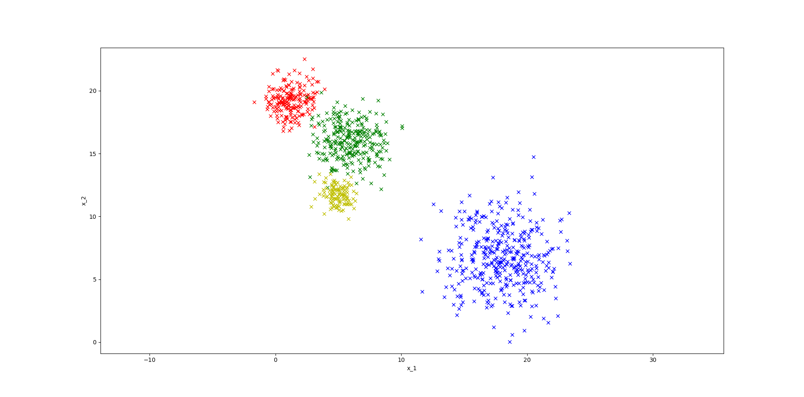

Results for Simple Gaussian Mixture model
import numpy as np
import matplotlib.pyplot as plt

def generate_mu_sigma(mu1, sigma1 ,mu2, sigma2, clusters):
mu_x = np.random.normal(mu1, sigma1, clusters)
mu_y = np.random.normal(mu1, sigma1, clusters)
sigma_x = np.random.normal(mu2, sigma2, clusters)
sigma_y = np.random.normal(mu2, sigma2, clusters)
mu = []
sigma = []
for i in range(clusters):
mu.append([mu_x[i], mu_y[i]])
sigma.append([[sigma_x[i], 0], [0, sigma_x[i]]])
return (mu, sigma)
print generate_mu_sigma(1, 0.5, 1, 1.0, 4)

def generate_z(theta):
z = []
z_end=0
for i in theta:
z.append(z_end + i)
z_end = z_end + i
x = np.random.random_sample()
sample = 0
for i in z:
if x < i:
break
sample += 1
return sample

print generate_z([0.1, 0.2, 0.5, 0.2])

def generate_x(theta, mu1, mu2, sigma1, sigma2, clusters, num_points = 1000):
mu, sigma = generate_mu_sigma(mu1, sigma1, mu2, sigma2, clusters)
xs = []
ys = []
color = ['b', 'g', 'r', 'y']
for i in range(num_points):
z = generate_z(theta)
x, y = np.random.multivariate_normal(mu[z], sigma[z], 1).T
plt.plot(x, y, 'x', c=color[z])
xs.append(x)
ys.append(y)
# plt.plot(xs, ys, 'x')
plt.axis('equal')
plt.xlabel('x_1')
plt.ylabel('x_2')
# plt.title('lamda = ' + str(lamda) + 'sigma = ' + str(sigma))
plt.show()

print generate_x([0.1, 0.2, 0.5, 0.2], 1.0, 5.0, 10.0, 2.0, 4)

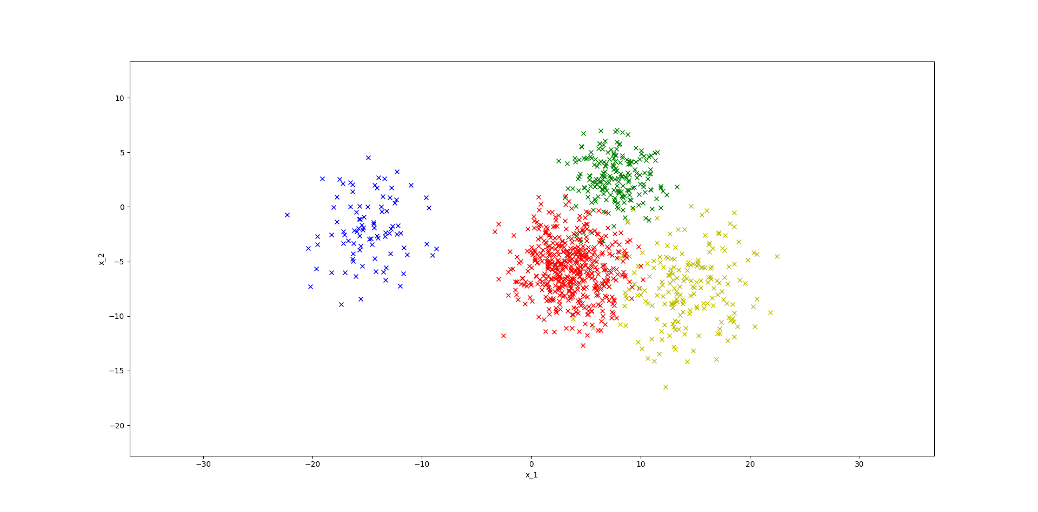
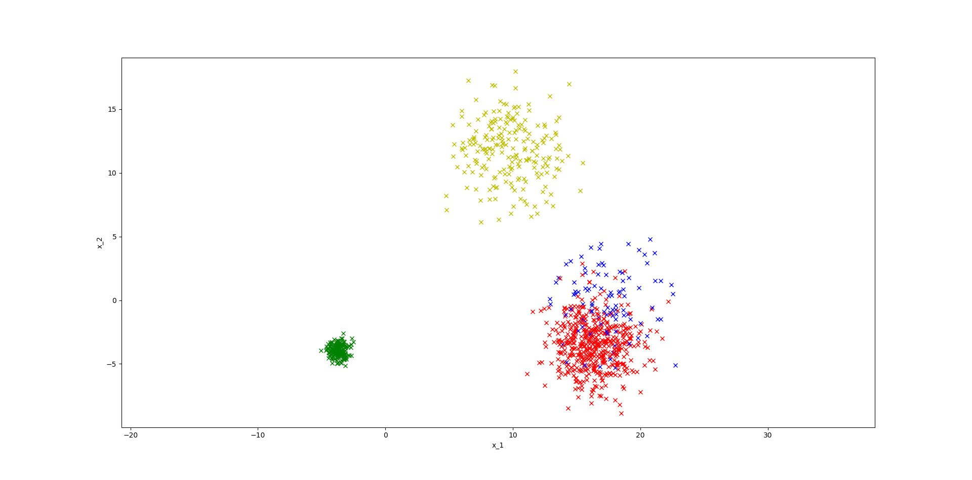
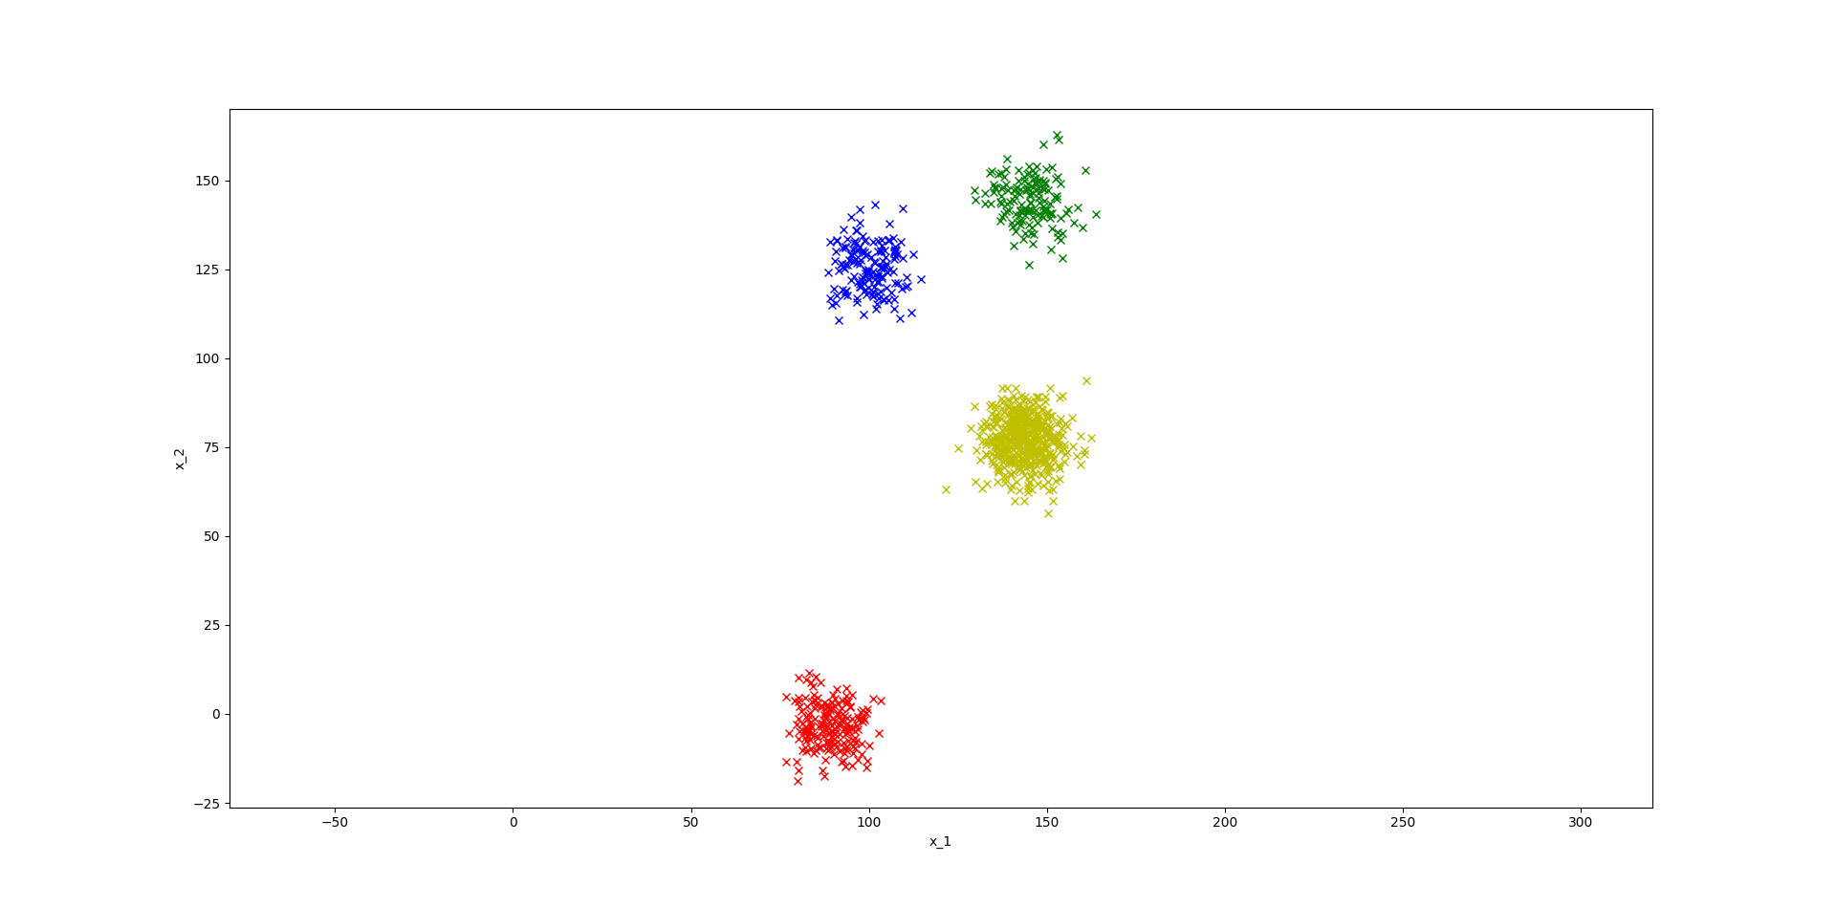
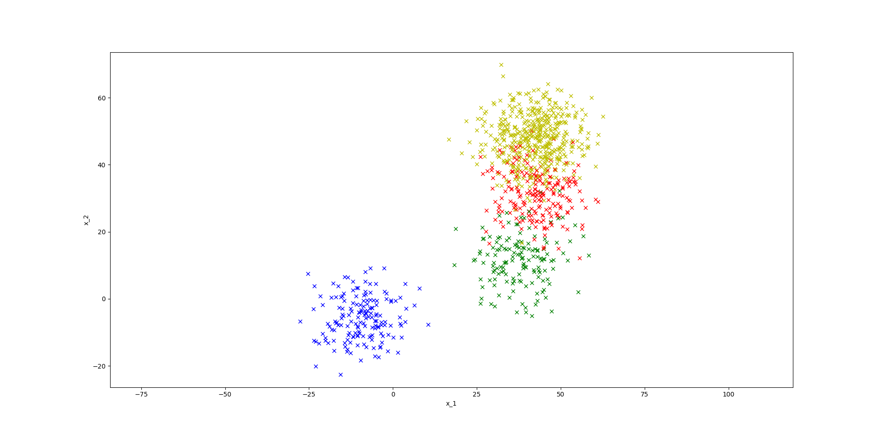
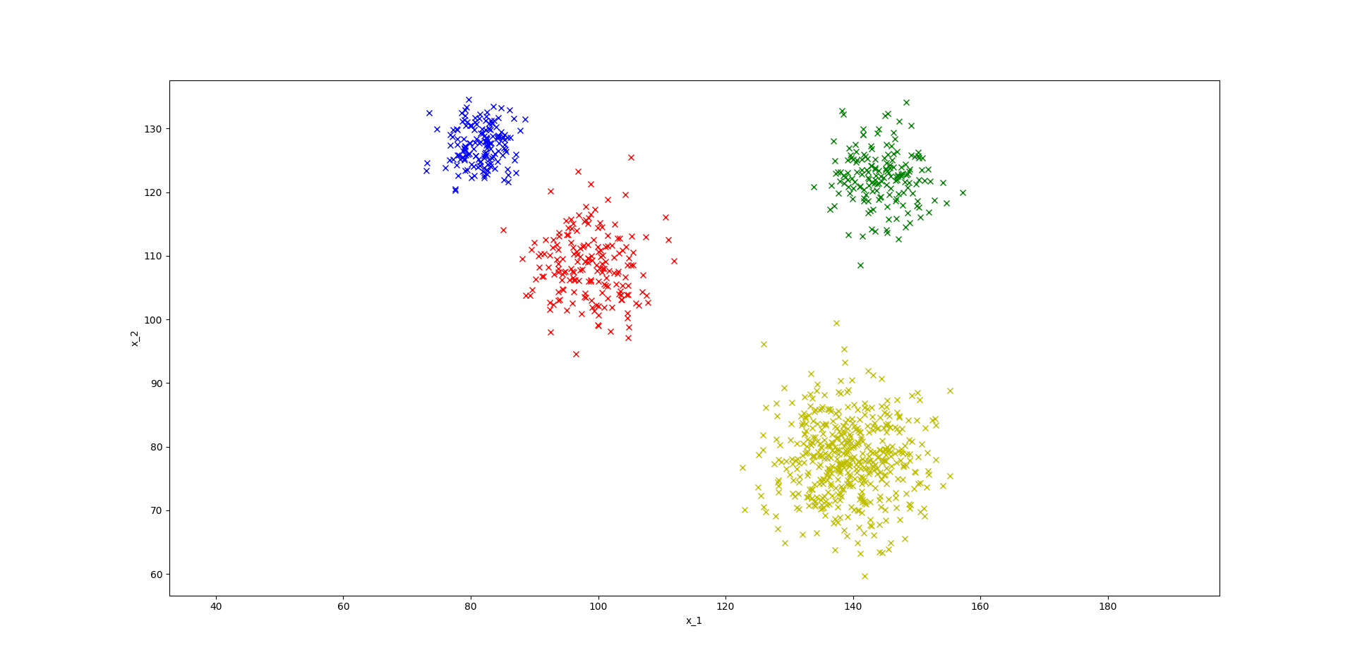

Modification of Gaussian Mixture model for Better Results

For generating points for a Gaussian Mixture having three clusters closer cluster and one cluster which have larger variance and also away from other clusters. From the given Dataset we can see that one cluster is away from other three clusters. So we have to generate mean for different distributions such that distributions comes closer as more clusters are generated. That is, we have to sample two points (mean for individual distributions) from a given Gaussian distribution and recursively sample another two points with one of the already generated mean (points). Thus we get means of the distribution get closer and closer as more means are generated.

μ

μ for distribution 1

μ for generating more μ for distribution 2
distribution

Results of Modified Gaussian Mixture Method
import numpy as np
import matplotlib.pyplot as plt

def generate_means(mu1, sigma1 , clusters):
mu_out = []
sigma_out = []
for i in range(clusters-1):
mu_1, mu1 = np.random.multivariate_normal(mu1, sigma1, 2)
print mu_1
sigma1 = np.array(sigma1)*0.5
mu_out.append(mu_1)
mu_out.append(mu1)
return mu_out

print generate_means([2,2], [[10, 0],[0, 10]], 4)

def generate_variances(mu1, sigma1 , clusters):
sigma_out = []
for i in range(clusters-1):
var_1, mu1 = np.random.normal(mu1, sigma1, 2)
sigma_out.append([[var_1, 0], [0, var_1]])
sigma_out.append([[mu1, 0], [0, mu1]])
return sigma_out
print generate_variances(5.0, 10.0, 4)

def generate_z(theta):
z = []
z_end=0
for i in theta:
z.append(z_end + i)
z_end = z_end + i
x = np.random.random_sample()
sample = 0
for i in z:
if x < i:
break
sample += 1
return sample

print generate_z([0.15, 0.15, 0.2, 0.5])

def generate_x(theta, mu1, mu2, sigma1, sigma2, clusters, num_points = 1000):
mu = generate_means(mu1, sigma1, clusters)
print mu
sigma = [[[5, 0],[0, 5]], [[2, 0],[0, 2]], [[1, 0],[0, 1]], [[0.5, 0],[0, 0.5]]]
xs = []
ys = []
color = ['b', 'g', 'r', 'y']
for i in range(num_points):
z = generate_z(theta)
x, y = np.random.multivariate_normal(mu[z], sigma[z], 1).T
plt.plot(x, y, 'x', c=color[z])
xs.append(x)
ys.append(y)
plt.axis('equal')
plt.xlabel('x_1')
plt.ylabel('x_2')
plt.show()

print generate_x([0.4, 0.3, 0.2, 0.1], [5,5] , 1.0 , [[100.0, 0], [0, 100.0]], 4.0, 4)

