**MALNUTRIENTS ACROSS THE GLOBE**

**ABOUT DATA:**

My dataset is about MALNUTRIENTS ACROSS THE GLOBE, in this dataset has four attributes they are country, income classification, wasting, stunning, underweight, overweight and U5 population.

There are 152 countries. In this income classification we have 4 division of income classification:

0 - low income

1. Middle income
2. Average income
3. High income.

The wasting, stunning, underweight, overweight is the four types of malnutrients and U5 is the population of under 5 age children in each country.

**ASSUMPTION:**

1. Here I assume that how the mal nutrients are in the income classification,

* Severe wasting with income classification
* Wasting with income classification
* Stunning with income classification
* Underweight with income classification
* Overweight with income classification

1. Next, I assumed each attribute with the population,

* Severe wasting, wasting, stunning, underweight, overweight of the

under 5 children’s population.

**INFERENCE:**

By the visualization of histogram, we assume that each of the mal nutrients like sever wasting, wasting, over weight and under weight has different percentage reach high in the classification. The maximum percentage of these four types of attributes are varied between the 10 to 20 percentage of the income classication. This shows that the nutrients level of the under 5 children varies according to income level of the individual people in each country.

Next as we assume the under 5 population with each mal nutrients are equally distributed in the scatter plot in the range of 1.0. This shows that the four type of mal nutrients are moderate when compared to the population of under 5 children.

**INSIGHT:**

This shows that the under 5 children are affected by this malnutrients deficiency because of the different income classification each family who have under 5 children been in low level of income classification can be affected more. To reduce this disaster, we can take over protective measures in each country so that we can reduce the malnutrients deficiency in the global level in the upcoming years.

library(readr)  
country1 <- read_csv("country-wise-average.csv")

## Rows: 152 Columns: 8  
## ── Column specification ────────────────────────────────────────────────────────  
## Delimiter: ","  
## chr (1): Country  
## dbl (7): IncomeClassification, SevereWasting, Wasting, Overweight, Stunting,...  
##   
## ℹ Use `spec()` to retrieve the full column specification for this data.  
## ℹ Specify the column types or set `show_col_types = FALSE` to quiet this message.

#View(country1)  
  
install.packages("dplyr")

## Installing package into '/cloud/lib/x86_64-pc-linux-gnu-library/4.2'  
## (as 'lib' is unspecified)

library(dplyr)

##   
## Attaching package: 'dplyr'  
##   
## The following objects are masked from 'package:stats':  
##   
## filter, lag  
##   
## The following objects are masked from 'package:base':  
##   
## intersect, setdiff, setequal, union

install.packages("lattice")

## Installing package into '/cloud/lib/x86_64-pc-linux-gnu-library/4.2'  
## (as 'lib' is unspecified)

library(lattice)  
summary(country1)

## Country IncomeClassification SevereWasting Wasting   
## Length:152 Min. :0.000 Min. : 0.000 Min. : 0.000   
## Class :character 1st Qu.:1.000 1st Qu.: 0.900 1st Qu.: 3.263   
## Mode :character Median :1.000 Median : 1.873 Median : 5.711   
## Mean :1.428 Mean : 2.169 Mean : 6.599   
## 3rd Qu.:2.000 3rd Qu.: 2.823 3rd Qu.: 8.740   
## Max. :3.000 Max. :11.400 Max. :23.650   
## NA's :12 NA's :2   
## Overweight Stunting Underweight U5Population   
## Min. : 0.9625 Min. : 1.00 Min. : 0.100 Min. : 1.0   
## 1st Qu.: 3.8500 1st Qu.:13.48 1st Qu.: 4.305 1st Qu.: 241.8   
## Median : 6.3000 Median :24.16 Median :10.380 Median : 981.2   
## Mean : 7.2016 Mean :25.81 Mean :13.503 Mean : 4042.9   
## 3rd Qu.: 9.0800 3rd Qu.:36.56 3rd Qu.:19.497 3rd Qu.: 3002.4   
## Max. :26.5000 Max. :57.60 Max. :46.267 Max. :123014.5   
## NA's :3 NA's :1 NA's :2

spec(country1)

## cols(  
## Country = col_character(),  
## IncomeClassification = col_double(),  
## SevereWasting = col_double(),  
## Wasting = col_double(),  
## Overweight = col_double(),  
## Stunting = col_double(),  
## Underweight = col_double(),  
## U5Population = col_double()  
## )

names(country1)

## [1] "Country" "IncomeClassification" "SevereWasting"   
## [4] "Wasting" "Overweight" "Stunting"   
## [7] "Underweight" "U5Population"

#sever wasting in low income  
income1 = filter(country1,IncomeClassification == 0)  
income1

## # A tibble: 31 × 8  
## Country Incom…¹ Sever…² Wasting Overw…³ Stunt…⁴ Under…⁵ U5Pop…⁶  
## <chr> <dbl> <dbl> <dbl> <dbl> <dbl> <dbl> <dbl>  
## 1 AFGHANISTAN 0 3.03 10.4 5.12 47.8 30.4 4919.  
## 2 BENIN 0 2.42 7.7 2.28 35.4 20.1 1477.  
## 3 BURKINA FASO 0 4.17 12.7 2.25 33.3 25.1 2796.  
## 4 BURUNDI 0 1.26 6.67 1.78 57.6 32.2 1498.  
## 5 CENTRAL AFRICAN REPU… 0 3.16 8.77 5.38 41.8 23.4 673.  
## 6 CHAD 0 5.5 15.2 3.04 41.3 31.4 2024.  
## 7 DEMOCRATIC PEOPLE'S … 0 1.27 8.84 1.07 40.3 23.1 1862.  
## 8 DEMOCRATIC REP. OF T… 0 4.15 10.9 5.75 45.5 26.8 10621.  
## 9 ERITREA 0 4.63 14.6 1.67 53.2 37.6 408.  
## 10 ETHIOPIA 0 3.02 9.96 2.75 47.8 31.1 13942.  
## # … with 21 more rows, and abbreviated variable names ¹​IncomeClassification,  
## # ²​SevereWasting, ³​Overweight, ⁴​Stunting, ⁵​Underweight, ⁶​U5Population

income2 = filter(country1,IncomeClassification == 1)  
income2

## # A tibble: 46 × 8  
## Country IncomeClassif…¹ Sever…² Wasting Overw…³ Stunt…⁴ Under…⁵ U5Pop…⁶  
## <chr> <dbl> <dbl> <dbl> <dbl> <dbl> <dbl> <dbl>  
## 1 ANGOLA 1 2.4 6.93 2.55 42.6 23.6 3980.   
## 2 BANGLADESH 1 2.81 14.5 0.962 54.2 46.3 15837.   
## 3 BHUTAN 1 1.4 4.53 5.1 44.2 17.8 74.8  
## 4 BOLIVIA 1 0.7 1.9 8.6 29.7 7.47 1104.   
## 5 CABO VERDE 1 NA 5.55 NA 24.1 12.8 60.6  
## 6 CAMBODIA 1 3.48 11.5 3.03 43.7 32.0 1652.   
## 7 CAMEROON 1 1.81 5.67 8.04 33.7 14.7 3171.   
## 8 COMOROS (THE) 1 5.4 10.1 12.5 39.1 19.6 90.3  
## 9 CONGO (THE) 1 2.43 7.2 4.88 26.7 13.1 615.   
## 10 COTE D'IVOIRE 1 2.6 8.8 4.3 31.4 17.7 2943.   
## # … with 36 more rows, and abbreviated variable names ¹​IncomeClassification,  
## # ²​SevereWasting, ³​Overweight, ⁴​Stunting, ⁵​Underweight, ⁶​U5Population

income3 = filter(country1,IncomeClassification == 2)  
income3

## # A tibble: 54 × 8  
## Country Incom…¹ Sever…² Wasting Overw…³ Stunt…⁴ Under…⁵ U5Pop…⁶  
## <chr> <dbl> <dbl> <dbl> <dbl> <dbl> <dbl> <dbl>  
## 1 ALBANIA 2 4.08 7.76 20.8 24.2 7.7 233.   
## 2 ALGERIA 2 2.73 5.94 12.8 19.6 7.34 3565.   
## 3 ARGENTINA 2 0.2 2.15 11.1 10.0 2.6 3614.   
## 4 ARMENIA 2 1.6 3.94 13.6 16.1 3.48 204.   
## 5 AZERBAIJAN 2 2.58 5.43 9.18 21.8 8.08 741.   
## 6 BELARUS 2 0.6 2.2 9.7 4.5 1.3 446.   
## 7 BELIZE 2 0.833 2.33 9.6 18.8 5.3 36.1  
## 8 BOSNIA AND HERZEGOVI… 2 2.2 4.57 19.8 10.9 2.47 194.   
## 9 BOTSWANA 2 2.85 8.8 10.0 31.0 12.7 227.   
## 10 BRAZIL 2 0.7 2.3 6.25 13.1 3.92 17071.   
## # … with 44 more rows, and abbreviated variable names ¹​IncomeClassification,  
## # ²​SevereWasting, ³​Overweight, ⁴​Stunting, ⁵​Underweight, ⁶​U5Population

income4 = filter(country1,IncomeClassification == 3)  
income4

## # A tibble: 21 × 8  
## Country IncomeCla…¹ Sever…² Wasting Overw…³ Stunt…⁴ Under…⁵ U5Pop…⁶  
## <chr> <dbl> <dbl> <dbl> <dbl> <dbl> <dbl> <dbl>  
## 1 AUSTRALIA 3 0 0 13.9 1 0.1 1443.   
## 2 BAHRAIN 3 NA 6.7 7.5 13.8 6.95 63.4  
## 3 BARBADOS 3 2 6.8 12.2 7.7 3.5 16.7  
## 4 BRUNEI DARUSSALAM 3 0.4 2.9 8.3 19.7 9.6 31.3  
## 5 CANADA 3 NA NA 10.4 NA NA 1698.   
## 6 CHILE 3 NA 0.467 11.3 3.45 0.747 1303.   
## 7 CZECHIA 3 1 3.7 5.55 2.9 1.5 544.   
## 8 GERMANY 3 0.1 0.65 3.35 1.5 0.8 3642.   
## 9 JAPAN 3 0.2 2.3 1.5 7.1 3.4 5554.   
## 10 KUWAIT 3 0.629 2.52 7.99 4.66 2.35 255.   
## # … with 11 more rows, and abbreviated variable names ¹​IncomeClassification,  
## # ²​SevereWasting, ³​Overweight, ⁴​Stunting, ⁵​Underweight, ⁶​U5Population

income_class = c(income1,income2,income3,income4)  
income_class

## $Country  
## [1] "AFGHANISTAN"   
## [2] "BENIN"   
## [3] "BURKINA FASO"   
## [4] "BURUNDI"   
## [5] "CENTRAL AFRICAN REPUBLIC (THE)"   
## [6] "CHAD"   
## [7] "DEMOCRATIC PEOPLE'S REP. OF KOREA (THE)"  
## [8] "DEMOCRATIC REP. OF THE CONGO (THE)"   
## [9] "ERITREA"   
## [10] "ETHIOPIA"   
## [11] "GAMBIA (THE)"   
## [12] "GUINEA"   
## [13] "GUINEA-BISSAU"   
## [14] "HAITI"   
## [15] "LIBERIA"   
## [16] "MADAGASCAR"   
## [17] "MALAWI"   
## [18] "MALI"   
## [19] "MOZAMBIQUE"   
## [20] "NEPAL"   
## [21] "NIGER (THE)"   
## [22] "RWANDA"   
## [23] "SIERRA LEONE"   
## [24] "SOMALIA"   
## [25] "SOUTH SUDAN"   
## [26] "SYRIAN ARAB REPUBLIC (THE)"   
## [27] "TAJIKISTAN"   
## [28] "TOGO"   
## [29] "UGANDA"   
## [30] "UNITED REPUBLIC OF TANZANIA (THE)"   
## [31] "YEMEN"   
##   
## $IncomeClassification  
## [1] 0 0 0 0 0 0 0 0 0 0 0 0 0 0 0 0 0 0 0 0 0 0 0 0 0 0 0 0 0 0 0  
##   
## $SevereWasting  
## [1] 3.033333 2.425000 4.169231 1.260000 3.160000 5.500000 1.275000  
## [8] 4.150000 4.633333 3.016667 2.085714 3.242857 2.925000 1.980000  
## [15] 1.780000 2.240000 1.607692 4.457143 2.566667 2.528571 4.330000  
## [22] 1.425000 3.075000 4.350000 11.400000 5.050000 2.483333 2.037500  
## [29] 1.333333 1.500000 5.300000  
##   
## $Wasting  
## [1] 10.350000 7.700000 12.730769 6.666667 8.766667 15.240000 8.842857  
## [8] 10.860000 14.600000 9.957143 8.385714 9.425000 8.125000 6.616667  
## [15] 5.840000 9.957143 4.640000 13.242857 6.800000 10.325000 15.936364  
## [22] 4.866667 8.610000 15.633333 23.650000 9.566667 8.290909 7.712500  
## [29] 4.522222 5.054545 15.242857  
##   
## $Overweight  
## [1] 5.125000 2.275000 2.250000 1.775000 5.380000 3.040000 1.066667  
## [8] 5.750000 1.666667 2.750000 2.228571 4.333333 6.750000 3.660000  
## [15] 3.480000 2.500000 7.484615 2.200000 6.566667 1.028571 1.520000  
## [22] 6.314286 6.237500 3.850000 8.450000 17.825000 6.116667 2.400000  
## [29] 4.277778 4.540000 4.842857  
##   
## $Stunting  
## [1] 47.77500 35.37500 33.34615 57.60000 41.78333 41.26000 40.30000 45.46000  
## [9] 53.22500 47.84286 23.70000 34.23750 35.27500 29.91667 37.22000 52.57500  
## [17] 49.10714 34.41429 47.84286 51.91250 46.00000 46.31111 37.20000 32.16667  
## [25] 33.75000 28.55000 33.77273 30.92222 38.33333 40.99091 51.90000  
##   
## $Underweight  
## [1] 30.37500 20.12500 25.07692 32.25000 23.36667 31.40000 23.12857 26.84000  
## [9] 37.55000 31.05714 16.30000 19.26250 18.05000 16.90000 17.74000 34.31429  
## [17] 17.40667 26.67143 20.75714 36.95000 38.26364 15.88889 20.39000 26.03333  
## [25] 30.10000 10.05000 10.93333 18.93333 15.53333 17.72727 37.78571  
##   
## $U5Population  
## [1] 4918.5615 1476.5258 2796.1906 1497.8880 673.2005 2024.2904  
## [7] 1862.4604 10621.0802 407.6545 13942.3456 317.1646 1712.4411  
## [13] 243.3268 1216.8087 618.2774 2932.9285 2409.5668 2533.5643  
## [19] 3619.8403 3226.0736 3137.2158 1423.7553 982.5267 2017.3263  
## [25] 1459.2625 2476.2093 979.9403 957.8651 5647.8906 7373.0489  
## [31] 3269.4760  
##   
## $Country  
## [1] "ANGOLA" "BANGLADESH"   
## [3] "BHUTAN" "BOLIVIA"   
## [5] "CABO VERDE" "CAMBODIA"   
## [7] "CAMEROON" "COMOROS (THE)"   
## [9] "CONGO (THE)" "COTE D'IVOIRE"   
## [11] "DJIBOUTI" "EGYPT"   
## [13] "EL SALVADOR" "ESWATINI"   
## [15] "GHANA" "HONDURAS"   
## [17] "INDIA" "INDONESIA"   
## [19] "KENYA" "KIRIBATI"   
## [21] "KYRGYZSTAN" "LAO PEOPLE'S DEMOCRATIC REP. (THE)"  
## [23] "LESOTHO" "MAURITANIA"   
## [25] "MONGOLIA" "MOROCCO"   
## [27] "MYANMAR" "NICARAGUA"   
## [29] "NIGERIA" "PAKISTAN"   
## [31] "PAPUA NEW GUINEA" "PHILIPPINES (THE)"   
## [33] "REPUBLIC OF MOLDOVA (THE)" "SAO TOME AND PRINCIPE"   
## [35] "SENEGAL" "SOLOMON ISLANDS"   
## [37] "STATE OF PALESTINE" "SUDAN (THE)"   
## [39] "TIMOR-LESTE" "TUNISIA"   
## [41] "UKRAINE" "UZBEKISTAN"   
## [43] "VANUATU" "VIET NAM"   
## [45] "ZAMBIA" "ZIMBABWE"   
##   
## $IncomeClassification  
## [1] 1 1 1 1 1 1 1 1 1 1 1 1 1 1 1 1 1 1 1 1 1 1 1 1 1 1 1 1 1 1 1 1 1 1 1 1 1 1  
## [39] 1 1 1 1 1 1 1 1  
##   
## $SevereWasting  
## [1] 2.4000000 2.8136364 1.4000000 0.7000000 NA 3.4833333 1.8142857  
## [8] 5.4000000 2.4333333 2.6000000 9.4000000 2.4875000 0.4333333 0.6000000  
## [15] 2.0111111 0.2750000 6.1166667 4.1714286 2.3625000 NA 0.8166667  
## [22] 3.2000000 1.6200000 3.9750000 0.9625000 1.9500000 2.5000000 0.7500000  
## [29] 4.3800000 4.5000000 2.8000000 1.9200000 1.4500000 2.3333333 1.8250000  
## [36] 2.3333333 0.8500000 4.7666667 4.7750000 1.1000000 3.8000000 2.9750000  
## [43] 1.7000000 2.3312500 2.0428571 1.3888889  
##   
## $Wasting  
## [1] 6.933333 14.537500 4.525000 1.900000 5.550000 11.466667 5.671429  
## [8] 10.125000 7.200000 8.800000 17.075000 5.790000 1.700000 1.700000  
## [15] 7.622222 1.828571 18.766667 11.375000 6.466667 12.600000 2.533333  
## [22] 10.514286 6.671429 13.410000 2.444444 4.483333 9.771429 2.033333  
## [29] 12.045455 14.314286 8.000000 7.127273 3.850000 7.020000 8.271429  
## [36] 6.733333 3.733333 15.400000 15.620000 3.583333 8.200000 6.475000  
## [43] 5.800000 8.661905 5.542857 4.166667  
##   
## $Overweight  
## [1] 2.550000 0.962500 5.100000 8.600000 NA 3.033333 8.042857  
## [8] 12.466667 4.875000 4.300000 8.250000 13.762500 4.750000 11.425000  
## [15] 2.822222 3.900000 2.933333 7.200000 5.950000 15.900000 7.666667  
## [22] 2.400000 9.820000 2.637500 9.925000 10.866667 4.620000 6.550000  
## [29] 4.890909 4.757143 6.733333 3.100000 6.900000 9.550000 2.115385  
## [36] 2.966667 7.580000 2.900000 3.650000 9.080000 26.500000 10.925000  
## [43] 4.800000 3.317647 7.228571 5.788889  
##   
## $Stunting  
## [1] 42.63333 54.22917 44.25000 29.72857 24.10000 43.68333 33.74286 39.12500  
## [9] 26.72500 31.38571 30.07500 28.50000 26.60000 32.50000 29.47778 36.85714  
## [17] 49.05556 38.36250 37.14444 34.40000 19.91667 44.92857 40.20000 34.17000  
## [25] 20.77778 23.85000 45.10000 24.06667 39.46364 46.67143 46.46667 36.27273  
## [33] 8.55000 28.88000 22.73571 32.73333 11.55000 36.86667 55.38000 12.45000  
## [41] 22.90000 23.70000 26.76667 34.92273 48.13750 30.45556  
##   
## $Underweight  
## [1] 23.600000 46.266667 17.800000 7.472727 12.750000 31.983333 14.685714  
## [8] 19.575000 13.100000 17.671429 22.625000 8.640000 7.766667 6.820000  
## [15] 17.244444 13.785714 42.977778 24.362500 16.750000 13.200000 4.366667  
## [22] 30.871429 14.085714 24.866667 5.911111 6.916667 29.755556 7.033333  
## [29] 26.681818 33.737500 22.900000 24.145455 2.700000 11.260000 16.300000  
## [36] 14.666667 2.920000 29.933333 42.800000 3.650000 4.100000 7.000000  
## [43] 11.266667 22.918182 17.885714 10.710000  
##   
## $U5Population  
## [1] 3980.05400 15837.42750 74.79675 1104.22218 60.58300  
## [6] 1651.66217 3170.71429 90.28775 614.63825 2943.45943  
## [11] 99.44525 8911.53982 696.23000 148.23040 3299.96189  
## [16] 963.02457 123014.49100 22286.51388 5569.00889 11.62600  
## [21] 642.15900 794.60286 263.29229 500.29490 290.82467  
## [26] 3310.86717 5089.45656 671.93883 26759.82036 21774.89788  
## [31] 869.42800 10529.68327 215.55150 25.89600 2036.35307  
## [36] 73.68667 594.95267 5551.01300 160.44480 928.92700  
## [41] 2160.09700 2957.50550 31.77133 7507.22027 2083.49450  
## [46] 1912.45040  
##   
## $Country  
## [1] "ALBANIA" "ALGERIA"   
## [3] "ARGENTINA" "ARMENIA"   
## [5] "AZERBAIJAN" "BELARUS"   
## [7] "BELIZE" "BOSNIA AND HERZEGOVINA"   
## [9] "BOTSWANA" "BRAZIL"   
## [11] "BULGARIA" "CHINA"   
## [13] "COLOMBIA" "COSTA RICA"   
## [15] "CUBA" "DOMINICAN REPUBLIC (THE)"   
## [17] "ECUADOR" "EQUATORIAL GUINEA"   
## [19] "FIJI" "GABON"   
## [21] "GEORGIA" "GUATEMALA"   
## [23] "GUYANA" "IRAN (ISLAMIC REPUBLIC OF)"   
## [25] "IRAQ" "JAMAICA"   
## [27] "JORDAN" "KAZAKHSTAN"   
## [29] "LEBANON" "LIBYA"   
## [31] "MALAYSIA" "MALDIVES"   
## [33] "MARSHALL ISLANDS" "MAURITIUS"   
## [35] "MEXICO" "MONTENEGRO"   
## [37] "NAMIBIA" "NAURU"   
## [39] "NORTH MACEDONIA" "PARAGUAY"   
## [41] "PERU" "ROMANIA"   
## [43] "SAINT LUCIA" "SAMOA"   
## [45] "SERBIA" "SOUTH AFRICA"   
## [47] "SRI LANKA" "SURINAME"   
## [49] "THAILAND" "TONGA"   
## [51] "TURKEY" "TURKMENISTAN"   
## [53] "TUVALU" "VENEZUELA (BOLIVARIAN REPUBLIC OF)"  
##   
## $IncomeClassification  
## [1] 2 2 2 2 2 2 2 2 2 2 2 2 2 2 2 2 2 2 2 2 2 2 2 2 2 2 2 2 2 2 2 2 2 2 2 2 2 2  
## [39] 2 2 2 2 2 2 2 2 2 2 2 2 2 2 2 2  
##   
## $SevereWasting  
## [1] 4.0750000 2.7333333 0.2000000 1.6000000 2.5750000 0.6000000 0.8333333  
## [8] 2.2000000 2.8500000 0.7000000 1.5333333 0.9200000 0.3666667 NA  
## [15] NA 0.7428571 0.5800000 2.4250000 2.0000000 1.4000000 0.8500000  
## [22] 0.8571429 2.4500000 1.4000000 2.1750000 0.9210526 0.7600000 1.5800000  
## [29] 2.2500000 3.2333333 NA 4.7250000 1.1000000 NA 0.6500000  
## [36] 1.7000000 2.7500000 0.2000000 0.6333333 0.3333333 0.2133333 0.9000000  
## [43] 0.7000000 1.3000000 1.2333333 2.9200000 2.4500000 1.2666667 1.4750000  
## [50] 2.1000000 0.6000000 1.6000000 0.9000000 NA  
##   
## $Wasting  
## [1] 7.7600000 5.9428571 2.1500000 3.9400000 5.4333333 2.2000000  
## [7] 2.3333333 4.5666667 8.8000000 2.3000000 4.6666667 3.1750000  
## [13] 1.6571429 1.7000000 2.4000000 2.2125000 2.1833333 4.7750000  
## [19] 8.0500000 3.8000000 2.5666667 2.2857143 9.1200000 5.7500000  
## [25] 5.5428571 3.3950000 2.5800000 4.2000000 5.1000000 6.7666667  
## [31] 11.6000000 15.7800000 3.5000000 17.0000000 3.8250000 3.5000000  
## [37] 8.5750000 1.0000000 2.3000000 1.3250000 0.7933333 3.7200000  
## [43] 3.7000000 2.6000000 3.9666667 5.3714286 15.7625000 5.6333333  
## [49] 6.0833333 3.2500000 2.1000000 6.1666667 3.3000000 4.3333333  
##   
## $Overweight  
## [1] 20.800000 12.833333 11.125000 13.620000 9.183333 9.700000 9.600000  
## [8] 19.800000 10.050000 6.250000 9.000000 7.027273 4.783333 8.800000  
## [15] NA 6.700000 5.720000 8.850000 3.650000 6.600000 19.533333  
## [22] 5.400000 5.240000 6.200000 9.500000 5.994737 5.720000 9.700000  
## [29] 18.750000 21.800000 6.200000 4.660000 4.100000 7.650000 7.371429  
## [36] 19.000000 4.125000 2.800000 12.733333 9.275000 8.940000 8.080000  
## [43] 6.300000 5.750000 16.266667 13.614286 1.050000 3.633333 6.620000  
## [50] 17.300000 7.750000 5.200000 6.300000 5.409524  
##   
## $Stunting  
## [1] 24.160000 19.571429 10.025000 16.120000 21.816667 4.500000 18.766667  
## [8] 10.933333 31.033333 13.133333 7.466667 20.600000 18.214286 6.900000  
## [15] 7.000000 12.750000 28.750000 35.650000 5.900000 21.450000 14.000000  
## [22] 54.100000 15.280000 14.675000 24.514286 8.680000 11.760000 15.020000  
## [29] 16.850000 26.733333 19.075000 32.600000 34.800000 20.450000 19.175000  
## [36] 8.650000 29.200000 24.000000 8.066667 13.025000 21.860000 13.220000  
## [43] 2.500000 5.650000 6.900000 29.071429 21.862500 11.166667 17.733333  
## [50] 5.150000 14.350000 19.500000 10.000000 16.957143  
##   
## $Underweight  
## [1] 7.700000 7.342857 2.600000 3.480000 8.083333 1.300000 5.300000  
## [8] 2.466667 12.666667 3.925000 2.000000 7.900000 5.857143 2.237500  
## [15] 3.400000 5.162500 8.316667 11.425000 6.100000 7.700000 2.066667  
## [22] 19.057143 11.383333 8.000000 8.500000 3.955000 3.500000 3.760000  
## [29] 3.850000 7.166667 18.140000 30.320000 11.900000 17.050000 6.525000  
## [36] 1.600000 18.050000 4.800000 1.666667 2.525000 4.320000 3.880000  
## [43] 2.800000 2.450000 1.733333 9.714286 26.000000 8.133333 12.466667  
## [50] 1.900000 4.842857 7.633333 1.600000 4.242857  
##   
## $U5Population  
## [1] 232.85980 3565.21314 3613.65175 204.14520 740.50167 445.67600  
## [7] 36.10450 194.15667 226.70900 17071.49600 344.03733 97488.13342  
## [13] 4111.35529 408.97213 750.47300 990.97350 1530.02483 115.38650  
## [19] 94.23800 219.33650 252.58000 1849.86429 87.14283 6392.82700  
## [25] 4213.45971 272.90005 828.37720 1485.45360 436.80650 621.90333  
## [31] 2533.19290 36.04540 1.00000 107.67500 11349.53525 39.32450  
## [37] 273.58850 1.00000 125.12867 679.47625 2922.84240 1268.18060  
## [43] 11.07000 27.09550 489.82667 5274.62200 1753.71225 53.05967  
## [49] 4651.62883 13.90050 6543.73957 563.62467 1.00000 2787.80010  
##   
## $Country  
## [1] "AUSTRALIA" "BAHRAIN"   
## [3] "BARBADOS" "BRUNEI DARUSSALAM"   
## [5] "CANADA" "CHILE"   
## [7] "CZECHIA" "GERMANY"   
## [9] "JAPAN" "KUWAIT"   
## [11] "OMAN" "PANAMA"   
## [13] "POLAND" "QATAR"   
## [15] "REPUBLIC OF KOREA (THE)" "SAUDI ARABIA"   
## [17] "SEYCHELLES" "SINGAPORE"   
## [19] "TRINIDAD AND TOBAGO" "UNITED STATES OF AMERICA (THE)"  
## [21] "URUGUAY"   
##   
## $IncomeClassification  
## [1] 3 3 3 3 3 3 3 3 3 3 3 3 3 3 3 3 3 3 3 3 3  
##   
## $SevereWasting  
## [1] 0.0000000 NA 2.0000000 0.4000000 NA NA 1.0000000  
## [8] 0.1000000 0.2000000 0.6285714 1.6800000 0.3333333 NA NA  
## [15] 0.1500000 4.5000000 1.2000000 0.5000000 1.4000000 0.0400000 0.6500000  
##   
## $Wasting  
## [1] 0.0000000 6.7000000 6.8000000 2.9000000 NA 0.4666667 3.7000000  
## [8] 0.6500000 2.3000000 2.5222222 7.7833333 1.3666667 NA 2.1000000  
## [15] 1.0500000 7.3500000 3.5000000 3.6000000 5.4666667 0.5142857 2.3833333  
##   
## $Overweight  
## [1] 13.875000 7.500000 12.200000 8.300000 10.400000 11.313333 5.550000  
## [8] 3.350000 1.500000 7.988889 3.550000 9.066667 NA 10.400000  
## [15] 6.750000 3.650000 8.000000 2.600000 6.633333 7.414286 9.166667  
##   
## $Stunting  
## [1] 1.000000 13.750000 7.700000 19.700000 NA 3.453333 2.900000  
## [8] 1.500000 7.100000 4.661111 16.066667 19.833333 2.750000 11.600000  
## [15] 2.500000 15.350000 7.800000 4.400000 6.933333 2.914286 14.242857  
##   
## $Underweight  
## [1] 0.1000000 6.9500000 3.5000000 9.6000000 NA 0.7466667  
## [7] 1.5000000 0.8000000 3.4000000 2.3533333 11.9166667 4.7333333  
## [13] NA 4.8000000 0.8000000 9.4000000 4.3000000 3.3000000  
## [19] 5.1333333 0.8800000 5.1285714  
##   
## $U5Population  
## [1] 1443.0745 63.3710 16.6530 31.3370 1697.6030 1303.0801  
## [7] 543.6065 3641.6900 5554.1440 254.7629 332.1560 346.0027  
## [13] 1951.3730 50.0120 2487.0970 2744.3970 8.1065 237.0830  
## [19] 113.7133 20077.9096 255.6590

hist1 = histogram(~SevereWasting,income_class,col = "green",breaks = 20)  
hist1

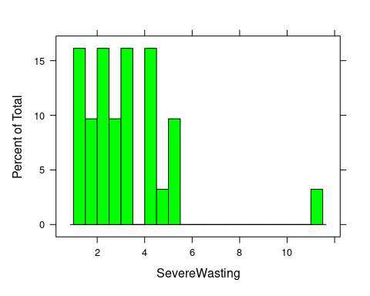

hist2 = histogram(~Wasting,income_class,col = "green",breaks = 20)  
hist2

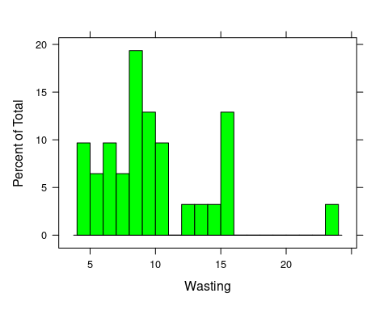

hist3 = histogram(~Stunting,income_class,col = "green",breaks = 20)  
hist3

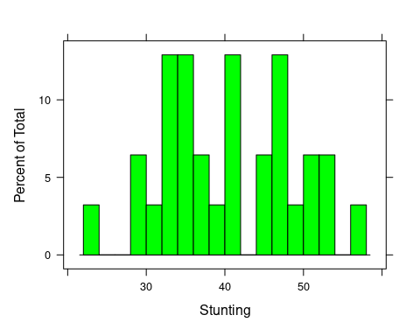

hist4 = histogram(~Underweight,income_class,col = "green",breaks = 20)  
hist4

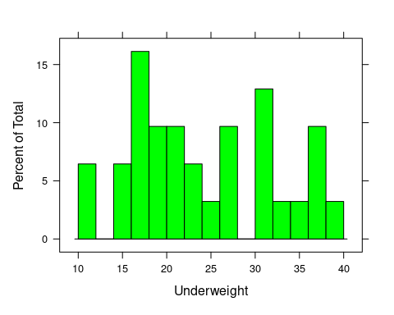

hist5 = histogram(~Overweight,income_class,col = "green",breaks = 20)  
hist5

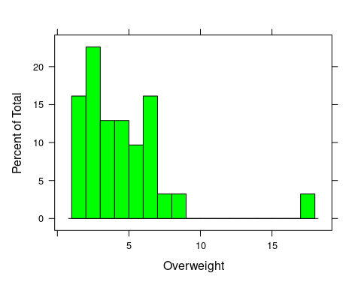

hist6= histogram(~U5Population,income_class,col = "green",breaks = 20)  
hist6

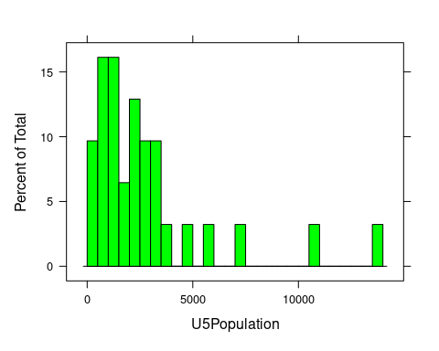

plot(~SevereWasting|U5Population,country1,col="pink")

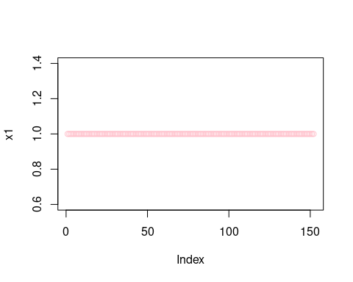

plot(~Wasting|U5Population,country1,col="blue")

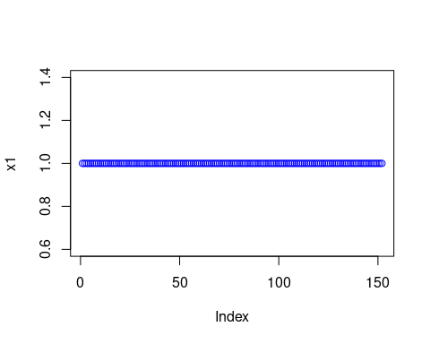

plot(~Underweight|U5Population,country1,col="brown")

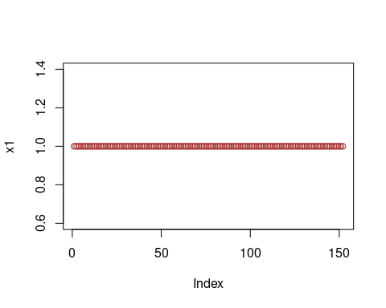

plot(~Overweight|U5Population,country1,col="black")

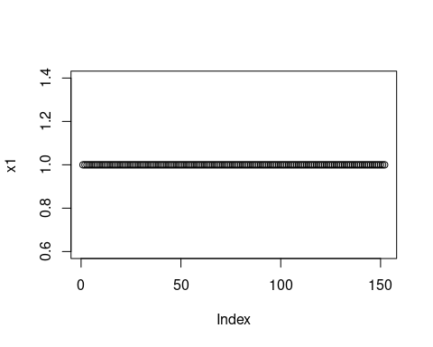

pairs(~SevereWasting+Wasting+Underweight+Overweight,country1,  
 main="Simple Scatterplot Matrix")

