确保一个类只有一个实例，并且提供一个全局访问点。
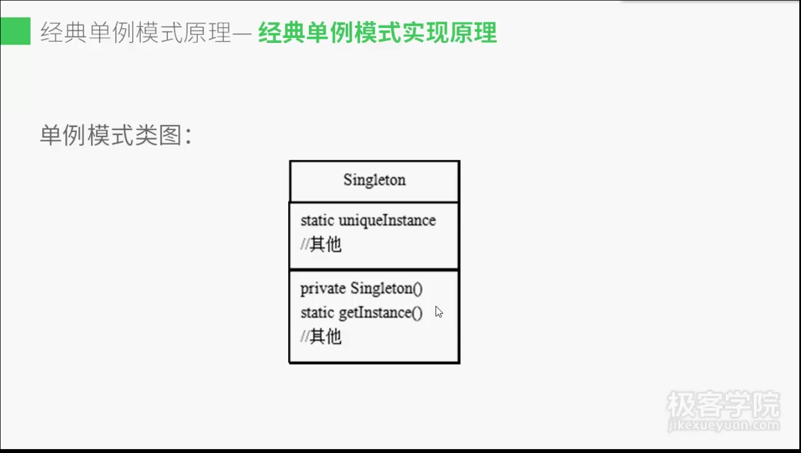
package single;
public class ChocolateFactory {
private boolean isEmpty;
private boolean isBoiled;
public static ChocolateFactory uniqeInstance = null;
private ChocolateFactory() {
isEmpty = true;
isBoiled = true;
}
public static ChocolateFactory getUniqeInstance() {
if(uniqeInstance == null) {
uniqeInstance = new ChocolateFactory();
}
return uniqeInstance;
}
public void fill() {
if(isEmpty) {
isEmpty = false;
isBoiled = false;
}
}
public void boil() {
if((!isEmpty)&&(!isBoiled)) {
isBoiled = true;
}
}

public void drain() {
if((!isEmpty)&&isBoiled) {
isEmpty = true;
}
}
}

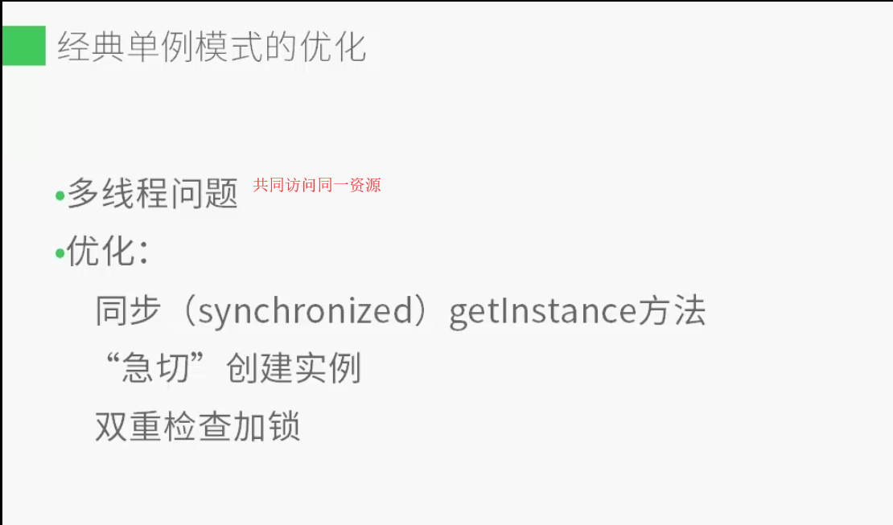
同步锁：（耗时）
public static synchronized ChocolateFactory getUniqeInstance() {
if(uniqeInstance == null) {
uniqeInstance = new ChocolateFactory();
}
return uniqeInstance;
}

急切创建实例：（消耗固定内存，不可避免）
public static ChocolateFactory uniqeInstance = null;
public static ChocolateFactory uniqeInstance = new ChocolateFactory();

双重检查加锁：
一旦一个共享变量（类的成员变量、类的静态成员变量）被volatile修饰之后，那么就具备了两层语义：
1）保证了不同线程对这个变量进行操作时的可见性，即一个线程修改了某个变量的值，这新值对其他线程来说是立即可见的。
2）禁止进行指令重排序。

public volatile static ChocolateFactory uniqeInstance = null;
public static ChocolateFactory getUniqeInstance() {
if(uniqeInstance == null) {
synchronized (ChocolateFactory.class) {
if(uniqeInstance == null) {
uniqeInstance = new ChocolateFactory();
}
}
}
return uniqeInstance;
}

