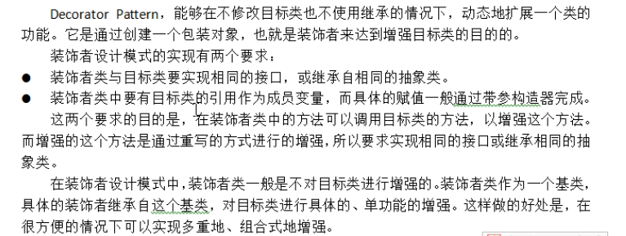
装饰者类的加强功能一般分开，再重新组合，形成方法链。
咖啡馆订单方案：不同咖啡可以搭配不同配料，从而价格各异
1.方案1：对象的自由组合十分困难，会导致子类爆炸
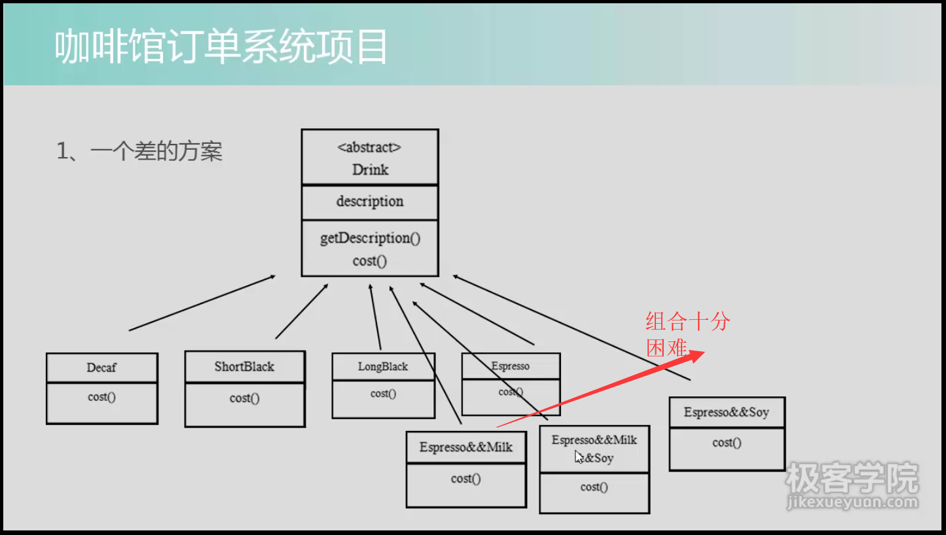
2.方案2：添加新配料时改动超类带来连锁反应
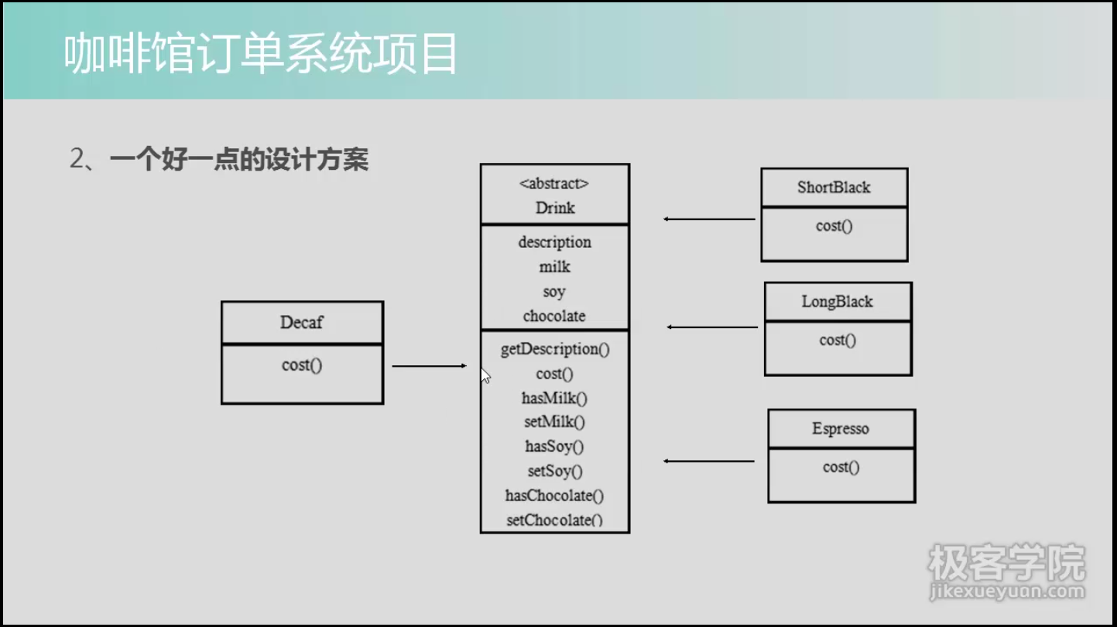

3.方案3：装饰者模式，递归，包装
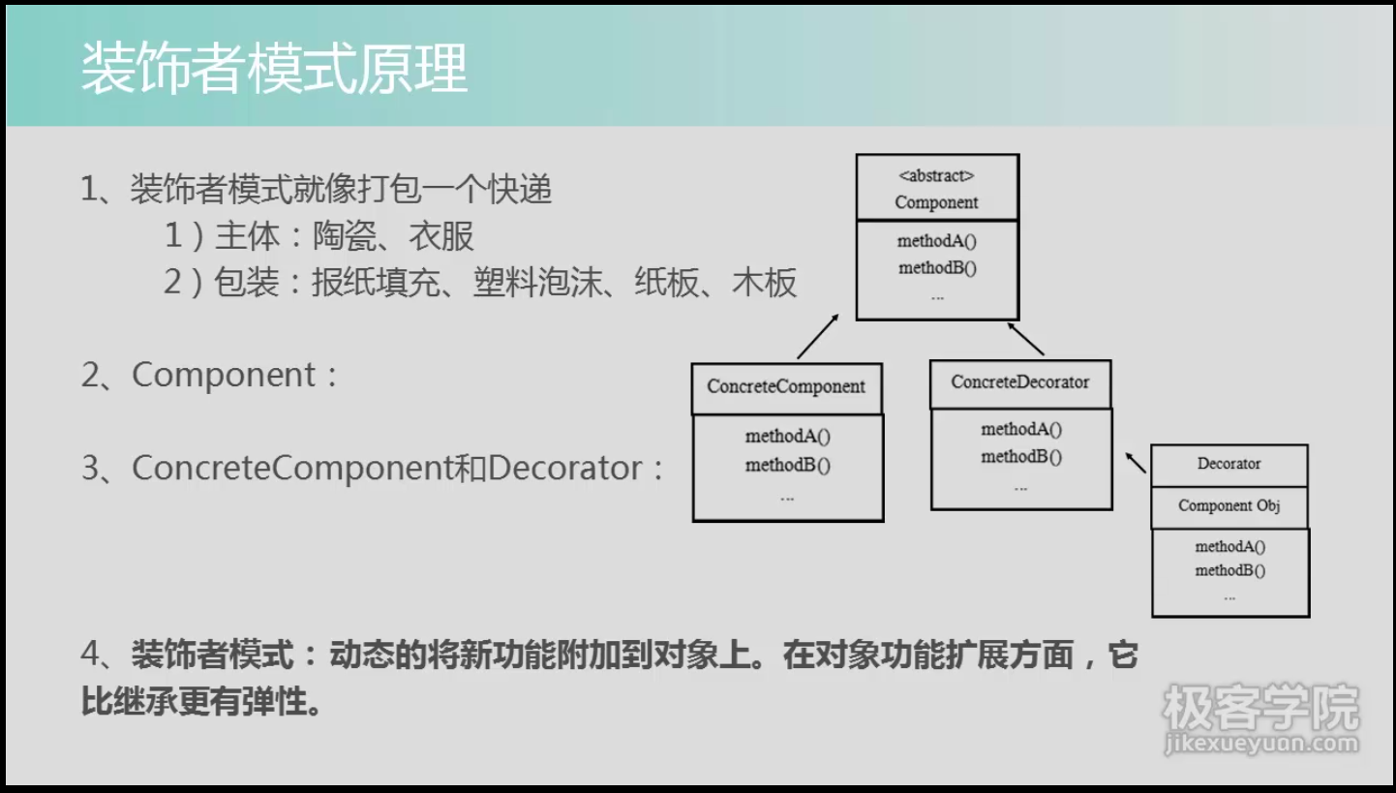
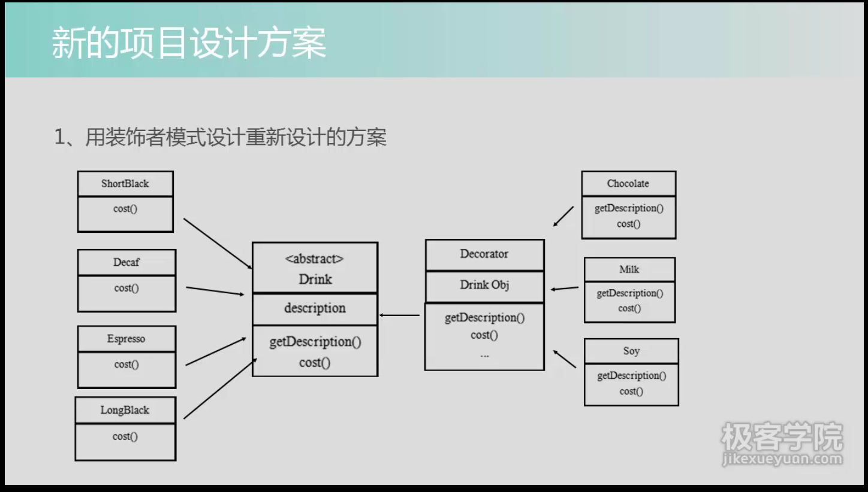
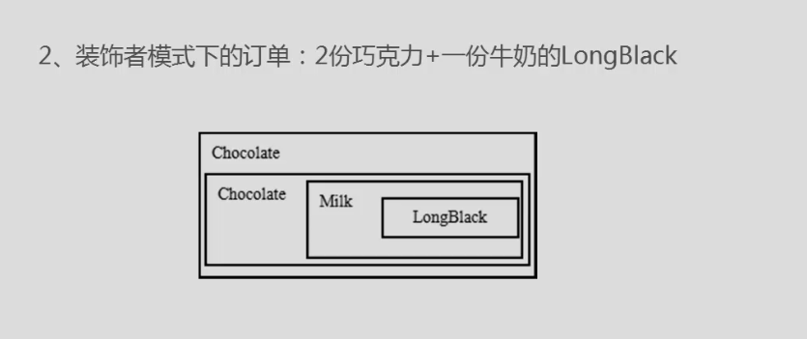
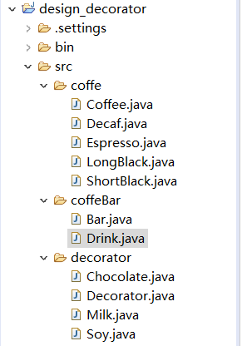
package coffeBar;
public abstract class Drink {
public String description = null;
private float price = 0f;
public String getDescription() {
return description+"-"+this.price;
}
public void setDescription(String description) {
this.description = description;
}
public float getPrice() {
return price;
}
public void setPrice(float price) {
this.price = price;
}
public abstract float cost();
}
package coffe;
import coffeBar.Drink;
public class Coffee extends Drink{//中间缓冲层
@Override
public float cost() {
return super.getPrice();
}
}
package coffe;
public class Decaf extends Coffee{
public Decaf() {
super.setDescription("Decaf");
super.setPrice(5.0f);
}
}
package coffe;
public class Espresso extends Coffee{
public Espresso() {
super.setDescription("Espresso");
super.setPrice(4.0f);
}
}
package coffe;
public class LongBlack extends Coffee{
public LongBlack() {
super.setDescription("LongBlack");
super.setPrice(6.0f);
}
}
package coffe;
public class ShortBlack extends Coffee{
public ShortBlack() {
super.setDescription("ShortBlack");
super.setPrice(7.0f);
}
}
package decorator;
import coffeBar.Drink;
public class Decorator extends Drink{
private Drink obj;//obj可以是单品或者已经包装过的对象，向上转型
public Decorator(Drink obj) {
this.obj = obj;
}
@Override
public String getDescription() {//递归
return super.description+""+super.getPrice()+"&&"+obj.getDescription();
}
@Override
public float cost() {//递归
return super.getPrice()+obj.cost();
}
}
package decorator;
import coffeBar.Drink;
public class Chocolate extends Decorator{
public Chocolate(Drink obj) {
super(obj);
super.setDescription("Chocolate");
super.setPrice(3.0f);
}
}
package decorator;
import coffeBar.Drink;
public class Milk extends Decorator{
public Milk(Drink obj) {
super(obj);
super.setDescription("Milk");
super.setPrice(2.0f);
}
}
package decorator; import coffeBar.Drink;
public class Soy extends Decorator{
public Soy(Drink obj) {
super(obj);
super.setDescription("Soy");
super.setPrice(1.0f);
}
}
package coffeBar;
import coffe.Decaf;import decorator.Chocolate;import decorator.Milk;
public class Bar {
public static void main(String[] args) {
Drink order = new Decaf();//向上转型
System.out.println("price = "+order.cost());
System.out.println("decription = "+order.getDescription());
System.out.println("**********");
order = new Milk(order);
System.out.println("price = "+order.cost());
System.out.println("decription = "+order.getDescription());
System.out.println("**********");
order = new Chocolate(order);
System.out.println("price = "+order.cost());
System.out.println("decription = "+order.getDescription());
System.out.println("**********");
}
}

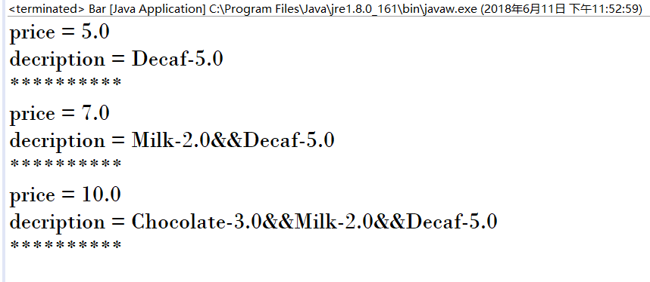
开放-关闭原则：开放“添加新功能”，关闭“修改已经测试好的代码”。
应用：订单系统，IO流

