Quarto Books 101

Jane Doe

11/9/2022

Table of contents

# Preface

This is a Quarto book.

To learn more about Quarto books visit <https://quarto.org/docs/books>.

1 + 1

[1] 2

# 1. Introduction

This is a book created from markdown and executable code.

See Knuth (1984) for additional discussion of literate programming.

1 + 1

[1] 2

# 2. Getting Started

1. RStudio IDE > New Project > New Directory > Quarto Book
2. Develop pages via-a-vis this template, or [quarto documentation for creating books](https://quarto.org/docs/books/)
3. Build tab > Render book
4. Publish to Quarto.pub (optional)
   * Terminal > quarto publish quarto-pub

# 3. Data wrangling

The Tidyverse is a dialect of R. When you load the tidyverse library(tidyverse) , R will import eight libraries. Among these eight include {reader} for importing CSV data; {dplyr} and {tidyr} for data wrangling; {ggplot2} for visualizations.

### 3.0.1 Import Data

Find the data import wizard in the Environment tab. Use that to help compose your data import statements.

For example

* readr::read_csv(my_csv_file.csv)
* readxl::read_excel(my_excel_file.xlsx)
* haven::read_stata(my_stata_file.dta)

### 3.0.2 Data wrangling

Use {dplyr} for basic wrangling

* select() columns
* filter() rows
* mutate() new or existing variables
* group_by() and summarize() to get column totals
* count() to generate simple tallys and frequencies

use {tidyr} for pivoting date

* pivot_longer()
* pivot_wider()

## 3.1 More information

* [QuickStart with R](https://rfun.library.duke.edu/portfolio/r_flipped/)

# 4. Vizualization

library([ggplot2](https://ggplot2.tidyverse.org))

starwars |>   
 filter(mass < 500) |>   
 drop_na(mass, height) |>   
 ggplot(aes(height, mass)) +  
 geom_point()

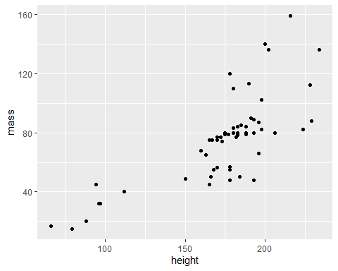

# 5. Managing a bibliography

1. Download [Zotero](zotero.org)
   * install *zotero connector* in your browser extensions
2. Export as BiBTex file: .bib
3. Store .bib file in your Quarto Book project directory.

### 5.0.1 DOI reference

Add reference with @ symbol and a [*DOI*](https://en.wikipedia.org/wiki/Digital_object_identifier)*.* For example ‘@10.1037/amp0000151’

### 5.0.2 from my_library.bib

Or, type @ and begin searching you local .bib files.

For example: George Saunders has a lot to say about conversations in graveyards. “Lincoln in the Bardo” (n.d.)

### 5.0.3 Compiled References

All references will be summarized in the [References](references.html) section of the book.

# 6. Summary

In summary, this book has no content whatsoever.

1 + 1

[1] 2

What would Colson Whithead say about this? Whitehead (1999)

# References

Knuth, Donald E. 1984. “Literate Programming.” *Comput. J.* 27 (2): 97–111. <https://doi.org/10.1093/comjnl/27.2.97>.

“Lincoln in the Bardo.” n.d. <https://www.goodreads.com/book/show/29906980-lincoln-in-the-bardo>.

Whitehead, Colson. 1999. *The Intuitionist*. 1st Anchor Books ed. New York : Anchor Books, 1999. <https://find.library.duke.edu/catalog/DUKE002589592>.