Test MS Word File

john little

September 27, 2018

Get Started

Create a new R Markdown document from the File Maneu

In RStudio…

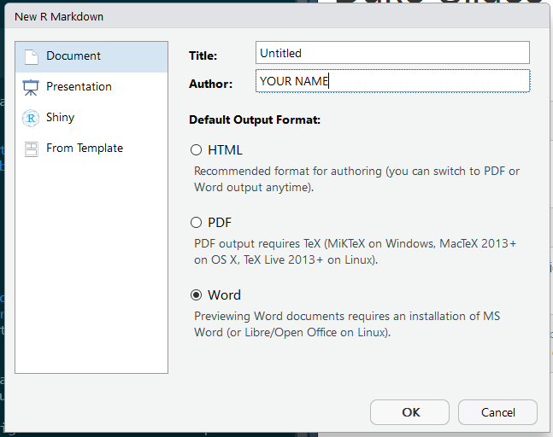

1. New File -> R Markdown -> Document ->Word
2. Generate some Literate Code
3. Knit (Knit to Word)

The challenge with generate MS Word files is to generate your tables with kintr::kable. There’s also a kableExtra package if you need more functionality with editing your tables.

knitr::kable(head(cars))

|  |  |
| --- | --- |
| speed | dist |
| 4 | 2 |
| 4 | 10 |
| 7 | 4 |
| 7 | 22 |
| 8 | 16 |
| 9 | 10 |