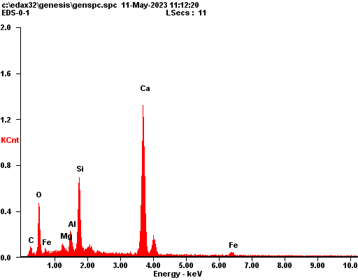
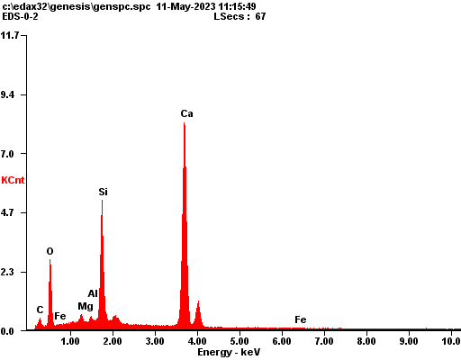
Element | Wt % | At %
C K | 03.23 | 06.95
O K | 27.17 | 43.92
MgK | 01.58 | 01.69
AlK | 03.04 | 02.92
SiK | 12.12 | 11.16
CaK | 48.70 | 31.43
FeK | 04.16 | 01.93
EDAX ZAF Quantification Standardless SEC Table : User
kV:15.00 Tilt: 0.50 Take-off:36.42 AmpT:51.2 Detector Type :SUTW-Sapphire Resolution :131.04

Element | Wt % | At %
C K | 02.69 | 05.74
O K | 28.78 | 46.18
MgK | 00.96 | 01.01
AlK | 00.42 | 00.40
SiK | 13.88 | 12.69
CaK | 52.52 | 33.63
FeK | 00.75 | 00.35
EDAX ZAF Quantification Standardless SEC Table : User
kV:15.00 Tilt: 0.50 Take-off:36.42 AmpT:51.2 Detector Type :SUTW-Sapphire Resolution :131.04
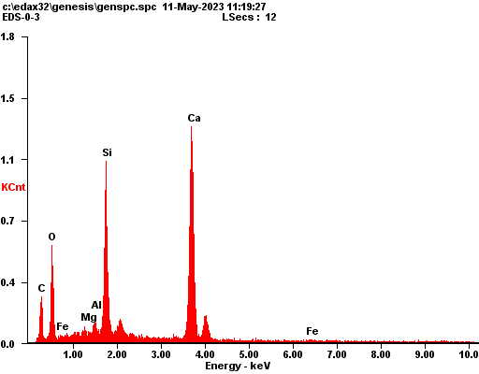
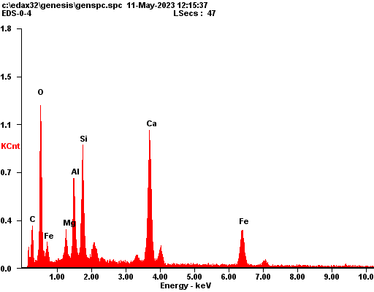
Element | Wt % | At %
C K | 10.18 | 19.55
O K | 28.70 | 41.35
MgK | 00.45 | 00.43
AlK | 00.94 | 00.80
SiK | 14.96 | 12.28
CaK | 43.80 | 25.19
FeK | 00.96 | 00.40
EDAX ZAF Quantification Standardless SEC Table : User
kV:15.00 Tilt: 0.50 Take-off:36.42 AmpT:51.2 Detector Type :SUTW-Sapphire Resolution :131.04

Element | Wt % | At %
C K | 07.90 | 16.15
O K | 28.29 | 43.45
MgK | 02.38 | 02.41
AlK | 06.19 | 05.64
SiK | 09.57 | 08.38
CaK | 22.42 | 13.75
FeK | 23.25 | 10.23
EDAX ZAF Quantification Standardless SEC Table : User
kV:15.00 Tilt: 0.50 Take-off:37.36 AmpT:51.2 Detector Type :SUTW-Sapphire Resolution :131.04
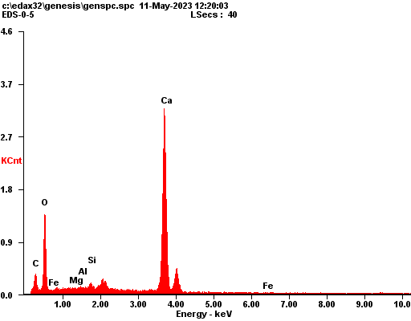
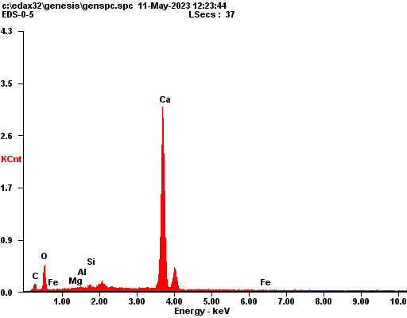
Element | Wt % | At %
C K | 04.26 | 08.38
O K | 39.35 | 58.07
MgK | 00.20 | 00.19
AlK | 00.38 | 00.33
SiK | 00.97 | 00.82
CaK | 54.23 | 31.95
FeK | 00.62 | 00.26
EDAX ZAF Quantification Standardless SEC Table : User
kV:15.00 Tilt: 0.50 Take-off:37.38 AmpT:51.2 Detector Type :SUTW-Sapphire Resolution :131.04

Element | Wt % | At %
C K | 02.24 | 05.37
O K | 22.10 | 39.79
MgK | 00.30 | 00.36
AlK | 00.41 | 00.44
SiK | 00.90 | 00.93
CaK | 73.53 | 52.85
FeK | 00.52 | 00.27
EDAX ZAF Quantification Standardless SEC Table : User
kV:15.00 Tilt: 0.50 Take-off:37.38 AmpT:51.2 Detector Type :SUTW-Sapphire Resolution :131.04
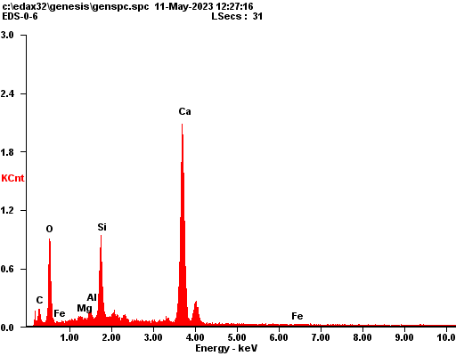
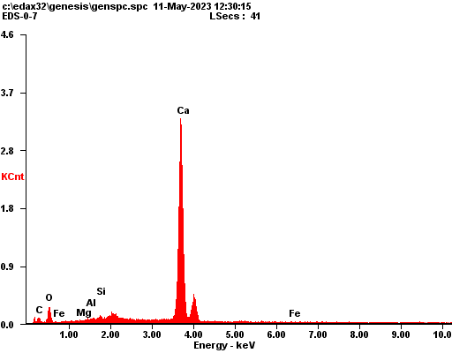
Element | Wt % | At %
C K | 04.00 | 08.03
O K | 34.67 | 52.24
MgK | 00.61 | 00.61
AlK | 00.97 | 00.87
SiK | 09.40 | 08.07
CaK | 49.79 | 29.95
FeK | 00.55 | 00.24
EDAX ZAF Quantification Standardless SEC Table : User
kV:15.00 Tilt: 0.50 Take-off:37.38 AmpT:51.2 Detector Type :SUTW-Sapphire Resolution :131.04

Element | Wt % | At %
C K | 01.37 | 03.63
O K | 14.85 | 29.56
MgK | 00.11 | 00.15
AlK | 00.34 | 00.40
SiK | 00.86 | 00.98
CaK | 81.36 | 64.65
FeK | 01.09 | 00.62
EDAX ZAF Quantification Standardless SEC Table : User
kV:15.00 Tilt: 0.50 Take-off:37.38 AmpT:51.2 Detector Type :SUTW-Sapphire Resolution :131.04
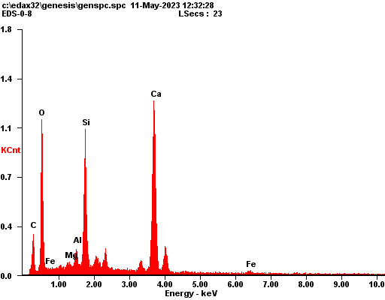
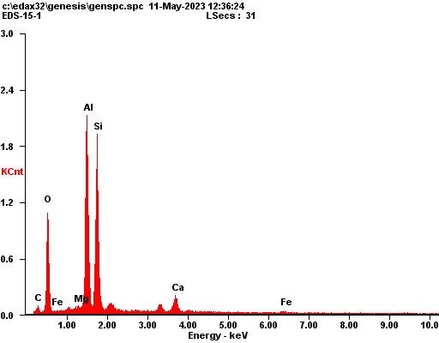
Element | Wt % | At %
C K | 08.04 | 14.52
O K | 40.04 | 54.29
MgK | 00.48 | 00.43
AlK | 01.49 | 01.20
SiK | 12.39 | 09.57
CaK | 35.43 | 19.17
FeK | 02.13 | 00.83
EDAX ZAF Quantification Standardless SEC Table : User
kV:15.00 Tilt: 0.50 Take-off:37.38 AmpT:51.2 Detector Type :SUTW-Sapphire Resolution :131.04

Element | Wt % | At %
C K | 05.53 | 10.11
O K | 29.58 | 40.58
MgK | 00.46 | 00.41
AlK | 26.03 | 21.17
SiK | 30.33 | 23.70
CaK | 05.58 | 03.05
FeK | 02.48 | 00.98
EDAX ZAF Quantification Standardless SEC Table : User
kV:15.00 Tilt: 0.50 Take-off:37.38 AmpT:51.2 Detector Type :SUTW-Sapphire Resolution :131.04
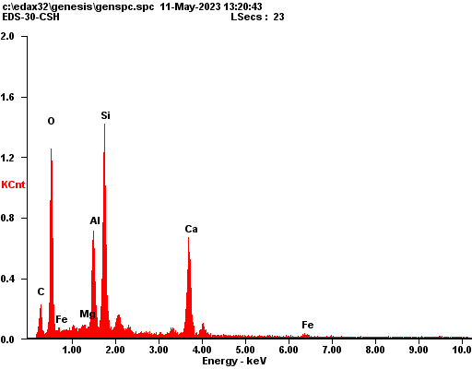
Element | Wt % | At %
C K | 09.18 | 15.71
O K | 40.78 | 52.38
MgK | 00.43 | 00.36
AlK | 08.57 | 06.53
SiK | 19.82 | 14.50
CaK | 18.75 | 09.61
FeK | 02.47 | 00.91
EDAX ZAF Quantification Standardless SEC Table : User
kV:15.00 Tilt: 0.50 Take-off:36.73 AmpT:51.2 Detector Type :SUTW-Sapphire Resolution :131.04

