A Unified LQR-VMC Framework for Multimodal Locomotion of a Serial-Leg Wheel-Legged Robot
First Author¹, Second Author², Corresponding author^{3*} (use style: unabbreviated first name, middle name initials, last name e.g. John AK Smith¹, Edward Jones²)
¹First Affiliation name of department and organisation, City, Country
²Second Affiliation name of department and organisation, Address, City, Country
³Third Affiliation name of department and organisation, Address, City, Country
⁴Current affiliation name of department and organisation, Address, Country
*email address of corresponding author
Keywords: Bipedal wheel-legged robot; LQR; Dynamic jumping; Locomotion control

Abstract
Bipedal wheel-legged robots are underactuated and have difficulty traversing unstructured terrain, and existing controllers are designed modality by modality. This paper proposes a unified framework: a single state machine schedules the whole robot, LQR parameters handle balance, velocity and heading, and the leg layer uses analytical support feedforward and joint PD to control leg height and posture, so that switching only changes references and limits. The feedforward includes the self-weight of the leg links, and the airborne attitude is driven by differential mirror torques about the hip axes. Simulations cover driving, turning, 20-65 mm obstacle crossing, wavy terrain and jumping; the body roll is reduced by about 30 times, the wavy-terrain response stays below 0.13 degrees, and a 0.20 m step is climbed at 3.00 m/s.

1 Introduction
Mobile robots are increasingly deployed in unstructured scenarios such as inspection, logistics and rescue, where terrain adaptability is critical. Wheeled locomotion is fast and energy-efficient but limited by the wheel diameter in obstacle crossing, whereas legged locomotion is adaptable but limited in speed and payload ^{[1-2]}. Bipedal wheel-legged robots support the body on two symmetric wheel-legs with a compact structure and strong maneuverability; typical platforms include Ascento ^{[3]}, Handle, Ollie and the direct-drive DIABLO ^{[4]}.
Such robots touch the ground at only two points and their wheel torques do not act directly on the body attitude: they are floating-base, strongly coupled and underactuated systems without static stability margin ^{[5-6]}, so dynamic balance is the prerequisite for all locomotion functions. Existing models include the variable-height wheeled linear inverted pendulum, whole-body dynamics and the composite center of mass ^{[7-9]}, while the controllers range from LQR balance control ^{[5]} and whole-body control ^{[11]} to observer- and learning-based schemes ^{[9,12,13,15]}.
Obstacle crossing is done by rolling over or by jumping over. Rolling over is limited by wheel diameter and adhesion: Li et al. let a quadruped wheel-legged robot climb a 0.36 m step, but assumed known terrain ^{[16]}. Jumping is not limited by the wheel diameter and is a research focus, yet it is usually treated as an integral task: Ascento's sequential controller lacks stability guarantees ^{[3]}, Lu et al. divided a jump into six phases ^{[17]}, Xia et al. tracked a target height with impedance control ^{[18]}, and Yu et al.'s simulated 0.55 m jump was achieved only to about 0.05 m by the prototype ^{[14,19]}.
In the airborne phase no external torque is available and the angular momentum can only be redistributed by the joints, so attitude control decides the jump's success. Xia et al. built a planar two-degree-of-freedom airborne model and used PD control to regulate the attitude, showing that the hip torque acts directly on body pitch and is coupled with the swing-rod angle ^{[10,18]}; Lu et al.'s prototype showed large pitch fluctuations during landing ^{[17]}.
In summary, existing methods still leave gaps for continuous traversal of unstructured terrain: expanding the locomotion capability expands the controller and parameter sets, and modality switching causes attitude impacts; support feedforward depends on hard-to-measure contact forces and center-of-mass states, the airborne attitude drive does not match the mirrored hip axes; and jumping capability is treated as one integral index without a basis for independent design. This paper therefore proposes a unified locomotion control framework whose main contributions are as follows:
(1) Unified control framework. One phase state machine, one leg controller and one parameter set cover driving, turning, single-leg variable-height obstacle crossing, wavy-terrain following and jumping, without re-tuning.
(2) Analytical gravity support feedforward. It uses no simulator-internal quantity and explicitly includes the leg self-weight; neglecting this term underestimates the support force and noticeably increases the body roll.
(3) Differential attitude actuation. With mirrored hip axes the attitude effects of same-sign joint torques cancel, so driving the hips by the torque difference reduces the airborne pitch peak and essentially eliminates the yaw drift.
(4) Decomposition of jumping capability. The obstacle-crossing capability is split into three independently designable quantities: center-of-mass ballistic trajectory, obstacle-crossing clearance and velocity retention, set respectively by the push-off impulse, the airborne leg tucking and the pre-takeoff duration.
2 Robot System Modeling

2.1 System Description and Coordinate System Definition
The bipedal wheel-legged robot in this paper consists of a body and two symmetric serial legs. Each leg contains two integrated joint motors at the hip and knee, and a drive wheel is mounted at the end of the leg, giving a total of six active joints. Unlike parallel four-bar configurations, the leg length of a serial dual-motor leg is determined jointly by the hip and knee angles. The same leg height corresponds to infinitely many joint-angle combinations, requiring explicit inverse kinematics. The main mechanical and actuation parameters are shown in Table 1.
Table 1. Mechanical and actuation parameters of the robot.
Symbol |  | Parameter | Value | Unit
 | Total mass |  | 17.00 | Kg
 | Torso mass |  | 10.00 | Kg
 | Thigh length |  | 0.300 | m
 | Shank length |  | 0.300 | m
 | Wheel radius |  | 0.070 | m
 | Wheel-center longitudinal offset from hip |  | −0.075 | m
 | Wheel track (lateral distance between wheels) |  | 0.364 | m
 | Hip height in body frame |  | −0.070 | m

The model retains the hip and knee degrees of freedom, ignores joint friction and motor dynamics, and simplifies the whole robot into an inverted pendulum model, as shown in Figure 1.
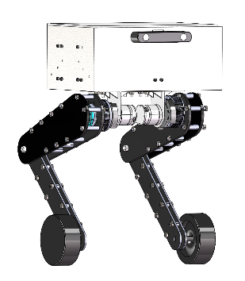
Figure 1. (a) Physical model of the bipedal wheel-legged robot; (b) simplified dynamic model of the bipedal wheel-legged robot.
The world coordinate system $W$ is fixed to the ground; the body coordinate system $b$ is fixed to the body, with its origin at the geometric center of the body. The leg height $h$is defined as:
$h=z_{b}-z_{w}$ (1)
the vertical distance from the body origin to the drive wheel center. The hip joint is located at $z=-0.070m$ in the body coordinate system, so the vertical hip-to-wheel distance is $h_{hip}=h-0.070$. The hip and knee joint angles of the right leg are denoted by $θ_{1}$, $θ_{2}$, respectively. Because the left and right leg joint axes are mirrored, under the same geometric posture the joint angles of the left leg are the negatives of those of the right leg:
$θ_{1}^{\text{L}}=-θ_{1},θ_{2}^{\text{L}}=-θ_{2}$ (2)

2.2 Single-Leg Jacobian Matrix Solution
Because the left and right legs are symmetric, the single-leg kinematics can be described by a two-link model in the sagittal plane. When $θ_{1}=θ_{2}=0$, the thigh and shank vectors are (both expressed in the body coordinate system $Y-Z$ plane, with lengths $L_{1}=0.300\text{m}$$L_{1}=0.300\text{m}$ and $L_{2}=0.34325\text{m}$). Then the two link vectors of the right leg are:
${\text{u}}_{1}=R_{x}\left(θ_{1}\right){\text{u}}_{1}^{0},{\text{u}}_{2}=R_{x}\left(θ_{1}+θ_{2}\right){\text{u}}_{2}^{0}$ (3)
where$R_{x}\left(α\right)$ represents rotation by angle$α$ about the body y-axis in the sagittal plane:
$R_{x}\left(α\right): \left(y,z\right)=\left(y , cosα-zsinα ysinα+zcosα\right)$(4)
The wheel center position is $p_{w}=p_{hip}+u_{1}+u_{2}$. From Eq. (1), the leg height is $h=0.070-{\left(u_{1}+u_{2}\right)}_{z}$.
To track different leg heights, inverse kinematics is required. Given the desired height $h$and wheel-center longitudinal offset $e$, the hip-to-wheel distance is $r=\sqrt{e^{2}+h_{hip}^{2}}$. By the law of cosines:
$\left\{\begin{aligned}a=\frac{L_{1}^{2}-L_{2}^{2}+r^{2}}{2r} \\ b=-\sqrt{L_{1}^{2}-a^{2}} \\ p_{k}=a \overset{ˆ}{u}+b {\overset{ˆ}{u}}_{⊥}\end{aligned}\right.$ (5)
where $\overset{ˆ}{u}=\left(e, -h_{hip}\right)/r$ is the unit vector along the hip-to-wheel direction, and ${\overset{ˆ}{u}}_{⊥}=\left(-u_{z}, u_{y}\right)$ is its perpendicular. The shank vector is $\left(e, -h_{hip}\right)-p_{k}$. Differentiating Eq. (3) with respect to the joint angles gives the Jacobian matrix of leg height with respect to joint angles:
$J_{j}=\frac{∂h}{∂θ_{j}},j∈\left\{1,2\right\}$ (6)
where$J_{1}$ corresponds to the hip joint and $J_{2}$ to the knee joint. $J_{j}$ represents the change in leg height when the joint rotates by a unit angle. By the principle of virtual work, the joint torque and the vertical support force $F$ at the wheel center satisfy:
$τ_{j}=J_{j}F$ (7)

2.3 Whole-Robot Dynamic Model
To make the model analyzable, it is assumed that all components are ideal rigid bodies, joints are ideal hinges (ignoring friction, clearance, and hysteresis), and the drive wheels roll purely without slipping. Accordingly, following the principle of motion decoupling, the system is divided into three interrelated subsystems: body, leg, and drive wheel.
The leg is simplified as a rigid swing rod with variable length $L_{p}$ and center-of-mass position, the body is simplified as a rigid body rotating about the hip joint, and the two legs are equivalent to one swing rod. This yields a two-wheel second-order inverted pendulum model with variable center-of-mass height (see Figure 1(b)). The displacements of the left and right drive wheels are calculated from motor feedback angles; the body horizontal displacement and yaw angle are:
$\left\{\begin{aligned}{x_{L}=R θ_{wL} \atop x_{R}=R θ_{wR}} \\ x_{b}=\frac{x_{L}+x_{R}}{2}+L_{p}{\sin{θ}}_{p} \\ χ=\frac{x_{R}-x_{L}}{W}\end{aligned}\right.$ (8)
where $θ_{wL}$ and $θ_{wR}$ are the rotation angles of the left and right drive wheels, $W=0.364m$ is the wheel track, and $R=0.07m$ is the wheel radius. The swing angle $θ_{p}$ of the equivalent swing rod is obtained from the body coordinates of the two wheel centers and the body pitch angle:
$θ_{p}=\frac{1}{2}\left[\arctan{\frac{y_{0L}}{z_{0L}}}+\arctan{\frac{y_{0R}}{z_{0R}}}\right]-ϕ$ (9)
In the support phase, the entire robot weight is transmitted to each joint through the drive wheels. By the principle of virtual work, the joint torque corresponding to the vertical support force $F$ acting at the wheel center is $τ_{j}=J_{j}F$. After including the self-weight of the leg links, the required feedforward torque for each leg joint is:
$τ_{j}=J_{j}⋅\frac{m g}{N}+\sum_{i∈\text{leg}}{m_{i}} g \frac{∂z_{i}}{∂θ_{j}},j∈\left\{1,2\right\}$ (10)
where $m$ is the total robot mass, $N=2$ is the number of legs, $m_{i}$ is the mass of the $i$ rigid body in the leg chain, $z_{i}$ is its center-of-mass height, and $∂z_{i}/∂θ_{j}$ is the Jacobian of the center-of-mass height with respect to the joint angle. The first term corresponds to the load path of the whole-robot weight transmitted through the wheels; the second term is the gravity torque of the leg links themselves. The single-leg mass of this robot is $3.495kg$, accounting for $20.6\%$ of the total mass. Ignoring the second term causes a deviation of about $5.5N·m$ in the knee feedforward torque and makes the static standing leg height lower by about $7mm$.
In the airborne phase of jumping, the robot is not subject to external torque, and the whole-robot center of mass undergoes projectile motion:
$\left\{\begin{aligned}h_{air}=\frac{v_{to}^{2}}{2g} \\ z_{CoM}\left(t\right)=z_{to}+v_{to}t-\frac{1}{2}gt^{2}\end{aligned}\right.$ (11)
where $v_{to}$ is the vertical velocity of the center of mass at the instant of leaving the ground. During push-off, the center-of-mass velocity and leg-height rate are related by the Jacobian in Eq. (6). Eq. (11) gives the quantitative relationship between "push-off impulse and jump height," which also provides the basis for the jumping capability decomposition presented later.
Taking the state vector $x={\left[ϕ , - , ϕ_{eq} , , \dot{ϕ} ψ \dot{ψ} {\dot{θ}}_{w}\right]}^{T}$ and control input $u={\left[τ_{w} , Δτ\right]}^{T}$ (forward wheel torque and differential steering torque), linearization near the nominal standing height gives:
$\dot{x}=Ax+Bu$ (12)
where $ϕ_{eq}$ is the static equilibrium pitch angle at the current leg height, determined by the position of the whole-robot center of mass relative to the wheel axle; ${\dot{θ}}_{w}$ is the average drive wheel speed.
3 Unified Locomotion Control Framework

3.1 Overall Architecture and Phase Scheduling
The control framework in this paper consists of three parts: command layer, balance layer, and leg layer. The command layer receives four types of commands: forward velocity, steering angular velocity, target leg height, and jump trigger. The balance layer uses LQR to uniformly handle body pitch balance, velocity tracking, and heading holding. The leg layer is responsible for torque output of each leg joint, including leg height tracking, terrain adaptation, push-off thrust, and airborne attitude.
To cover multiple locomotion modalities with the same set of parameters, phase-exclusive scheduling is adopted: the whole-robot state is managed uniformly by a phase machine (STAND/CROUCH/EXTEND/FLIGHT/LAND/FALLEN). In each phase, only one type of task is allowed to occupy the torque budget of the leg and wheel motors.
STAND: the balance layer works on all channels (balance, velocity, position, heading), and the leg layer tracks leg height and adjusts the left-right leg height difference according to terrain. Flat-ground driving, in-place turning, variable height, and terrain following are all completed in this phase. CROUCH/EXTEND/LAND: the legs are taken over by the jump trajectory, the balance layer is degraded to "wheel-only," and heading integration is frozen to prevent unilateral errors from slipping during takeoff and landing from being amplified by integration.
FLIGHT: wheel torques are set to zero, and the leg layer switches to airborne attitude control and leg tucking; FALLEN: all outputs are set to zero.
The above modalities share the same controller structure and basic parameters. Switching only changes references and output limits. Only some jump phases scale the leg-layer gains proportionally (see Section 3.4), without re-tuning the controller for each modality.

3.2 Balance and Motion Control
Body balance is achieved by the wheeled inverted pendulum loop. Taking pitch angle error and pitch rate as states, the forward wheel torque is:
$\left\{\begin{aligned}τ_{w}=-K\left[\begin{matrix}ϕ-ϕ_{ref} \\ \dot{ϕ}\end{matrix}\right] \\ K=\left[-45.0, -7.0\right]\end{aligned}\right.$ (13)
where $K$ is calibrated from the real robot's single-step response (see Section 2.3). $ϕ_{ref}$ is the target pitch angle, given jointly by the equilibrium angle and the velocity outer loop:
$\left\{\begin{aligned}ϕ_{ref}=ϕ_{eq}+clip​\left(K_{pv}e_{v}+K_{iv}​\int{e_{v}} dt,0.2 rad\right) \\ e_{v}=v_{cmd}-v\end{aligned}\right.$ (14)
where $e_{v}$ is the velocity error, $K_{pv}=0.35$,$K_{iv}=0.3$. The integral term is gated and accumulates only when the robot is in the driving state and the target pitch is not saturated, avoiding wheel torque jumps caused by integral residue at the instant of stopping. $ϕ_{eq}$ is the equilibrium pitch angle determined by the whole-robot center-of-mass position at the current leg height, recalculated in real time as leg height changes.
When there is no velocity command, the position outer loop slowly pulls the body back to the starting point: the position error generates a velocity correction (proportional gain 3.0, damping gain 3.5) with a limit of 0.6 m/s. The heading channel consists of a damping term and an integral term. When there is no steering command, it pulls the yaw angle back to the anchored value at a rate not exceeding 0.8 rad/s:
$τ_{χ}=-clip​\left(K_{dχ}{\dot{χ}}_{err}+K_{iχ}​\int{{\dot{χ}}_{err}} dt, ±2.0 N⋅m\right)$(15)
where $K_{dχ}=8.0$, $K_{iχ}=6.0$. The output limit $±2.0N·m$ is based on the fact that normal driving and steering require only about $0.8N·m$. If the body is yawed by an external force without limiting, the heading channel would occupy the entire torque budget of the wheel motors, squeezing the available margin of the balance channel.

3.3 Leg Control: Support Feedforward and Terrain-Adaptive Leg Length
The leg layer performs tracking in joint space. For each leg joint ($j=1,2$ corresponding to hip and knee, respectively), the output torque consists of support feedforward and joint PD:
$τ_{j}=τ_{ff,j}+k_{p}\left(θ_{ref,j}-θ_{j}\right)+k_{d}\left({\dot{θ}}_{ref,j}-{\dot{θ}}_{j}\right)$ (16)
where $θ_{ref,j}$ is solved from the target leg height by the inverse kinematics in Section 2.2, $k_{p}=200$, $k_{d}=60$; ${\dot{θ}}_{ref,j}$ is the target joint angular velocity feedforward obtained from the target leg-height rate via the Jacobian. The support feedforward $τ_{ff,j}$ uses the analytical expression of Eq. (10) in Section 2, whose first term corresponds to the load path of the whole-robot weight transmitted through the wheels, and the second term is the self-weight of the leg links.
Terrain-adaptive leg length: when one wheel rides onto a step or slope, the heights of the two wheel centers are no longer equal. To keep the body horizontal, the target leg heights of the left and right legs need to take different values:
$\left\{\begin{aligned}Δh_{L}=-\frac{1}{2}\left(z_{L}-z_{R}\right)+k_{ψ}ψ+k_{dψ}\dot{ψ} \\ Δh_{R}=-Δh_{L} \\ \left|Δh_{L}\right|≤0.035 m\end{aligned}\right.$ (17)
where $z_{L},z_{R}$ are the heights of the left and right wheel centers, and $ψ$ is the body roll angle; the target leg height of that side is $h_{ref}=h_{cmd}+Δh$. Eq. (17) is directly given by terrain geometry and is feedforward; the roll feedback term is set to zero by default ($k_{ψ}=0$) because the measured feedback term introduces oscillation. The offset limit $±0.035m$ is used to leave margin in the available leg-length range.

3.4 Jump Trajectory and Thrust Feedforward
The jumping process is divided by phase into CROUCH (crouching to store energy, 0.08 s, crouch depth 0.03 m), EXTEND (push-off), FLIGHT (airborne), and LAND (landing buffer, 0.15 s). CROUCH and LAND use quintic polynomials to connect displacement, velocity, and acceleration boundaries. EXTEND uses a constant-acceleration trajectory, whose duration is inferred from the leg extension stroke Δh_s and the takeoff velocity: $T_{ext}=2Δh_{s}/v_{to}$, where$v_{to}$ is given by the desired jump height according to Eq. (11) in Section 2.
Replacing the gravitational acceleration in Eq. (10) in Section 2 with $g+{\ddot{h}}_{ref}$ gives the joint torque feedforward required for push-off:
$τ_{j}^{thrust}=J_{j}⋅\frac{m\left(g+{\ddot{h}}_{ref}\right)}{N}+\sum_{i∈\text{leg}}{m_{i}}\left(g+{\ddot{h}}_{ref}\right)\frac{∂z_{i}}{∂θ_{j}}$(18)
where ${\ddot{h}}_{ref}$ is the desired leg-height acceleration given by the trajectory. This feedforward term is not gated by contact state: at the end of push-off, the robot is about to leave the ground, which is exactly when thrust is most needed.
Because the leg-height rate during CROUCH/EXTEND is much larger than in flat-ground conditions, the derivative term of the joint PD forms a two-step limit cycle with the stiffness loop formed by "joint-ground contact" (measured: after amplifying the derivative gain to 1.5 times, the motor torques of all four legs saturate throughout, and the ballistic trajectory actually decreases). Therefore, within the jump phase, the leg-layer gains are scaled by phase: $k_{p}×1.5$, $k_{d}×0.15$, while the controller structure and the basic parameters remain unchanged.
Landing buffer uses independent PD gains ($k_{p}=80$, $k_{d}=8$, corresponding to a buffer mode damping ratio of about 0.65), and in this phase the leg torque soft limit of the STAND phase is canceled, directly using the actuator upper limit, to ensure that the impact absorption at the instant of touchdown is not truncated by the limit.
Jump triggering must satisfy four conditions: standing stabilization time ≥ 1.2 s, both wheels on the ground, $∣ϕ∣<0.2 rad$, and each angular rate and wheel-ground slip within limits; if not satisfied, the command is discarded to avoid yaw divergence caused by taking off during residual oscillation. In addition, the landing phase duration directly affects the attitude response to landing impact: during CROUCH/EXTEND, the whole-robot center of mass gradually moves backward relative to the wheel axle. The longer the phase, the greater the distance of the center of mass from the wheel axle at the instant of landing, and the greater the backward-pitch angular impulse injected by the landing impact through this moment arm; the balance loop can only pull pitch back by reducing forward speed, manifesting as "brake then accelerate" after jumping. After shortening the descent duration from 0.25 s to 0.08 s, the 2 s travel retention rate of jumping while driving at 2.5 m/s increased from 49% to 84%.

3.5 Jump Attitude Control
In the airborne phase, the robot cannot obtain external torque and can only adjust attitude by redistributing angular momentum through joint torques. From the joint-angle mirror relation in Eq. (2) of Section 2, when the left and right hip joint axes are arranged in a mirror configuration, same-sign joint torques on both sides cancel each other in the body coordinate system; only differential actuation can generate attitude torque. Accordingly, the airborne attitude control takes:
$\left\{\begin{aligned}τ_{R}=+τ_{att} \\ τ_{L}=-τ_{att} \\ τ_{att}=clip​\left(-K_{fl}\dot{ϕ}, ±6.0 N⋅m\right)\end{aligned}\right.$ (19)
where $K_{fl}=1.5 N⋅m⋅s/rad$. Eq. (19) contains only the damping term of pitch rate and no position feedback term of attitude angle: during airborne flight, the leg gravity swing and the angular momentum feedback at the end of push-off give the body a constant bias torque of about $+2.3 N⋅m$. If a position term is introduced, it forms positive feedback with this bias; measured pitch diverges to $±0.6 rad$.
Airborne leg tucking: obstacle-crossing clearance equals the sum of the center-of-mass ballistic height and the tucking amount. From Eq. (11) in Section 2, the center-of-mass ballistic trajectory is limited by the peak torque of the knee joint motor (when the ballistic trajectory is 133 mm, the knee torque has reached 97% of the peak), while the tucking amount is not subject to this limit, so tucking becomes a direct means to improve obstacle-crossing clearance. The tucking timing is divided according to normalized airborne time $τ=t/t_{f}$:
$h_{ref}\left(τ\right)=\left\{\begin{matrix}h_{high}, & τ<0.15 \\ h_{high}-\left(h_{high}-h_{tuck}\right)S​\left(\frac{τ-0.15}{0.30}\right), & 0.15≤τ<0.45 \\ h_{tuck}, & 0.45≤τ<0.62 \\ h_{tuck}+\left(h_{high}-h_{tuck}\right)S​\left(\frac{τ-0.62}{0.30}\right), & 0.62≤τ<0.92 \\ h_{high}, & τ≥0.92\end{matrix}\right.$(20)
where $S\left(x\right)=x^{2}\left(3-2x\right)$ is a smooth transition function, $h_{high}$ is the leg height at the end of push-off, $h_{tuck}=0.35 m$ is the target leg height for tucking, and $t_{f}$ is the estimated airborne time. Tucking and extending are driven by symmetric joint PD, and their derivative terms need target angular velocity feedforward; otherwise the damping term opposes the tucking motion itself, causing the actual tucking amount to lose about half. Tucking is completed before landing, and the LAND phase takes over from the actual touchdown leg height. When the estimated airborne time is less than 0.25 s (small jump), the tuck-extend timing cannot be completed; in this case, it falls back to the holding strategy of "latching the knee angle at the instant of entering airborne flight."
4 Simulation Validation

4.1 Simulation Setup and Evaluation Metrics
Simulations are conducted in MuJoCo, with an integration step of 2 ms, and the controller runs at the same frequency (500 Hz). There are three types of terrain: single-wheel trapezoidal slope (20, 40, 65 mm), wavy terrain (peak-to-valley amplitude about 60 mm, wavelength 0.35 m), and vertical step (20 cm). Evaluation metrics: steady-state velocity error is the difference between the average measured forward velocity in the last 1 s of the command plateau and the command value; rise time is the time required for velocity to reach 90% of the command value; roll peak-to-peak is the peak-to-peak value of body roll angle within the specified section; airborne ratio is the proportion of time when the two-wheel contact count is 0; center-of-mass ballistic trajectory is the whole-robot center-of-mass height increment from the instant of leaving the ground to the highest point (using the center of mass rather than the body origin avoids artifacts caused by leg tucking); wheel clearance is the maximum lift of the wheel center relative to the instant of leaving the ground during the airborne phase; travel retention rate is the ratio of forward displacement within 2 s after takeoff to the displacement of moving uniformly for 2 s at the pre-takeoff speed; yaw drift is the difference in yaw angle before and after one jump.

4.2 Single-Leg Variable-Height Obstacle Crossing

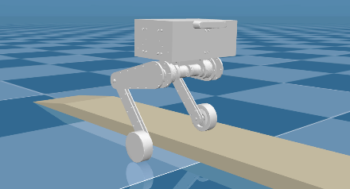
Figure 2. Simulation of the robot crossing an obstacle with single-leg variable height.

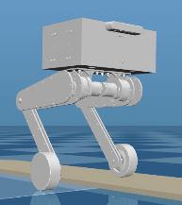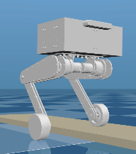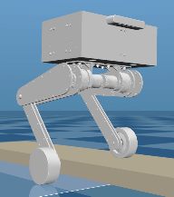
Figure 3. Single-leg variable-height slope obstacle crossing at three heights.
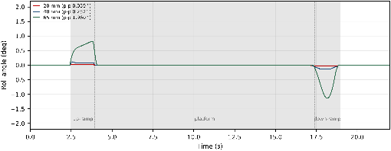
Figure 4. Roll angle during robot obstacle crossing without target joint angular velocity feedforward.
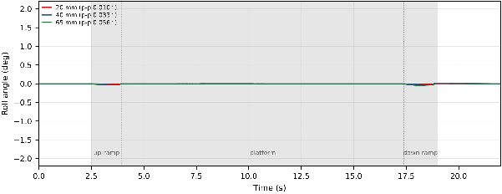
Figure 5. Roll angle during robot obstacle crossing with target joint angular velocity feedforward.
Figures 2 and 3 show the obstacle-crossing process and the slope conditions at three heights. With the target joint angular velocity feedforward turned off (Figure 4), the roll peak-to-peak value of the 65 mm single-wheel slope condition reaches 1.96°, i.e. when only the support feedforward is provided and the leg is left to track passively according to the position error, the body roll is about 2°; with the feedforward turned on (Figure 5), the roll peak-to-peak values of the three conditions are 0.016°, 0.058° and 0.068°, respectively, all at the 0.07° level and about 30 times lower than with the feedforward off, and no wheel leaves the ground throughout (airborne ratio 0%). When the terrain is switched to the right wheel (right wheel 65 mm slope, 0.30 m/s), the roll peak-to-peak value is 0.072°, basically consistent with 0.068° on the left side, which indicates that the single-leg variable-height compensation is symmetric for the left and right sides. This also confirms the causal relationship stated in Section 3.3: what determines roll is not the magnitude of the leg-height offset, but whether the leg can keep up with the continuously changing terrain target.

4.3 Leg Control on Wavy Terrain


Figure 6. Simulation of the bipedal wheel-legged robot passing over wavy terrain.
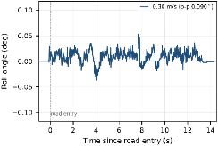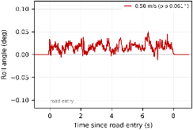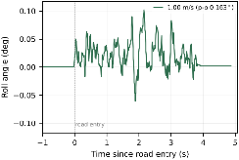
Figure 7. Roll angle when passing over wavy terrain at speeds of 0.30 m/s, 0.50 m/s and 1.00 m/s.
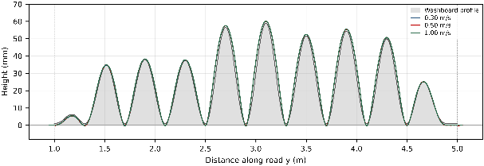
Figure 8. Wheel heights when passing over wavy terrain at different speeds.
The robot passed over the wavy terrain at 0.30-1.00 m/s (Figure 6), with the roll peak-to-peak value not exceeding 0.13° throughout, and the airborne ratio rising from 0.3% to 1.9%. As shown in Figure 7, the roll is suppressed within 0.13° at all three speeds; as shown in Figure 8, the wavy terrain undulates along the longitudinal direction, so the wheel heights vary accordingly and the body pitch follows the terrain: roll is actively compensated by the left-right leg height difference, and pitch follows the terrain through the balance loop.

4.4 Jump Attitude Control
The jump simulation scenario is a long step with a height of 0.20 m, a width of 1.00 m, and a length of 20 m. The body travels at 3.00 m/s, triggers takeoff 0.42 m before the step edge, and continues driving after jumping onto the step.

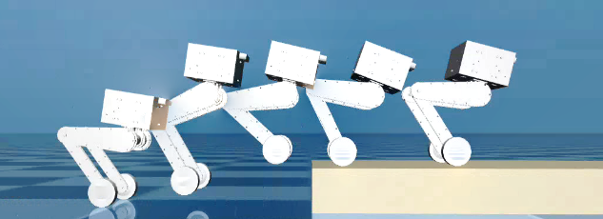
Figure 9. Simulation of the jumping process of the bipedal wheel-legged robot.

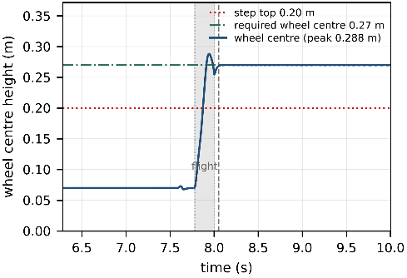
Figure 10. Wheel height of the bipedal wheel-legged robot during jumping.
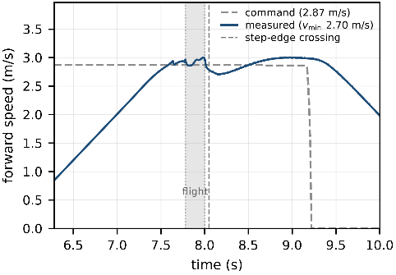
Figure 11. Longitudinal velocity of the bipedal wheel-legged robot during jumping.
As shown in Figure 9, the robot successfully climbed the step and continued driving without losing stability throughout, with a roll peak-to-peak of only 0.01° and a yaw drift of 0.011°. Vehicle speed, wheel-center height and pitch angular velocity are used as three observation quantities to characterize velocity retention, obstacle-crossing clearance and attitude cost, respectively: as shown in Figure 10, the wheel-center height rises from 0.07 m on flat ground to a peak of 0.286 m, crossing the 0.27 m required by the step edge (step height 0.20 m plus wheel radius 0.07 m), and stabilizes at 0.270 m after mounting the step, while the forward speed returns to 3.00 m/s, consistent with the command value; as shown in Figure 11, the attitude cost is concentrated in the two impacts of push-off and landing, with a pitch angular velocity peak of 111°/s, a flight-phase pitch peak of 14.3 degrees and a landing pitch peak of 9.1°, after which it converges under the balance controller.
5 Conclusion
This paper proposes a unified control framework covering multimodal locomotion for a bipedal wheel-legged robot with serial dual-motor legs, and completes systematic validation in MuJoCo. The main conclusions are as follows:
(1) The unified framework is feasible. With a single phase state machine, a single leg controller, and the same set of control parameters (balance LQR gain K = [-45.0, -7.0], leg layer k_p = 200, k_d = 60), the robot completed flat-ground driving, in-place turning, 20/40/65 mm single-leg variable-height obstacle crossing, wavy terrain following, and 0.20 m step dynamic jumping. Modality switching only changes references and output limits, without re-tuning the controller, indicating that the expansion of locomotion capability does not have to come at the cost of expanding the controller and parameter set.
(2) The analytical gravity support feedforward is effective. This feedforward does not depend on simulator internal quantities and explicitly includes the self-weight of the leg links. The single-leg mass of this robot is 3.50 kg, accounting for 20% of the total mass. Ignoring the self-weight term causes a deviation of about 5.5 N·m in the knee feedforward torque and a static standing leg height lower by about 7 mm. Under the 65 mm single-wheel slope condition, combined with target joint angular velocity feedforward, the body roll peak-to-peak value is reduced from 1.96° to 0.068°, i.e. by about 30 times, indicating that what limits roll is whether the leg can keep up with the continuously changing terrain target, rather than the leg-height offset itself.
(3) Differential attitude actuation is superior to common-mode actuation. When the left and right hip axes are arranged in a mirror configuration, the attitude effects of same-sign joint torques on both sides cancel each other. After switching to actuation by the difference of joint torques, when the robot climbs a 0.20 m step at 3.00 m/s, the flight-phase pitch peak is 14.3°, the landing pitch peak is 9.1°, the roll peak-to-peak during the entire jump is 0.01°, and the yaw drift is 0.011°.
(4) Jumping capability can be decomposed and designed. The center-of-mass ballistic trajectory is determined by the push-off impulse. When the ballistic trajectory is 133 mm, the knee joint torque has reached 97% of the peak, which is the main constraint on jump height; obstacle-crossing clearance is determined by airborne leg tucking, and tucking does not increase torque demand. The wheel center is raised from 0.07 m on flat ground to 0.286 m, crossing the 0.27 m required by the step edge; velocity retention is determined by the pre-takeoff phase duration. After shortening the crouch duration from 0.25 s to 0.08 s, the 2 s travel retention rate of jumping while driving at 2.5 m/s increased from 49% to 84%.
6 References
[1] ZHANG G Q, CUI J F, WANG X, et al. Review of the development and research of wheel-legged robots[J]. Robot Technique and Application, 2024(2): 14-21. DOI: to be supplied.
[2] ZHAO Y H, CHEN C, ZHUANG X H, et al. Review and prospect of multi-mode mobile robots[J]. Journal of Mechanical Engineering, 2026, 62(13): 22-40. DOI: to be supplied.
[3] KLEMM V, MORRA A, SALZMANN C, et al. Ascento: a two-wheeled jumping robot[C]//2019 International Conference on Robotics and Automation (ICRA). Piscataway: IEEE, 2019: 7515-7521. DOI: 10.1109/ICRA.2019.8793792.
[4] LIU D, YANG F, LIAO X, et al. DIABLO: a 6-DoF wheeled bipedal robot composed entirely of direct-drive joints[C]//2024 IEEE/RSJ International Conference on Intelligent Robots and Systems (IROS). Piscataway: IEEE, 2024: 3605-3612. DOI: 10.1109/IROS58592.2024.10801943.
[5] ZHAO H Y, WANG Q L, YU L L. Dynamic balance control of a two-wheel-legged robot[J]. Control Theory & Applications, 2026, 43(8): 1667-1677. DOI: to be supplied.
[6] WANG Y. Research on system design and motion control of an electrically driven wheeled biped robot[D]. Jinan: Shandong University, 2023. DOI: to be supplied.
[7] ZHAO H, YU L, QIN S, et al. Design and control of a bio-inspired wheeled bipedal robot[J]. IEEE/ASME Transactions on Mechatronics, 2025, 30(4): 2461-2472. DOI: 10.1109/TMECH.2024.3449397.
[8] KLEMM V, MORRA A, GULICH L, et al. LQR-assisted whole-body control of a wheeled bipedal robot with kinematic loops[J]. IEEE Robotics and Automation Letters, 2020, 5(2): 3745-3752. DOI: 10.1109/LRA.2020.2979625.
[9] LIU X, SUN Y, HAN Q, et al. A novel adaptive dynamic optimal balance control method for wheel-legged robot[J]. Applied Mathematical Modelling, 2025, 137: 115737. DOI: 10.1016/j.apm.2024.115737.
[10] XIA H. Research on high-dynamic jumping and obstacle-crossing control of bipedal wheel-legged robots[D]. Chongqing: Chongqing University, 2025. DOI: to be supplied.
[11] BJELONIC M, BELLICOSO C D, DE VIRAGH Y, et al. Keep rollin’—whole-body motion control and planning for wheeled quadrupedal robots[J]. IEEE Robotics and Automation Letters, 2019, 4(2): 2116-2123. DOI: 10.1109/LRA.2019.2899750.
[12] CUI L, WANG S, ZHANG J, et al. Learning-based balance control of wheel-legged robots[J]. IEEE Robotics and Automation Letters, 2021, 6(4): 7667-7674. DOI: 10.1109/LRA.2021.3100269.
[13] XIE J S, HAN L J, LIU H, et al. Attitude control method for a serial wheel-legged robot[J]. Acta Armamentarii, 2025, 46(2): 78-92. DOI: to be supplied.
[14] YU C, ZHU X, MA X, et al. Motion control study of a two wheel-leg robot with terrain adaptation capability[C]//2024 IEEE 8th International Conference on Vision, Image and Signal Processing (ICVISP). Piscataway: IEEE, 2024: 1-6. DOI: 10.1109/ICVISP64524.2024.10959649.
[15] ZHANG Q, PAN K X, WANG Z Y, et al. Pose control of a bionic wheel-legged robot in complex terrain[J]. Transactions of the Chinese Society for Agricultural Machinery, 2024, 55(6): 380-391. DOI: to be supplied.
[16] LI J, MA J, NGUYEN Q. Balancing control and pose optimization for wheel-legged robots navigating high obstacles[C]//2022 IEEE/RSJ International Conference on Intelligent Robots and Systems (IROS). Piscataway: IEEE, 2022: 8835-8841. DOI: 10.1109/IROS47612.2022.9981432.
[17] LU Z, XIONG Y, LIU H, et al. Trajectory planning for jumping and soft landing with a new wheeled bipedal robot[J]. IEEE Transactions on Industrial Informatics, 2024, 20(11): 13406-13415. DOI: 10.1109/TII.2024.3435556.
[18] XIA H, HE Y, LEI H, et al. Jump planning and airborne attitude control of bipedal wheel-legged robots[J]. IEEE Robotics and Automation Letters, 2025, 10(9): 9384-9391. DOI: 10.1109/LRA.2025.3588050.
[19] HOSSEINI M, RODRIGUEZ D, BEHNKE S. Dynamic hybrid locomotion and jumping for wheeled-legged quadrupeds[C]//2023 IEEE/RSJ International Conference on Intelligent Robots and Systems (IROS). Piscataway: IEEE, 2023: 793-799. DOI: 10.1109/IROS55552.2023.10341824.

